3GPP TSG-SA5 Meeting #133e S5-205107

e-meeting 12th - 21st October 2020

Source: Huawei, China Telecom, CATT, China Unicom

Title: Discuss on NR NRM update to support MOCN network sharing scenario

Document for: Endorsement
Agenda Item: 6.4.4

1 Decision/action requested
The group is asked to discuss and endorse.

2 References
[1] 3GPP TS 38.300: "NR; Overall description; Stage-2".
[2] 3GPP TS 23.501: "System Architecture for the 5G System; Stage 2".

Rationale
Following are some observations related to MOCN network sharing scenario described in other groups (i.e. SA2 and RAN3).
Obervation#1: Following are RAN sharing related content described in TS 38.300[1], according to following description, the TAC and Cell Identity for the supported operators (i.e. PLMNs) may be different.
/***************Beginning of TS 38.300*******************/

4.6 Radio Access Network Sharing
NG-RAN supports radio access network sharing as defined in TS 23.501 [3].
If NR access is shared, system information broadcast in a shared cell indicates a TAC and a Cell Identity for each subset of PLMNs, PNI-NPNs and SNPNs. NR access provides only one TAC and one Cell Identity per cell per PLMN, SNPN or PNI-NPN. In this version of the specification, a Cell Identity can only belong to one network type among PLMN, PNI-NPN or SNPN as defined in TS 23.501 [3].
Each Cell Identity associated with a subset of PLMNs, SNPNs or PNI-NPNs identifies its serving NG-RAN node.
/***************End of TS 38.300*******************/

Obervation#2: Following are the description for Cell Identity described in TS 38.300, according to following description, the gNB ID for different operators (i.e. PLMNs) may be different.
/***************Beginning of TS 38.300*******************/

8.2 Network Identities
….
- gNB Identifier (gNB ID): used to identify gNBs within a PLMN. The gNB ID is contained within the NCI of its cells.
/***************End of TS 38.300*******************/

Obervation#3: Following are 5G Multi-Operator Core Network (5G MOCN) network sharing architecture described in TS 23.501, t the instances of EP_NgC and EP_NgU for operators (i.e. PLMNs) may be different.
/***************Beginning of TS 23.501*******************/

5.18 Network Sharing

Figure 5.18.1-1: A 5G Multi-Operator Core Network (5G MOCN) in which multiple CNs are
connected to the same NG-RAN

/***************End of TS 23.501*******************/

According to above description, the following NR NRM fragment is proposed to support MOCN network sharing scenario.

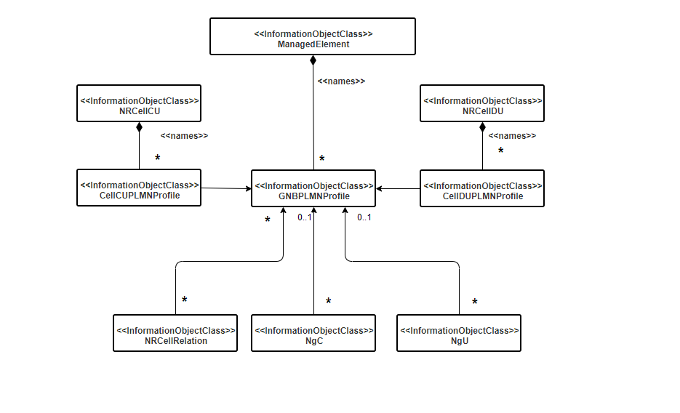
- GNBPLMNProfile <<IOC>> is introduced to hold gNB level PLMN specific configuration (e.g. PLMNId, gNBId, gNBIdlength) for each operator.
- CellDUPLMNProfile <<IOC>> is introduced to hold Cell level PLMN specific configuration (e.g. celllocalId, nRTAC) for each operator.

In order to give an overview of NR NRM support the RAN sharing scenario, following is the merged NR NRM fragement which merging the basic NR NRM fragement and NR NRM fragement support NR NRM fragment is proposed to support MOCN:
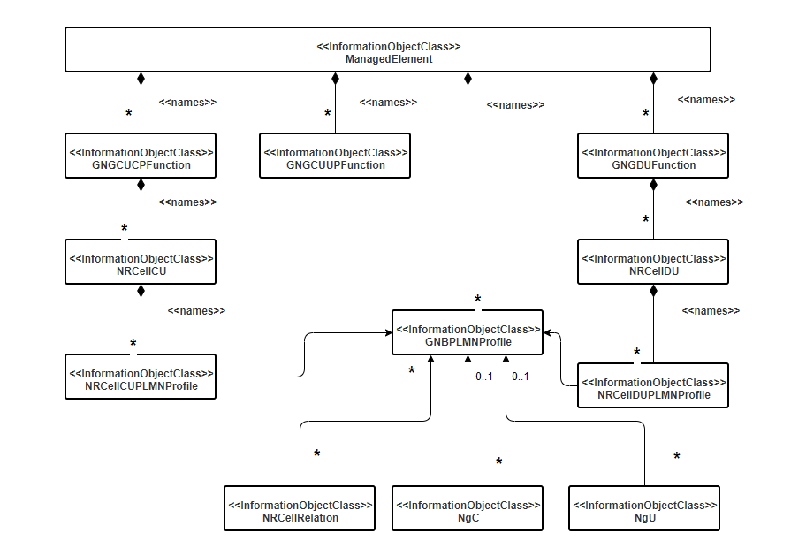

Following are some benefits for the proposed NR NRM to support MOCN network sharing scenario.
- The proposed model is backward compatible with R16/R15 NR NRM, the existing IOC and relationship between existing IOC haven’t be changed
- The NR NRM without supporting MOCN and NR NRM supporting MOCN have same basic NR NRM fragment (These IOC and relationship are not related to MOCN feature).
- The NRCellCUPLMNProfile/NRCellDUPLMNProfile are introduced to support cell level operator specific (PLMN specific) configuration parameters, from PM/FM management view, these IOC are also can be used for Operator specific measurement or alarm, which is operator-oriented. From PM view, the proposed NRM also support measurement be reported on NRCellCU/DUPLMNProfile (for operator specific measurement) or be reported on NRCellCU/DU (for Cell Level measurement, which consider all supported operators)
- Avoid redundancy and inconsistence issue for PLMNId in multiple IOC. Configure PLMN Id once in GNBPLMNProfile and associated all PLMN specific IOC with the GNBPLMNProfile.
- Support flexible and efficient cell relation configuration capability in MOCN scenario. In case of multiple Operator share the same cell relation, only one NRCellReleation MOI is created and associated to multiple GNBPLMNProfile. In case of Operator specific cell relation, one NRCellRelation is created and associated to one GNBPLMNProfile.

4 Detailed proposal
It proposes to discuss and endorse the following principles and detaild proposal:

Principles:
Principle#1: R17 focus on MOCN network sharing scenario.
Principle#2: R17 NR NRM supporting MOCN network sharing feature should backwards compatible with R16/R15 NR NRM, which means the existing IOC definition and relation between existing IOCs defined in R16/R15 should not be changed.
Principle#3: The basic NR NRM (defined in R16/R15) should be same for R17 NR NRM with or without MOCN network sharing feature.

Proposals for NR NRM update:

Proposal#1: It proposes to add NRM fragment for MOCN network sharing scenario as follows in TS 28.514 in Rel-17.
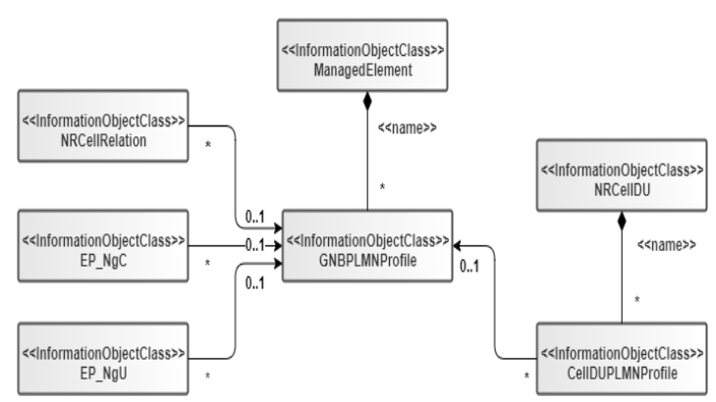

Proposal#2: It proposes to add GNBPLMNProfile <<IOC>> name contained by ManagedElement to represent the gNB level PLMN specific configuration, following are the proposed attributes for GNBOperator<<IOC>>
Attribute name | Support Qualifier | isReadable | isWritable | isInvariant | isNotifyable
pLMNId | M | T | T | F | T
gNBId | O | T | T | F | T
gNBIdLength | O | T | T | F | T
masterOperatorIndicator | M | T | T | F | T

Proposal#3: It propose to add CellDUPLMNProfile <<IOC>> name contained by NRCellDU to represent the cell level PLMN specific configuration for NRCellDU, following are the proposed attributes for CellDUPLMNProfile<<IOC>>
Attribute name | Support Qualifier | isReadable | isWritable | isInvariant | isNotifyable
cellLocalId | O | T | T | F | T
nRTAC | O | T | T | F | T
Attribute related to role
gNBPLMNProfileRef | M | T | T | F | T

Proposal#3-1: It propose to add CellCUPLMNProfile <<IOC>> name contained by NRCellCU to represent the cell level PLMN specific configuration for NRCellCU, following are the proposed attributes for CellCUPLMNProfile<<IOC>>
Attribute name | Support Qualifier | isReadable | isWritable | isInvariant | isNotifyable
cellLocalId | O | T | T | F | T
Attribute related to role
gNBPLMNProfileRef | M | T | T | F | T

Proposal#4: It propose to add gNBPLMNProfileRef in EP_NgC<<IOC>> and EP_NgU<<IOC>> to represent the PLMN specific EP_NgC and EP_NgU, following are the detailed proposals:

4.3.10 EP_NgC
……
4.3.10.2 Attributes
The EP_NgC IOC includes attributes inherited from EP_RP IOC (defined in TS 28.622[30]) and the following attributes:
Attribute name | Support Qualifier | isReadable | isWritable | isInvariant | isNotifyable
localAddress | O | T | T | F | T
remoteAddress | O | T | T | F | T
Attribute related to role
gNBPLMNProfileRef | CM | T | T | F | T

4.3.11 EP_NgU
……
4.3.11.2 Attributes
The EP_NgU IOC includes attributes inherited from EP_RP IOC (defined in TS 28.622[30]) and the following attributes:
Attribute name | Support Qualifier | isReadable | isWritable | isInvariant | isNotifyable
localAddress | O | T | T | F | T
remoteAddress | O | T | T | F | T
Attribute related to role
epTransportRef | O | T | F | F | T
gNBPLMNProfileRef | CM | T | T | F | T

Proposal#5: It propose to add gNBPLMNProfileRef in NRCellRelation<<IOC>> to represent the PLMN specific NRCellRelation, following is the detailed proposal:

4.3.32 NRCellRelation

4.3.32.1 Definition
…..
Attribute name | Support Qualifier | isReadable | isWritable | isInvariant | isNotifyable
nRTCI | O | T | T | F | T
cellIndividualOffset | M | T | T | F | T
isRemoveAllowed | CM | T | T | F | T
isHOAllowed | CM | T | T | F | T
isESCoveredBy | CM | T | T | F | T
isENDCAllowed | CM | T | T | F | T
isMLBAllowed | CM | T | T | F | T
attribute related to role
nRFreqRelationRef | M | T | T | F | T
adjacentNRCellRef | M | T | T | F | T
gNBPLMNProfileRef | CM | T | T | F | T

