3GPP TSG-SA5 Meeting #133e S5-205xxx

e-meeting 12th -21st October 2020

Source: Ericsson

Title: Discussion paper on Assurance Closed Loop model updates

Document for: Endorsement
Agenda Item: 6.3

1 Decision/action requested
The group is asked to endorse the proposal in section 4.

2 References
[1] SA5-204007 SA5#132e OAM Chair notes and conclusions
[2] 3GPP TS 28.535 Management and orchestration; Management services for communication service assurance; Requirements
[3] 3GPP TS 28.536 Management and orchestration; Management services for communication service assurance; Stage 2 and stage 3
[4] 3GPP TS 28.622 Telecommunication management; Generic Network Resource Model (NRM) Integration Reference Point (IRP); Information Service (IS)
[5] 3GPP TS 28.623 Telecommunication management; Generic Network Resource Model (NRM) Integration Reference Point (IRP); Solution Set (SS) definitions
[6] 3GPP TS 28.541 Management and orchestration; 5G Network Resource Model (NRM); Stage 2 and stage 3

3 Rationale
At the last meeting #132e the group agreed to clean-up the model for the assurance closed loop specified in TS 28.536 [2] before agreeing any new Rel-17 contributions. This contribution discusses the changes proposed to the stage 2 model and the CR’s in which the detailed changes are proposed for stage 2 and stage 3.
The following aspects regarding the stage 2 where identified as issues:
- The association relationship between SubNetwork and AssuranceControlLoop
- The relationship between the AssuranceControlLoop and Managed Entities
- The difference between AssuranceGoalStatus and AssuranceControlLoopGoal
This contribution describes the relationships between SubNetwork and AssuranceControlLoop, AssuranceControlLoop and NetworkSlice (Managed Entity), and AssuranceControlLoop and AssuranceControlLoopGoal (including AssuranceControlStatus)
The association relationship between SubNetwork and AssuranceControlLoop
As shown in Figure 4.1.2.2.1.1 in [3] a SubNetwork can contain 0..n instances of class AssuranceControlLoop. The way to show this relationship is to use stereotype <<names >> on the association relationship between SubNetwork and AssuranceControlLoop. The updated relationship diagram is shown in the figure 3.1 below.
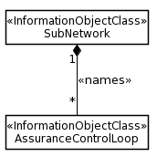
Figure 3.1: Relationship diagram for AssuranceControlLoop
The relationship where an AssuranceControlLoop is directly associated through the <<names>> association with SubNetwork shown in Figure 3.1 is not documented. The proper place to document this relationship is either in either:
- Option 1: TS 28.541 [1]
- Option 2: TS 28.622 [4] for stage 2 and TS 28.623 for stage 3
Option 1
TS 28.541 includes all new 5G NRM fragments such as NR, 5GC and Network Slicing. Adding the top-level relationship between SubNetwork and AssuranceControlLoop as new fragment makes sense. TS 28.536 would reference TS 28.541 for this part of the NRM.
A single CR is needed to introduce the change which includes stage 2 and stage 3 in [6].
Option 2
TS 28.622 and TS 28.623 includes all IOC’s that are generic (agnostic of RAN/CN), an AssuranceControlLoop is also generic concept and have direct includes
Two CR’s are needed, one to introduce the stage 2 in [4] and one to introduce stage 3 [5]
The relationship between the AssuranceControlLoop and Managed Entities
A network slice is subject to requirements derived from one or more SLSs (Service Level Specification), for each SLS one or more AssuranceControlLoops may be created in the corresponding network slice subnet. This relationship was not shown correctly in Figure 4.1.2.2.1.1 in [3]. It is proposed to insert a new diagam showing this relationship, the new relationship diagram is shown in figure 3.2 below.
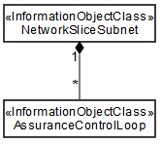
Figure 3.2: Relationship between AssuranceControlLoop and NetworkSliceSubnet
An assurance control loop includes a goal that contains information derived from an SLS. The information extracted from an SLS includes attributes subject to assurance requirements (attribute is indicated with goal name) and their value (target value). It is proposed to insert a new diagam showing this relationship, see figure 3.3 below.
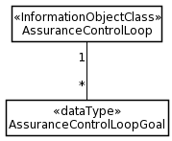
Figure 3.3: Relationship diagram for AssuranceControlLoopGoal
AssuranceControlLoop attributes
The attributes of an AssuranceControlLoop shown in Table 4.1.2.4.1.1 in [3] should include a list of assuranceControlLoopGoal instead of assuranceGoalStatus. A list as a goal may be defined containing multiple attributes. The update is shown in Tabel 3.1 below.
Attribute name | Support Qualifier | isReadable | isWritable | isInvariant | isNotifyable
operationalState | M | T | F | F | T
administrativeState | M | T | T | F | T
controlLoopLifeCyclePhase | M | T | T | F | T
observationTimePeriod | M | T | T | F | T
assuranceControlLoopGoalList | M | T | F | F | T
Table 3.1: overview of attributes included in AssuranceControlLoop
AssuranceControlLoopGoal attributes
The AssuranceControlLoopGoal includes all relevant information associated with goals that are assured by the control loop. The attibutes are shown in the Table 3.2 below. An example of a value for an assuranceGoalName is delay. The value of an assuranceGoalTarget is derived from an SLS.
Example SLS specifies the throughput of a NetworkSlice is 150 kb/s.
Note that the SLS specifies other characterstics which may or may not be included in the AssuranceControlLoopGoal. In this example the only goal is to assure that the NetworkSlice throughput is 150 kbit/s.
In this example the throughput of the NetworkSlice as part of the AssuranceControlLoopGoal is captured by the attribute-value-pair assuranceGoalTarget=150. The OAM system monitors the throughput of the NetworkSlice and captures the current value of the throughput and observes that the target has not been reached, the OAM system predicts (based on algorithms) that a reconfiguration of the NetworkSlice or any of its dependent resources can improve the throughput and the reconfiguration is carried out. Using a different algorithm may result in a different outcome, for the same assuranceGoalTarget=150. The operator technician can check the effectiveness of the assuranceControlLoop by consulting the performance measurements and KPI’s associated with the named assuranceGoalName.
The AsssuranceControlLoopGoal attributes are shown in Table 3.2.
Attribute name | Support Qualifier | isReadable | isWritable | isInvariant | isNotifyable
assuranceGoalName | M | T | T | F | T
assuranceGoalTarget | M | T | T | F | T
Table 3.2: overview of attributes included in AssuranceControlLoopGoal
Examples of assuranceGoalName
An attribute included in an AssuranceControlLoopGoal has a name, examples of names of goals are characteristics attributes such as the examples shown in Table 3.3:
maxNumberofUEs | dLThptPerSlice | activityFactor
coverageArea | dLThptPerUE | uESpeed
coverageAreaTAList | uLThptPerSlic | jitter
latency | uLThptPerUE | survivalTime
uEMobilityLevel | maxPktSize | reliability
availability | maxNumberofConns
delayTolerance | termDensity
Table 3.3: examples of assuranceGoalNames
Datastructure for AssuranceControlLoopGoal
The assuranceControlLoopGoal represents a subset of attributes that are specified in a SLS, i.e. ServiceProfile or SliceProfile. In figure 3.4 the AssuranceControlLoopGoal: goalId=1 represents SLS-A and AssuranceControlLoopGoal: goalId=8 represents SLS-B.
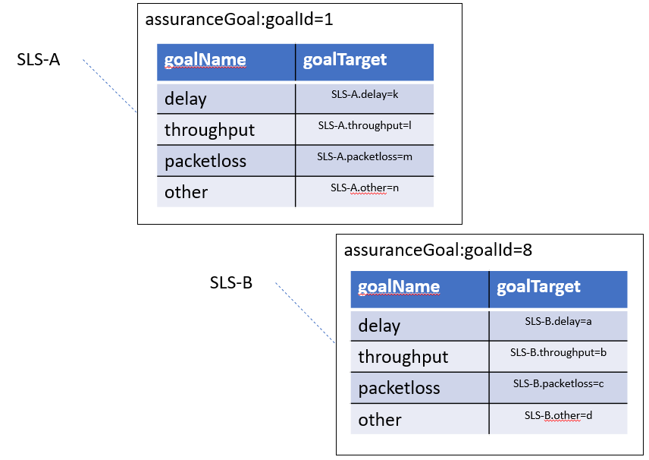
Figure 3.4: example data structure for assuranceControlLoopGoal
The mapping of the tables in figure 3.4 to a generic datastructure is shown in figure 3.5 below.
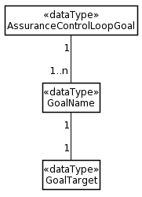
Figure 3.5: Relationship diagram for option 1

Discussion
The discussion paper proposes to update the class diagram, inheritance, definitions and attribute definition table. These changes impact both stage 2 and stage 3 clauses in TS 28.536, and TS 28.541 (Option 1) or TS 28.622/623 (Option 2).
When choosing option 1 the following CR’s are proposed:
- S5-205xxx Rel-16 CR 28.536 Update class diagram inheritance definitions and attribute definition table in clause 4.1.2
- S5-205xxx Rel-16 CR 28.536 Update solution set for JSON-YAML in clasue 4.2.1
- S5-205xxx Rel-16 CR 28.541 Add assuranceControlLoop class definition and include refences to TS 28.536
When choosing option 2 the following CR’s are proposed
- S5-205xxx Rel-16 CR 28.622 Add assuranceControlLoop class definition and include refences to TS 28.536
- S5-205xxx Rel-16 CR 28.623 Add mapping IOC assuranceControlLoop and YAML definition and references to TS 28.536
- S5-205xxx Rel-16 CR 28.536 Update class diagram inheritance definitions and attribute definition table in clause 4.1.2
- S5-205xxx Rel-16 CR 28.536 Update solution set for JSON-YAML in clasue 4.2.1

4 Detailed proposal
The group is asked to endorse the proposed updates to the AssuranceControlLoop IOC including AssuranceControlLoopGoal and implementation proposal Option 1 or Option 2

