3GPP TSG-SA5 Meeting #132e S5-204299

e-meeting 17th 28th August 2020

Source: Huawei, China Mobile

Title: Update workflow

Document for: Approval
Agenda Item: 6.6.2

1 Decision/action requested
The group is asked to discuss and approval.

2 References
[1] 3GPP TR 28.810: “Study on concept, requirements and solutions for levels of autonomous network v1.0.0”.

3 Rationale
This contribution proposes to update the workflow in the following aspect:
- Change the intent translation to intent management which include not only intent translation but also intent feedback which evaluate whether the intent is satisfied or not and feed back to the operator or customer, to make up a complete intent driven closed loop.
- Update the description of Awareness by adding awareness of the network status based on the collected network data besides collecting network data.

4 Detailed proposal
It proposes to make the following changes to TR 28.810[1].
1st Change

4.4.2 Workflow
Workflow is used to describe the necessary steps to fulfil certain management purposes. A workflow is composed of one or more management tasks. Each workflow task may be accomplished by human, or accomplished by telecom system with human assistance, or accomplished by telecom system without human intervention. The autonomy capabilities of the tasks in the workflow may impact the network autonomy level.
Following are the potential categorization of the tasks in a workflow:
- Intent translation: The group of tasks which translate network or service intent from operator or customer into detailed management operations which may affect one or more of the following groups of tasks (i.e. awareness, analysis, decision, execution) and translate the detailed network and service information to intent fulfillment information (e.g. the intent is satisfied or not).
- Awareness: The group of tasks which monitor network information (including network performance, network anomaly, network event, etc).
- Analysis: The group of tasks which analyse the obtained network information (e.g. network status, network issues and so on) or based on the historical network information to further predict the future change trend of the above network status, and make recommendation for decision.
- Decision: The group of tasks which evaluate and decide the necessary management operation for execution, e.g. network configuration or adjustment.
- Execution: The group of tasks which execute the management operations.
Figure 4.4.2-1 illustrate the general workflow for network autonomy.

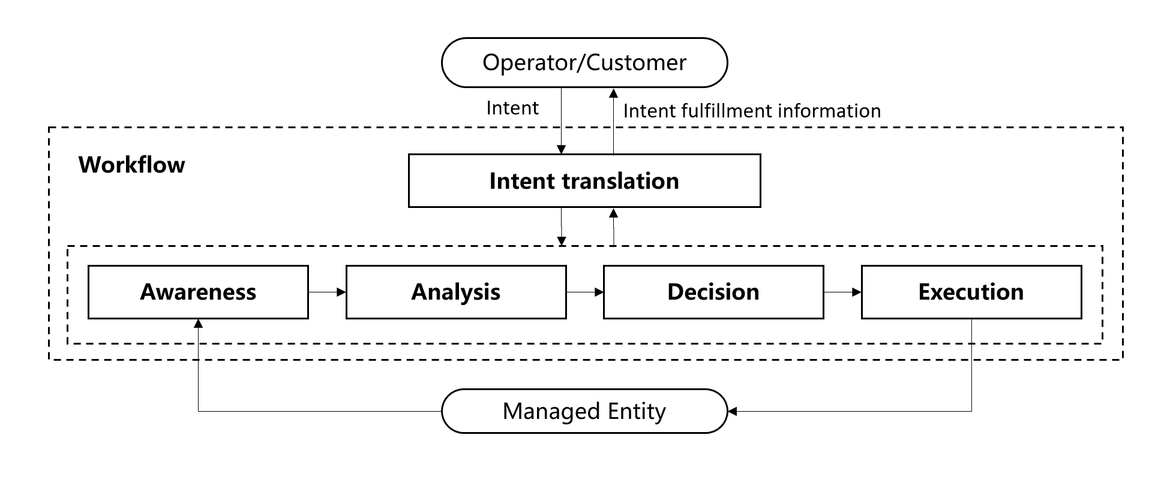
Figure 4.4.2-1: General workflow for network autonomy

2nd Change

6.1.2 Framework approach for classification of autonomous network level
According to the potential categorization of the tasks in a general network autonomy workflow, a framework approach for classification of autonomous network level is introduced as following, which is used for evaluating the autonomy capability of telecom system.
Table 6.1.2-1: Framework approach for classification of autonomous network level
Network autonomy level |  | Task categories
 |  | Execution | Awareness | Analysis | Decision | Intent translation
L0 | Manual operating network | Human | Human | Human | Human | Human
L1 | Assisted operating network | Human & Telecom system | Human & Telecom system | Human | Human | Human
L2 | Preliminary autonomous network | Telecom system | Human & Telecom system | Human & Telecom system | Human | Human
L3 | Intermediate autonomous network | Telecom system | Telecom system | Human & Telecom system | Human & Telecom system | Human
L4 | Advanced autonomous network | Telecom system | Telecom system | Telecom system | Telecom system | Human & Telecom system
L5 | Full autonomous network | Telecom system | Telecom system | Telecom system | Telecom system | Telecom system
Note 1: Human reviewed decision have the highest authority in each level if there is any confliction between human reviewed decision and telecom system generated decision.
Note 2: The present of above five task categories does not reflect the workflow sequence.

Level 0 manual operating network: No categorization of the tasks is accomplished by telecom system itself.
Level 1 assisted operating network: A part of the execution and awareness tasks are accomplished automatically by telecom system itself based on human defined rules. At this level, telecom system can assist human to improve the execution and awareness efficiency.
Level 2 preliminary autonomous network: All the execution tasks are accomplished automatically by telecom system itself. A part of the awareness and analysis tasks are accomplished automatically by telecom system itself based on human defined policies. At this level, telecom system can assist human to achieve the close loop based on human defined policies.
Level 3 intermediate autonomous network: All the execution and awareness tasks are accomplished automatically by telecom system itself. A part of the analysis and decision tasks are accomplished automatically by telecom system itself based on human defined policies. At this level, the telecom system can achieve the close loop automation based on the human defined close loop automation policies.
Level 4 advanced autonomous network: All the execution, awareness, analysis and decision tasks are accomplished automatically by telecom system itself. And intent translation tasks can be partly accomplished automatically by telecom system itself based on human defined intent translation policies. At this level, telecom system can achieve the intent driven close loop automation based on human defined intent translation policies, which means the telecom system can translate the intent to the detailed close loop automation policies and translate the detailed network and service information to intent fulfillment information (e.g. the intent is satisfied or not) based on human defined intent translation policies.
Level 5 fully autonomous network: The entire network autonomy workflow is accomplished automatically by telecom system without human intervention. At this level, telecom system can achieve the whole network autonomy.
Note: Above framework approach for classification of autonomous network level are applicable for evaluating the autonomous network level from both management scope and scenario perspective. The overall autonomous network level of the whole telecom system is a comprehensive reflection of autonomous network level of the individual management scope and scenarios, which means in fully autonomous network level, the telecom system can achieve the whole network autonomy for all management scopes and scenarios.

End of changes

