3GPP TSG-SA5 Meeting #132e S5-204126

Online, , 17 Aug- 28 Aug 2020

Source: Samsung

Title: pCR Introduction

Document for: Approval

Agenda Item: 6.6.6

1 Decision/action requested
The group is asked to discuss and agree on the proposal.

2 References

3 Rationale
This contribution provide concept and overview for the study.

4 Detailed proposal
1st Modified Section

X. Concepts and Overview

X.1 Overview
5G brings ultra-low latency requirements which are difficult to satisfy with conventional data processing in mobile networks, where data is sent to remote data networks that introduces longer delay in communication.
Edge computing enables connected devices to process data closer to the terminal, the “edge.” This edge can be either within the device itself (i.e. processing input from sensors), or close to the device in a dedicated network offering services within a short communication delay of the access network. This provides an alternative to sending data to a centralized cloud for processing.
The following figure shows an example of edge computing usages where the user request for a VR content is served locally closer to the user at the edge of the network. The content from the content provider is being constantly cached at the local content server hosted at the edge via network core. When user request for the content the local breakout is initiated and the content is provided locally. This will help is attaining required latency requirement.

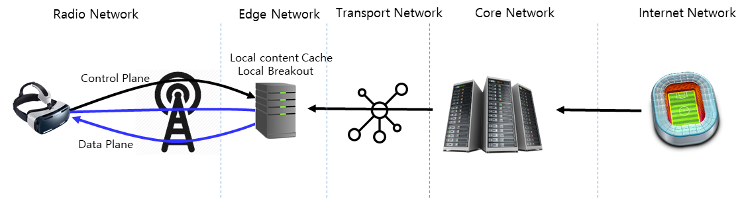
An architecture for enabling edge service is defined in TS 23.558 [x]. The architecture includes various components and interfaces working together to enable edge services. This document studies the management requirements/solutions for EAS, EES and ECS.

X.3 Deployment Models
Several entities are envolved in an edge computing ecosystem as defined in SA6 including ASP (Application Service Provider), ECSP (Edge Computing Service Provider), PLMN Operator etc. The application service provider consumes the edge services (e.g. infrastructure, platform) provided by the edge computing service provider (ECSP). As per the architecture defined in TS 23.558 there can be multiple deployment variations. While some of the deployment model are very well in-scope of this document, some falls out of the scope. The following figures captures various deployment model pertaining to EAS, EES and ECS management.
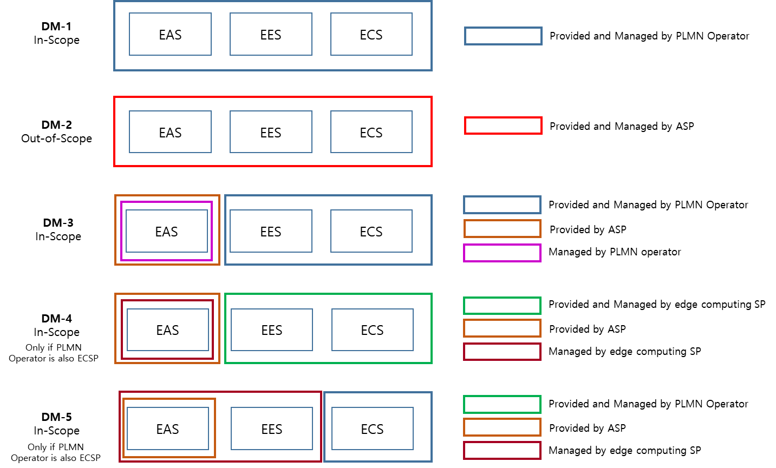

X.3 Management Aspect of Edge
The management aspect of EDN includes (not limited to) the following:
- Lifecyle management of EDN as a 3GPP Local Data Network.
- Lifecycle management of EDN components including EAS, EES and ECS.
- Performance Assurance of EDN components including EAS, EES and ECS.
- Fault Supervision of EDN components including EAS, EES and ECS.
- Virtual resource management for EDN components including EAS, EES and ECS.
- EDN capability management including the type and capabilities of EAS(s) available in the EDN.

End of Modified Sections

