3GPP TSG-SA5 Meeting #132e S5-204065rev3

e-meeting, 17 - 28 August 2020

Source: Orange, Intel, NEC, Nokia, AT&T, Deutsche Telekom

Title: Key Issue: Network data analysis assisted ES - Possible OA&M centric solution

Document for: Approval
Agenda Item: 6.6.5

1 Decision/action requested
The group is asked to discuss and agree on the proposal.

2 References
[1] TR 28.813 0.1.0: Study on new aspects of Energy Efficiency (EE) for 5G

3 Rationale
Regarding the key issue #3 (network data analysis assisted energy saving), it is proposed to describe an OA&M centric solution, where MDAF plays a key role.

4 Detailed proposal
This document proposes the following changes in TR 28.813 [1].

1st Change

2 References
The following documents contain provisions which, through reference in this text, constitute provisions of the present document.
- References are either specific (identified by date of publication, edition number, version number, etc.) or non-specific.
- For a specific reference, subsequent revisions do not apply.
- For a non-specific reference, the latest version applies. In the case of a reference to a 3GPP document (including a GSM document), a non-specific reference implicitly refers to the latest version of that document in the same Release as the present document.
[1] 3GPP TR 21.905: "Vocabulary for 3GPP Specifications".
[2] 3GPP TS 23.501: "5G; System Architecture for the 5G System".
[3] 3GPP TS 32.130: "Telecommunication management; Network sharing; Concepts and requirements".
[4] 3GPP TS 28.552: "Management and orchestration; 5G performance measurements".
[5] 3GPP TS 28.554: "Management and orchestration; 5G end to end Key Performance Indicators (KPI)".
[6] ETSI ES 203 228 v1.2.1: "Environmental Engineering (EE);Assessment of mobile network energy efficiency".
[7] S5-201169/S2-1912770: LS on analytics support for energy saving
[x] 3GPP TS 28.809: "Management and orchestration; Study on enhancement of Management Data Analytics (MDA)".

Next Change

4.3 Key Issue #3: Network data analysis assisted energy saving

4.3.1 Description
In S5-201169 / S2-1912770 [7], SA2 describes the following use case related to energy saving in the 5GC:
“
In particular, the network data analysis may indicate that all the UEs served by some UPF instances are low priority UEs. Based on this information, the SMF can intentionally re-allocate the low priority UEs among fewer dedicated UPF instances which are used only for serving the low priority UEs at night and running on fewer dedicated servers. As a result, there can be more UPF instances having no UE allocated to them and can be removed by the NFV orchestrator. Consequently, there can be more physical resources, such as servers, to be shut down at night and less energy to be consumed.
”.
From SA5 point of view, some points are to be investigated, including:
- It is not clear:
  - how UEs are characterized as low or high priority and on which criteria (e.g. user profile, etc.),
  - where NWDAF gets this information from,
  - whether UE priority is relative to within a given network slice (i.e. priority amongst UEs of a given network slice) or across network slices (i.e. priority amongst UEs of different network slices);
- It is not clear if the main criteria for reallocating traffic from some UPF instances to fewer UPF instances is the UE priority or the time of the day (the above text mentions ‘at night’) or service level parameters. In other words, can’t the reallocation of traffic from some UPF instances to fewer UPF instances be decided only based on the traffic load at some time of the day / night?
- Since UEs can be attached to up to eight network slices simultaneously and UPF instances either belong to a single network slice (in such a case, traffic reallocation can be done only between UPF instances of the same network slice) or are shared amongst two or more network slices (in such a case, traffic reallocation can be done between UPF instances of different network slices serving the low priority UEs), the re-allocation of the traffic from some UPF instances to some other UPF instances must take this into consideration, implying that the NWDAF must have this knowledge prior to taking any decision;
- Is it necessary that NWDAF have the information about which UPF instances are susceptible to receive traffic from other UPF instances? If yes, how does it obtain this information?
- Migrating the traffic from some UPF instances to other UPF instances so as to switch off some servers requires interacting with NFV MANO functions (e.g. for VNF instance migration / termination). How NWDAF interacts with NFV MANO function(s) and via which reference point(s) is not specified. The reference point Os-Ma-Nfvo is for interactions between NFV Orchestrator and OSS/BSS and, consequently, can’t be used by NWDAF;
- Reallocating traffic from some UPF instances to other UPF instances may have to take into consideration additional information such as e.g.:
  - When ordering a network slice to his Network Slice Provider (NSP), a Network Slice Customer (NSC) may express isolation requirements such as e.g. ‘I want my UPF instances be physically isolated from any other UPF instances allocated to other NSCs’. NWDAF has no knowledge of this, only OSS can have such information;
  - All concerned UPF instances may not be on the same site / data centre, which potentially are not powered by the same source of energy. The network operator may be willing to privilege green sources of energy. In addition, the cost of energy may highly differ between sites / data centres. NWDAF has no knowledge of this, only OSS can have such information;
  - All these UPF instances may be hosted on different types of servers, where some types of servers can be more energy efficient than others, so that the network operator may be willing to privilege these energy efficient servers. NWDAF has no knowledge of this, only OSS can have such information.
Editor’s note: this use case and high-level solution description are still FFS in SA2. Therefore, an alternative potential solution, in which MDAF plays a central role, is proposed in clause 4.3.2.1.

4.3.2 Potential solutions

4.3.2.1 Potential solution #1: OA&M centric energy saving

4.3.2.1.1 Introduction

In this potential solution, the 3GPP management system, in particular the MDAF, plays the central role during the observation phase, the analytics phase and the decision phase (cf. TS 28.809 [x] clause 5.1). A Management Function, in charge of energy saving, consumes analytics produced by MDAF and takes appropriate decisions so as to save energy in the 5G core network.

4.3.2.1.2 Description

After a preparation phase, this potential solution is divided into four phases, as described in TS 28.809 [x] clause 5.1:
- Observation,
- Analytics,
- Decision,
- Execution.
Preparation phase:

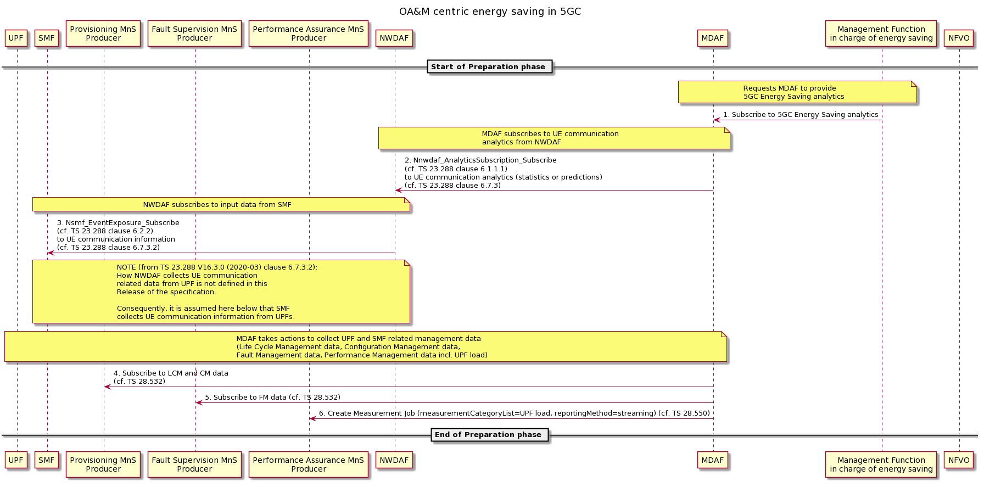

1. The Management Function in charge of energy saving sends a request to MDAF asking to get 5GC Energy Saving analytics report;
2. MDAF subscribes to UE Communication analytics from NWDAF;
3. NWDAF subscribes to UE Communication information from SMF. In Release 16 TS 23.288, the NWDAF can’t collect information from UPF. So it is assumed here that this UE Communication information is collected from SMF;
4. MDAF subscribes to UPF and SMF related lifecycle and configuration management data) from the Provisioning MnS Producer (see NOTE 3);
5. MDAF subscribes to UPF and SMF related fault management data (from the Fault Supervision MnS Producer (see NOTE 3);
6. MDAF creates a Performance Management job to collect UPF load value; the selected reporting method is streaming;
NOTE 1: Steps 2 to 3 might not be needed, depending on whether UE Communication analytics are actually needed for this use case (cf. clause 4.3.1 items 1, 2).
NOTE 2: See TR 28.809 for the mechanisms for interaction between MDAS consumer and MDAS producer.
NOTE 3: In the above procedure, the Performance Assurance MnS Producer, Provisioning MnS Producer and Fault Supervision MnS Producer are to be considered as logical entities which can be either embedded in Network Functions (UPF and SMF), or part of an 5GC Element Management System.

Observation phase:

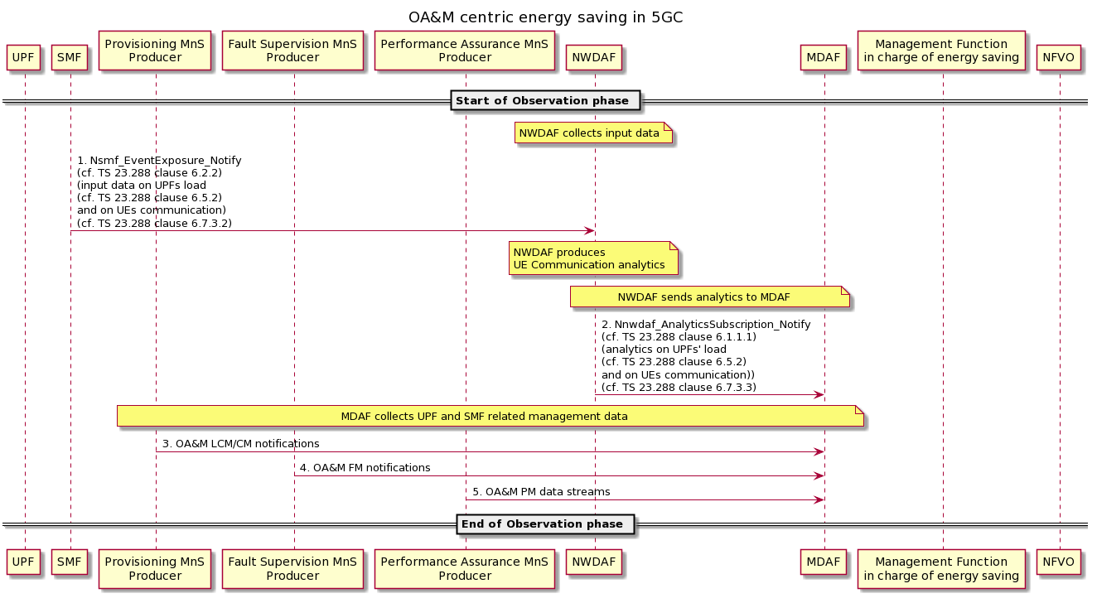

1. SMF notifies NWDAF of UE Communication information;
2. Once NWDAF has produced UE Communication analytics, it notifies MDAF of these analytics;
3. MDAF receives OA&M LCM/CM notifications about SMF and UPF, if any, from the Provisioning MnS Producer;
4. MDAF receives OA&M FM notifications about SMF and UPF, if any, from the Fault Supervision MnS Producer;
5. MDAF receives requested OA&M performance measurements related to UPF load, from the Performance Assurance MnS Producer.

NOTE 4: Steps 1 to 2 might not be needed, depending on whether UE Communication analytics are actually needed for this use case (cf. clause 4.3.1 items 1, 2).
NOTE 5: In the above procedure, the Performance Assurance MnS Producer, Provisioning MnS Producer and Fault Supervision MnS Producer are to be considered as logical entities which can be either embedded in Network Functions (UPF and SMF) or part of an 5GC Element Management System.

Analytics phase:

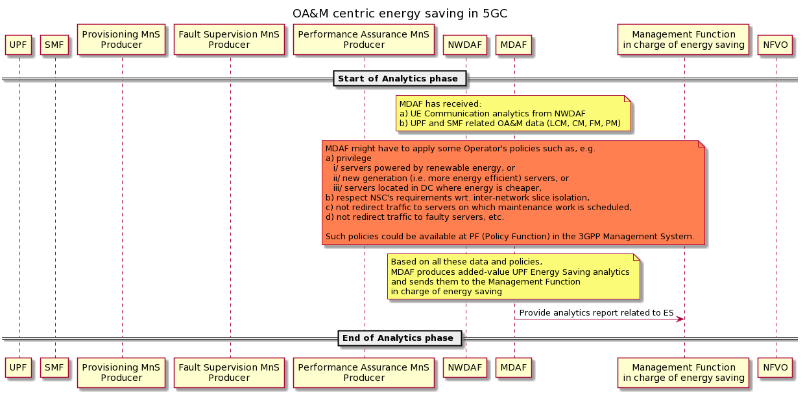
NOTE 6: See TR 29.809 for the mechanisms for interaction between MDAS consumer and MDAS producer

Decision phase:

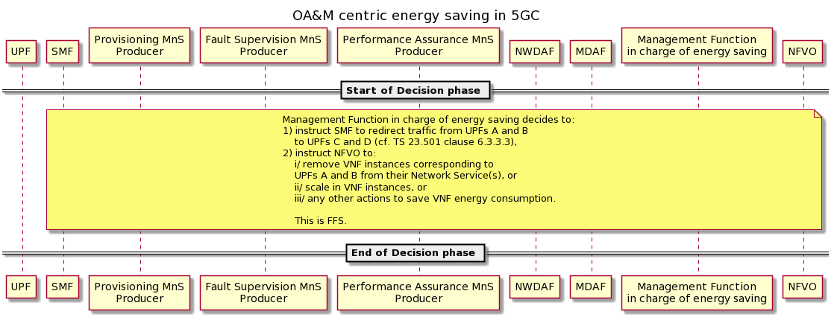
NOTE 7: Which decision is taken by the Management Function in charge of energy saving with regard to saving the energy consumed by the VNF instances corresponding to UPFs A and B is FFS.

Execution phase:

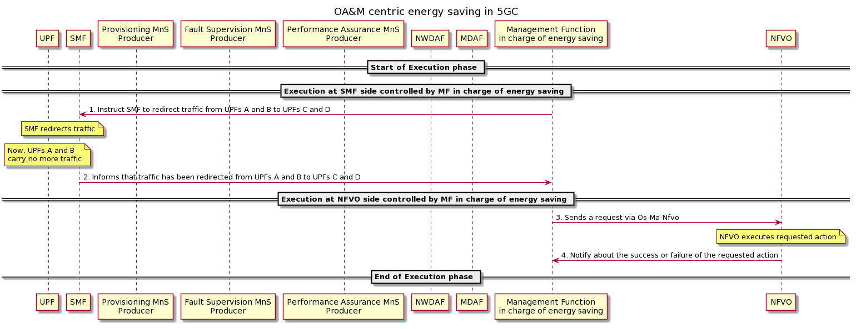

1. The Management Function in charge of energy saving instructs the SMF to redirect the traffic from UPFs A and B to UPFs C and D;
2. Once traffic has been redirected, SMF informs the Management Function in charge of energy saving;
3. Depending on which decision has been taken by the Management Function in charge of energy saving, it sends a request to the NFVO to either terminate part of or all the VNF instances corresponding to UPFs A and B and remove them from their respective Network Service(s), or scale in the VNF instances, or any other action (see NOTE 5);
4. Once the NFVO has executed the requested action, NFVO informs the Management Function in charge of energy saving.

End of change

