3GPP TSG-SA5 Meeting #130-e S5-202295r1

Online, , 20th Apr 2020 - 28th Apr 2020
CR-Form-v12.0
CHANGE REQUEST
 | 28.622 | CR | 0080 | rev | 1 | Current version: | 16.3.0
For HELP on using this form: comprehensive instructions can be found at
http://www.3gpp.org/Change-Requests.

Proposed change affects: | UICC apps |  | ME |  | Radio Access Network |  | Core Network

Title: | Rel-16 CR 28.622 Fix inconsistent formatting
Source to WG: | Nokia
Source to TSG: | SA5
Work item code: | TEI16 |  |  |  |  |  | Date: |  |  | 2020-04-12
Category: | D |  |  |  |  |  | Release: |  |  | Rel-16
 | Use one of the following categories:  F (correction)  A (mirror corresponding to a change in an earlier release)  B (addition of feature),  C (functional modification of feature)  D (editorial modification)  Detailed explanations of the above categories can  be found in 3GPP TR 21.900. |  |  |  |  |  |  |  | Use one of the following releases:  Rel-8 (Release 8)  Rel-9 (Release 9)  Rel-10 (Release 10)  Rel-11 (Release 11)  Rel-12 (Release 12)  Rel-13 (Release 13)  Rel-14 (Release 14)  Rel-15 (Release 15)  Rel-16 (Release 16)
Reason for change: |  | Wrong formatting (e.g. heading types applied to empty lines and figure titles) makes it very difficult to navigate the specification.
Summary of change: |  | Applied correct 3GPP format styles to restore the document structure:  - Figure titles formatted as "TF"  - Empty lines formatted as "Normal"  - Annex headings formatted as "Heading 8"  - Fixed the title of clause 4.3.28 (un-merged it from the content of clause 4.3.27)
Consequences if not approved: |  | Inconsistent specification potentially leading to misinterpretations and incorrect implementations.
Clauses affected: |  | 4.2, 4.3, Annex A, Annex B
 |  | Y | N
Other specs |  |  | x | Other core specifications |  |  |  | TS/TR ... CR ...
affected: |  |  | x | Test specifications |  |  |  | TS/TR ... CR ...
(show related CRs) |  |  | x | O&M Specifications |  |  |  | TS/TR ... CR ...
Other comments:
This CR's revision history: |  | S5-202295

1st Modified Section

4.2 Class diagrams

4.2.1 Relationships
This clause depicts the set of classes (e.g. IOCs) that encapsulates the information relevant for this IRP. This clause provides the overview of the relationships of relevant classes in UML. Subsequent clauses provide more detailed specification of various aspects of these classes.
The following figure shows the containment/naming hierarchy and the associations of the classes defined in the present document. See Annex A of a class diagram that combines this figure with Figure 1 of [2], the class diagram of UIM.
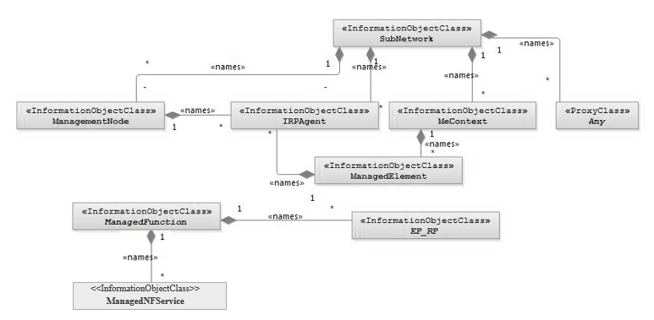
NOTE 1: ManagedElement may be contained either
- in a SubNetwork (since SubNetwork inherits from Domain_ and ManagedElement inherits from ManagedElement_ and Domain_ name-contained ManagedElement_ as observed in the figure of Annex A) or
- in a MeContext instance as observed by the above figure or in the figure of Annex A.
This either-or relation cannot be shown by using an {xor} constraint in the above figure.
ManagedElement may also have no parent instance at all.
NOTE 2: Each instance of the VsDataContainer shall only be contained under one IOC. The VsDataContainer can be contained under IOCs defined in other NRMs.
NOTE 3: If the configuration contains several instances of SubNetwork, exactly one SubNetwork instance shall directly or indirectly contain all the other SubNetwork instances.
NOTE 4: The SubNetwork instance not contained in any other instance of SubNetwork is referred to as "the root SubNetwork instance".
NOTE 5: ManagementNode shall be contained in the root SubNetwork instance.
NOTE 6: If contained in a SubNetwork instance, IRPAgent shall be contained in the root SubNetwork instance.
NOTE 7: For a clarification on the choice of containment of the IRPAgent (since it has three possible parents), see the def. of IRPAgent.
NOTE 8: Cardinality * is identical to multiplicity 0..*.

Figure 4.2.1-1: Containment/Naming and Association NRM fragment
Each Managed Object is identified with a Distinguished Name (DN) according to 3GPP TS 32.300 [13] that expresses its containment hierarchy. As an example, the DN of a ManagedElement instance could have a format like:
SubNetwork=Sweden,MeContext =MEC-Gbg-1, ManagedElement=RNC-Gbg-1.
NOTE 8: Each instance of the VsDataContainer shall only be contained under one IOC. The VsDataContainer can be contained under IOCs defined in other NRMs by virtue of inheritance from the GENERIC NRM.
NOTE 9: The VsDataContainer is only used for the Bulk CM IRP.

Figure 4.2.1-2: VsDataContainer Containment/Naming and Association in NRM fragment

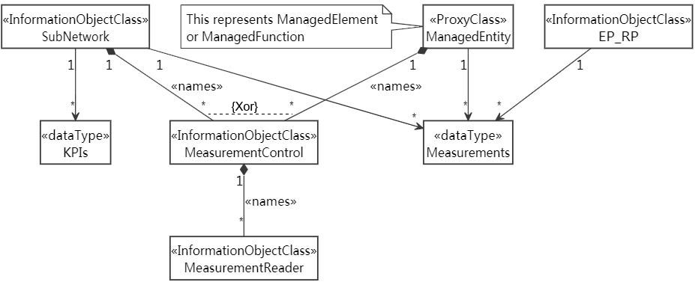
Figure 4.2.1-3: Performance measurement control NRM fragment
Figure 4.2.1-4: Measurement threshold monitoring control fragment
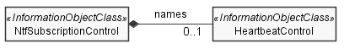
Figure 4.2.1-5: Heartbeat notification control fragment
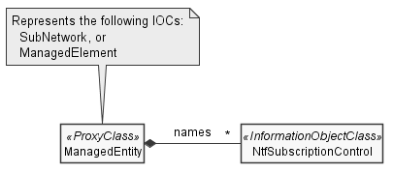
Figure 4.2.1-6: Notification subscription control fragment

4.2.2 Inheritance
This clause depicts the inheritance relationships.

Figure 4.2.2-1: Inheritance Hierarchy NRM fragment
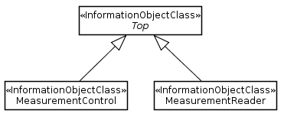
Figure 4.2.2-2: Performance measurement control NRM fragment

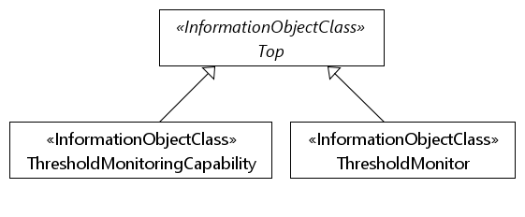
Figure 4.2.2-3: Measurement threshold monitoring NRM fragment
Figure 4.2.2-4: Heartbeat notification control fragment

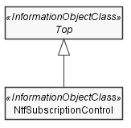
Figure 4.2.2-5: Notification subscription fragment
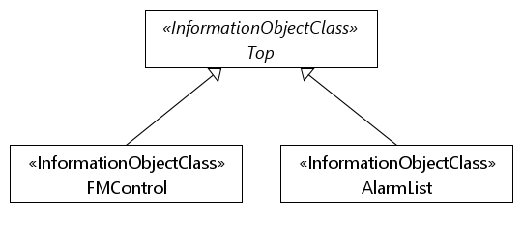
Figure 4.2.2-6: FM control NRM fragment

2nd Modified Section

4.3 Class definitions

4.3.1 Any

4.3.1.1 Definition
This class represents the classes (e.g. IOC) that are not defined in this specification but are or will be defined in other IRP specification(s).

4.3.1.2 Attributes
None

4.3.1.3 Attribute constraints
None

4.3.1.4 Notifications
This class does not support any notification.

4.3.2 IRPAgent

4.3.2.1 Definition
This IOC represents the functionality of an IRPAgent. It shall be present. For a definition of IRPAgent, see 3GPP TS 32.102 [2].
The IRPAgent will be contained under an IOC as follows (only one of the options shall be used):
1) ManagementNode, if the configuration contains a ManagementNode;
2) SubNetwork, if the configuration contains a SubNetwork and no ManagementNode;
3) ManagedElement, if the configuration contains no ManagementNode or SubNetwork.

4.3.2.2 Attributes
The IRPAgent IOC includes the attributes inherited from Top_ IOC (defined in TS 28.620 [9]), attributes inherited from Top IOC (defined in clause 4.3.8) and the following attributes:
Attribute Name | Support Qualifier | isReadable | isWritable | isInvariant | isNotifyable
systemDN | M | T | F | F | T

4.3.2.3 Attribute constraints
None

4.3.2.4 Notifications
The common notifications defined in clause 4.5 are valid for this IOC, without exceptions or additions

4.3.3 ManagedElement

4.3.3.1 Definition
This IOC represents telecommunications equipment or TMN entities within the telecommunications network providing support and/or service to the subscriber.
An ME communicates with a manager (directly or indirectly) over one or more management interfaces for the purpose of being monitored and/or controlled. MEs may or may not additionally perform element management functionality.
An ME contains equipment that may or may not be geographically distributed. An ME is often referred to as a "Network Element".
A telecommunication equipment has software and hardware components. The IOC described above represents the case when the software component is designed to run on dedicated hardware component. In the case when the software is designed to run on ETSI NFV defined NFVI [15], the IOC description would exclude the NFVI component supporting the above mentioned subject software. A ManagedElement may be contained in either a SubNetwork or in a MeContext instance. A single ManagedElement may also exist stand-alone with no parent at all.
The ManagedElement IOC may be used to represent combined ME functionality (as indicated by the managedElementType attribute and the contained instances of different functional IOCs).
Single function ManagedElement IOC instances will have a 1..1 containment relationship to a function IOC instance (in this context a function IOC instance is an instance of an IOC derived from the ManagedFunction IOC). Multiple function ManagedElement instances will have a 1..N containment relationship to function IOC instances.
NOTE: For some specific functional IOCs a 1..N containment relationship is permitted. The specific functional entities are identified in the NRMs that define subclasses of ManagedFunction.

4.3.3.2 Attributes
The ManagedElement IOC includes the attributes inherited from ManagedElement_ IOC (defined in TS 28.620 [9]), attributes inherited from Top IOC (defined in clause 4.3.8) and the following attributes:
Attribute Name | Support Qualifier | isReadable | isWritable | isInvariant | isNotifyable
vendorName | M | T | F | F | T
userDefinedState | M | T | T | F | T
swVersion | M | T | F | F | T
priorityLabel | O | T | F | T | F
measurementsList | M | T | F | F | T

4.3.3.3 Attribute constraints
Attribute constrains for dnPrefix: The attribute dnPrefix shall be supported if an instance of ManagedElement is the local root instance of the MIB. Otherwise the attribute shall be absent or carry no information.

4.3.3.4 Notifications
The common notifications defined in clause 4.5 are valid for this IOC. In addition, the following set of notifications is also valid.
Name | Qualifier | Notes
notifyDownloadNESwStatusChanged | See Software Management IRP (3GPP TS 32.532 [6])
notifyInstallNESwStatusChanged | See Software Management IRP (3GPP TS 32.532 [6])
notifyActivateNESwStatusChanged | See Software Management IRP (3GPP TS 32.532 [6])

4.3.4 ManagedFunction

4.3.4.1 Definition
This IOC is provided for sub-classing only. It provides attribute(s) that are common to functional IOCs. Note that a ManagedElement may contain several managed functions. The ManagedFunction may be extended in the future if more common characteristics to functional objects are identified.
This IOC can represent a telecommunication function either realized by software running on dedicated hardware or realized by software running on NFVI. Each ManagedFunction instance communicates with a manager (directly or indirectly) over one or more management interfaces exposed via its containing ME instance.

4.3.4.2 Attributes
The ManagedFunction IOC includes the attributes inherited from Function_ IOC (defined in TS 28.620 [9]), attributes inherited from Top IOC (defined in clause 4.3.8) and the following attributes:
Attribute Name | Support Qualifier | isReadable | isWritable | isInvariant | isNotifyable
vnfParametersList | CM | T | T | F | T
peeParametersList | CM | T | T | F | T
priorityLabel | O | T | F | T | F
measurementsList | M | T | F | F | T

4.3.4.3 Attribute constraints

Name | Definition
vnfParametersList Support Qualifier | Condition: The ManagedFunction instance is realized by one or more VNF instance(s). Otherwise this attribute shall be absent.
peeParametersList Support Qualifier | Condition: The control and monitoring of PEE parameters is supported by the ManagedFunction or sub-class instance.

4.3.4.4 Notifications
There is no notification defined.

4.3.5 ManagementNode

4.3.5.1 Definition
This IOC represents a telecommunications management system (EM) within the TMN that contains functionality for managing a number of ManagedElements (MEs). The management system communicates with the MEs directly or indirectly over one or more interfaces for the purpose of monitoring and/or controlling these MEs.
This class has similar characteristics as the ManagedElement. The main difference between these two classes is that the ManagementNode has a special association to the managed elements that it is responsible for managing.

4.3.5.2 Attributes
The ManagementNode IOC includes the attributes inherited from ManagementSystem_ IOC (defined in TS 28.620 [9]), attributes inherited from Top IOC (defined in clause 4.3.8) and the following attributes:
Attribute Name | Support Qualifier | isReadable | isWritable | isInvariant | isNotifyable
vendorName | M | T | F | F | T
userDefinedState | M | T | T | F | T
locationName | M | T | F | F | T
swVersion | M | T | F | F | T

4.3.5.3 Attribute constraints
None

4.3.5.4 Notifications
The common notifications defined in clause 4.5 are valid for this IOC, without exceptions or additions.

4.3.6 MeContext

4.3.6.1 Definition
This IOC is introduced for naming purposes. It may support creation of unique DNs in scenarios when some MEs have the same RDNs due to the fact that they have been manufacturer pre-configured.
If some MEs have the same RDNs (for the above mentioned reason) and they are contained in the same SubNetwork instance, some measure shall be taken in order to assure the global uniqueness of DNs for all IOC instances under those MEs. One way could be to set different dnPrefix for those NEs, but that would require either that:
a) all LDNs or DNs are locally modified using the new dnPrefix for the upper portion of the DNs, or
b) a mapping (translation) of the old LDNs or DNs to the new DNs every time they are used externally, e.g. in alarm notifications.
As both the two alternatives above may involve unacceptable drawbacks (as the old RDNs for the MEs then would have to be changed or mapped to new values), using MeContext offers a new alternative to resolve the DN creation. Using MeContext as part of the naming tree (and thus the DN) means that the dnPrefix, including a unique MeContext for each ME, may be directly concatenated with the LDNs, without any need to change or map the existing ME RDNs to new values.
MeContext have 0..N instances. It may exist even if no SubNetwork exists. Every instance of MeContext contains exactly one ManagedElement during steady-state operations.

4.3.6.2 Attributes
The MeContext IOC includes the attributes inherited from Top_ IOC (defined in TS 28.620 [9]), attributes inherited from Top IOC (defined in clause 4.3.8) and the following attributes:
Attribute Name | Support Qualifier | isReadable | isWritable | isInvariant | isNotifyable
dnPrefix | CM | T | F | F | T

4.3.6.3 Attribute constraints
Name | Definition
dnPrefix Support Qualifier | Condition: The instance of MeContext is the local root instance of the MIB. Otherwise the attribute shall be absent or carry no information.

4.3.6.4 Notifications
The common notifications defined in clause 4.5 are valid for this IOC, without exceptions or additions.

4.3.7 SubNetwork

4.3.7.1 Definition
This IOC represents a set of managed entities.There may be zero or more instances of a SubNetwork. It shall be present if either a ManagementNode or multiple ManagedElements are present (i.e. ManagementNode and multiple ManagedElement instances shall have SubNetwork as parent).
The SubNetwork instance not contained in any other instance of SubNetwork is referred to as "the root SubNetwork instance".

4.3.7.2 Attributes
The SubNetwork IOC includes the attributes inherited from Domain_ IOC (defined in TS 28.620 [9]), attributes inherited from Top IOC (defined in clause 4.3.8) and the following attributes:
Attribute Name | Support Qualifier | isReadable | isWritable | isInvariant | isNotifyable
setOfMcc | CM | T | F | F | T
priorityLabel | O | T | F | T | F
measurementsList | M | T | F | F | T

4.3.7.3 Attribute constraints
Name | Definition
dnPrefix (inherited from Domain_) Support Qualifier | Condition: The instance of SubNetwork is the local root instance of the MIB. Otherwise the attribute shall be absent or carry no information.
setOfMcc Support Qualifier | Condition: There is more than one value in setOfMcc of the SubNetwork ; otherwise the support is optional.

4.3.7.4 Notifications
The common notifications defined in clause 4.5 are valid for this IOC, without exceptions or additions

4.3.8 Top

4.3.8.1 Definition
This IOC is provided for sub-classing only. All information object classes defined in all TS that claim to be conformant to 32.102 [2] shall inherit from Top.

4.3.8.2 Attributes
Attribute Name | Support Qualifier | isReadable | isWritable | isInvariant | isNotifyable
objectClass | M | T | F | T | T
objectInstance | M | T | F | T | T

4.3.8.3 Attribute constraints
None

4.3.8.4 Notifications
There is no notification defined.

4.3.9 VsDataContainer

4.3.9.1 Definition
The VsDataContainer managed object is a container for vendor specific data. The number of instances of the VsDataContainer can differ from vendor to vendor. This IOC shall only be used by the Bulk CM IRP for all the NRMs.

4.3.9.2 Attributes
The VsDataContainer IOC includes the attributes inherited from Top_ IOC (defined in TS 28.620 [9]), attributes inherited from Top IOC (defined in clause 4.3.8) and the following attributes:
Attribute Name | Support Qualifier | isReadable | isWritable | isInvariant | isNotifyable
vsDataType | M | T | F | F | O
vsData | M | T | O | F | O
vsDataFormatVersion | M | T | F | F | O

4.3.9.3 Attribute constraints
None

4.3.9.4 Notifications
Support for notification on the change of attribute value is vendor-specific.

4.3.10 Link

4.3.10.1 Definition
This IOC is provided for sub-classing only. This IOC represents a communication link or reference point between two network entities. The Link IOC does not indicate whether the represented communication link or reference point is a physical or logical entity.
For the subclasses of Link, the following rules apply:
1) The subclass names shall have the form “Link_<X>_<Y>”, where <X> is a string that represents the IOC at one end of the association related to the particular Link subclass, and <Y> is a string that represents the IOC at the other end of the association. For the order of the two strings, <X> shall come alphabetically before <Y>.
2) In case <X> and <Y> are YyyFunction IOCs (inheriting from ManagedFunction and on first level below ManagedElement), the <X> and <Y> strings shall have the same form as the legal values of the managedElementType attribute (see clause 4.5.1), e.g. “Auc”. Otherwise <X> and <Y> shall be the full IOC names.
Thus, two valid examples of Link subclass names would be: Link_As_Cscf and Link_Mrfc_Mrfp.

4.3.10.2 Attributes
The Link IOC includes the attributes inherited from TopologicalLink_ (defined in TS 28.620 [9]), attributes inherited from Top IOC (defined in clause 4.3.8) and the following attributes:
Attribute Name | Support Qualifier | isReadable | isWritable | isInvariant | isNotifyable
userLabel | M | T | T | F | T
linkType | O | T | F | F | T
protocolVersion | O | T | F | F | T

4.3.10.3 Attribute constraints
Name | Definition
aEnd and zEnd (inherited from TopologicalLink_) Support Qualifier | Condition: The property multiplicity is 1.

4.3.10.4 Notifications
The common notifications defined in subclause 4.5 are valid for this IOC, without exceptions or additions

4.3.11 EP_RP

4.3.11.1 Definition
This IOC is provided for sub-classing only. This IOC represents an end point of a link used across a reference point between two network entities.
The detailed subclassed IOC, e.g. EP_X2, will be defined in E-UTRAN NRM IRP, by inheriting from this EP_RP.
For naming the subclasses of EP_RP, the following rules shall apply:
- The name of the subclassed IOC shall have the form “EP_<rp>”, where <rp> is a string that represents the name of the reference point.
Thus, two valid examples of EP_RP subclassed IOC names would be: EP_S1 and EP_X2.

4.3.11.2 Attributes
The EP_RP IOC includes the attributes inherited from Top_ (defined in TS 28.620 [9]), attributes inherited from Top IOC (defined in clause 4.3.8) and the following attributes:
Attribute Name | Support Qualifier | isReadable | isWritable | isInvariant | isNotifyable
farEndEntity | O | T | - | - | T
userLabel | O | T | T | - | T
measurementsList | M | T | F | F | T

4.3.11.3 Attribute constraints
None

4.3.11.4 Notifications
This class does not support any notification.

4.3.12 MeasurementControl

4.3.12.1 Definition
This IOC captures the properties of the file-based and stream-based delivery methods.
The file-based delivery method has properties for the file location, the file reporting period and the file-based GP. The stream-based delivery method has properties for the stream target and the stream-based GP.
These properties are labelled as default (e.g. defaultFileBasedGP) in that they will be ignored in case the same properties captured in MeasurementReader are used.
Instance of this IOC shall not be created nor deleted by consumer. It shall be created and deleted by the producer.
Depending on particular deployment context and agreement between operator and vendor, the isWritable for all attributes could be ‘F’.
This IOC can be used for measurement collecting or KPI reporting. When this IOC is used for measurement collecting, it can be name contained by ManagedElement, ManagedFunction and SubNetwork.When this IOC is used for KPI reporting, it can be name contained by SubNetwork.

4.3.12.2 Attributes
The MeasurementControl IOC includes attributes inherited from Top IOC (defined in clause 4.3.8) and the following attributes:
Attribute name | Support Qualifier | isReadable | isWritable | isInvariant | isNotifyable
pMAdministrativeState | M | T | T | F | T
pMOperationalState | M | T | F | F | T
defaultFileBasedGP | M | T | T | F | F
defaultFileReportingPeriod | M | T | T | F | F
defaultFileLocation | M | T | T | F | F
streamBasedGP | O | T | T | F | F
defaultStreamTarget | O | T | T | F | F

4.3.12.3 Attribute constraints
None.

4.3.12.4 Notifications
The common notifications defined in clause 4.5 are valid for this IOC, without exceptions or additions

4.3.13 MeasurementReader

4.3.13.1 Definition
This IOC identifies the entity whose measurements or KPIs are required by consumer to be produced and captured. The types of Measurements or the names of KPIs required are identified by the attribute measurementTypes.
This IOC captures the properties of the two delivery methods for delivering the measurements or KPIs.
The file-based delivery method has properties: fileLocation, reportingPeriod and fileBasedGP. The stream-based delivery method has properties: streamTarget and streamBasedGP.
The MeasurementControl also can capture the properties of the file-based and stream-based delivery methods.
If the MeasurementReader instance’s file-based delivery method has valid properties, the file-based delivery method is used and the MeasurementControl instance’s file-based delivery method is ignored
If the MeasurementReader instance’s stream-based delivery method has valid properties, the stream-based delivery method is used and the MeasurementControl instance’s stream-based delivery is ignored.
A file-based and stream-based delivery methods can be active at the same time for a MeasurementReader instance.
The activity of a MeasurementReader instance is independent of that of other MeasurementReader instances.
This IOC uses attributes managedObjectDNs or managedObjectDNsBasic to identify specific managed entities whose Measurements or KPIs are required by consumer.

4.3.13.2 Attributes
The MeasurementReader IOC includes attributes inherited from Top IOC (defined in clause 4.3.8) and the following attributes:
Attribute name | Support Qualifier | isReadable | isWritable | isInvariant | isNotifyable
measurementTypes | M | T | T | F | F
fileBasedGP | O | T | T | F | F
fileReportingPeriod | O | T | T | F | F
fileLocation | O | T | T | F | F
streamBasedGP | O | T | T | F | F
streamTarget | O | T | T | F | F
managedObjectDNsBasic | CM | T | T | F | F
managedObjectDNs | CM | T | T | F | F

4.3.13.3 Attribute constraints
Name | Definition
managedObjectDNsBasic, managedObjectDNs Support Qualifier | Condition: It shall be supported if the MeasurementReader is a subordinate of SubNetwork or NetworkSliceSubnet. If both attributes contain information, the information in managedObjectDNs is ignored.

4.3.13.4 Notifications
The common notifications defined in clause 4.5 are valid for this IOC, without exceptions or additions

4.3.14 Measurements <<dataType>>

4.3.14.1 Definition
This <<dataType>> captures the Measurement types supported by its associated IOC, i.e. ManagedFunction or ManagedElement or EP_RP. It also captures the list of GPs supported, on per Measurement type. This <<datatype>> indicates a capability of the associated IOC and therefore its isWritable property is False and its isInvariant property is False (since vendor product upgrade can increase or decrease the number of supported Measurement types without the need to deleting the older-version instance and creating a newer-version instance.)

4.3.14.2 Attributes
Attribute name | Support Qualifier | isReadable | isWritable | isInvariant | isNotifyable
measurementTypes | M | T | F | F | F
gPs | M | T | F | F | F

4.3.14.3 Attribute constraints
None

4.3.14.4 Notifications
Not applicable.

4.3.15 ThresholdMonitoringCapability

4.3.15.1 Definition
This IOC represents the capability of threshold monitoring(s) allowed to be created by <<IOC>>ThresholdMonitor to monitor some or all of the measurements identified by Measurements<<datatype>>.
One instance of this IOC can be name-contained by one instance of <<IOC>>SubNetwork or one instance of <<IOC>>ManagedElement or one instance of <<IOC>>ManagedFunction.
This IOC instance provides the capability of the threshold monitor(s) allowed to be created for the measurements of the (tree) nodes of a name-containment tree whose top (tree) node is the IOC instance name-containing the said <<IOC>>ThresholdMonitoringCapability instance. In case one instance (say A) of this IOC is contained by a tree node (say X), and another instance (say B) of this IOC is contained by a subordinate tree node (of tree node X), the instance (B) of this IOC contained by the subordinate tree node (Y) prevail.
Instance of this IOC shall not be created nor deleted by consumer. It shall be created and deleted by the producer.

4.3.15.2 Attributes
The ThresholdMonitoringCapability IOC includes attributes inherited from Top IOC (defined in clause 4.3.8) and the following attributes:
Attribute name | Support Qualifier | isReadable | isWritable | isInvariant | isNotifyable
supportedMonitoringGPs | M | T | F | F | T

4.3.15.3 Attribute constraints
None.

4.3.15.4 Notifications
The common notifications defined in clause 4.5 are valid for this IOC, without exceptions or additions

4.3.16 ThresholdMonitor

4.3.16.1 Definition
This IOC identifies the threshold monitor that is created by the consumer for the monitored entities whose measurements are required by consumer to monitor. The monitored entities are identified by the attribute monitoredObjectDNs.
The MOI creation request for this IOC may be rejected, if
the measurements to be monitered are being collected (e.g., by measurement job or NRM configurations) with the GP different from the monitoringGP; or
the measurements to be monitered are not being collected.
One instance of this IOC can be name-contained by one instance of <<IOC>>SubNetwork, one instance of <<IOC>>ManagedElement, one instance of <<IOC>>ManagedFunction or one instance of <<IOC>>EP_RP.
In case one instance (say A) of this IOC is contained by a tree node (say X), and another instance (say B) of this IOC is contained by a subordinate tree node (of tree node X), when these two instances have overlaps the instance (B) of this IOC contained by the subordinate tree node (Y) prevail for the overlapped parts.

4.3.16.2 Attributes
The ThresholdMonitor IOC includes attributes inherited from Top IOC (defined in clause 4.3.8) and the following attributes:
Attribute name | Support Qualifier | isReadable | isWritable | isInvariant | isNotifyable
thresholdInfoList | M | T | T | F | F
monitoringGP | M | T | T | F | F
monitoringNotifTarget | M | T | T | F | F
monitoredIOCName | M | T | T | F | F
monitoredObjectDNs | M | T | T | F | F

4.3.16.3 Attribute constraints
None.

4.3.16.4 Notifications
The common notifications defined in clause 4.5 are valid for this IOC, without exceptions or additions

4.3.17 ManagedNFService

4.3.17.1 Definition
A ManagedNFService represents a Network Function (NF) service as defined in clause 7 of 3GPP TS 23.501[22].

4.3.17.2 Attributes
The ManagedNFService IOC includes attributes inherited from Top IOC (defined in clause 4.3.8) and the following attributes:
Attribute Name | Support Qualifier | isReadable | isWritable | isInvariant | isNotifyable
userLabel | O | T | T | F | T
nFServiceType | M | T | F | T | F
sAP | M | T | T | F | T
operations | M | T | T | F | T
administrativeState | M | T | T | F | T
operationalState | M | T | F | T | T
usageState | M | T | F | T | T
registrationState | CM | T | F | F | T

4.3.17.3 Attribute constraints
Attribute constraint for registrationState: The attribute registrationState should be supported by instance of a ManagedNFService if the service is designed for being publicshed and discovered by other NFs, and need to be registered to a repository function. E.g. Authentication service provided by AUSF should include this attribute. NF management services provided by NRF don’t include this attribute.

4.3.17.4 Notifications
The common notifications defined in clause 4.5 are valid for this IOC, without exceptions or additions

4.3.18 Operation <<dataType>>

4.3.18.1 Definition
This data type represents an Operation. An Operation is comprised of a name, an allowedNFType and an operationSemantics (See TS 23.502 [23]).

4.3.18.2 Attributes
Attribute Name | Support Qualifier | isReadable | isWritable | isInvariant | isNotifyable
name | M | T | F | T | F
allowedNFTypes | M | T | T | F | T
operationSemantics | M | T | F | T | T

4.3.18.3 Attribute constraints
None

4.3.18.4 Notifications
The subclause 4.5 of the <<IOC>> using this <<dataType>> as one of its attributes, shall be applicable.

4.3.19 SAP <<dataType>>

4.3.19.1 Definition
This data type represents the access point of a managed NF service which is comprised of a host and a port.

4.3.19.2 Attributes
Attribute Name | Support Qualifier | isReadable | isWritable | isInvariant | isNotifyable
host | M | T | T | F | T
port | M | T | T | F | T

4.3.19.3 Attribute constraints
None

4.3.19.4 Notifications
The subclause 4.5 of the <<IOC>> using this <<dataType>> as one of its attributes, shall be applicable.

4.3.20 ManagedEntity <<ProxyClass>>

4.3.20.1 Definition
This represents an <<IOC>>SubNetwork, <<IOC>>ManagedElement or <<IOC>>ManagedFunction.

4.3.20.2 Attributes
See that defined in <<IOC>>SubNetwork, <<IOC>>ManagedElement or <<IOC>>ManagedFunction.

4.3.20.3 Attribute constraints
See that defined in <<IOC>>SubNetwork, <<IOC>>ManagedElement or <<IOC>>ManagedFunction.

4.3.20.4 Notifications
See respective IOCs.

4.3.21 HeartbeatControl

4.3.21.1 Definition
MnS consumers (i.e. notification recipients) use heartbeat notifications to monitor the communication channels between them and data report MnS producers emitting notifications such as notifyNewAlarm and notifyFileReady.
A HeartbeatControl instance allows controlling the emission of heartbeat notifications by MnS producers. The recipients of heartbeat notifications are specified by the notificationRecipientAddress attribute of the NtfSubscriptionControl instance name containing the HeartbeatControl instance.
Note that the MnS consumer managing the HeartbeatControl instance and the MnS consumer receiving the heartbeat notifications may not be the same.
As a pre-condition for the emission of heartbeat notifications, a HeartbeatControl instance needs to be created. Creation of an instance with an initial non-zero value of the heartbeatNtfPeriod attribute triggers an immediate heartbeat notification emission. Creation of an instance with an initial zero value of the heartbeatPeriod attribute does not trigger an emission of a heartbeat notification. Deletion of this instance does not trigger an emission of a heartbeat notification.
Creation and deletion of HeartbeatControl instances by MnS Consumers is optional; when not supported, the HeartbeatControl instances may be created and deleted by the system or be pre-installed.
No subscription is required for heartbeat notifications.

4.3.21.2 Attributes
Attribute Name | Support Qualifier | isReadable | isWritable | isInvariant | isNotifyable
heartbeatNtfPeriod | M | T | T | F | T
triggerHeartbeatNtf | M | F | T | F | F

4.3.21.3 Attribute constraints
None.

4.3.21.4 Notifications
The common notifications defined in clause 4.5 are valid for this IOC. In addition, the following set of notifications is also valid.
Name | Qualifier | Notes
notifyHeartbeat | M | --

4.3.22 NtfSubscriptionControl

4.3.22.1 Definition
A NtfSubscriptionControl instance represents the notification subscription of a particular notification recipient.
The scope attribute is used to select managed object instances. The base object instance of the scope is the object instance name-containing the NtfSubscriptionControl instance. The notifications related to the selected managed object instances are candidates to be sent to the address specified by the notificationRecipientAddress attribute.
The notificationType attribute and notificationFilter attribute allow MnS consumers to exercise control over which candidate notifications are sent to the notificationRecipientAddress.
If the notificationType attribute is supported, its value identifies the types of notifications that are candidate to be sent to the notificationRecipientAddress. If the notificationType attribute is not supported, all types of notifications are candidate to be sent to notificationRecipientAddress.
If supported, the notificationFilter attribute defines a filter that is applied to the set of candidate notifications. Only candidate notifications that pass the filter criteria are sent to the notificationRecipientAddress. If the notificationFilter attribute is not supported all candidate notificatios are sent to the notificationRecipientAddress.
To receive notifications, a MnS consumer has to create NtfSubscriptionControl object instancess on the MnS producer. A MnS consumer can create a subscription for another MnS consumer since it is not required the notificationRecipientAddress be his own address.
When a MnS consumer does not wish to receive notifications any more the MnS consumer shall delete the corresponding NtfSubscriptionControl instance.
Creation and deletion of NtfSubscriptionControl instances by MnS consumers is optional; when not supported, the NtfSubscriptionControl instances may be created and deleted by the system or be pre-installed.

4.3.22.2 Attributes
Attribute Name | Support Qualifier | isReadable | isWritable | isInvariant | isNotifyable
notificationRecipientAddress | M | T | T | F | T
notificationTypes | O | T | T | F | T
scope | M | T | T | F | T
notificationFilter | O | T | T | F | T

4.3.22.3 Attribute constraints
None.

4.3.22.4 Notifications
The common notifications defined in clause 4.5 are valid for this IOC, without exceptions or additions

4.3.23 Scope <<dataType>>

4.3.23.1 Definition
The scope attribute has the data type Scope. The scope describes which object instances are selected with respect to a base object instance. The base object instance needs to be specified using a dedicated attribute.

4.3.23.2 Attributes
Attribute Name | Support Qualifier | isReadable | isWritable | isInvariant | isNotifyable
scopeType | M | T | T | F | F
scopeLevel | O | T | T | F | F

4.3.23.3 Attribute constraints
None.

4.3.23.4 Notifications
The subclause 4.5 of the <<IOC>> using this <<dataType>> as one of its attributes, shall be applicable.

4.3.24 FMControlAttachment <<ProxyClass>>

4.3.24.1 Definition
This represents an <<IOC>>SubNetwork or <<IOC>>ManagedElement.

4.3.24.2 Attributes
See that defined in <<IOC>>SubNetwork or <<IOC>>ManagedElement.

4.3.24.3 Attribute constraints
See that defined in <<IOC>>SubNetwork or <<IOC>>ManagedElement.

4.3.24.4 Notifications
See respective IOCs.

4.3.25 FMControl

4.3.25.1 Definition
This IOC represents a capability to manage alarm records and alarm notifications. The alarm records and notifications managed are related to managed entities of the naming-tree whose top instance is one name-containing this FMControl.
The MnS producer, upon detection of an abnormal behaviour of its managed entities, would create or update an alarm record of the AlarmList. Consumer who has a subscription with NtfSubscriptionControl MnS would receive alarm notifications specified in subclause 11.2.1.1 of TS 28.532 [27].

4.3.25.2 Attributes
Attribute Name | Support Qualifier | isReadable | isWritable | isInvariant | isNotifyable
administrativeState | M | T | T | F | T
operationalState | M | T | F | F | T

4.3.25.3 Attribute constraints
None.

4.3.25.4 Notifications
The common notifications defined in clause 4.5 are valid for this IOC, without exceptions or additions.

4.3.26 AlarmList

4.3.26.1 Definition
This represents the list of alarm records. The alarm records are related to managed entities of the naming-tree whose top instance is one name-containing this AlarmList.
The producer would create this AlarmList instance.
Over time, the producer may produce, say n notifications, for a particular alarmed object instance. The number of records in the AlarmList may not be n.
AlarmList shall hold, for the same alarmed object instance, only one record if and only if, the notifications carry identical values for eventType, probableCause and specificProblem. See the Matching-Criteria-Attributes definition in [x].

4.3.26.2 Attributes
Attribute Name | Support Qualifier | isReadable | isWritable | isInvariant | isNotifyable
numOfAlarmRecords | M | T | F | F | F
lastModification | M | T | F | F | F
alarmRecordList | M | T | T | F | T

4.3.26.3 Attribute constraints
None

4.3.26.4 Notifications
The common notifications defined in clause 4.5 are valid for this IOC, without exceptions or additions.

4.3.27 AlarmRecord <<dataType>>

4.3.27.1 Definition
AlarmRecord contains alarm information of an alarmed entity of a name-tree whose top is FMControlAttachment.
One MonitoredEntity2 has at most one AlarmList. The producer assigns an identifier, called alarmId, to each AlarmRecord in the AlarmList. An alarmId unambiguously identifies one alarm record in the AlarmList.
The producer maintains one AlarmList containing currently active alarms i.e.:
a) Alarm record(s) whose perceivedSeverity is not CLEARED and;
b) Alarm record(s) whose perceivedSeverity is CLEARED and its ackState is not ACKNOWLEDGED.
The producer may remove alarm records that are not active alarms.

4.3.27.2 Attributes
This set is based on those defined at clause Table 11.2.1.1.3.3-2 of TS 28.532 [27].
Table 4.3.27.2: Sub-elements of the alarmInformationList
Attribute name | Support Qualifier | isReadable | isWritable | isInvariant | isNotifyable
alarmType | M | T | F | T | F
objectClass/objectInstance | M | T | F | F | F
alarmId | M | T | F | F | F
alarmRaisedTime | M | T | F | F | T (note 5)
alarmChangedTime | O | T | F | F | T (note 6)
alarmClearedTime | M | T | F | F | T (note 7)
probableCause | M | T | F | T | F
perceivedSeverity | M | T | T (note 4) | F | T (note 6)
rootCauseIndicator | O | T | F | F | T (Note 6)
specificProblem | O | T | F | T | F
backedUpStatus | O | T | F | F | F
trendIndication | O | T | F | F | F
thresholdInfo | O | T | F | F | F
stateChangeDefinition | O | T | F | F | F
monitoredAttributes | O | T | F | F | F
proposedRepairActions | O | T | F | F | F
additionalText | O | T | F | F | F
additionalInformation | O (see note 3) | T | F | F | F
ackTime | M | T | F | F | F
ackUserId | M | T | F | F | F
ackSystemId | O | T | F | F | F
ackState | M | T | T | F | F
clearUserId | O (see note 1) | T | F | F | F
clearSystemId | O (see note 1) | T | F | F | F
serviceUser | O (see note 2) | T | F | F | F
serviceProvider | O (see note 2) | T | F | F | F
securityAlarmDetector | O (see note 2) | T | F | F | F
NOTE 1: These attributes and qualifiers are applicable only if producer supports consumer to set perceivedSeverity to CLEARED.
NOTE 2: These attributes are supported if the producer emits notifyNewAlarm that carries security alarm information.
NOTE 3: This attribute is supported to carry vendor specific information.
NOTE 4: This isWritable property is True only if producer supports consumer to set perceivedSeverity to CLEARED
NOTE 5: Emit notifyNewAlarm.
NOTE 6: Emit notifyChangedAlarm
NOTE 7: Emit notifyClearedAlarm

4.3.27.3 Attribute constraints
None.

4.3.27.4 Notifications
See subclause 4.5.1.

4.3.28 KPIs <<dataType>>

4.3.28.1 Definition
This <<dataType>> captures the KPIs supported by its associated IOC, i.e. SubNetwork and derivatives of it. It also captures the list of GPs supported, on per KPI. This <<datatype>> indicates a capability of the associated IOC and therefore its isWritable property is False and its isInvariant property is False (since vendor product upgrade can increase or decrease the number of supported KPIs without the need to deleting the older-version instance and creating a newer-version instance.)

4.3.28.2 Attributes
Attribute name | Support Qualifier | isReadable | isWritable | isInvariant | isNotifyable
kPINames | M | T | F | F | F
gPs | M | T | F | F | F

3rd Modified Section

Annex A (informative): Alternate class diagram
This class diagram combines the Figure 4.2.1-1 of this document with Figure 1 of [9], the class diagram of UIM.
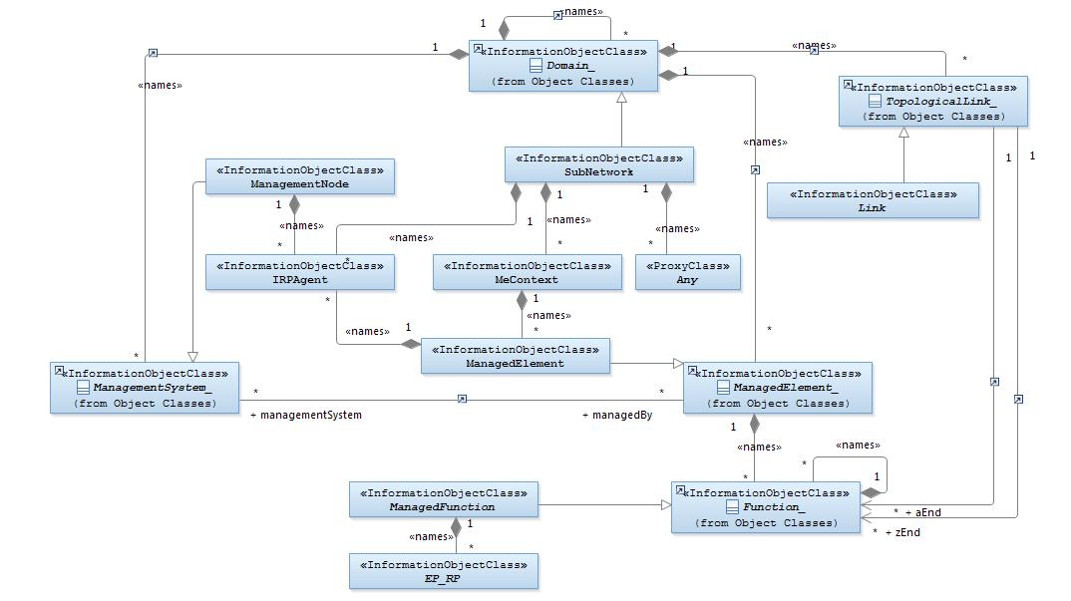
Figure A-1: Alternate class diagram

Annex B (informative):
Change history

Change history
Date | TSG # | TSG Doc. | CR | Rev | Subject/Comment | Old | New
2012-12 |  |  |  |  | New version after approval | 2.0.0 | 11.0.0
2012-02 |  |  |  |  | MCC update of TOC | 11.0.0 | 11.0.1
2014-06 | SA#64 | SP-140332 | 001 | - | Correction of reference | 11.0.1 | 11.1.0
2014-06 | SA#64 | SP-140358 | 002 | - | Remove the feature support statements | 11.0.1 | 11.1.0
2014-09 | SA#65 |  |  |  | Upgrade to Rel-12 | 11.1.0 | 12.0.0
2015-12 | SA#70 | SP-150691 | 005 | 1 | Add missing id attribute for 28.622 | 12.0.0 | 12.1.0
2016-01 |  |  |  |  | Upgrade to Rel-13 (MCC) | 12.1.0 | 13.0.0

Change history
Date | Meeting | TDoc | CR | Rev | Cat | Subject/Comment | New version
2016-12 | SA#74 | SP-160853 | 0010 | - | A | Clarification on the need to show VsDataContainer self-containing itself several times | 13.1.0
2017-03 | SA#75 | SP-170139 | 0012 | 2 | A | Clarify notification triggered by VsDataContainer change | 13.2.0
2017-03 | SA#75 | SP-170143 | 0015 | 1 | B | Modify definitions of ME and MF to support virtualized network element | 14.0.0
2017-03 | SA#75 | SP-170142 | 0016 | 3 | B | Adding an attribute for ManagedFunction to support management of virtualized NE | 14.0.0
2017-06 | SA#76 | SP-170510 | 0019 | 2 | B | Add VNFInfo related attributes in IOC ManagedFunction | 14.1.0
2018-01 | SA#78 | SP-170969 | 0021 | - | F | Missing note in table of Attribute Properties | 14.2.0
2018-03 | SA#79 | SP-180060 | 0022 | - | B | Add new attribute peeParametersList to IOC ManagedFunction | 15.0.0
2018-06 | SA#80 | SP-180421 | 0024 | 1 | B | Remove references to Itf-N | 15.1.0
2018-12 | SA#82 | SP-181156 | 0027 | - | F | Add the missing NRM fragment supporting network performance management | 15.2.0
2018-12 | SA#82 | SP-181042 | 0028 | 1 | F | Replace MF with ManagedFunction | 15.2.0
2018-12 | SA#82 | SP-181042 | 0029 | 1 | F | Update NRM root IOCs to support slice priority | 15.2.0
2019-06 | SA#84 | SP-190371 | 0031 | 2 | B | Add IOCs for threshold monitoring control | 16.0.0
2019-06 | SA#84 | SP-190373 | 0033 | 2 | B | Update generic NRM Information Service to support Managed NF Service Object | 16.0.0
2019-09 | SA#85 | SP-190744 | 0038 | 2 | A | Update class definition with inheritance information | 16.1.0
2019-09 | SA#85 | SP-190744 | 0043 | 1 | A | Correct PMControl (Add report period attribute and disambiguate the delivery method attributes) | 16.1.0
2019-09 | SA#85 | SP-190751 | 0044 | - | A | Correct NR definition to avoid misalignment with RAN2 and add NRM definition | 16.1.0
2019-09 | SA#85 | SP-190744 | 0046 | 1 | A | Correct definitions of granularity period. | 16.1.0
2019-09 | SA#85 |  |  |  |  | Correction in implementation of CR0043 | 16.1.1
2019-12 | SA#86 | SP-191158 | 0057 | 2 | A | Correct definition of network resource | 16.2.0
2019-12 | SA#86 | SP-191173 | 0059 | - | A | Add measurementsList attribute into related IOCs | 16.2.0
2019-12 | SA#86 | SP-191166 | 0062 | 2 | B | Add heartbeat control NRM fragment | 16.2.0
2019-12 | SA#86 | SP-191166 | 0063 | 2 | B | Add notification subscription control fragment | 16.2.0
20120-03 | SA#87E | SP-200169 | 0066 | - | B | Add configurable FM. | 16.3.0
20120-03 | SA#87E | SP-200163 | 0069 | 1 | B | Add configurable KPI control NRM | 16.3.0
20120-03 | SA#87E | SP-200169 | 0071 | 1 | F | Correct definition of HeartbeatControl and attribute NotificationType | 16.3.0

End of modifications

