3GPP TSG-SA5 Meeting #130e S5-202259

e-meeting, 20 April – 29 April 2020

Source: Ericsson, Deutsche Telekom

Title: Assurance data

Document for: Approval
Agenda Item: 6.4.7

1 Decision/action requested
In this box give a very clear / short /concise statement of what is wanted.

2 References
[1] 3GPP TS 28.535: Management and orchestration; Management Services for Communication Service Assurance; Requirements
[2] 3GPP TS 28.541: Management and orchestration; 5G Network Resource Model (NRM); Stage 2 and stage 3 (Release 16)
[3] 3GPP TS 28.622: Telecommunication management; Generic Network Resource Model (NRM) Integration Reference Point (IRP); Information Service (IS) (Release 16)
[4] 3GPP TS 32.422: " Telecommunication management; Subscriber and equipment trace; Trace control and configuration management (Release 16)"
[5] 3GPP TS 38.331: "NR; Radio Resource Control (RRC) protocol specification (Release 16)"
[6] 3GPP TS 36.314 "Evolved Universal Terrestrial Radio Access (E-UTRA); Layer 2 - Measurements (Release 15)"

3 Rationale
This contribution proposes to add assurance data to this specification. The assurance measurements are input the closed loop assurance solution.
A simplified example of delay measurements from UE up to to and including UPF.
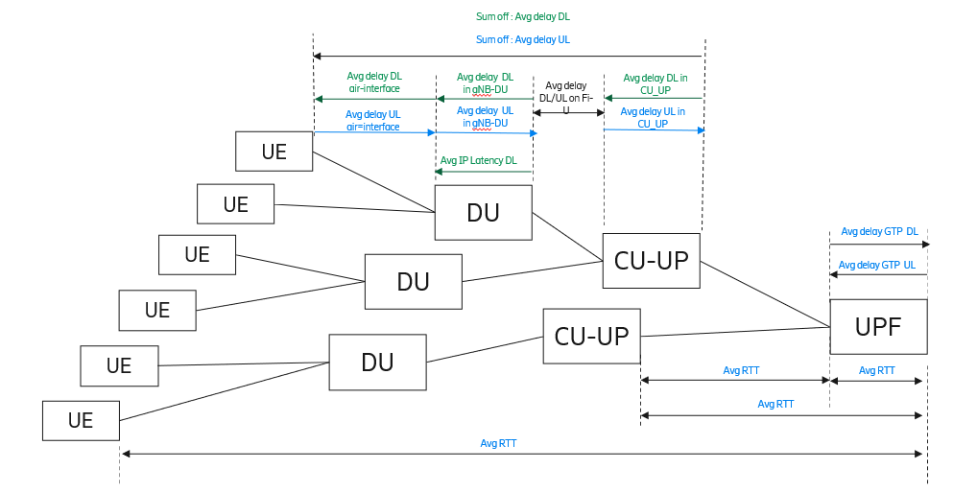
Figure 1: Example of delay measurement in the userplane path

The measurements shown the diagram are specified in TS 28.552 and TS 28.554. The measurements are averaged over node, cell, S-NSSAI and QCI depending on the measurement point.
For individual measurements (not shown in Figure 1) from an UE to RAN the MDT messages M1 [4][5] and M6 [4][6] may be used for communication service assurance,

4 Detailed proposal
First change

2 References
The following documents contain provisions which, through reference in this text, constitute provisions of the present document.
- References are either specific (identified by date of publication, edition number, version number, etc.) or non-specific.
- For a specific reference, subsequent revisions do not apply.
- For a non-specific reference, the latest version applies. In the case of a reference to a 3GPP document (including a GSM document), a non-specific reference implicitly refers to the latest version of that document in the same Release as the present document.
[1] 3GPP TR 21.905: "Vocabulary for 3GPP Specifications".
[2] ETSI GS ZSM 002 V1.1.1 (2019-08): “Zero-touch network and Service Management (ZSM); Reference Architecture”
[3] 3GPP TS 28.550: "Management and orchestration; Performance assurance”
[4] 3GPP TS 28.545: "Management and orchestration; Fault Supervision (FS) "

[a] 3GPP TS 32.422: " Telecommunication management; Subscriber and equipment trace; Trace control and configuration management (Release 16)"
[b] 3GPP TS 38.331: "NR; Radio Resource Control (RRC) protocol specification (Release 16)"
[c] 3GPP TS 36.314 "Evolved Universal Terrestrial Radio Access (E-UTRA); Layer 2 - Measurements (Release 15)"

Second change

4.1.y Assurance data

4.1.y.1 Objective
The objective of communication service assurance is to provide the users of a communication service with the expected level of QoE/QoS which may or may not be documented in an SLS. The main contributing factor to a poor perception of a communication service is the e2e delay.
Editor’s Note: more detailed description of the e2e path is FFS
Editor’s Note: other assurance data is FFS

4.1.x.2 Assurance measurements

4.1.x.2.1 Assurance measurements between UE and RAN
The measurements that can be used as input for the analysis step in a control loop are the M1 (Radio frequnecy conditions) message and M6 (Packet delay) message as defined in TS 32.422 [a].
Editor’s Note: more detailed description of the FFS

Editor’s Note: other assurance measurements is FFS

