3GPP TSG-SA5 Meeting #130e S5-202254Rev1

e-meeting 20-28 April 2020

Source: China Mobile, Huawei, CATT

Title: pCR 28.810 Update Clause 5.1 Fault RCA and recovery scenario example for classification of network autonomy

Document for: Approval
Agenda Item: 6.6.4

1 Decision/action requested
The group is asked to discuss and approval.

2 References
[1] 3GPP TR 28.810: “Study on concept, requirements and solutions for levels of autonomous network v0.3.0”.

3 Rationale
This contribution proposes to update Clause 5.1 Fault RCA and recovery scenario example for classification of network autonomy in the following aspects:
- Update the title of Clause 5.1 and corresponding text.
- Update Clause 5.1.3 and add a figure to describe the classification intuitively.

4 Detailed proposal
It proposes to make the following changes to TR 28.810[1].
1st Change

5.1 Fault recovery scenario example for network autonomy level

5.1.1 Introduction
Fault recovery scenario refers to the entire workflow of network fault management, full autonomy of fault recovery can help the network operator to reduce OPEX by reducing manual involvement in such tasks and to enhance user experience by reducing the time for network fault recovery. However, full autonomy of fault recovery is a long term goal, it will be beneficial for operator to achieve this goal step by step and have clear view on which typical issues can be addressed by utilizing network autonomy mechanism in corresponding steps.

5.1.2 Entire workflow
The entire close-loop workflow of fault recovery is as following:
- Task A: Fault recovery intent translation. The task which translate the fault recovery intent to the detailed fault management operations.
NOTE: the examples of fault recovery intent are alarm compression rate increasing, fault recovery response time reducing, etc.
- Task B: Fault related information collection. The task which collect the alarm information and other fault related information (e.g. performance information and configuration information etc.).
- Task C: Alarm filtering. The task which filter the alarms collected in Task B based on the filtering rules specified. A single network fault may generate a large number of correlative alarms over space and time, therefore it is considered advantageous to have methods filtering the redundant alarms. Reporting only effective alarms without redundant alarms would improve the efficiency of alarm management.
- Task D: Fault recognition. The task which recognize or predict the fault and its category based on the alarm information and other fault related information.
- Task E: Fault root cause analysis (RCA). The task which analyze the detailed root cause of the network fault.
- Task F: Fault recovery mechanism analysis. The task which analyze the possible fault recovery mechanisms and corresponding solutions for support of maintenance based on the fault root cause, thereby generate the feasible options (e.g. recovery procedures).
- Task G: Fault recovery action generation. The task which determine the fault recovery action.
- Task H: Fault recovery execution. The task which execute the fault recovery actions (e.g. reconfiguring the network), and other corresponding actions (e.g. clearing of alarms, storage and retrieval of alarms).

5.1.3 Potential classification of network autonomy for fault recovery
Each of the detailed task in clause 5.1.2 can be accomplished either manually by the operator or automatically by the telecom system. Following are the potential classifications of network autonomy for fault recovery based on the participation degree of the human operator and the telecom system:
Level 0:
- All the tasks in the fault recovery workflow in clause 5.1.2 are accomplished by human.
Level 1:
- Fault related information are collected (Task B) automatically by telecom system based on human predefined rules. Fault recovery actions (Task H) which can be executed without human intervention (e.g. system initialisations, activation of a backup or fall back software load) are triggered by human and executed by telecom system based on human defined execution rules.
- All the other tasks in the fault recovery workflow are accomplished by human.
Level 2:
- Compared to Level 1, telecom system additionally assist human operator to filter the alarms (Task C) based on the filtering rules predefined by human operator. Fault recovery execution (only for the actions that can be executed without human intervention) (Task H) are triggered by human and fully executed by telecom system based on human defined rules.
- All the other tasks (Task A, Task D, Task E, Task F and Task G) are accomplished by human.
Level 3:
- Compared to Level 2, telecom system can additionally identify the fault domain and type (Task D except for fault prediction) and analyse the root cause of the network fault (Task E). For ceratin network faults, telecom system can accomplish the fault recovery mechanism analysis (Task F) and action generation (Task G) based on the fault recovery policies pre-defined and specified by human.
- Fault recovery intent translation (Task A) is accomplished by human, and all the other tasks (Task F and Task G) are accomplished by human operator for most of the faults except several conventional ones.
Level 4:
- Compared to Level 3, the fault recovery mechanism analysis (Task F) and action generation (Task G) are accomplished automatically by telecom system without human intervention. Telecom system also can predict the fault based on service performance (e.g. QoE, call drop ratio, user experience). For certain scenario, telecom system additionally assist human operator to translate the fault recovery intent to the detailed fault recovery policies (Task A) based on human predefined policies.
- Intent translation policies can be pre-defined and specified by human.
Level 5:
- The entire fault recovery workflow is accomplished automatically by telecom system without human intervention and human predefined rules or policies.
- Human can but not have to supervise the fault recovery decision generated by telecom system.
Figure 5.1.3-X illustrate the classification of network autonomy for fault recovery.
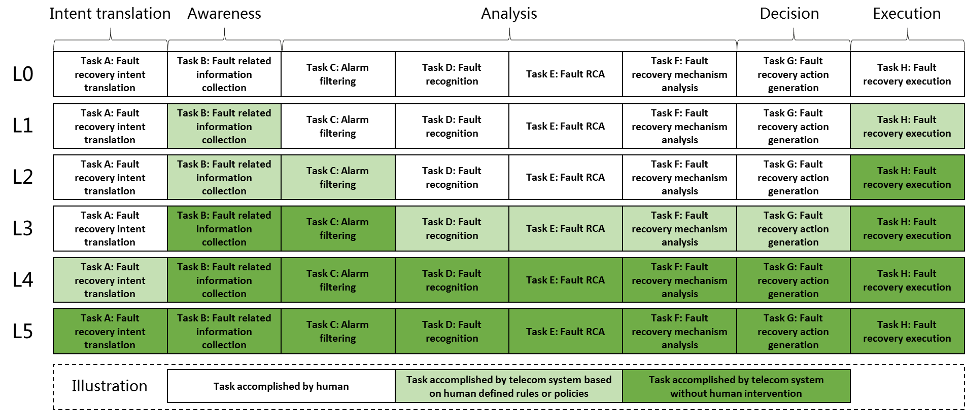
Figure 5.1.3-X Classification of network autonomy for fault recovery

End of changes

