3GPP TSG-SA5 Meeting #130e S5-202245

e-meeting 20-28 April 2020 Revision of S5-201585

Source: Huawei, China Telecom

Title: Update usecase and procedures for establishment of a new RAN NE in network

Document for: Approval
Agenda Item: 6.4.12

1 Decision/action requested
The group is asked to discuss and approval.

2 References
[1] 3GPP TR 28.810: “Study on concept, requirements and solutions for levels of autonomous network v0.3.0”.

3 Rationale
This contribution proposes to update the establishement of a new RAN NE in network with following modification:
- Update the Clause 6.4.2.2 by address the Editor’s Note.
- Update Clause 8.3.2 Procedures for establishment of a new RAN NE in network.

4 Detailed proposal
It proposes to make the following changes to TR 28.313[1].
1st Change

2 References
The following documents contain provisions which, through reference in this text, constitute provisions of the present document.
- References are either specific (identified by date of publication, edition number, version number, etc.) or non-specific.
- For a specific reference, subsequent revisions do not apply.
- For a non-specific reference, the latest version applies. In the case of a reference to a 3GPP document (including a GSM document), a non-specific reference implicitly refers to the latest version of that document in the same Release as the present document.
[1] 3GPP TR 21.905: "Vocabulary for 3GPP Specifications".
[2] 3GPP TS 32.500: "Telecommunication Management; Self-Organizing Networks (SON); Concepts and requirements".
[3] 3GPP TS 28.532: "Management and orchestration; Generic management services”
[4] 3GPP TS 38.321 “NR; Medium Access Control (MAC) protocol specification”.
[5] 3GPP TS 28.552 “Management and orchestration; 5G performance measurements”
[6] 3GPP TS 32.511 " Telecommunication management; Automatic Neighbour Relation (ANR) management; Concepts and requirements"
[7] 3GPP TS 38.300 "NR; Overall description; Stage-2"
[8] 3GPP TS 36.300 "Evolved Universal Terrestrial Radio Access (E-UTRA) and Evolved Universal Terrestrial Radio Access Network (E-UTRAN); Overall description; Stage 2"
[9] 3GPP TS 38.331: "NR; Radio Resource Control (RRC) protocol specification".
[10] 3GPP TS 28.545 "Management and orchestration; Fault Supervision (FS)”
[11] 3GPP TS 28.531 "Management and orchestration; Provisioning"
[12] 3GPP TS 28.550: "Management and orchestration; Performance assurance".
[X] 3GPP TS 32.508: "Telecommunication management; Procedure flows for multi-vendor plug-and-play eNodeB connection to the network".

2nd Change

6.4.2.2 Use case for establishment of a new RAN NE in network

6.4.2.2.1 Use case for RAN NE plug and connect to management system
Use Case Stage | Evolution / Specification | <<Uses>>  Related use
Goal | After NE installation, connect the NE to its MnF providing support for self-configuration process, and to the External Network(s) as automatically as possible.  The NE described in this use case can be gNB in non-split scenario and gNB-DU in split scenario.  Note: The NE within virtualization or other type of RAN NE (e.g. GNB-CU) is not addressed in this use case.
Actors and Roles | NE
Telecom resources | IP networks: Non-Secure Operator Network, External Network, and its elements like DHCP server optionally DNS, CA/RA servers, Security Gateway(s) (each protecting one or more Secure Operator Networks), Secure Operator Network(s) including MnF providing support for self-configuration process.
Assumptions | There is a functional power supply for the NE. There may be one or more IP Autoconfiguration Services like DHCP and Router Advertisements and zero or more DNS servers.
Pre conditions | The NE is installed.  IP connectivity exists between the involved telecom resources.  The involved telecom resources are functional.  The relevant information is stored and available:  - Vendor Certificate at the NE  - Operator Certificate at the CA/RA  - For the External Network or Non-Secure Operator Network:  - (Outer) IP autoconfiguration information at the IP Autoconfiguration Service  - FQDN of the initial OAM SeGW at the NE  and/or  FQDN or IP address of the initial OAM SeGW at the IP Autoconfiguration Service  - FQDN of the CA/RA servers at the NE  and/or  FQDN or IP address of the CA/RA servers at the IP Autoconfiguration Service  - If FQDNs need to be resolved, corresponding IP address(es) at the DNS server(s)  - For the Secure Operator Network:  - (Inner) IP autoconfiguration information at the IP Autoconfiguration Service or at the initial OAM SeGW  - FQDN or IP address of the initial MnF at the NE and/or DHCP Server of the Secure Operator Network.  - If FQDNs need to be resolved, corresponding IP address(es) at the DNS server(s)  - Configuration and software for the NE at the MnF(s)
Begins when | The NE is installed.
Step 1 (M) | If a VLAN ID is available the NE uses it. Otherwise the NE uses the native VLAN where PnP traffic is sent and received untagged
Step 2 (M) | The NE acquires its IP address through stateful or stateless IP autoconfiguration. This may provide 0 or more DNS server addresses.
Step 3 (M) | The NE acquires the IP address of the CA/RA server. The FQDN of the CA/RA server may be pre-configured in the NE or the FQDN or IP address of the CA/RA server may be provided by the IP Autoconfiguration Service. FQDNs are resolved through the DNS if necessary. Information provided by the IP Autoconfiguration Services shall supersede those pre-configured at the NE.
Step 4 (M) | The NE performs Certificate Enrolment.
Step 5 (M) | The NE acquires the IP address of the OAM SeGW. The FQDN of the OAM SeGW may be pre-configured in the NE or the FQDN or the IP address of the OAM SeGW may be provided by the IP Autoconfiguration Service. FQDNs are resolved through the DNS if necessary.
Step 6 (M) | The NE establishes a secure connection (tunnel) to the Security Gateway given by Step 5.  The NE receives its (inner) IP autoconfiguration information (which may be the same as the outer IP address obtained in step2) and optionally the address of one or more DNS servers within the Secure Operator Network from the Configuration Parameters of IKEv2 during tunnel establishment.
Step 7 (M) | The NE acquires the IP address of the correct MnF by either, issuing a DHCP request including the NE’s vendor information, resolving FQDNs via DNS if necessary, or by having a pre-configured FQDN (including the NE’s vendor information) resolved via DNS.
Step 8 (M) | The NE establishes a connection to the provided MnF and acquires its configuration and software if any.  The configuration may contain an address to another MnF that this specific node shall use as MnF.  The configuration may contain an address to another SeGW that should be used before connecting to the MnF.  The MnF may then  - release the connection to the current MnF and OAM SeGW and then restart (returning to step 1),  - release the connection to the current MnF and OAM SeGW and then return to step 6,  - release the connection to the current MnF and then repeat step 8, or  - continue with step 9.
Step 9 (M) | The NE establishes a connection to the External Network(s) using the transport (VLAN ID, IP addresses) and security parameters provided in step 8.
Ends when | Ends when all mandatory steps identified above are successfully completed or when an exception occurs.
Exceptions | One of the steps identified above fails.
Post Conditions | One or more secure connections exist between the NE and the MnF and the External Network(s). Via the connection to the MnF the NE can receive further instructions to become operational and carry user traffic, e.g. the administrativeState is set to “unlocked”. | Clause 6.4.2.2.2 Use case for self-configuration of a new RAN NE
Traceability | All requirements of clause 6.1.2.2

6.4.2.2.2 Use case for self-configuration of a new RAN NE
Use Case Stage | Evolution / Specification | <<Uses>>  Related use
Goal (*) | After installation, put in an automated manner the NE into a state to be ready to carry traffic.
Actors and Roles (*) | MnF providing support for self-configuration process act as MnS Producer for Self-configuration management
Telecom resources | NE  MnS Consumer of Self-configuration management
Assumptions | IP network connectivity exists between the NE and the MnF(s) providing support for the self-configuration process.
Pre conditions | The NE is installed and connected to an IP network. | Clause 6.4.2.2.1 Use case for Plug and connect to management system
Begins when | The field personnel start the self-configuration process. It is also possible that the process is triggered automatically after the completion of an NE self-test or receiving the self-configuration management profile creation request from MnS Consumer for self-configuration management.
Step 1 (O) | MnF providing support for self-configuration process may notify MnS Consumer of self-configuration management about the start of the self configuration process.
Step 1 (*) (M|O) | The order of the bullet points in the list below does not imply any statements on the order of execution.  - An NE IP address is allocated to the new NE.  - Basic information about the transport network (e. g. gateways) environment is provided to the NE. With this information the NE is able to exchange IP packets with other internet hosts.  - The NE provides information about its type, hardware and other relevant data about itself to the MnF(s) providing support for the self-configuration process.  - The address(es) of the MnF(s) providing support for the self-configuration process (e.g. MnF for software download, MnF for configuration data download) is provided to the NE. The address is equal to an IP address and a port number, or a DNS name and port number, or an URI.  The address(es) of the MnF(s) providing support for normal OAM functions after completion of the self-configuration process are provided to the NE. The address is equal to an IP address and a port number, or a DNS name and port number, or an URI.  - The NE connects to the MnF providing support for the software download.  - The decision which software or software packages have to be downloaded to the NE is taken.  - The software is downloaded into the NE.  - The NE connects to the MnF providing support for the configuration data download.  - The configuration data for the NE is made available by either preparing it or making prepared configuration data available.  - The configuration data is downloaded into the NE.  - Dependent External nodes are updated with new configuration data as well (if required).  - The NE connects to the MnF providing support for normal OAM functions after completion of the self-configuration process.  - The inventory system in the MnF is informed that a new NE is in the field.  - The NE performs a self-test. Self-tests of different types can run at different places within the self-configuration procedure.  - The operator is informed about the progess of the self-configuration process and important events occuring during the self-configuration process.  - The network resource models are updated during and after the self-configuration process.  - SW is installed, i.e. prepared in such a way, that the NE is ready to use it. NE is allowed to use the SW.
Step 3 (O) | MnF providing support for self-configuration process may notify MnS Consumer of Self-configuration management about the progress of the self configuration during self-configuration process.
Ends when (*) | Ends when all steps identified above are successfully completed or when an exception occurs.
Exceptions
Post Conditions | The NE is ready to carry traffic.
Traceability (*) | All requirements of clause 6.1.2.3

3rd Change

8.3.2.1 Procedures for RAN NE plug and connect to management system
The Figure 8.3.2.1-1 illustrates the procedure for plug and connect to management system. The NE described in this procedure can be gNB in non-split scenario and gNB-DU in split scenario.
Note 1: The NE within virtualization and or other type of RAN NE (e.g. gNB-CU) is not addressed in this procedure.

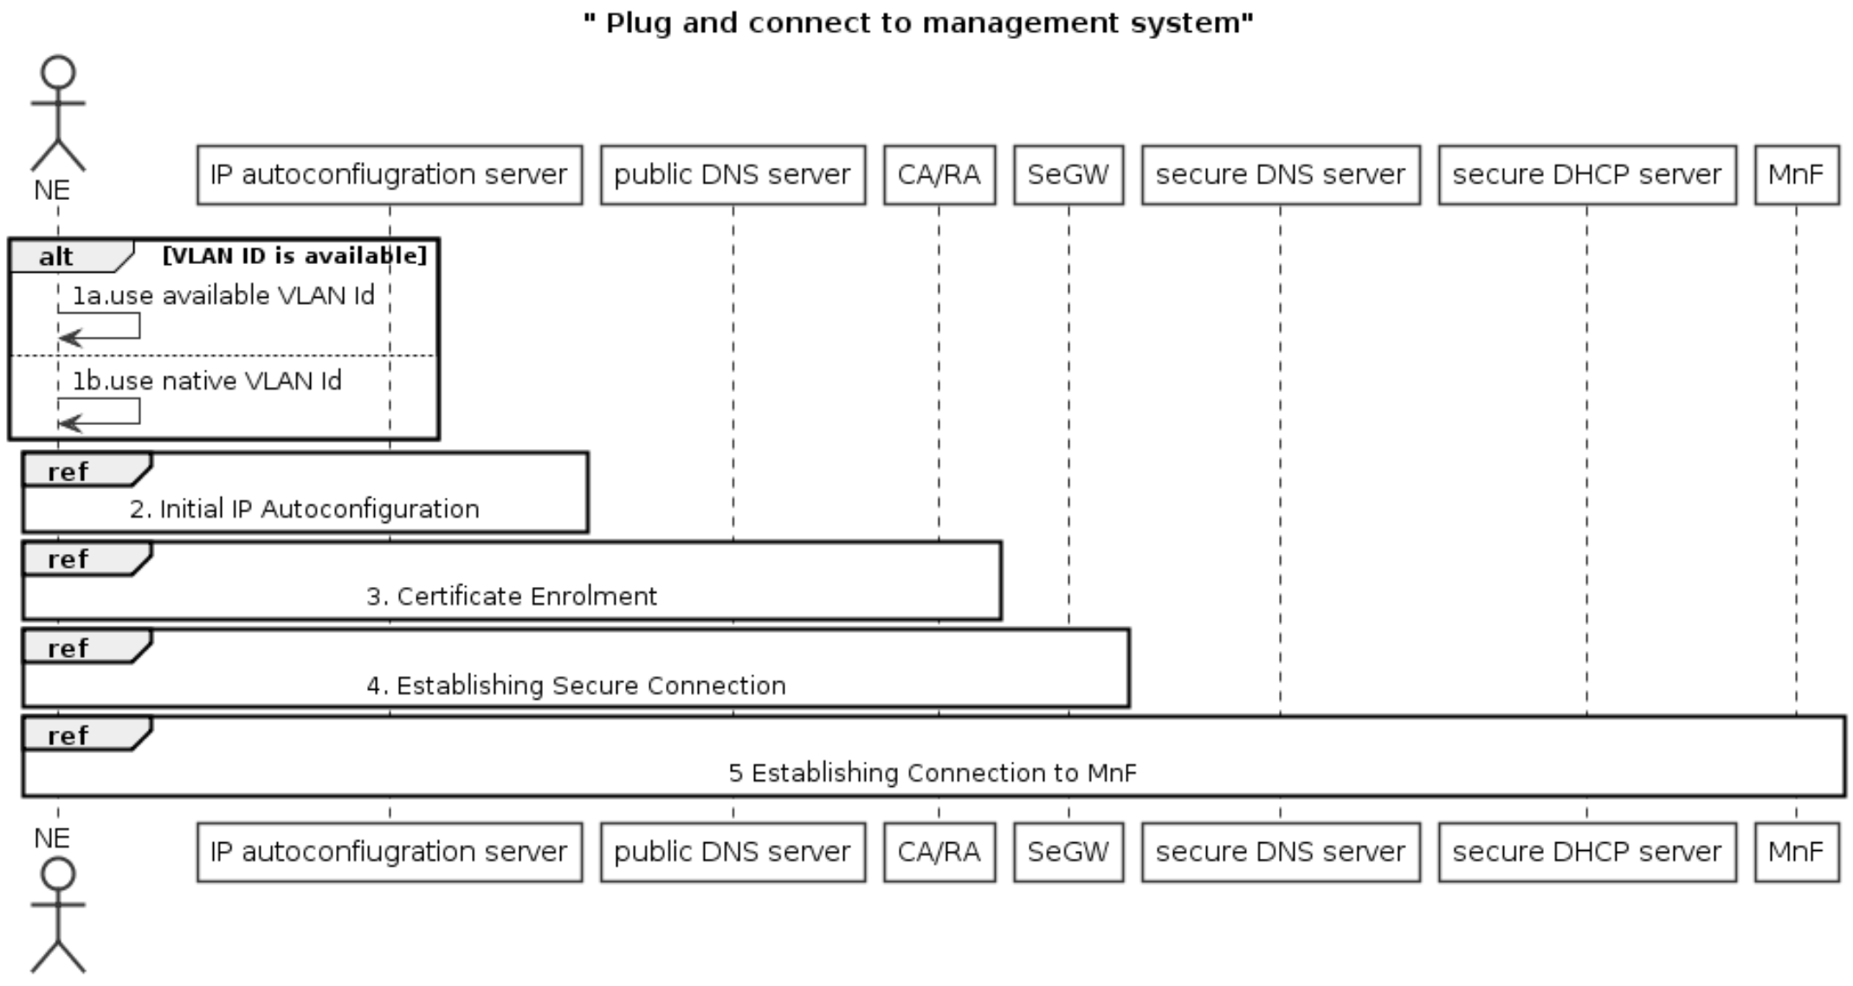
Figure 8.3.2.1-1 Procedures for plug and connect to management system
1. If a VLAN ID is available, the NE uses it. Otherwise the NE uses the native VLAN where PnP traffic is sent and received untagged.
2. NE invokes the “Initial IP Autoconfiguration” procedure and acquires its IP address through stateful or stateless IP Autoconfiguration. There may be additional information provided to the NE.
Note: the detailed “Initial IP Autoconfiguration” procedure refers to clause 5.2 of TS 32.508[X].
3. NE invokes the "Certificate Enrolment" procedure.
Note: the detailed “Certificate Enrolment” procedure refers to clause 5.3 of TS 32.508[X].
4. NE invokes the "Establishing Secure Connection" procedure and connects to the OAM SeGW.
Note: the detailed “Establishing Secure Connection” procedure referes to clause 5.4 of TS 32.508[X].
5. NE invokes the "Establishing Connection to MnF" procedure.
Note: the detailed “Establishing Connection to MnF” procedure refers to clause 5.5 of TS 32.508[X] and MnF act as the role of EM.

End of changes

