3GPP TSG-SA5 Meeting #130e S5-202240

e-meeting 20-28 April 2020

Source: Huawei, China Mobile

Title: Update Clause 5.2 Coverage optimization scenario example for classification of network autonomy level

Document for: Approval

Agenda Item: 6.6.4

1 Decision/action requested
The group is asked to discuss and approval.

2 References
[1] 3GPP TR 28.810: “Study on concept, requirements and solutions for levels of autonomous network v0.3.0”.

3 Rationale
This contribution proposes to update Clause 5.2 coverage optimization scenario example for classification of network autonomy.

4 Detailed proposal
It proposes to make the following changes to TR 28.810[1].
1st Change

5.2 Network optimization scenario example for classification of network autonomy
Editor’s Note: whether all following use cases or only one use case needed for classification of network autonomy for network optimization is FFS.

5.2.X Coverage optimization scenario example for classification of network autonomy

5.2.X.Y Introduction
Coverage is critical for good user experience, however, coverage optimization is complexity. Full autonomy of coverage optimization for whole network is a long term goal, it will be beneficial for operator to achieve this goal step by step and have clear view on which typical issues can be addressed by utilizing network autonomy mechanism in corresponding steps.

5.2.X.Z Entire workflow
Following are the entire workflow for the radio network coverage optimization:
- Task A: Coverage requirements determination. The tasks of determining the coverage requirements (e.g. coverage area, weak coverage ratio) based on service assurance intent specified by customer.
- Task B: Coverage optimization policies determination. The tasks of determining the coverage optimization related policies (e.g, weak coverage analysis policies, weak coverage optimization policies).
- Task C: Coverage related information collection. The tasks of collecting coverage performance data (e.g. measurement data, MDT data).
- Task D: Coverage issues identification. The tasks of analysing the coverage performance and identifying the coverage issues (e.g. weak coverage).
- Task E: Coverage adjustment solution analysis and generation. The tasks of analysing the cause of the identified coverage issues and generating the coverage adjustment actions.
- Task F: Coverage adjustment actions determination. The tasks of deciding the coverage adjustment actions to be executed.
- Task G: Coverage adjustment actions execution (e.g. selection of coverageShape, digitalTilt and digitalAzimuth). The tasks of adjusting and configuring the coverage related parameters.

5.2.X.M Potential classification of network autonomy for coverage optimization
Level 0:
  - All the tasks in the radio network coverage optimization workflow (Task A, Task B, Task C, Task D, Task E, Task F, Task G) are accomplished by human.
Level 1:
  - Telecom system executes the tasks of adjusting and configuring coverage related parameters (e.g. coverageShape, digitalTilt and digitalAzimuth) based on coverage related parameters specified by human (Task G). Telecom system also can execute the tasks of collecting coverage related data (e.g. measurement data, MDT data and trace data) based on collection rule specified by human (Task C).
  - All the other tasks in the radio network coverage optimization workflow (Task A, Task B, Task D, Task E, Task F) are accomplished by human.
Level 2:
  - Compared to Level 1, telecom system can analyse the coverage performance and identify the coverage issue based on the coverage issue rule specified by human (Task D).
  - All the other tasks in the radio network coverage optimization workflow (Task A, Task B, Task E, Task F) are accomplished by human.
Level 3:
  - Compared to Level 2, telecom system additionally executes the tasks of analysing the coverage optimization solution (Task E) and determining the coverage adjustment actions (Task F) to be executed based on coverage requirements and/or optimization policies specified by human.
  - All the other tasks in the radio network coverage optimization workflow (Task A, Task B) are accomplished by human.
Level 4:
  - Compared to Level 3, the telecom system additionally executes the tasks of determining coverage optimization policies (e.g, weak coverage cause analysis policies, weak coverage adjustment policies) (Task B). For certain scenarios, the telecom system can determines the coverage requirements (e.g. coverage area, weak coverage ratio) based on service assurance intent.
  - The intent translation policies maybe pre-defined and specified by human to assist the telecom system.
Level 5:
  - Telecom system can autonomously execute the entire workflow of radio network coverage optimization for all scenarios, which means the telecom system can achieve the full autonomy for radio network coverage optimization for full scenarios.
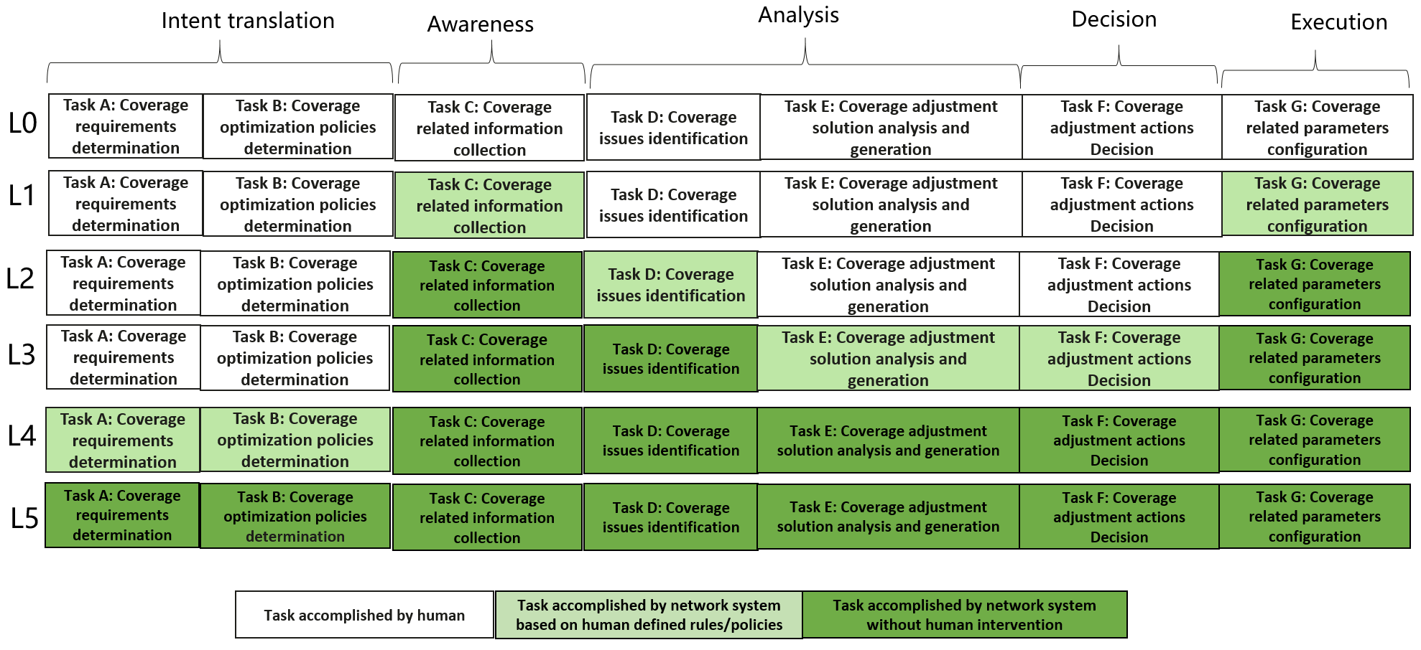 
Fgiure 5.2..X.M-1 Classification of network autonomy for radio network coverage optimization
Editor’s Note: The relation of above classification of network autonomy for radio network coverage optionzation and Framework approach for classification of network autonomy level defiend in Clause 6.1.2 is FFS.

End of changes

