3GPP TSG-SA5 Meeting #130e S5-202239

e-meeting 20-28 April 2020

Source: Huawei, China Mobile

Title: Update NE deployment scenario example for classification of network autonomy level

Document for: Approval

Agenda Item: 6.6.4

1 Decision/action requested
The group is asked to discuss and approval.

2 References
[1] 3GPP TR 28.810: “Study on concept, requirements and solutions for levels of autonomous network v0.3.0”.

3 Rationale
This contribution proposes to update NE provisioning scenario example for classification of network autonomy.

4 Detailed proposal
It proposes to make the following changes to TR 28.810[1].
1st Change

5.3 RAN NE provisioning scenario example for classification of network autonomy

5.3.1 Introduction
RAN NE provisioning scenario refers to the entire workflow of deploying an RAN NE, full autonomy of RAN NE provisioning can help the network operator to reduce OPEX by reducing manual involvement in such tasks. However, full autonomy of RAN NE provisioning is a long term goal, it will be beneficial for operator to achieve this goal step by step and have clear view on which typical issues can be addressed by utilizing network autonomy mechanism in corresponding steps.

5.3.2 Entire workflow
Following are the entire workflow for RAN NE provisioning:
- Task A: RAN NE provisioning decision making.
- Task B: Determining the network planning data (i.e. radio planning data, transport planning data) for the new RAN NE to be provisioned.
- Task C: Generating the network configuration data for the RAN NE based on the network planning data for the RAN NE and hardware information collected.
- Task D: Connecting the RAN NE to the management system (including NE acquire its IP address and corresponding management system IP address) and collecting the RAN NE information (e.g. hardware information).
- Task E: Downloading and activating network configuration data and software in RAN NE.
- Task F: Performing the RAN NE verification (e.g. RAN NE test).

5.3.3 Potential classification of network autonomy for RAN NE provisioning
Following are the potential classification of network autonomy for RAN NE provisioning:
Level 0:
- All the tasks in the RAN NE provisioning workflow (Task A, Task B, Task C, Task D, Task E, Task F) are accomplished by human.
Level 1:
  - Telecom system executes tasks of downloading and activating the available RAN NE network configuration data (i.e. transport and radio configuration data) and software prepared by human (Task E).
  - Human makes the RAN NE provisioning decision and prepares the network configuration data for the RAN NE (Task A, Task B, Task C). Human connects the RAN NE to the management system and collects the RAN NE information (Task D).
Level 2:
  - Compared to Level 1, telecom system additionally executes the tasks of connecting RAN NE to the management system and collecting the RAN NE information (Task D).
  - Human makes the RAN NE provisioning decision and prepares the network configuration data for the RAN NE (Task A, Task B, Task C).
Level 3:
  - Compared to Level 2, based on the network configuration data generation policies specified by human, the telecom system additionally executes tasks of analysing and determining the network configuration data for the RAN NE according to the network planning data specified by human (Tack C). Telecom system also can executes tasks of performing the RAN NE verification (e.g. RAN NE test) (Task F) based on test policies specified by human.
  - Human makes the RAN NE provisioning decision and prepares the network planning data (Task A and Task B). Human pre-defines the network configuration data generation policies.
Level 4:
  - Compared to Level 3, for certain scenarios, the telecom system additionally execute the task of making the RAN NE provisioning decision (Task A), analysing and determining network planning data (i.e. radio planning data, transport planning data) for the RAN NE to be provisioned (Task B) based on radio network deployment intent (e.g. provisioning radio network in certain area with network characteristics or SLA specified).
  - The intent translation policies maybe pre-defined and specified by human.
Level 5: Telecom system can autonomously execute the entire workflow of provisioning an RAN NE for all scenarios, which means the network system can achieve the full autonomy for RAN NE provisioning.

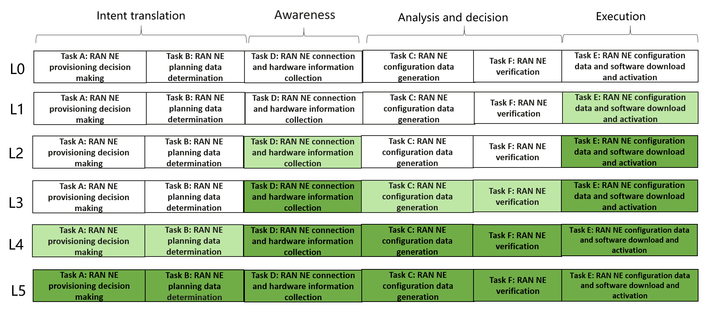
Figure 5.3.3-1 Classification of network autonomy for RAN NE provisioning
Editor’s Note: The relation of above classification of network autonomy for RAN NE provisioning and Framework approach for classification of network autonomy level defiend in Clause 6.1.2 is FFS.

End of changes

