**3GPP TSG-SA5 Meeting #130e *S5-202236***

**e-meeting 20-28 April 2020**

|  |  |  |  |  |  |  |  |  |
| --- | --- | --- | --- | --- | --- | --- | --- | --- |
| *CR-Form-v11.4* | | | | | | | | |
| **CHANGE REQUEST** | | | | | | | | |
|  | | | | | | | | |
|  | **28.541** | **CR** | **0275** | **rev** | **-** | **Current version:** | **16.4.1** |  |
|  | | | | | | | | |
| *For* [***HE******LP***](http://www.3gpp.org/3G_Specs/CRs.htm#_blank)*on using this form: comprehensive instructions can be found at* [*http://www.3gpp.org/Change-Requests*](http://www.3gpp.org/Change-Requests)*.* | | | | | | | | |
|  | | | | | | | | |

|  |  |  |  |  |  |  |  |  |
| --- | --- | --- | --- | --- | --- | --- | --- | --- |
| ***Proposed change affects:*** | UICC apps |  | ME |  | Radio Access Network | **X** | Core Network |  |

|  |  |  |  |  |  |  |  |  |  |  |
| --- | --- | --- | --- | --- | --- | --- | --- | --- | --- | --- |
|  | | | | | | | | | | |
| ***Title:*** | Clarify the NR NRM used for different deployment scenarios | | | | | | | | | |
|  |  | | | | | | | | | |
| ***Source to WG:*** | Huawei,China Mobile | | | | | | | | | |
| ***Source to TSG:*** | S5 | | | | | | | | | |
|  |  | | | | | | | | | |
| ***Work item code:*** | eNRM | | | | |  | ***Date:*** | | | 2020-04-10 |
|  |  | | | |  | |  | | |  |
| ***Category:*** | **F** |  | | | | | ***Release:*** | | | Rel-16 |
|  | *Use one of the following categories:* ***F*** *(correction)* ***A*** *(mirror corresponding to a change in an earlier release)* ***B*** *(addition of feature),* ***C*** *(functional modification of feature)* ***D*** *(editorial modification)*  Detailed explanations of the above categories can be found in 3GPP [TR 21.900](http://www.3gpp.org/ftp/Specs/html-info/21900.htm). | | | | | | | | *Use one of the following releases: Rel-8 (Release 8) Rel-9 (Release 9) Rel-10 (Release 10) Rel-11 (Release 11) Rel-12 (Release 12)* *Rel-13 (Release 13) Rel-14 (Release 14) Rel-15 (Release 15) Rel-16 (Release 16)* | |
|  |  | | | | | | | | | |
| ***Reason for change:*** | | Currently, the NR NRM fragments are for management representation of gNB and en-gNB for all NG-RAN deployment scenario is not clear. In the LS S5-197637, the clarification for how NR NRM fragments provide management representation of gNB and en-gNB for all NG-RAN deployment scenario is described. So it is better to capture such clarification in TS 28.541. | | | | | | | | |
|  | |  | | | | | | | | |
| ***Summary of change:*** | | Add clarification for how NR NRM fragments provide management representation of gNB and en-gNB for all NG-RAN deployment scenario | | | | | | | | |
|  | |  | | | | | | | | |
| ***Consequences if not approved:*** | | The NR NRM fragments are for management representation of gNB and en-gNB for all NG-RAN deployment scenario is not clear for the reader. | | | | | | | | |
|  | |  | | | | | | | | |
| ***Clauses affected:*** | | 4.2.1.1 | | | | | | | | |
|  | |  | | | | | | | | |
|  | | **Y** | **N** |  | | | |  | | |
| ***Other specs*** | |  | **X** | Other core specifications | | | | TS/TR ... CR ... | | |
| ***affected:*** | |  | **X** | Test specifications | | | | TS/TR ... CR ... | | |
| ***(show related CRs)*** | |  | **X** | O&M Specifications | | | | TS/TR ... CR ... | | |
|  | |  | | | | | | | | |
| ***Other comments:*** | |  | | | | | | | | |

|  |  |
| --- | --- |
| ***This CR's revision history:*** |  |

|  |
| --- |
| **1st Change** |

### 4.2.1 Class diagram for gNB and en-gNB

#### 4.2.1.1 Relationships

This clause depicts the set of classes (e.g. IOCs) that encapsulates the information relevant for this gNB and en-gNB. For the UML semantics, see 3GPP TS 32.156 [43]. Subsequent clauses provide more detailed specification of various aspects of these classes.

The model fragments are for management representation of gNB and en-gNB for all NG-RAN deployment scenario as listed below.

- Non-split NG-RAN deployment scenario, represents the gNB defined in TS 38.401[4]. In this scenario, a gNB is represented by a combination of a GNBCUCPFunction, one or more GNBCUUPFunctions and one or more GNBDUFunctions.

- 2-split NG-RAN deployment scenario, represents the gNB consist of gNB-CU and gNB-DU defined in TS 38.401[4] clause 6.1.1. In this scenario, a gNB-CU is represented by a GNBCUCPFunction and one or more GNBCUUPFunctions, whereas a gNB-DU is represented by a GNBDUFunction.

- 3-split NG-RAN deployment scenario, represents the gNB consist of gNB-CU-CP, gNB-CU-UP and gNB-DU defined in TS 38.401[4] clause 6.1.2. In this scenario, a gNB-CU-CP is represented by a GNBCUCPFunction, a gNB-CU-UP is represented by a GNBCUUPFunction, and a gNB-DU is represented by a GNBDUFunction.

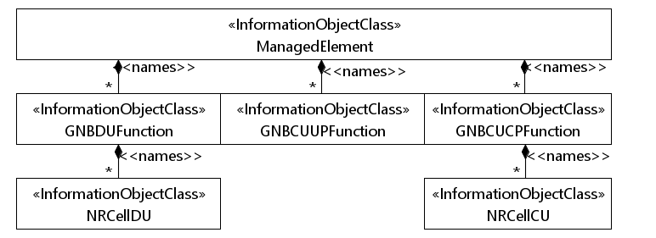

Figure 4.2.1.1-1: NRM for all deployment scenarios

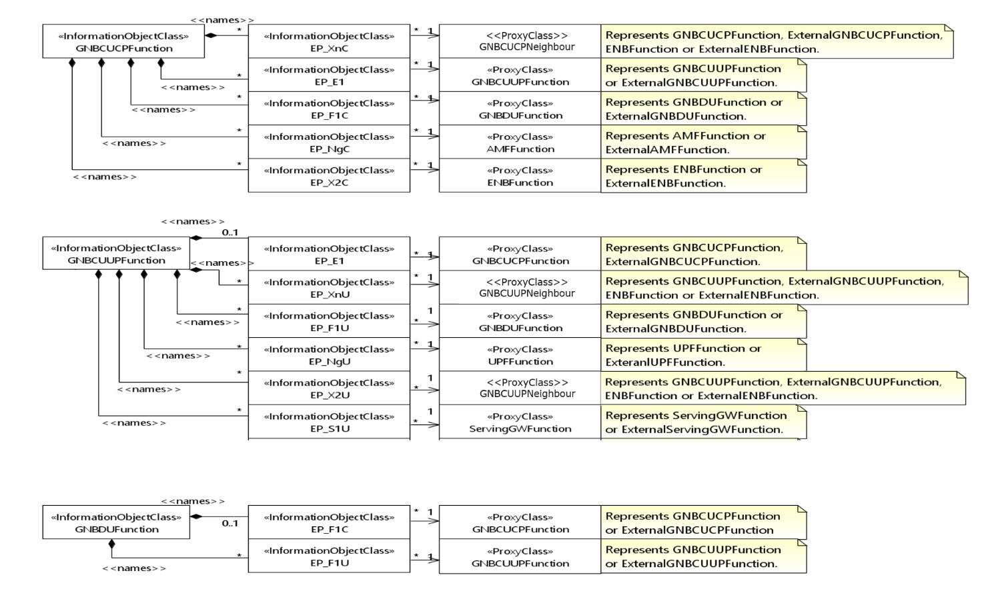

Figure 4.2.1.1-2: NRM for EPs for all deployment scenarios

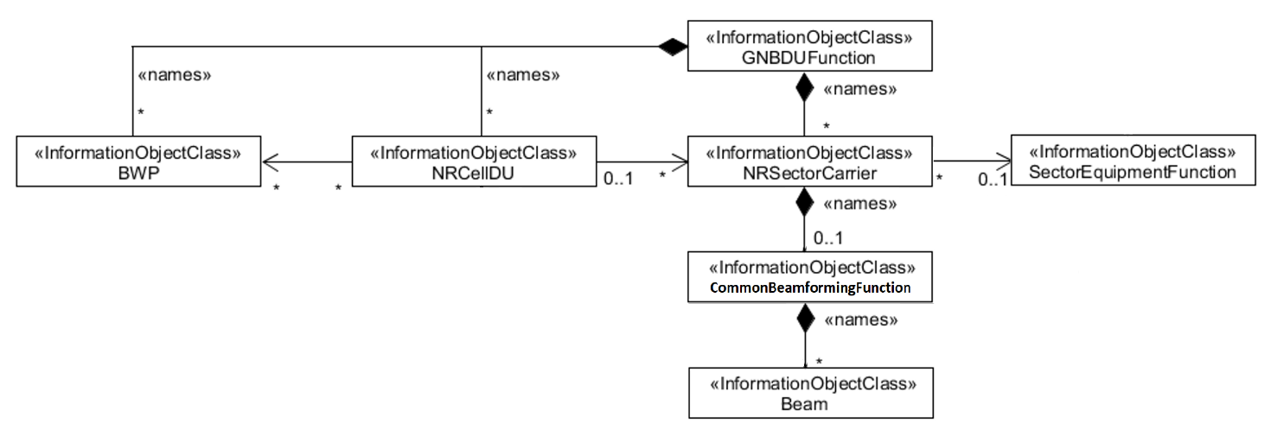

Figure 4.2.1.1-3: NRM for <<IOC>>NRSectorCarrier and <<IOC>>BWP for all deployment scenarios

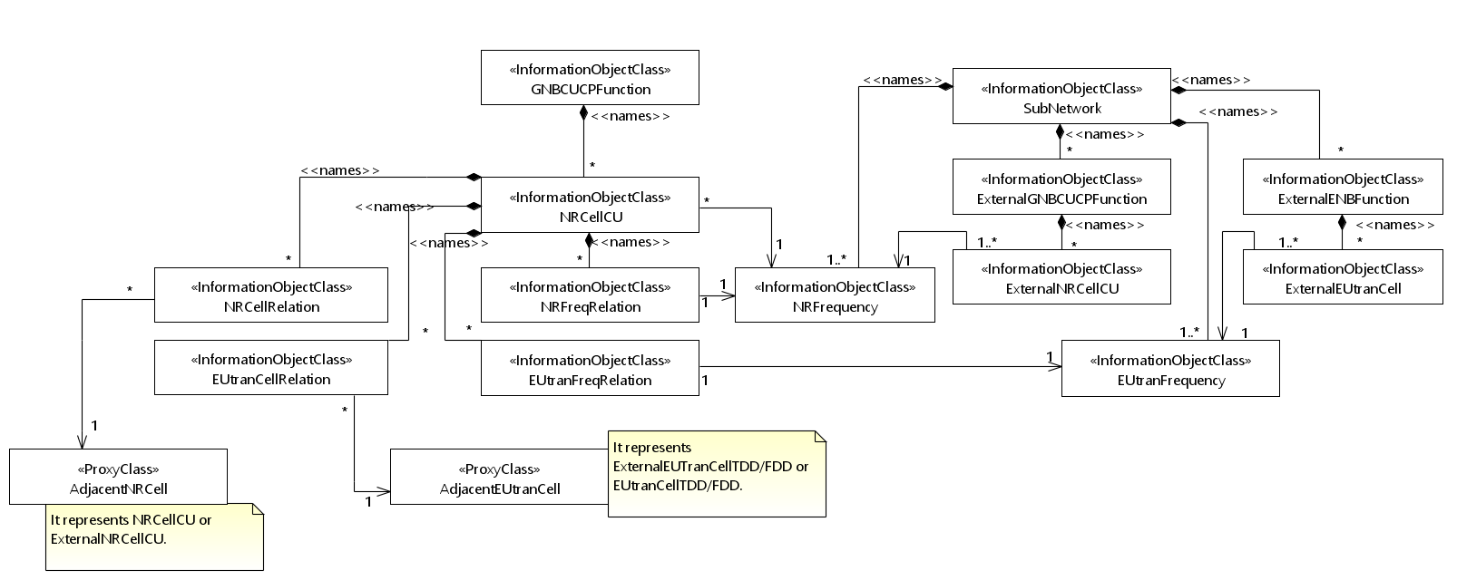

Figure 4.2.1.1-4: Cell Relation view for all deployment scenarios

NOTE 1: The above NRM fragment uses SubNetwork to hold both NR and LTE external entities and frequencies.

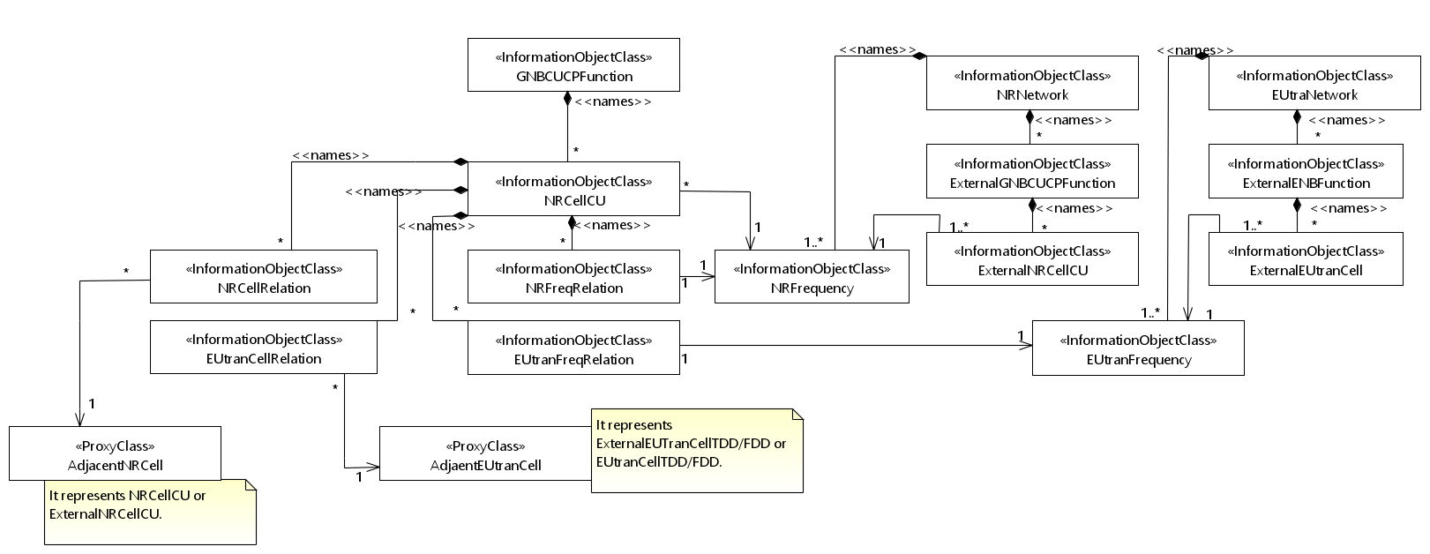

Figure 4.2.1.1-5: Cell Relation view for all deployment scenarios

NOTE 2: The above NRM fragment uses NRNetwork to hold NR external entities and frequency and using EUtraNetwork to hold LTE external entities and frequency. The NRNetwork and EUtraNetwork are subclasses of SubNetwork (defined in TS 28.622 [30]) with no additional attributes. The reason using NRNetwork and EUtraNetwork is for a clean separation of NR external entities and frequency and LTE external entities and frequency.



Figure 4.2.1.1-6: NRM fragement for RRM Policies

|  |
| --- |
| **End of Change** |