3GPP TSG-SA5 Meeting #130e S5-202226

e-meeting 20-28 April 2020

Source: Huawei

Title: Discussion on general CRUD operation for different management purposes

Document for: Discussion and endorsement
Agenda Item: 6.3

1 Decision/action requested
The group is asked to discuss and approval.

2 References
[1] 3GPP TS 28.532 Management and Orchestration; Generic management services;

3 Rationale
Following Action point is created in SA5#129 emeeting based on the discussion of contribution S5-201319.
129e.2 | Clarify the definition and solution for MnS with CRUD operations for different management purposes (e.g. Node configuration, PM control, NotificationSubscriptionControl). (related tdoc S5-201319) | Rel-16 | Xuruiyue, Olaf,Edwin | Open | SA5#130

This contribution proposes to discuss and clarify the definition and solution for MnS with CRUD operations for different management purposes (e.g. Node configuration, PM control, NotificationSubscriptionControl).
Following are some observations of existing specification which can be used as background for this discussion.
Background observation#1: As described in TS 28.533 Clause 4.3, A MnS is composed by a MnS component type A and
- a MnS component type B, or
- a MnS component type B and a MnS component type C.
Background observation#2: As described in TS 28.531 Clause 4.1, provisioning MnS described in TS 28.531 means the provisioning of network slicing/network slice subnet which includes the four phases which are preparation, commissioning, operation and decommissioning.
Background observation#3: As described in TS 28.622, several concrete NRM fragments are introduced in R16 to be work together with CRUD operation/notification for certain control purpose, for example, NRM fragment for Measurement control, NRM fragment for FM control, NRM fragment for Subscription control, NRM fragment for Threshold control, NRM fragment for Heartbeat control.
Background observation#4: As described in TS 28.532, the generic provisioning MnS include CRUD operations and ProxyClsss ManagedEntity.

RAN Node management for configuration and PM control purposes is illustrated as a concrete example for discussion.
Following is the NRM tree implemented by MnS Producer for the RAN Node management for configuration and PM control purposes.
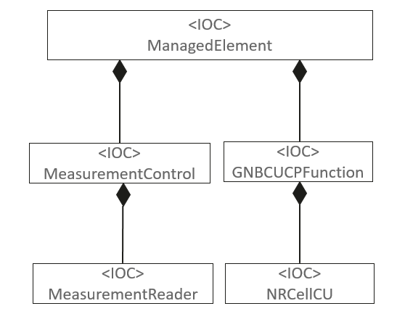
NRM tree implemented by MnF (plays the roles of multiple MnS producer)
Following are the poential MnS(s) that can be provided by the MnS Producer based on the above NRM.
- MnS X: MnS with CRUD operation and NRM fragment for RAN Node configuration purpose;
  - The MnS X consumer can access the ManagedElement<IOC> and containing subtree on the right (GNBCUCPFunction-> NRCellCU).
  - The MnS X consumer can configure attributes of ManagedElement <IOC>, GNBCUCPFunction<IOC> and NRCellCU<IOC>.
  - In the Restful Solution Set view, the MnS X consumer can access following URI with both writable and readable capability:
http://{URI-DN-prefix}/{root}/ProvMnS/v1630/ManagedElement=1 ,
http://{URI-DN-prefix}/{root}/ProvMnS/v1630/ManagedElement=1/GNBCUCPFunction=2 ,
http://{URI-DN-prefix}/{root}/ProvMnS/v1630/ManagedElement=1/GNBCUCPFunction=2/NRCellCU=3 ,
It is clear that the MnS Y is Provisioning MnS.

- MnS Y: MnS with CRUD operation and Measurement control NRM fragment for RAN Node PM control purpose;
  - The MnS Y consumer can access the ManagedElement<IOC> and containing subtree on the left (MeasurementControl->MeasurementReader).
  - The MnS Y consumer can only configure attributes of MeasurementControl<IOC> and MeasurementReader<IOC>. The ManagedElement<IOC> can not be configured and read by MnS Y consumer, except the attribute “DN” which can be read.
  - In the Restful Solution Set view, the MnS Y consumer can access following URI with both writable and readable capability:
http://{URI-DN-prefix}/{root}/MnSname?/v1630/ManagedElement=1/MeasurementControl=4 ,
http://{URI-DN-prefix}/{root}/MnSname?/v1630/ManagedElement=1/MeasurementControl=4/MeasurementReader=5 .
It is confuse for MnS Y? Following are two potential options:
- Option#1 ProvMnS (Same as MnS X). It is confuse to say Provisioning MnS is used for PM control. Also How to differentiate the MnS X and MnS Y, because the consumer of MnS X and MnS Y can be different and the accessed object tree also are different. How to capture such difference.
- Option#2 Configurable PM Control MnS. Generic Provisioning MnS is an abstract MnS with CRUD operation and ProxyClass ManagedEntity, while Configurable PM control MnS is composed of the generic provisioning MnS CRUD operations/notifications and concrete measurement control NRM fragment. In the RESTFul Solution Set view, the URI for generic Provisioning MnS defined in TS 28.532 should be changed to: http://{URI-DN-prefix}/{root}/{GenericProvMnS}/v1630/{LDN-first-part}/{ClassName}={id}. And the variables GenericProvMnS can be :
  - Configurable PM Control MnS for the MnS with CRUD operation for PM control purpose (MnS Y). And the resource representation for the PM Control MnS should be PM control NRM fragment. So in the implementation view, the URI for Configurable PM Control MnS should be http://{URI-DN-prefix}/{root}/ConfigurablePMControlMnS/v1630/{LDN-first-part}/{ClassName}={id}.
  - Provisioning MnS for the CRUD operation for Node configuration purpose (MnS X). And the resource representation for the Provisioning MnS can be NR NRM, 5GC NRM and SliceNRM. So in the implementation view, the URI for Provisioning MnS should be http://{URI-DN-prefix}/{root}/ProvMnS/v1630/{LDN-first-part}/{ClassName}={id}
  - SON Management MnS for the MnS with CRUD operation for SON management/control purpose. And the resource representation for SON MnS can be SON NRM fragment. So in the implementation view, the URI for SON Management MnS should be http://{URI-DN-prefix}/{root}/SONManagementMnS/v1630/{LDN-first-part}/{ClassName}={id}
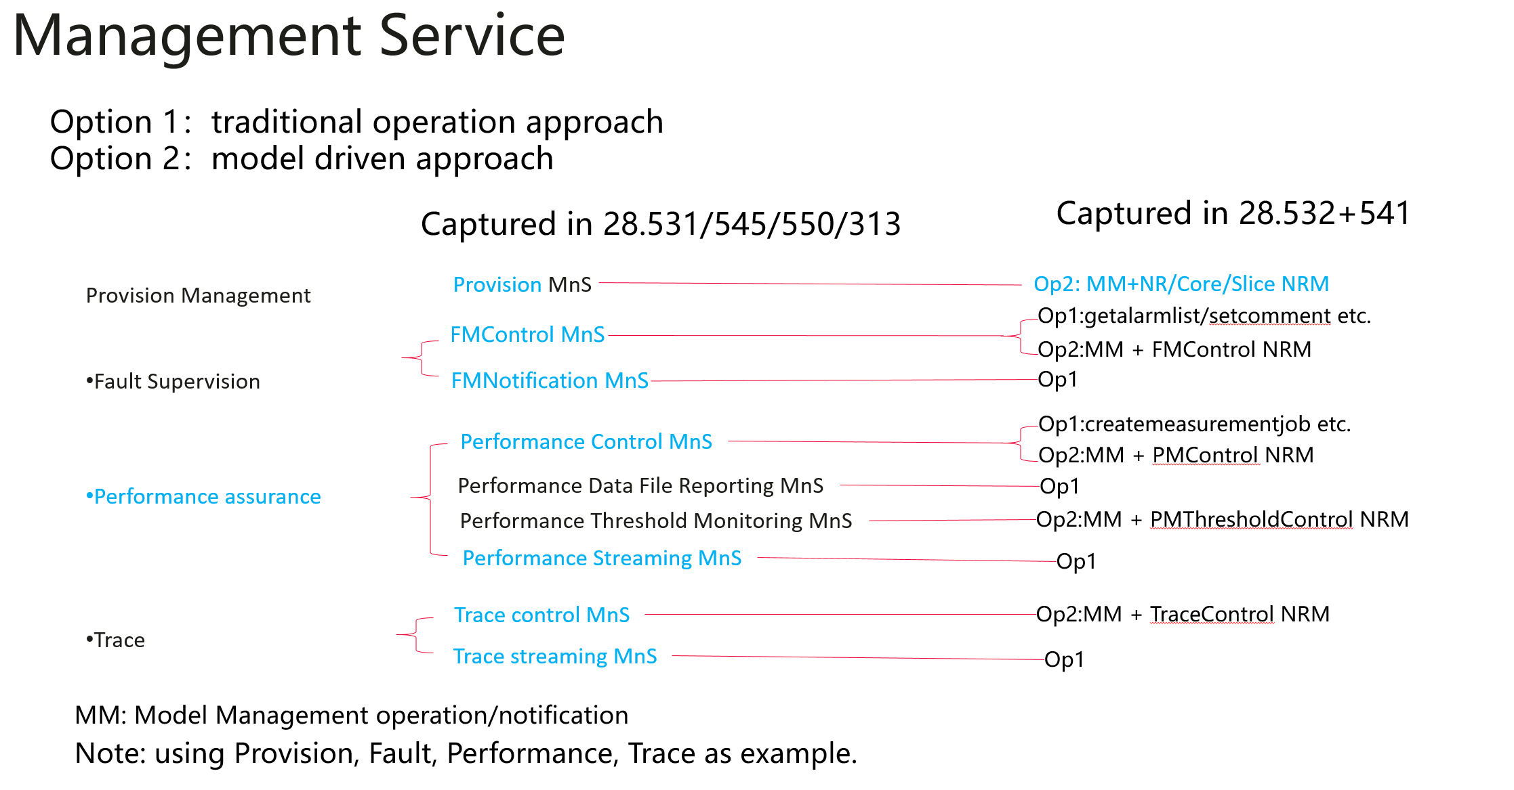

4 Detailed proposal
Based on the above analysis, following are some detailed proposals:
- Rename the generic provisioning MnS in TS 28.532, proposes to use model management for CRUD operations and notification.
- Keep the provisioning MnS in TS 28.531 which is the combination of model management and NR/5GC/Slice NRM.

- Update feature specification (e.g. TS 28.531, TS 28.550, TS28.545 ) to describe Fearure MnS (e.g. configurable PM control MnS) is the combination of model managemet defined in TS 28.532 and concerate feature NRM fragments defined in TS 28.541/28.622. For example, following description should be added in TS 28.550.

7.5 Management Service for Configurable PM Control
Configurable PM Control MnS is the combination of the model management (MnS ComponentType A) and PM Control NRM fragment (MnS ComponentType B).
The components of Configurable PM Control MnS are listed in table 7.5-1.
Table 7.5-1: Components of Configurable PM Control MnS
Management service | Management service component type A | Management service component type B
Configurable PM control MnS | Model management operations and notification defined in TS 28.532 clause11.1.1. | IOCs (i.e. MeasurementControl, MeasurementReader) for PM Control NRM fragment defined in TS 28.622.

Note: the implementation of configuration PM control MnS is by utilizing the implematation of above MnS component type A and the implementation of above MnS component type B.

- For the etsi forge, also needs to show the feature MnS and link(s) to corresponding MnS component code file (e.g. YAML) in the README.MD. Following is one example:
Performance Management Control
  - Configuration PM Control MnS:
    - Link to YAML file containing model management operation and notification
    - Link to YAML file containing PM control NRM fragment
  - Operation based PM Control MnS
    - Link to YAML file containing measurement job control operations

