**3GPP TSG-SA5 Meeting #130e *S5-202203***

**e-meeting 20-28 April 2020**

|  |  |  |  |  |  |  |  |  |
| --- | --- | --- | --- | --- | --- | --- | --- | --- |
| *CR-Form-v12.0* | | | | | | | | |
| **CHANGE REQUEST** | | | | | | | | |
|  | | | | | | | | |
|  | **28.622** | **CR** | **0074** | **rev** | **1** | **Current version:** | **16.3.0** |  |
|  | | | | | | | | |
| *For* [***HE******LP***](http://www.3gpp.org/3G_Specs/CRs.htm#_blank)*on using this form: comprehensive instructions can be found at* [*http://www.3gpp.org/Change-Requests*](http://www.3gpp.org/Change-Requests)*.* | | | | | | | | |
|  | | | | | | | | |

|  |  |  |  |  |  |  |  |  |
| --- | --- | --- | --- | --- | --- | --- | --- | --- |
| ***Proposed change affects:*** | UICC apps |  | ME |  | Radio Access Network | **X** | Core Network | **X** |

|  |  |  |  |  |  |  |  |  |  |  |
| --- | --- | --- | --- | --- | --- | --- | --- | --- | --- | --- |
|  | | | | | | | | | | |
| ***Title:*** | Add TOP_ as parent IOC | | | | | | | | | |
|  |  | | | | | | | | | |
| ***Source to WG:*** | ZTE | | | | | | | | | |
| ***Source to TSG:*** | S5 | | | | | | | | | |
|  |  | | | | | | | | | |
| ***Work item code:*** | eNRM | | | | |  | ***Date:*** | | | 2020-04-03 |
|  |  | | | |  | |  | | |  |
| ***Category:*** | F |  | | | | | ***Release:*** | | | Rel-16 |
|  | *Use one of the following categories:* ***F*** *(correction)* ***A*** *(mirror corresponding to a change in an earlier release)* ***B*** *(addition of feature),* ***C*** *(functional modification of feature)* ***D*** *(editorial modification)*  Detailed explanations of the above categories can be found in 3GPP [TR 21.900](http://www.3gpp.org/ftp/Specs/html-info/21900.htm). | | | | | | | | *Use one of the following releases: Rel-8 (Release 8) Rel-9 (Release 9) Rel-10 (Release 10) Rel-11 (Release 11) Rel-12 (Release 12)* *Rel-13 (Release 13) Rel-14 (Release 14) Rel-15 (Release 15) Rel-16 (Release 16)* | |
|  |  | | | | | | | | | |
| ***Reason for change:*** | | Currently, some IOCs are inherited only from TOP, which does not have the attribute Id. But in the solution set of these IOCs, there is the attribute Id. So there is inconsistency in the current specification. | | | | | | | | |
|  | |  | | | | | | | | |
| ***Summary of change:*** | | Rename the original Top IOC to TopX, and add a new IOC Top which inherits from both TopX and Top_. | | | | | | | | |
|  | |  | | | | | | | | |
| ***Consequences if not approved:*** | | there is inconsistency in the specification. | | | | | | | | |
|  | |  | | | | | | | | |
| ***Clauses affected:*** | | 4.2.2, 4.3.8, 4.3.8.1, 4.3.21.2, 4.3.22.2, 4.3.25.2, 4.3.26.2, 4.3.X(new) | | | | | | | | |
|  | |  | | | | | | | | |
|  | | **Y** | **N** |  | | | |  | | |
| ***Other specs*** | |  | **X** | Other core specifications | | | | TS/TR ... CR ... | | |
| ***affected:*** | |  | **X** | Test specifications | | | | TS/TR ... CR ... | | |
| ***(show related CRs)*** | |  | **X** | O&M Specifications | | | | TS/TR ... CR ... | | |
|  | |  | | | | | | | | |
| ***Other comments:*** | |  | | | | | | | | |
|  | |  | | | | | | | | |
| ***This CR's revision history:*** | |  | | | | | | | | |

|  |
| --- |
| **1st Modified Section** |

### 4.2.2 Inheritance

This clause depicts the inheritance relationships.

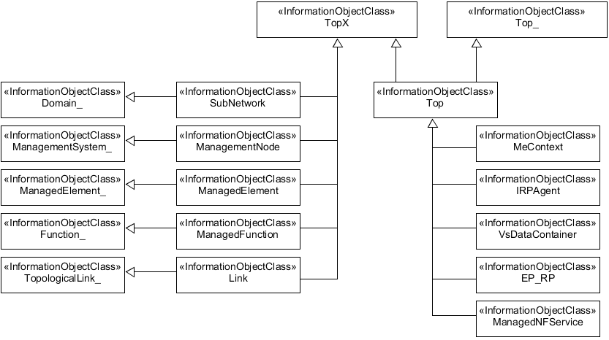

Figure 4.2.2-1: Inheritance Hierarchy NRM fragment

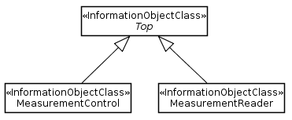

Figure 4.2.2-2: Performance measurement control NRM fragment

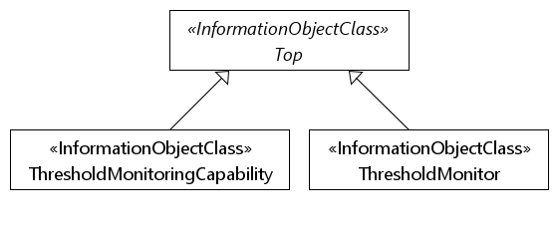

Figure 4.2.2-3: Measurement threshold monitoring NRM fragment



Figure 4.2.2-4: Heartbeat notification control fragment

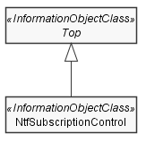

Figure 4.2.2-5: Notification subscription fragment

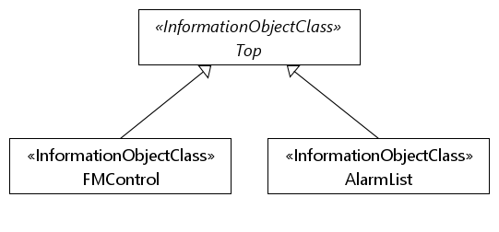

Figure 4.2.2-6: FM control NRM fragment

|  |
| --- |
| **Next Modified Section** |

### 4.3.8 *TopX*

#### 4.3.8.1 Definition

This IOC is provided for sub-classing only. All information object classes defined in all TS that claim to be conformant to 32.102 [2] shall inherit from TopX.

#### 4.3.8.2 Attributes

|  |  |  |  |  |  |
| --- | --- | --- | --- | --- | --- |
| Attribute Name | Support Qualifier | isReadable | isWritable | isInvariant | isNotifyable |
| objectClass | M | T | F | T | T |
| objectInstance | M | T | F | T | T |

#### 4.3.8.3 Attribute constraints

None

#### 4.3.8.4 Notifications

There is no notification defined.

|  |
| --- |
| **Next Modified Section** |

#### 4.3.21.2 Attributes

The HeartbeatControl IOC includes attributes inherited from Top IOC (defined in clause 4.3.8) and the following attributes:

|  |  |  |  |  |  |
| --- | --- | --- | --- | --- | --- |
| Attribute Name | Support Qualifier | isReadable | isWritable | isInvariant | isNotifyable |
| heartbeatNtfPeriod | M | T | T | F | T |
| triggerHeartbeatNtf | M | F | T | F | F |

|  |
| --- |
| **Next Modified Section** |

#### 4.3.22.2 Attributes

The NtfSubscriptionControl IOC includes attributes inherited from Top IOC (defined in clause 4.3.8) and the following attributes:

|  |  |  |  |  |  |
| --- | --- | --- | --- | --- | --- |
| Attribute Name | Support Qualifier | isReadable | isWritable | isInvariant | isNotifyable |
| notificationRecipientAddress | M | T | T | F | T |
| notificationTypes | O | T | T | F | T |
| scope | M | T | T | F | T |
| notificationFilter | O | T | T | F | T |

|  |
| --- |
| **Next Modified Section** |

#### 4.3.25.2 Attributes

The FMControl IOC includes attributes inherited from Top IOC (defined in clause 4.3.8) and the following attributes:

|  |  |  |  |  |  |
| --- | --- | --- | --- | --- | --- |
| **Attribute Name** | **Support Qualifier** | **isReadable** | **isWritable** | **isInvariant** | **isNotifyable** |
| administrativeState | M | T | T | F | T |
| operationalState | M | T | F | F | T |

|  |
| --- |
| **Next Modified Section** |

#### 4.3.26.2 Attributes

The AlarmList IOC includes attributes inherited from Top IOC (defined in clause 4.3.8) and the following attributes:

|  |  |  |  |  |  |
| --- | --- | --- | --- | --- | --- |
| **Attribute Name** | **Support Qualifier** | **isReadable** | **isWritable** | **isInvariant** | **isNotifyable** |
| numOfAlarmRecords | M | T | F | F | F |
| lastModification | M | T | F | F | F |
| alarmRecordList | M | T | T | F | T |

|  |
| --- |
| **Next Modified Section** |

### 4.3.X *Top*

#### 4.3.8.1 Definition

This IOC is provided for sub-classing only. All information object classes defined in all TS that claim to be conformant to 32.102 [2] and support the Federated Network Information Model (FNIM) concept shall inherit from Top.

#### 4.3.8.2 Attributes

This IOC includes attributes inherited from TopX IOC (defined in clause 4.3.8) and the attributes inherited from Top_ IOC (defined in TS 28.620 [9]).

#### 4.3.8.3 Attribute constraints

None

#### 4.3.8.4 Notifications

There is no notification defined.

|  |
| --- |
| **End of Modified Sections** |