**3GPP TSG-SA5 Meeting #130-e *S5-202145***

**Online, , 20th Apr 2020 - 28th Apr 2020**

|  |  |  |  |  |  |  |  |  |
| --- | --- | --- | --- | --- | --- | --- | --- | --- |
| *CR-Form-v12.0* | | | | | | | | |
| **CHANGE REQUEST** | | | | | | | | |
|  | | | | | | | | |
|  | **28.531** | **CR** | **0043** | **rev** | **-** | **Current version:** | **16.5.0** |  |
|  | | | | | | | | |
| *For* [***HE******LP***](http://www.3gpp.org/3G_Specs/CRs.htm#_blank)*on using this form: comprehensive instructions can be found at* [*http://www.3gpp.org/Change-Requests*](http://www.3gpp.org/Change-Requests)*.* | | | | | | | | |
|  | | | | | | | | |

|  |  |  |  |  |  |  |  |  |
| --- | --- | --- | --- | --- | --- | --- | --- | --- |
| ***Proposed change affects:*** | UICC apps |  | ME |  | Radio Access Network | **x** | Core Network | **x** |

|  |  |  |  |  |  |  |  |  |  |  |
| --- | --- | --- | --- | --- | --- | --- | --- | --- | --- | --- |
|  | | | | | | | | | | |
| ***Title:*** | Fix inconsistencies | | | | | | | | | |
|  |  | | | | | | | | | |
| ***Source to WG:*** | Huawei | | | | | | | | | |
| ***Source to TSG:*** | S5 | | | | | | | | | |
|  |  | | | | | | | | | |
| ***Work item code:*** | eNRM | | | | |  | ***Date:*** | | | 2020-04-10 |
|  |  | | | |  | |  | | |  |
| ***Category:*** | **F** |  | | | | | ***Release:*** | | | Rel-16 |
|  | *Use one of the following categories:* ***F*** *(correction)* ***A*** *(mirror corresponding to a change in an earlier release)* ***B*** *(addition of feature),* ***C*** *(functional modification of feature)* ***D*** *(editorial modification)*  Detailed explanations of the above categories can be found in 3GPP [TR 21.900](http://www.3gpp.org/ftp/Specs/html-info/21900.htm). | | | | | | | | *Use one of the following releases: Rel-8 (Release 8) Rel-9 (Release 9) Rel-10 (Release 10) Rel-11 (Release 11) Rel-12 (Release 12)* *Rel-13 (Release 13) Rel-14 (Release 14) Rel-15 (Release 15) Rel-16 (Release 16)* | |
|  |  | | | | | | | | | |
| ***Reason for change:*** | | There are three concepts which need clarifications:  - Network Slice  - Network Slice Instance  - NSI ID   1. "Network Slice" term/definition: The definition of “Network Slice” (defined in TS 23.501) is conceptually aligned between SA2 and SA5. "NetworkSlice" IOC represents the SA2 defined "Network Slice" for the management purpose. This is the general network slicing management approach as we did for management of other network elements. 2. "Network Slice Instance" term/defintion: The definition of "Network Slice Instance" (defined in TS 23.501) is conceptually aligned between SA2 and SA5. It focuses on the depolyment aspect and composition of Network Slice (defined in TS 23.501). In SA5 understanding, the Network Slice Instance contains the related resources which are needed to compose a network slice including both 3GPP defined Core network and RAN. 3. "NSI ID" term: The term "NSI ID" might lead to conslusion that it is the identifier of NSI, which is actually DN of NSI. In the context of SA2, the NSI ID usage is optional and for the purpose to identify the core network part of NSI using NRF discovery mechanism.   Potential confusion is mainly caused by the use of "NSI ID" term. | | | | | | | | |
|  | |  | | | | | | | | |
| ***Summary of change:*** | | Fix inconsistencies related to "Network Slice instance (NSI)" term usage. | | | | | | | | |
|  | |  | | | | | | | | |
| ***Consequences if not approved:*** | | Inconsistent term usage may lead to incorrect implementation. | | | | | | | | |
|  | |  | | | | | | | | |
| ***Clauses affected:*** | | 5.1.1, 5.1.2, 5.1.3, 5.1.4, 5.1.5, 5.1.6, 5.1.7, 5.1.8, 5.1.9, 5.1.10, 5.1.12, 5.1.13, 5.1.14, 5.1.15, 5.1.16, 5.1.21, 5.1.22, 5.1.23 | | | | | | | | |
|  | |  | | | | | | | | |
|  | | **Y** | **N** |  | | | |  | | |
| ***Other specs*** | |  | **x** | Other core specifications | | | | TS/TR ... CR ... | | |
| ***affected:*** | |  | **x** | Test specifications | | | | TS/TR ... CR ... | | |
| ***(show related CRs)*** | |  | **x** | O&M Specifications | | | | TS/TR ... CR ... | | |
|  | |  | | | | | | | | |
| ***Other comments:*** | |  | | | | | | | | |
|  | |  | | | | | | | | |
| ***This CR's revision history:*** | |  | | | | | | | | |

|  |
| --- |
| **1st change** |

# 4 General

## 4.1 Overview

A 5G system consists of a 5G Access Network (AN), and a 5G Core Network (5GC). Network slicing is one of the key 5G features.

The management aspects of an network slice are described by the four phases shown in Figure 4.3.1.1 of TS 28.530 [4].

The provisioning of network slicing includes the four phases which are preparation, commissioning, operation and decommissioning:

- In the preparation phase the NSI does not exist. The preparation phase includes network slice design, on-boarding, evaluation of the network slice requirements, preparing the network environment and other necessary preparations required to be done before the creation of an NSI.

- During the NSI lifecycle stage which include commissioning phase, operation phase and decommissioning phase, the NSI provisioning operations include:

- Create an NSI;

- Activate an NSI;

- De-active an NSI;

- Modify an NSI;

- Terminate an NSI.

The operations of the provisioning of an NSI occurs during different phases of a NSI:

a) During the commissioning phase:

- Create an NSI.

During NSI creation all resources to the NSI have been created and configured to satisfy the network slice requirements. NSI creation may trigger NSSI(s) creation or using existing NSSI(s) and setting up the corresponding associations.

b) During the operation phase:

- Activate an NSI;

- Modify an NSI;

- De-active an NSI.

NSI activation includes any actions that make the NSI active to provide communication services. NSI activation may trigger NSSI activation.

NSI modification in operation phase could map to several workflows, e.g. changes of NSI capacity, changes of NSI topology, NSI reconfiguration. NSI modification can be triggered by receiving new network slice related requirements, new communication service requirements, or the result of NSI supervision automatically. NSI modification may trigger NSSI modification.

The NSI deactivation operation may be needed before NSI modification operation and the NSI activation operation may be needed after the NSI modification operation. NSI deactivation includes any actions that make the NSI inactive and not providing any communication services. NSI deactivation trigger NSSI deactivation to deactivate constituent NSSI(s) which is not used by other NSI(s). Operator may decide to keep the NSI without termination after deactivation and reactivate it when receives new communication service request.

c) During the decommissioning phase:

- Terminate an NSI.

NSI termination step includes any action that make the NSI does not exist anymore and release resources that are not used by other NSI(s). NSI termination may trigger NSSI termination to terminate constituent NSSI(s) which is not used by other NSI(s).

Similarly, provisioning for NSSI includes the following operations:

- Create an NSSI;

- Activate an NSSI and associate it with certain NSI to be used by the NSI;

- Disassociate the NSSI with certain NSI and de-active the NSSI if it’s not associated with any NSI;

- Modify an NSSI;

- Terminate an NSSI.

## 4.2 Configuration information for the constituents of an NSI

To use network slice to support communication service or deliver a network slice as a service, the 3GPP defined constituents of the NSI should be configured by 3GPP management system according to the types and requirements of the network slice so that the NSI can be operated and maintained.

The configuration information of these components may include:

*- Information on the requirements to be applied to every NSI constituent to satisfy the requirements of multiple NSIs* if the constituent is shared by multiple NSIs;

*- Network function selection information:* Information on the selection of the NFs (e.g., AMF) according to the requirements of this NSI;

*- Connection information*: The information of the logical links to carry the NSI’s CP and UP data between the component and other NFs and NSSIs belonging to the NSI.

NOTE 1: The list of information above is not exhaustive.

NOTE 2: The list of information above is not all necessary for an NSI.

## 4.3 General information for NSI

The general information used to describe an NSI may include:

- Resource model information, which describes the static parameters and functional components of network slice, includes service profile, network slice type (e.g. eMBB), additional system feature (e.g. multicast, Edge Computing), priority.

- Management model information, which describes the information model that is used for network slice lifecycle management, includes configuration profile (e.g. application configuration parameters).

- Capability model information, which describes the capability including supported communication service characteristic information (e.g. service type, UE mobility level, density of users, traffic density), QoS attributes (e.g. bandwidth, latency, throughput and so on) and capacity (e.g. maximum number of UEs), can be exposed to CSC .

## 4.4 General information for NSSI

The general information used to describe an NSSI may include:

- Resource model information, which describes the static parameters and functional component of network slice subnet, includes slice profile, network slice subnet type (e.g. RAN eMBB, CN eMBB), additional system feature (e.g. multicast, Edge Computing), priority, QoS attributes (e.g. bandwidth, latency, number of subscribers and so on), NSD ID.

- Management model information, which describes the information model that is used for network slice subnet lifecycle management, includes configuration profile (e.g. application configuration parameters).

- Capability model information, which describes the capability including supported communication service characteristic information (e.g. service type, UE mobility level, density of users, traffic density), QoS attributes (e.g. bandwidth, latency, throughput and so on) and capacity (e.g. maximum number of UEs).

## 4.5 General information for service profile

Depending on industry requirements and operator’s design requirements, different service profiles may be used to represent SLS associated with instances of Network Slice IOC.

The following are examples for service profiles:

- A service profile is used to capture a set of requirements for the new network slice such as (eMBB, MIoT, URLLC).

- A service profile is used to capture a set of specific industry requirements for creation of network slice such as V2X, smart grid, Remote Healthcare.

## 4.6 General information for network slice related identifiers

There are following network slice related identifiers which serve different purposes:

|  |  |
| --- | --- |
| **Identifier** | **Description** |
| **Identifiers for network slice management purpose** | |
| NetworkSlice identifier | Represent the management identifier of NSI. Management identifier of NSI is defined in TS 28.541[6] as objectinstance attribute of NetworkSlice IOC. |
| NetworkSliceSubnet identifier | Represent the management identifier for an NSSI. Management identifier of NSSI is defined in TS 28.541[6] as objectinstance attribute of NetworkSliceSubnet IOC. |
| **Identifiers for network slice selection purpose** | |
| NSI ID | Represent Core Network part of a Network Slice instance when multiple Network Slice instances of the same Network Slice are deployed, and there is a need to differentiate between them in the 5GC. Referred to TS 23.501[10]. |
| S-NSSAI | Represent network slice. Referred to TS 23.501[10] and TS 38.300[11]. |
| PLMN ID | Represent PLMN identifier. |

The NSI ID and S-NSSAI are configured by the management system.

|  |
| --- |
| **2nd change** |

## 5.1 Use cases

### 5.1.1 NSI creation

| Use case stage | Evolution/Specification | <<Uses>> Related use |
| --- | --- | --- |
| **Goal** | To satisfy request for allocation of an NSI with certain characteristics, by creation of new or using existing NSI; the request includes the network slice related requirements. |  |
| **Actors and Roles** | A network slice provisioniong management service consumer. NOP (Network Operator) |  |
| **Telecom resources** | NSI NSSI Transport network A network slice provisioning management service provider. A network slice subnet provisioning management service provider. |  |
| **Assumptions** | N/A |  |
| **Pre-conditions** | N/A |  |
| **Begins when** | The network slice provisioning management service provider receives the request for allocation of the NSI with certain characteristics; the request contains network slice related requirements and the information indicating whether the requested NSI could be shared with other consumers. |  |
| **Step 1 (M)** | If the requested NSI can be shared and if an existing NSI can be used, the network slice provisioning management service provider decides to use the existing NSI. Modification of the existing NSI may be needed to satisfy the NSI related requirements. Use case is completed go to “Step 8". Otherwise, the network slice provisioning management service provider triggers to create a new NSI, for which the following steps 2 – 8 are needed. |  |
| **Step 2 (M)** | The network slice provisioning management service provider decides on the constituent NSSIs and the topology of the NSI to be created using the information from service profile [6]. For the constituent NSSIs, the network slice provisioning management service provider derives network slice subnet related requirements from the network slice related requirements. If reconfiguration of the transport network is needed, the network slice provisioning management service provider derives transport network related requirements (e.g. latency, bandwidth) from the network slice related requirements. |  |
| **Step 3 (M)** | For the required NSSI(s), the network slice provisioning management service provider sends network slice subnet related requirements to the network slice subnet provisioning management service provider to request allocation of the required NSSI(s). | NSSI creation use case |
| **Step 4 (M)** | The network slice provisioning management service provider receives the information of the allocated NSSI(s) (e.g. the management identifier of NSSI, service access point information of NSSI, external connection point information of NSSI) from NSSMF. |  |
| **Step 5 (M)** | The network slice provisioning management service provider, via the network slice subnet provisioning management service provider, sends the transport network related requirements (e.g. external connection point, latency and bandwidth) to the TN Manager. The TN manager reconfigures the TN accordingly and responds to the network slice provisioning management service provider via the network slice subnet provisioning management service provider. |  |
| **Step 6 (M)** | The network slice provisioning management service provider receives the response from TN Manager via the network slice subnet provisioning management service provider. |  |
| **Step 7 (M)** | The network slice provisioning management service provider associates the NSSI(s) with the corresponding NSI (e.g. allocation of the management identifier of NSI and mapping the management identifier of NSI with the received management Identifier of NSSI(s)) and triggers to establish the links between the service access points of the NSSI(s). |  |
| **Step 8 (M)** | The network slice provisioning management service provider notifies the NSI information of NSI (e.g., the management identifier of NSI). |  |
| **Ends when** | All the steps identified above are successfully completed. |  |
| **Exceptions** | One of the steps identified above fails. |  |
| **Post-conditions** | An NSI is ready to satisfy the network slice related requirements. |  |
| **Traceability** | REQ-PRO_NSSI-FUN-1, REQ-PRO_NSI-FUN-3. |  |

### 5.1.2 NSSI creation

| Use case stage | Evolution/Specification | <<Uses>> Related use |
| --- | --- | --- |
| **Goal** | Create a new NSSI or use an existing NSSI to satisfy the network slice subnet related requirements; provide the provisioning service consumer with identity of the NFVO which the consumer can use for further access to the information of the involved VNFs, PNFs and NSs. |  |
| **Actors and Roles** | A network slice subnet provisioning management service consumer. |  |
| **Telecom resources** | NSSI NSI A network slice subnet provisioning management service provider. The operator deployed NFVO to manage the lifecycle of VNFs and interconnection between the VNFs and PNFs in terms of the NS instances. |  |
| **Assumptions** | NSSI may include network functions which are virtualized. |  |
| **Pre-conditions** | VNF Packages for virtualized network functions to be included in the NSSI have been already on-boarded. |  |
| **Begins when** | The network slice provisioning management service provider sends to the network slice subnet provisioning management service provider a request for a NSSI to be associated with the NSI; the request contains network slice subnet related requirements including the SliceProfile [6].  The network slice subnet provisioning management service provider receives request for an NSSI. The request contains network slice subnet related requirements. The request may include guidance for use of particular NFVO(s) when VNFs and PNFs in certain part of the network are involved. The request may also include query of the identity of the NFVO to be used. |  |
| **Step 1 (M)** | Based on the network slice subnet related requirements received, the network slice subnet provisioning management service provider decides to create a new NSSI or use an existing NSSI. |  |
| **Step 2 (M)** | If an existing NSSI is decided to be used, the network slice subnet provisioning management service provider may trigger to modify the existing NSSI to satisfy the network slice subnet related requirements. Go to “Step 8”. Otherwise, the network slice subnet provisioning management service provider triggers to create a new NSSI, the following steps are needed. |  |
| **Step 3 (O)** | If the required NSSI contains constituent NSSI(s) managed by other network slice subnet provisioning management service provider (s), the first network slice subnet provisioning management service provider derives the requirements for the constituent NSSI(s) and sends those requirements to the corresponding network slice subnet provisioning management service provider (s) which manages the constituent NSSI(s).  The first network slice subnet provisioning management service provider receives the constituent NSSI information from the other network slice subnet provisioning management service provider (s) and associates the constituent NSSI(s) with the required NSSI. |  |
| **Step 4 (M)** | Based on the network slice subnet related requirements received and SliceProfile [6], the network slice subnet provisioning management service provider decides that to satisfy the NSSI requirements, the part of the network controlled by certain NFVO should be involved. The network slice subnet provisioning management service provider determines the NS related requirements (i.e. information about the target NSD and additional parameterization for the specific NS to instantiate, see clause 7.3.3 in ETSI GS NFV-IFA013 [3]). |  |
| **Step 5 (M)** | Based on the NS related requirements, the network slice subnet provisioning management service provider triggers corresponding NS instantiation request to NFVO via Os-Ma-nfvo interface as described in clause 6.4.3 in TS 28.525 [2], and the NFVO performs NS instantiation. (see note) | TS 28.525 [2] Clause 6.4.3 NS instance use cases |
| **Step 6 (M)** | The network slice subnet provisioning management service provider associates the NS instance with corresponding NSSI (e.g. allocation of the management identifier of NSSI and mapping with the corresponding identifiers). |  |
| **Step 7 (M)** | The network slice subnet provisioning management service provider is using the NF provisioning service to configure the NSSI constituents.  In case of RAN NSSI, the configuration contains RRM policy information for individual Radio cells. In the cells shared by multiple NSSIs such policy includes guidance for split of Radio resources between the NSSIs. | NF provisioning service |
| **Step 8 (M)** | The network slice subnet provisioning management service provider notifies the provisioning service consumer with the NSSI information (e.g. the management identifier of NSSI) and the NFVO identity when relevant. The network slice provisioning management service provider associates the NSSI with the NSI. |  |
| **Ends when** | All the steps identified above are successfully completed. |  |
| **Exceptions** | One of the steps identified above fails. |  |
| **Post-conditions** | A NSSI is ready to satisfy the network slice subnet related requirements. |  |
| **Traceability** | REQ-PRO_NSSI-FUN-2, REQ-PRO_NSSI-FUN-3, REQ-PRO_NSSI-FUN-4, REQ-PRO_NSSI-FUN-5, REQ-PRO_NSSI-FUN-6, REQ-PRO_NSSI-FUN-14. |  |
| NOTE: According to the TS 28.525 [2], for the PNFs, NS instantiation includes only establishment of interconnection with other NFs. | | |

### 5.1.3 NSI termination

| Use case stage | Evolution/Specification | <<Uses>> Related use |
| --- | --- | --- |
| **Goal** | To terminate an existing NSI in case it is no longer needed. |  |
| **Actors and Roles** | A network slice provisioning management service consumer. NOP Operator |  |
| **Telecom resources** | NSI NSSI A network slice provisioning management service provider. A network slice subnet provisioning management service provider. |  |
| **Assumptions** | N/A |  |
| **Pre-conditions** | N/A |  |
| **Begins when** | The network slice provisioning management service provider receives the request indicating that an existing NSI is no longer needed to support particular service. The NSI identification is included in the request. |  |
| **Step 1 (M)** | Based on the request, the network slice provisioning management service provider checks if there are no other services to be supported by the NSI. If there are none the network slice provisioning management service provider may decide to terminate the NSI; then proceed to Step 2. Otherwise, the network slice provisioning management service provider may decide to trigger to modify the NSI or to do nothing. The use case is completed; skip the remaining steps. | NSI modification use case |
| **Step 2 (M)** | If the NSI to be terminated is in active state, the network slice provisioning management service provider de-activates the NSI. Then, the NSI to be terminated is inactive. | NSI de-activation use case |
| **Step 3 (M)** | The network slice provisioning management service provider identifies the NSSI used by the NSI, and for every such NSSI sends the request to the corresponding network slice subnet provisioning management service provider (s) indicating that the NSSI(s) are no longer needed for the NSI. The network slice subnet provisioning management service provider (s) may decide to terminate or modify the NSSI(s) based on the request and disassociates them with the NSI. |  |
| **Step 4 (M)** | The network slice provisioning management service provider receives the response from the network slice subnet provisioning management service provider (s) and terminates the NSI. |  |
| **Step 5 (M)** | The network slice provisioning management service provider notifies its consumer of the NSI termination. |  |
| **Ends when** | All the steps identified above are successfully completed or skipped per condition in the Step 1. |  |
| **Exceptions** | One of the steps identified above fails. |  |
| **Post-conditions** | The NSI has been terminated. |  |
| **Traceability** | REQ-PRO_NSI-FUN-3 |  |

### 5.1.4 NSSI termination

| Use case stage | Evolution/Specification | <<Uses>> Related use |
| --- | --- | --- |
| **Goal** | To terminate or disassociate an existing NSSI which was used by the NSI or NSSI, but is no longer needed |  |
| **Actors and Roles** | Network slice subnet provisioning management service consumer. |  |
| **Telecom resources** | NSSI Network slice subnet provisioning management service provider. |  |
| **Assumptions** | N/A |  |
| **Pre-conditions** | N/A |  |
| **Begins when** | The network slice subnet provisioning management service provider receives network slice subnet related request from its authorized consumer indicating that an existing NSSI is no longer needed. |  |
| **Step 1 (M)** | Based on the request, the network slice subnet provisioning management service provider decides whether the NSSI should be terminated.  If the decision is the NSSI should be terminated, go to the Step 2.  If the decision is the NSSI is not terminated (e.g., the NSSI is shared or the network slice subnet provisioning management service provider decides to keep the NSSI for later use), the network slice subnet provisioning management service provider disassociates the NSSI from its consumer and provides feedback to the authorized consumer, maybe with removing its consumer’s configuration or not. Go to Step 5. |  |
| **Step 2 (M)** | If the NSSI consists of constituent NSSIs that are not managed directly by the network slice subnet provisioning management service provider, the network slice subnet provisioning management service provider sends a request to other network slice subnet provisioning management service provider(s) indicating that the constituent NSSIs are no longer needed for the NSSI. |  |
| **Step 3 (M)** | If the NSSI is associated with NSI, the network slice subnet provisioning management service provider disassociates the NSI with the NSSI to be terminated, and the network slice subnet provisioning management service provider may trigger corresponding NS instance related request to NFVO indicating that the NSI is no longer needed for the NSSI. |  |
| **Step 4 (M)** | If there exists a transport network segment used by the NSSI, the network slice subnet provisioning management service provider may indicate that the transport network segment is no longer needed to support the NSSI. |  |
| **Step 5 (M)** | The network slice subnet provisioning management service provider sends response to its consumer. |  |
| **Ends when** | All the steps identified above are successfully completed. |  |
| **Exceptions** | One of the steps identified above fails. |  |
| **Post-conditions** | The NSSI has been terminated. |  |
| **Traceability** | REQ-PRO_NSSI-FUN-8, REQ-PRO_NSSI-FUN-11 |  |

### 5.1.5 Obtaining NSSI information

| Use case stage | Evolution/Specification | <<Uses>> Related use |
| --- | --- | --- |
| **Goal** | Enable the network slice subnet provisioning management service consumer to obtain NSSI information (e.g. Slice/Service type, network slice subnet capability information). |  |
| **Actors and Roles** | Network slice subnet provisioning management service consumer. |  |
| **Telecom resources** | NSSI Network slice subnet provisioning management service provider. |  |
| **Assumptions** | The network slice subnet provisioning management service consumer is authorized to obtain the NSSI information from the network slice subnet provisioning management service provider. |  |
| **Pre-conditions** | NSSI is created. |  |
| **Begins when** | The network slice subnet provisioning management service consumer wants to obtain the NSSI information. |  |
| **Step 1 (M)** | The network slice subnet provisioning management service consumer sends a request to the network slice subnet provisioning management service provider to obtain the NSSI information.  The indication on which information needs to be obtained may be included in the request. |  |
| **Step 2 (M)** | The network slice subnet provisioning management service provider processes this request. |  |
| **Step 3 (M)** | The network slice subnet provisioning management service provider sends the result of NSSI information to the network slice subnet provisioning management service consumer. |  |
| **Ends when** | All the steps identified above are successfully completed. |  |
| **Exceptions** | One of the steps identified above fails. |  |
| **Post-conditions** | The network slice subnet provisioning management service consumer has obtained the NSSI information. |  |
| **Traceability** | REQ-PRO_NSSI-FUN-7. |  |

### 5.1.6 Network slice feasibility check

| Use case stage | Evolution/Specification | <<Uses>> Related use |
| --- | --- | --- |
| **Goal** | To check the feasibility of provisioning a network slice to determine whether the network slice requirements can be satisfied at a particular point in time (e.g., in terms of resources) |  |
| **Actors and Roles** | Network slice management service consumer. For example, CSP providing NSaaS plays the role of network slice management service consumer. |  |
| **Telecom resources** | Network slice management service provider. |  |
| **Assumptions** | Network slice management service consumer has decided to check the feasibility of provisioning a network slice based on, for example, internal decision or to facilitate an external service requests. |  |
| **Pre-conditions** | Network slice requirements have been derived or received by network slice management service consumer. |  |
| **Begins when** | Network slice management service provider receives the request to evaluate the feasibility of provisioning a network slice according to the network slice requirements at a particular point in time. |  |
| **Step 1 (M)** | Network slice management service provider identifies the network slice subnets according to the requirements. |  |
| **Step 2 (M)** | Network slice management service provider obtains the information necessary to evaluate the feasibility of provisioning a network slice by requesting the network slice subnet service provider(s) to evaluate the availability of resources under their contol. |  |
| **Step 3 (M)** | Network slice subnet management service provider(s) checks the feasibility of provisioning a slice subnet(s) by analysing network constituents to ensure that their capabilities, e.g., resources, management services, etc. are (or will be) adequate to provision a network slice , satisfying all requirements without impacting existing services. For the purpose of checking the feasibility of provisioning a network slice subnet(s) of the network slice, network slice subnet management service provider(s) may obtain information from the network (e.g., current or predicted load level information from the NWDAF). | 5.1.21 Network slice subnet feasibility check |
| **Ends when** | Feasibility check results have been provided to network slice management service consumer. |  |
| **Exceptions** | One of the mandatory steps fails. |  |
| **Post-conditions** | N/A |  |
| **Traceability** | REQ-PRO_NSSI-FUN-12, REQ-PRO_NSSI-FUN-13, REQ-PRO_NSI-FUN-8. |  |

### 5.1.7 NSI activation

| **Use case stage** | **Evolution/Specification** | **<<Uses>> Related use** |
| --- | --- | --- |
| **Goal** | To activate an existing NSI which is in inactive state |  |
| **Actors and Roles** | Network slice provisioning management service consumer. For example, CSP providing NSaaS plays the role of Network slice management service consumer. |  |
| **Telecom resources** | NSI Network slice provisioning management service provider. |  |
| **Assumptions** | N/A |  |
| **Pre-conditions** | An NSI has already been created and it is inactive. |  |
| **Begins when** | The network slice provisioning management service provider decides to activate an NSI based on the received network slice related request from its authorized consumer. |  |
| **Step 1 (M)** | The network slice provisioning management service provider checks whether NSSIs associated with the NSI are all in active state, if there is an inactive NSSI, the network slice provisioning management service provider requests the network slice provisioning management service provider to activate the corresponding NSSI. | NSSI activation use case |
| **Step 2 (M)** | The network slice provisioning management service provider receives response from the network slice provisioning management service provider indicating that the NSSI is active. |  |
| **Step 3 (M)** | The network slice provisioning management service provider sets the state of the NSI as active and sends response to the requesting consumer. |  |
| **Ends when** | All the steps identified above are successfully completed. |  |
| **Exceptions** | One of the steps identified above fails. |  |
| **Post-conditions** | An NSI has been activated. |  |
| **Traceability** | REQ-PRO_NSI–FUN-4 |  |

### 5.1.8 NSI deactivation

| **Use case stage** | **Evolution/Specification** | **<<Uses>> Related use** |
| --- | --- | --- |
| **Goal** | To deactivate an existing NSI which is in active state. |  |
| **Actors and Roles** | Network slice provisioning management service consumer. For example, CSP providing NSaaS plays the role of network slice provisioning management service consumer. |  |
| **Telecom resources** | NSI Network slice provisioning management service provider. |  |
| **Assumptions** | N/A |  |
| **Pre-conditions** | NSI has already been created and it is active. |  |
| **Begins when** | The network slice provisioning management service provider decides to deactivate an NSI based on the received network slice related request from its authorized consumer. |  |
| **Step 1 (M)** | The network slice provisioning management service provider stops the NSI serving its subscribers. |  |
| **Step 2 (M)** | The network slice provisioning management service provider checks whether NSSIs associated with the NSI are all in inactive state. If there is an active NSSI, the network slice provisioning management service provider requests the network slice provisioning management service provider to deactivate the corresponding NSSI. The network slice provisioning management service provider receives the request and decides if the NSSI will be disassociated and deactivated. | NSSI deactivation use case |
| **Step 3 (M)** | The network slice provisioning management service provider receives response from the network slice provisioning management service provider that the NSSI deactivation request has been processed. |  |
| **Step 4 (M)** | The network slice provisioning management service provider sets the NSI state as inactive and sends response to its authorized consumer. |  |
| **Ends when** | All the steps identified above are successfully completed. |  |
| **Exceptions** | One of the steps identified above fails. |  |
| **Post-conditions** | An NSI has been deactivated. |  |
| **Traceability** | REQ-PRO_NSI–FUN-5 |  |

### 5.1.9 NSImodification

| Use case stage | Evolution/Specification | <<Uses>> Related use |
| --- | --- | --- |
| **Goal** | To modify an existing NSI |  |
| **Actors and Roles** | Network slice provisioning management service consumer. For example, CSP providing NSaaS plays the role of network slice provisioning management service consumer. |  |
| **Telecom resources** | NSI Network slice provisioning management service provider. |  |
| **Assumptions** | N/A |  |
| **Pre-conditions** | N/A. |  |
| **Begins when** | The network slice provisioning management service provider receives request from its authorized customer with new set of network slice related requirements and decides to modify an existing NSI. |  |
| **Step 1 (M)** | The network slice provisioning management service provider identifies the NSSI(s) associated with the NSI to be modified and generates network slice subnet related requirements for the NSSI(s). |  |
| **Step 2 (M)** | The network slice provisioning management service provider sends requests to the network slice subnet provisioning management service provider with new sets of network slice subnet related requirements.  The network slice provisioning management service provider receives request and decides whether the NSSI needs to be modified. | NSSI modification use case |
| **Step 3 (M)** | The network slice provisioning management service provider receives the response from the network slice subnet provisioning management service provider. If the NSSI modification request cannot be satisfied by the network slice subnet provisioning management service provider, the network slice provisioning management service provider may re-generate the network slice subnet related requirements for the NSSI and go to step 2, or the network slice provisioning management service provider may decide the modification request cannot be satisfied. |  |
| **Step 4 (M)** | The network slice provisioning management service provider sends response to its authorized consumer. |  |
| **Ends when** | All the steps identified above are successfully completed. |  |
| **Exceptions** | One of the steps identified above fails. |  |
| **Post-conditions** | The NSI is modified. |  |
| **Traceability** | REQ-PRO_NSI-FUN-6 |  |

### 5.1.10 NSSIactivation

| **Use case stage** | **Evolution/Specification** | **<<Uses>> Related use** |
| --- | --- | --- |
| **Goal** | To activate an existing NSSI which is in inactive state. |  |
| **Actors and Roles** | Network slice subnet provisioning management service consumer. |  |
| **Telecom resources** | NSSI Network slice subnet provisioning management service provider. |  |
| **Assumptions** | N/A |  |
| **Pre-conditions** | An NSSI has already been created and it is inactive. |  |
| **Begins when** | The network slice subnet provisioning management service provider decides to activate an NSSI based on the received network slice subnet related request from its authorized consumer. |  |
| **Step 1 (M)** | The network slice subnet provisioning management service provider identifies inactive constituents (e.g. NSSI, NF) of the NSSI and decides to activate those constituents. |  |
| **Step 2 (M)** | If the constituent of NSSI is managed directly by the the network slice subnet provisioning management service provider, the network slice subnet provisioning management service provider activates the NSSI constituent directly. |  |
| **Step 3 (M)** | If an NSSI constituent is managed by other network slice subnet provisioning management service provider, the network slice subnet provisioning management service provider requests other network slice subnet provisioning management service provider to activate the constituent NSSI. |  |
| **Step 4 (M)** | If an NSSI constituent is an NF managed by NF related provisioning management service provider, the network slice subnet provisioning management service provider request the NF related provisioning management service provider to activate the NF (e.g., activate the NF in sleep mode, turn on the ports). |  |
| **Step 5 (M)** | The network slice subnet provisioning management service provider receives response indicating that NSSI constituents are all activated. |  |
| **Step 6 (M)** | The network slice subnet provisioning management service provider sets the state of the NSSI as active and sends response to its authorized consumer. |  |
| **Ends when** | All the steps identified above are successfully completed. |  |
| **Exceptions** | One of the steps identified above fails. |  |
| **Post-conditions** | An NSSI has been activated. |  |
| **Traceability** | REQ-PRO_NSSI–FUN-9 |  |

### 5.1.11 NSSI deactivation

| **Use case stage** | **Evolution/Specification** | **<<Uses>> Related use** |
| --- | --- | --- |
| **Goal** | To deactivate an existing NSSI which is in active state. |  |
| **Actors and Roles** | Network slice subnet provisioning management service consumer. |  |
| **Telecom resources** | NSSI. Network slice subnet provisioning management service provider. |  |
| **Assumptions** | N/A |  |
| **Pre-conditions** | An NSSI has already been created and is in active state. |  |
| **Begins when** | The network slice subnet provisioning management service provider decides to deactivate an NSSI based on the received network slice subnet related request from its authorized customer. |  |
| **Step 1 (M)** | The network slice subnet provisioning management service provider identifies the NSSI constituents that need to be deactivated. |  |
| **Step 2 (M)** | If the constituent of NSSI is managed directly by the network slice subnet provisioning management service provider, the network slice subnet provisioning management service provider deactivates the NSSI constituent directly. |  |
| **Step 3 (M)** | If an NSSI constituent is managed by other network slice subnet provisioning management service provider, the network slice subnet provisioning management service provider requests other network slice subnet provisioning management service provider to deactivate the constituent NSSI. |  |
| **Step 4 (M)** | If an NSSI constituent is managed by the NF related provisioning management service provider, the network slice subnet provisioning management service provider requests the NF related provisioning management service provider to deactivate the NF. |  |
| **Step 5 (M)** | The network slice subnet provisioning management service provider receives response indicating that corresponding NSSI constituents are deactivated or not deactivated (e.g., shared constituents cannot be deactivated). |  |
| **Step 6 (M)** | The network slice subnet provisioning management service provider sets the state of the NSSI as inactive and send response to its authorized consumer. |  |
| **Ends when** | All the steps identified above are successfully completed. |  |
| **Exceptions** | One of the steps identified above fails. |  |
| **Post-conditions** | A NSSI has been deactivated. |  |
| **Traceability** | REQ-PRO_NSSI–FUN-10 |  |

### 5.1.12 NSSI modification

| Use case stage | Evolution/Specification | <<Uses>> Related use |
| --- | --- | --- |
| **Goal** | To modify an existing NSSI. |  |
| **Actors and Roles** | Network slice subnet provisioning NetworkSliceSubnet management service consumer. For example, NSMF or NSSMF plays the role of NetworkSliceSubnet management service consumer. |  |
| **Telecom resources** | NSSI Network SliceSubnet slice subnet provisioning management service provider. For example, NSSMF plays the role of NetworkSliceSubnetmanagement service provider. |  |
| **Assumptions** | N/A |  |
| **Pre-conditions** | N/A |  |
| **Begins when** | The network slice subnet provisioning management service provider receives request from its authorized consumer with new sets of network slice subnet related requirements and decides to modify an existing NSSI. |  |
| **Step 1 (M)** | The network slice subnet provisioning management service provider identifies the NSSI constituents as well as the transport network (TN) part within the NSSI that needs to be modified, and generates new sets of requirements for the NSSI constituents and transport network if needed. |  |
| **Step 2 (M)** | The network slice subnet provisioning management service provider checks whether the requirements for the identified NSSI constituents managed by itself could be satisfied, and then triggers the modification of the corresponding NSSI constituents if needed. |  |
| **Step 3 (M)** | If the NSSI consists of constituent NSSI managed by other network slice subnet provisioning management service provider, and the constituent NSSI is identified to be modified, the network slice subnet provisioning management service provider sends modification request to other network slice subnet provisioning management service provider which manages the constituent NSSI with new sets of constituent NSSI requirements. | NSSI modification use case |
| **Step 4 (M)** | If the NS instance associated with the NSSI needs to be modified, the network slice subnet provisioning management service provider derives the new sets of NS related requirements and triggers corresponding NS instance request to NFVO with Os-Ma-nfvo interface as described in clause 6.4.3 in TS 28.525 [2]. | TS 28.525 [2] Clause 6.4.3 NS instance use cases |
| **Step 5 (M)** | If the related TN part of the NSSI is identified to be modified, the network slice subnet provisioning management service provider derives new sets of requirements for the TN part and coordinates with the corresponding TN management system. |  |
| **Step 6 (M)** | The network slice subnet provisioning management service provider generates the modification result based on the received response and send response to its authorized consumer. |  |
| **Ends when** | All the steps identified above are successfully completed. |  |
| **Exceptions** | One of the steps identified above fails. |  |
| **Post-conditions** | The NSSI is modified. |  |
| **Traceability** | REQ-PRO_NSSI-FUN-11 |  |

### 5.1.13 Network slice subnet configuration

| Use case stage | Evolution/Specification | <<Uses>> Related use |
| --- | --- | --- |
| **Goal** | To provide service for slice-specific (re)configuration of network slice subnet. |  |
| **Actors and Roles** | NSS Network slice subnet provisioning management service consumer (e.g., the operator or NSMF) |  |
| **Telecom resources** | Network slice subnet provisioning NSS management service provider (e.g., NSSMF)  Network slice subnet  NF(s) |  |
| **Assumptions** | Authorized network slice subnet provisioning NSS management service consumer provide slice operation information (see 4.2) for (re-)configuring NSSI constituents. |  |
| **Pre-conditions** | NSSI exists. |  |
| **Begins when** | The network slice subnet provisioning NSS management service consumer wants to (re-)configure the constituents of a network slice subnet. |  |
| **Step 1 (M)** | The network slice subnet provisioning NSS management service consumer sends requests to the network slice subnet provisioning NSS management service provider with slice operation information for (re-)configuring a network slice subnet. |  |
| **Step 2 (M)** | The network slice subnet provisioning NSS management service provider (derives and) decomposes the received slice operation information, and then makes them as separate CM requests for each constituent if necessary and applicable. These (decomposed) requests may be delegated to other CM provisioning management service providers (e.g., other network slice subnet provisioning NSS service providers, CM of NFsNF provisioning management service providers) with corresponding slice operation information.  These requests may contain configuration for specific NFs such as 1) *Configuration of dedicated NFs* (e.g., configure the SMF with the information of new instantiated UPFs, see 6.3.2, 6.3.3 in [3]) and 2) *Configuration of shared NFs* (see 4.2 so that this information can be accessed by other constituents of the NSS (e.g., NSSF, AMF, SMF). |  |
| **Step 3 (M)** | The network slice subnet provisioning NSS management service provider sends the processing result to the network slice subnet provisioning NSS management service consumer (might be based on applicable processing results from other CM service providers). |  |
| **Ends when** | All the steps identified above are successfully completed. |  |
| **Exceptions** | One of the steps identified above fails. |  |
| **Post-conditions** | The required (re)configuration is configured at the corresponding constituent(s). |  |
| **Traceability** | REQ-PRO_NSSI-FUN-16 |  |

### 5.1.14 Exposure of network slice management data

| Use case stage | Evolution/Specification | <<Uses>> Related use |
| --- | --- | --- |
| **Goal** | Enable network slice management service consumer to obtain network slice management data (e.g. PM data, FM data). |  |
| **Actors and Roles** | Network slice management service consumer. For example, CSMF plays the role of network slice management service consumer.  Network slice management service provider. For example, NSMF plays the role of network slice management service provider. |  |
| **Telecom resources** | Network slice |  |
| **Assumptions** | Network The network slice management service consumer is authorized to obtain the network slice management data from the network slice management service provider. |  |
| **Pre-conditions** | NSI is created. |  |
| **Begins when** | Network The network slice management service consumer wants to obtain the network slice management data. |  |
| **Step 1 (M)** | Network The network slice management service consumer sends a request to the network slice management service provider to obtain the network slice management data. |  |
| **Step 2 (M)** | Network The network slice management service provider provides the network slice management service consumer with the network slice management data. |  |
| **Ends when** | All the steps identified above are successfully completed. |  |
| **Exceptions** | One of the steps identified above fails. |  |
| **Post-conditions** | Network The network slice management service consumer obtained the network slice management data. |  |
| **Traceability** | REQ-PRO_NSI-FUN-7 |  |

### 5.1.15 Exposure of network slice management capability

| Use case stage | Evolution/Specification | <<Uses>> Related use |
| --- | --- | --- |
| **Goal** | Enable authorized network slice management service consumer to obtain certain management capability to manage the network slice (e.g., provisioning) through the exposure interface. |  |
| **Actors and Roles** | Network slice management service consumer. For example, CSP providing NSaaS plays the role of network slice management service consumer. |  |
| **Telecom resources** | NSI  Network slice management service provider. For example, NSMF plays the role of network slice management service provider. |  |
| **Assumptions** | The network slice management service consumer is authorized to obtain the allowed management capability from the network slice management service provider according to the pre-defined agreements. |  |
| **Pre-conditions** | Level of management exposure has been agreed upon between the network slice management service provider and the network slice management service consumer. |  |
| **Begins when** | The network slice management service consumer wants to obtain the network slice management capability. |  |
| **Step 1 (M)** | The network slice management service consumer sends a request to the network slice management service provider to obtain the network slice management capability.  The information indicating which specific management capability needs to be obtained may be included in the request. |  |
| **Step 2 (M)** | The network slice management service provider provides the required management capability to the network slice management service consumer. |  |
| **Ends when** | All the steps identified above are successfully completed. |  |
| **Exceptions** | One of the steps identified above fails. |  |
| **Post-conditions** | The network slice management service consumer obtained the allowed network slice management capability. |  |
| **Traceability** | REQ-PRO_NSI-FUN-1, REQ-PRO_NSI-FUN-3, REQ-PRO_NSI-FUN-6 |  |

### 5.1.16 Network slice subnet management capability exposure

| Use case stage | Evolution/Specification | <<Uses>> Related use |
| --- | --- | --- |
| **Goal** | Enable authorized NSS management service consumer to obtain network slice subnet management capability (e.g. obtaining measurement, updating resource allocations). |  |
| **Actors and Roles** | NSS management service consumer (e.g., the operator) |  |
| **Telecom resources** | NSS management service provider  NSSI  NF(s) |  |
| **Assumptions** | The NSS management service consumer is authorized to obtain the allowed management capability from NSS management service provider. |  |
| **Pre-conditions** | NSSI is created. |  |
| **Begins when** | The NSS management service consumer wants to obtain the network slice subnet management capability. |  |
| **Step 1 (M)** | The NSS management service consumer sends a request to NSS management service provider to obtain the NSSI management capability.  The information indicating which specific management capability need to be obtained may be included in the request. |  |
| **Step 2 (M)** | The NSS management service provider processes this request. |  |
| **Step 3 (M)** | The NSS management service provider provides the required exposure interfaces to the NSS management service consumer. |  |
| **Ends when** | All the steps identified above are successfully completed. |  |
| **Exceptions** | One of the steps identified above fails. |  |
| **Post-conditions** | The NSS management service consumer obtained the allowed NSSI management capability. |  |
| **Traceability** | REQ-PRO_NSSI-FUN-15 |  |

### 5.1.17 Creation of a 3GPP NF

| Use case stage | Evolution/Specification | <<Uses>> Related use |
| --- | --- | --- |
| **Goal** | To enable the authorized consumer to request creation of an instance of 3GPP NF. |  |
| **Actors and Roles** | An authorized consumer of the NF creation provisioning management service. |  |
| **Telecom resources** | VNF package(s) of the virtualized part of 3GPP NF;  ETSI NFV MANO system;  NF provisioning management creation service producer. |  |
| **Assumptions** | N/A |  |
| **Pre-conditions** | The VNF package(s) of the virtualized part of 3GPP NF have been on-boarded to ETSI NFV MANO system. |  |
| **Begins when** | The authorized consumer needs to create a new instance of 3GPP NF. |  |
| **Step 1 (M)** | The authorized consumer requests the NF provisioning management creation service producer to create a new instance of 3GPP NF. |  |
| **Step 2 (M)** | The NF provisioning management creation service producer checks the subject 3GPP NF contains virtualized part and/or non-virtualized part. If it contains virtualized part, then the NF instantiation service producer performs the step 3 and 4 to instantiate the virtualized part of the subject 3GPP NF.  How to instantiate the non-virtualized part of the subject 3GPP NF is out of scope of present specification. |  |
| **Step 3 (M)** | The NF provisioning management creation service producer interacts, or requests another NF provisioning management creation service producer to interact, with ETSI NFV MANO system to instantiate the VNF(s) that are realizing the virtualized part of subject 3GPP NF. |  |
| **Step 4 (M)** | If all of the contained parts (i.e., virtualized part and non-virtualized part if any) of the 3GPP NF have been successfully instantiated, the NF provisioning management creation service producer informs the consumer(s) (who have subscribed to the notifications for NF creation) that the instance of 3GPP NF has been created, and creates the MOI(s) for the subject 3GPP NF. |  |
| **Step 5 (M)** | Created MOI(s) may be maintained by a Management Function which has the NF provisioning management creation service or the 3GPP NF. When the MOI(s) is maintained by the 3GPP NF, the NF provisioning management creation service producer sends a request of creating the MOI(s) to the corresponding NF provisioning management service producers in the created NF. |  |
| **Ends when** | All the steps identified above are successfully completed. |  |
| **Exceptions** | One of the steps identified above fails. |  |
| **Post-conditions** | The instance of 3GPP NF has been created, and the MOI(s) of the 3GPP NF have been created. |  |
| **Traceability** | REQ-PRO_NF-FUN-1, REQ-PRO_NF-FUN-2, REQ-PRO_NF-FUN-7 |  |

### 5.1.18 Configuration of a 3GPP NF instance

| Use case stage | Evolution/Specification | <<Uses>> Related use |
| --- | --- | --- |
| **Goal** | To enable the authorized consumer to request configuration of a 3GPP NF instance. |  |
| **Actors and Roles** | An authorized consumer of the NF provisioning management service. |  |
| **Telecom resources** | ETSI NFV MANO system;  NF provisioning management service producer. |  |
| **Assumptions** | N/A |  |
| **Pre-conditions** | The NF to be configured has been instantiated;  The MOI of the NF has been created. |  |
| **Begins when** | The authorized consumer needs to configure a 3GPP NF instance. |  |
|  |  |  |
| **Step 1 (M)** | The consumer requests the NF provisioning management service producer to modify the attribute(s) of the MOI of the 3GPP NF instance. |  |
| **Step 2 (O)** | If the 3GPP NF contains virtualized part and the corresponding VNF instance(s) need to be updated, the NF provisioning management service producer interacts, or requests another NF provisioning management service producer to interact, with ETSI NFV MANO system to update the corresponding VNF instance(s). |  |
| **Step 3 (M)** | The NF provisioning management service producer configures the 3GPP NF instance, per the MOI attribute modification request received from the consumer. |  |
| **Step 4 (M)** | The NF provisioning management service producer modifies the attributes of the MOI and informs the consumer that the 3GPP NF instance has been configured successfully. |  |
| **Ends when** | All the steps identified above are successfully completed. |  |
| **Exceptions** | One of the steps identified above fails. |  |
| **Post-conditions** | The 3GPP NF instance has been configured. |  |
| **Traceability** | REQ-PRO_NF-FUN-4, REQ-PRO_NF-FUN-5, REQ-PRO_NF-FUN-6, REQ-PRO_NF-FUN-3 |  |

### 5.1.19 Creation of a 3GPP sub-network

| Use case stage | Evolution/Specification | <<Uses>> Related use |
| --- | --- | --- |
| **Goal** | To enable the authorized consumer to request creation of a 3GPP sub-network. |  |
| **Actors and Roles** | An authorized consumer of the sub-network provisioning managementcreation service. |  |
| **Telecom resources** | VNF package(s) of the virtualized part of 3GPP NF(s);  NSD(s) of the NS(s);  ETSI NFV MANO system;  Network creation provisioning service producer;  NF provisioningconfiguration service producer. |  |
| **Assumptions** | N/A |  |
| **Pre-conditions** | The non-virtualized part of the NFs (including completely non-virtualized NFs) constituting the 3GPP sub-network have been deployed;  The VNF package(s) of the virtualized part of 3GPP NF(s) have been on-boarded to ETSI NFV MANO system;  The NSD(s) of the NS realizing the 3GPP sub-network have been on-boarded to ETSI NFV MANO system. |  |
| **Begins when** | The authorized consumer needs to create a 3GPP sub-network. |  |
| **Step 1 (M)** | The authorized consumer requests the sub-network provisioning creation management service producer to create a 3GPP sub-network. The request needs to indicate the network capacity (e.g., the number of instances of each kind of NFs, and the capacity of each NF instance, for example, number of flows with certain QoS attributes to be supported), network topology information (e.g., the connections between NF instances), and the network QoS requirements (e.g., bandwidth and latency requirements of the interface between two NF instances). |  |
| **Step 2 (M)** | The network provisioning management creation service producer interacts, or requests another network provisioning managementcreation service producer to interact, with ETSI NFV MANO system to instantiate the NS(s) realizing the sub-network. |  |
| **Step 3 (M)** | ETSI NFV MANO system informs the NF provisioning managementconfiguration service producer about the instantiation of the NSs and the new VNFs. |  |
| **Step 4 (M)** | The NF provisioning management configuration service producer creates the MOI(s) of the 3GPP NFs that are realized by the newly instantiated VNF(s); there may be MOI(s) that specify the topology of the instantiated NSs. |  |
| **Step 5 (M)** | The sub-network provisioning managementcreation service producer is using the NF provisioning managementconfiguration service to configure the 3GPP NF instance(s) that are constituting the subject 3GPP sub-network. | NF configuration service |
| **Ends when** | All the steps identified above are successfully completed. |  |
| **Exceptions** | One of the steps identified above fails. |  |
| **Post-conditions** | The 3GPP sub-network has been created. |  |
| **Traceability** | REQ-PRO_NW-FUN-1, REQ-PRO_NW-FUN-2 |  |

### 5.1.20 Configuration of a 3GPP sub-network

| Use case stage | Evolution/Specification | <<Uses>> Related use |
| --- | --- | --- |
| **Goal** | To enable the authorized consumer to request configuration of a 3GPP sub-network. |  |
| **Actors and Roles** | An authorized consumer of the network provisioning managementconfiguration service. |  |
| **Telecom resources** | 3GPP network;  3GPP NFs;  ETSI NFG MANO system;  Network provisioning management service producer. |  |
| **Assumptions** | N/A |  |
| **Pre-conditions** | The 3GPP sub-network has been created;  The MOI(s) related to the sub-network has been created. |  |
| **Begins when** | The authorized consumer needs to configure a 3GPP sub-network. |  |
| **Step 1 (M)** | The authorized consumer requests to configure a 3GPP sub-network. |  |
| **Step 2 (M)** | The consumer requests the network provisioning management management service producer to modify the attribute of the MOI(s) related to the 3GPP sub-network. |  |
| **Step 3 (O)** | If the 3GPP network is realized by NS(s) (ETSI ISG NFV concept), the network provisioning management service producer requests (directly or indirectly via another) ETSI NFV MANO system to update the NS(s) realizing the 3GPP sub-network. |  |
| **Step 4 (O)** | If there are new VNFs instantiated by the NS update, ETSI NFV MANO system informs the NF provisioning management service producer about the instantiation of VNFs. |  |
| **Step 5 (O)** | The NF provisioning management service producer creates the MOI(s) of the 3GPP NFs that are realized by the newly instantiated VNF(s). |  |
| **Step 6 (M)** | The network provisioning management service producer consumes the NF provisioning management service to configure the impacted 3GPP NF instance(s). | NF configuration service |
| **Step 7 (M)** | The network provisioning management service producer configures the 3GPP sub-network, per the MOI attribute modification request received from the consumer. |  |
| **Step 8 (M)** | The NF provisioning management service producer modifies the attributes of the MOI(s) of the 3GPP network and informs the consumer that the 3GPP sub-network has been configured successfully. |  |
| **Ends when** | All the steps identified above are successfully completed. |  |
| **Exceptions** | One of the steps identified above fails. |  |
| **Post-conditions** | The 3GPP network has been configured. |  |
| **Traceability** | REQ-PRO_NW-FUN-3, REQ-PRO_NW-FUN-4 |  |

### 5.1.21 Network slice subnet feasibility check

| Use case stage | Evolution/Specification | <<Uses>> Related use |
| --- | --- | --- |
| **Goal** | To check the feasibility of provisioning a network slice subnet to determine whether network slice subnet requirements can be satisfied at a particular point of time (e.g., in terms of resources) |  |
| **Actors and Roles** | Network slice subnet management service consumer. |  |
| **Telecom resources** | NSSI Network slice management service provider. For example, a management function that plays the role of network slice management service provider. |  |
| **Assumptions** | Network slice subnet management service consumer has decided to check the feasibility of provisioning a network slice subnet based on, for example, internal decision or to facilitate an external service requests. |  |
| **Pre-conditions** | Network slice subnet requirements have been derived or received by network slice subnet management service consumer. |  |
| **Begins when** | Network slice subnet management service provider receives the request to evaluate the feasibility of provisioning a network slice subnet according to the network slice requirements at a particular point in time. |  |
| **Step 1 (M)** | Network slice subnet management service provider identifies the network slice subnets constituents according to the requirements, e.g., network services to be requested from MANO. |  |
| **Step 2 (O)** | For the purpose of checking the feasibility of provisioning a network slice subnet(s) of the network slice, network slice subnet management service provider(s) may obtain information from the network (e.g., current or predicted load level information, current or predicted resource usage information from management data analytics services). |  |
| **Step 3 (M)** | Network slice subnet management service provider sends enquiries with reservation requests to other management providers (e.g., MANO) to determine availability of network constituents, e.g., network services, network functions. If some of the responses are negative, network slice subnet management service provider may send enquiries to different management providers. |  |
| **Ends when** | Feasibility check results have been provided to network slice subnet management service consumer. |  |
| **Exceptions** | One of the mandatory steps fails. |  |
| **Post-conditions** | N/A |  |
| **Traceability** |  |  |

### 5.1.22 Network slice resource capacity planning

| Use case stage | Evolution/Specification | <<Uses>> Related use |
| --- | --- | --- |
| **Goal** | To calculate capacity of network slice and network slice subnet. |  |
| **Actors and Roles** | Network slice management service consumer. For example, NSMF or NSSMF plays the role of network slice management service consumer. |  |
| **Telecom resources** | NSI  NSSI Network slice management service provider. For example, NSMF or NSSMF plays the role of network slice management service provider. |  |
| **Assumptions** | The Network network slice management service consumer has decided to perform network slice resource capacity optimization process. |  |
| **Pre-conditions** | Network slice resource capacity optimization objectives are set by the network slice management service consumer. |  |
| **Begins when** | Network The network slice management service consumer requests resource capacity planning of the NSIs and/or NSSIs when the pre-set resource optimization objectives need to be satisfied. |  |
| **Step 1 (M)** | Network The network slice management service provider obtains information needed for the optimization process such as slice provisioning requirements, existing active or non-active NSI and/or NSSI resource information, and performance measurement data by requesting feasibility check operation. |  |
| **Step 2 (M)** | Network The network slice management service provider performs resource optimization process based on the information obtained in Step 1. The goal of the process is to find an optimal capacity availability against the target objective |  |
| **Step 3 (M)** | Network The network slice management service provider proceeds with network slice (NSI and/or NSSI) provisioning or modification processes until it meets the resource capacity optimization objective. | NSI creation or modification/network NSSI creation or modification use cases |
| **Step 4 (M)** | Network The network slice management service provider updates capacity availability information after provisioning or modification processes. |  |
| **Ends when** | The capacity resource planning ends when it meets the optimization objective. |  |
| **Exceptions** | One of the mandatory steps fails. |  |
| **Post-conditions** | Capacity planning policy for either provisioning or modification is generated. |  |
| **Traceability** | REQ-PRO_NSSI-FUN-3, REQ-PRO_NSI-FUN-9 |  |

### 5.1.23 Network slice subnet management with assigned priority

| Use case stage | Evolution/Specification | <<Uses>> Related use |
| --- | --- | --- |
| **Goal** | To assign priority on existing NSSI(s). |  |
| **Actors and Roles** | Network slice subnet provisioning management service consumer.  Network slice subnet provisioning management service provider (e.g. NSSMF) |  |
| **Telecom resources** | NSSI Network slice subnet provisioning management service provider |  |
| **Assumptions** | Network slice subnet is deployed to support a communication service with priority, set by the operator. |  |
| **Pre-conditions** | This use case is based on the condition that operator requires a priority assigned to network slice subnet. |  |
| **Begins when** | The NSSI(s) should have been assigned with priority set by the operator. |  |
| **Step 1 (M)** | The network slice provisioning management service provider identifies the NSSI(s) that needs to be associated with the priority, requested by authorized network slice subnet provisioning management service consumer.  The network slice provisioning management service provider assigns priority to the identified NSSI(s) | NSSI modification use case |
| **Step 2 (M)** | The network slice provisioning management service provider sends response to its authorized consumer about assigned priority on identified NSSI(s). |  |
| **Ends when** | All the steps identified above are successfully completed. Network slice subnet priority was assigned by the network slice subnet management service provider. |  |
| **Exceptions** | One of the steps identified above fails. |  |
| **Post-conditions** |  |  |
| **Traceability** | REQ-PRO_NSI-FUN-x |  |

### 5.1.24 Management interaction with NFV MANO for network service priority

| Use case stage | Evolution/Specification | <<Uses>> Related use |
| --- | --- | --- |
| **Goal** | To enable the authorized consumer to request creation of a 3GPP sub-network, management interactions with NFV MANO is needed. This management interaction will assign priority on NFV NS(s). |  |
| **Actors and Roles** | An authorized consumer of 3GPP sub-network creation. |  |
| **Telecom resources** | VNF package(s) of the virtualized part of 3GPP NF(s);  NSD(s) of the NS(s);  ETSI NFV MANO system; |  |
| **Assumptions** | N/A |  |
| **Pre-conditions** | The ETSI NFV VNF package(s) of the virtualized part of 3GPP NF(s) have been on-boarded to ETSI NFV MANO system;  The ETSI NFV NSD(s) used to instantiate NS(s) for realizing the 3GPP sub-network have been on-boarded to ETSI NFV MANO system. |  |
| **Begins when** | The authorized consumer needs to create a 3GPP sub-network. This creation operation also needs to assign priority on 3GPP sub-network and on related ETSI NFV NS(s). |  |
| **Step 1 (M)** | The authorized consumer requests the 3GPP sub-network creation service producer to create a 3GPP sub-network. |  |
| **Step 2 (M)** | The sub-network creation service producer interacts, or requests another sub-network creation service producer to interact, with ETSI NFV MANO system to instantiate the NS(s) realizing the 3GPP sub-network. |  |
| **Step 3 (M)** | ETSI NFV MANO is informed about NS priority. |  |
| **Ends when** | All the steps identified above are successfully completed. |  |
| **Exceptions** | One of the steps identified above fails. |  |
| **Post-conditions** | The 3GPP sub-network has been created. Network service priority is identified by NFVO to support the 3GPP sub-network. |  |
| **Traceability** | REQ-PRO_NW-FUN-1, REQ-PRO_NW-FUN-2 |  |

|  |
| --- |
| **4th change** |

### 5.2.1 Requirements for network slice provisioning service

**REQ-PRO_NSI-FUN-1** The network slice provisioning service provider shall have the capability allowing its authorized consumer to request an NSI.

**REQ-PRO_NSI-FUN-2** The network slice provisioning service provider shall have the capability allowing its authorized consumer to send the network slice related requirements.

NOTE: The network slice related requirements include requirements such as area traffic capacity, charging, coverage area, isolation, end-to-end latency, mobility, overall user density, priority, service availability, service reliability, UE speed; see TS 22.261 [5] where these parameters are defined for end user services.

**REQ-PRO_NSI-FUN-3** The network slice provisioning service provider shall have the capability allowing its authorized consumer to request the deallocation of an NSI.

**REQ-PRO_NSI–FUN-4** The network slice provisioning service provider shall have the capability allowing its authorized consumer to request activation of an NSI.

**REQ-PRO_NSI–FUN-5** The network slice provisioning service provider shall have the capability allowing its authorized consumer to request deactivation of an NSI.

**REQ-PRO_NSI-FUN-6** The network slice provisioning service provider shall have the capability allowing its authorized consumer to request the modification of an NSI.

**REQ-PRO_NSI-FUN-7** The network slice provisioning service provider shall have the capability allowing its consumer to obtain the network slice management data.

**REQ-PRO_NSI-FUN-8** The network slice provisioning service provider shall have the capability allowing its authorized consumer to obtain the feasibility of provisioning the requested NSI at a particular point of time.

**REQ-PRO_NSI-FUN-9** The network slice management service provider shall have the capability allowing its authorized consumer to request the capacity planning of an NSI.

### 5.2.2 Requirements for network slice subnet provisioning service

**REQ-PRO_NSSI-FUN-1** The network slice subnet provisioning service provider shall have the capability allowing its authorized consumer to request an NSSI.

**REQ-PRO_NSSI-FUN-2** The network slice subnet provisioning service provider shall have the capability of interaction with NFVO via the NS lifecycle management interface.

**REQ-PRO_NSSI-FUN-3** The network slice subnet provisioning service provider shall have the capability allowing its authorized consumer to send network slice subnet related requirements.

**REQ-PRO_NSSI-FUN-4** The network slice subnet provisioning service provider shall have the capability allowing its authorized consumer to request to create a new NSSI or use an existing NSSI based on the network slice subnet related requirements.

**REQ-PRO_NSSI-FUN-5** The network slice subnet provisioning service provider shall have the capability allowing its authorized consumer to request to associate the NS instance with corresponding NSSI.

**REQ-PRO_NSSI-FUN-6** The network slice subnet provisioning service provider shall have the capability allowing its authorized consumer to request the configuration of the RAN NSSI constituents with the RRM policy information for simultaneous support of multiple NSIs.

**REQ-PRO_NSSI-FUN-7** The network slice subnet provisioning service provider shall have the capability allowing its authorized consumer to obtain NSSI information.

**REQ-PRO_NSSI-FUN-8** The network slice subnet provisioning service provider shall have the capability of allowing its authorized consumer to request the deallocation of an NSSI.

**REQ-PRO_NSSI-FUN-9** The network slice subnet provisioning service provider shall have the capability allowing its authorized consumer to request activation of an NSSI.

**REQ-PRO_NSSI-FUN-10** The network slice subnet provisioning service provider shall have the capability allowing its authorized consumer to request deactivation of an NSSI.

**REQ-PRO_NSSI-FUN-11** The network slice subnet provisioning service provider shall have the capability allowing its authorized consumer to request modification of an NSSI.

**REQ-PRO_NSSI-FUN-12** The network slice subnet provisioning service provider shall have the capability allowing its consumer to obtain information regarding available network slice subnet resources.

**REQ-PRO_NSSI-FUN-13** The network slice subnet provisioning service provider shall have the capability allowing its authorized consumer to obtain the feasibility of provisioning an NSSI at a particular point of time.

**REQ-PRO_NSSI-FUN-14** The network slice subnet provisioning service provider shall have the capability to satisfy the request to consume the NF provisioning service.

**REQ-PRO_NSSI-FUN-15** The network slice subnet provisioning service provider shall have the capability to expose limited management capability to its consumer according to mutual agreement.

**REQ-PRO_NSSI-FUN-16** The network slice subnet provisioning service provider shall have the capability allowing its consumer to provide slice specific operation information for the (re)configuration to a NSSI.

**REQ-PRO_NSI-FUN-x** The network slice subnet provisioning service provider shall have the capability allowing its authorized consumer to assign priority of a network slice subnet.

|  |
| --- |
| **5th change** |

### 6.5.1 AllocateNsi operation

#### 6.5.1.1 Description

This operation is invoked by allocateNsi operation service consumer to request the provider to allocate an NSI to satisfy network slice related requirements. The provider may create a new NSI or using existing NSI to satisfy the request.

#### 6.5.1.2 Input parameters

|  |  |  |  |
| --- | --- | --- | --- |
| Parameter Name | Support Qualifier | Information Type / Legal Values | Comment |
| attributeListIn | M | LIST OF SEQUENCE< attribute name, attribute value> | This parameter specifies the network slice related requirements defined in ServiceProfile in Clause 6.3.3 in TS 28.541 [6]. |

#### 6.5.1.3 Output parameters

|  |  |  |  |
| --- | --- | --- | --- |
| Parameter name | Support Qualifier | Matching Information / Legal Values | Comment |
| attributeListOut | M | LIST OF SEQUENCE< attribute name, attribute value> | This list of name/value pairs contains the attributes of the NSI which has been allocated and the actual value assigned to each. |
| status | M | ENUM (OperationSucceeded, OperationFailed) | An operation may fail because of a specified or unspecified reason. |
| nSId | M | An attribute uniquely identifies theNSI. | It specifies the unifique identifier of the NSI which has been allocated. |

### 6.5.2 AllocateNssi operation

#### 6.5.2.1 Description

This operation is invoked by allocateNssi operation service consumer to request the provider to allocate an NSSI to satisfy the network slice subnet related requirements. The provider may create a new NSSI or using existing NSSI to satisfy the request.

#### 6.5.2.2 Input parameters

|  |  |  |  |
| --- | --- | --- | --- |
| Parameter Name | Support Qualifier | Information Type / Legal Values | Comment |
| attributeListIn | M | LIST OF SEQUENCE< attribute name, attribute value> | This parameter specifies the network slice subnet related requirements defined in SliceProfile in Clause 6.3.4 in TS 28.541 [6]. |

#### 6.5.2.3 Output parameters

|  |  |  |  |
| --- | --- | --- | --- |
| Parameter name | Support Qualifier | Matching Information / Legal Values | Comment |
| attributeListOut | M | LIST OF SEQUENCE< attribute name, attribute value> | This list of name/value pairs contains the attributes of the NSSI which has been allocated and the actual value assigned to each. |
| status | M | ENUM (OperationSucceeded, OperationFailed) | An operation may fail because of a specified or unspecified reason. |
| nSSId | M | An attribute uniquely identifies the NSSI. | It specifies the unifique identifier of the NSSI which has been allocated. |

### 6.5.3 DeallocateNsi operation

#### 6.5.3.1 Description

This operation is invoked by deallocateNsi operation service consumer to request the provider to deallocate an NSI since the NSI is no longer needed for the consumer. The provider may terminate the requested NSI or modify the requested NSI without termination to satisfy the request.

#### 6.5.3.2 Input parameters

|  |  |  |  |
| --- | --- | --- | --- |
| Parameter Name | Support Qualifier | Information Type / Legal Values | Comment |
| nSId | M | An attribute uniquely identifies the NSI. | It specifies the unifique identifier of the NSI which need to be deallocated. |

#### 6.5.3.3 Output parameters

|  |  |  |  |
| --- | --- | --- | --- |
| Parameter name | Support Qualifier | Matching Information / Legal Values | Comment |
| status | M | ENUM (OperationSucceeded, OperationFailed) | An operation may fail because of a specified or unspecified reason. |

### 6.5.4 DeallocateNssi operation

#### 6.5.4.1 Description

This operation is invoked by deallocateNssi operation service consumer to request the provider to deallocate an NSSI since the NSSI is no longer needed for the consumer. The provider may terminate the requested NSSI or modify the requested NSSI without termination to satisfy the request.

#### 6.5.4.2 Input parameters

|  |  |  |  |
| --- | --- | --- | --- |
| Parameter Name | Support Qualifier | Information Type / Legal Values | Comment |
| nSSId | M | An attribute uniquely identifies the NSSI. | It specifies the unifique identifier of the NSSI which need to be deallocated. |

#### 6.5.4.3 Output parameters

|  |  |  |  |
| --- | --- | --- | --- |
| Parameter name | Support Qualifier | Matching Information / Legal Values | Comment |
| status | M | ENUM (OperationSucceeded, OperationFailed) | An operation may fail because of a specified or unspecified reason. |

|  |
| --- |
| **6th change** |

## 7.2 Procedure of NSI Allocation

The Figure 7.2-1 illustrates the procedure of creating a new NSI or using an existing NSI to satisfy the required network slice related requirements.

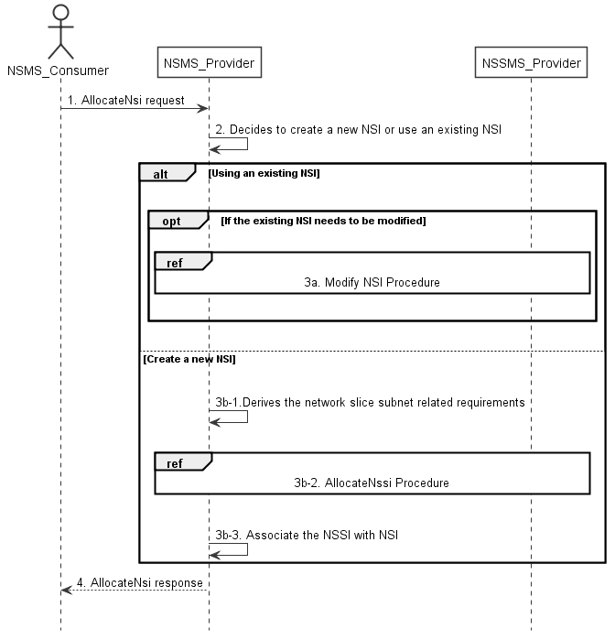

Figure 7.2-1: NSI Allocation Request procedure

1) Network Slice Management Service Provider (NSMS_Provider) receives an AllocateNsi request (see AllocateNsi operation defined in clause 6.5.1) from Network Slice Management Service Consumer (NSMS_Consumer) with network slice related requirements (see ServiceProfile defined in claue 6.3.3 in TS 28.541[6]).

2) Based on the network slice related requirements, the NSMS_Provider decides whether to use an existing NSI or create a new NSI. If the network slice related requirements allow the requested NSI to be shared and if an existing suitable NSI can be reused, the NSMS_Provider may decide to use the existing NSI.

3a) If using an existing NSI and the existing NSI needs to be modified to satisfy the network slice related requirements, the NSMS_Provider invokes the procedure to modify the existing NSI as described in clause 7.6.

3b-1) If creating a new NSI, the NSMS_Provider derives the network slice subnet related requirements from the received network slice related requirements. Before NSMS_Provider derives the network slice subnet related requirements, NSMS_Provider may invoke corresponding network slice subnet capability information querying procedure as descried in clause 7.8.

3b-2) The NSMS_Provider invokes the NSSI allocation procedure as described in clause 7.3.

3b-3) The NSMS_Provider creates the MOI for NSI and configures the MOI with the DN of MOI for the NSSI, other configuration information may be configured for the created MOI.

Note: The detailed configuration information is described in network slice NRM (see NetworkSlice IOC defined in clause 6.3.1 in TS 28.541 [6]).

4) The NSMS_Provider sends NSI allocation result (see AllocateNsi operation defined in clause 6.5.1) to the NSMS_Consumer. If an existing NSI is modified or a new NSI is created successfully to satisfy the network slice related requirements, the result includes the relevant NSI information (see NetworkSlice IOC defined in clause 6.3.1 in TS 28.541 [6]):

- DN of the MOI for NSI.

Otherwise the result may include the reason of failure, for example, the required latency or user number cannot be satisfied, or the physical resource is not enough.

## 7.3 Procedure of NSSIAllocation

The Figure 7.3-1 illustrates the procedure of creating a new NSSI or using an existing NSSI to satisfy the required network slice subnet related requirements.

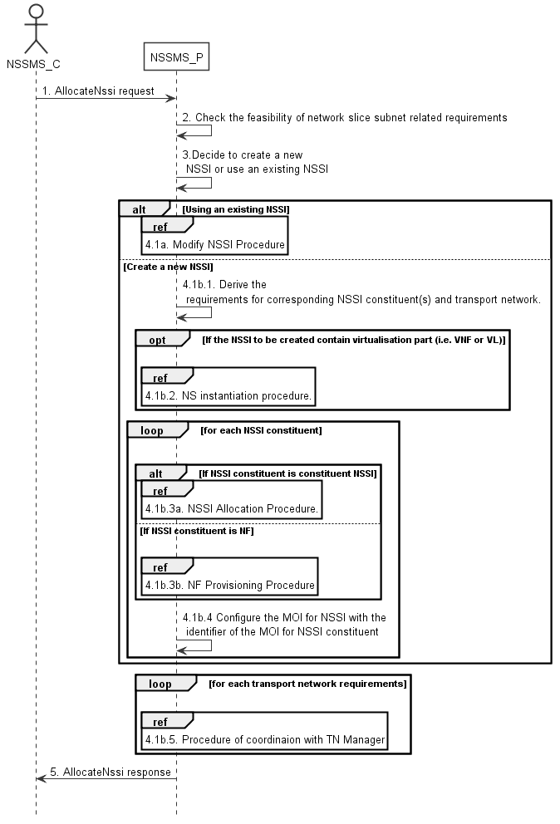

Figure 7.3-1: NSSI Allocation Request procedure

1) Network Slice Subnet Management Service Provider (NSSMS_P) receives an AllocateNssi request (see AllocateNssi operation defined in clause 6.5.2) from Network Slice Subnet Management Service Consumer (NSSMS_C) with network slice subnet related requirements (see SliceProfile defined in claue 6.3.4 in TS 28.541[6]).

2) NSSMS_P check the feasibility of network slice subnet related requirements. If the network slice subnet related requirements can be satisfied, the following step 3) are needed, else go to step 5).

3) Based on the network slice subnet related requirements, NSSMS_P decides whether to use an existing NSSI or create a new NSSI. If the network slice subnet related requirements allow the requested NSSI to be shared and if an existing suitable NSSI can be reused, the NSSMS_P decides to use the existing NSSI.

4.1a) If using an existing NSSI and the existing NSSI needs to be modified to satisfy the network slice subnet related requirements, the NSSMS_P invokes the procedure to modify the existing NSSI as described in clause 7.7.

4.1b.1) If creating a new NSSI, the NSSMS_P creates the MOI for the NSSI to be created. NSSMS_P derives the corresponding network slice subnet constituent (i.e. NF, constituent NSS) related requirements and transport network related requirements (e.g. 3GPP endpoint information, latency requirements, bandwidth requirements, isolation requirements) from the received network slice subnet related requirements. Before NSSMS_Provider derives the constituent network slice subnet related requirements, NSMS_Provider may invoke corresponding network slice subnet capability information querying procedure as described in clause 7.8.2.

4.1b.2) If the NSSI to be created contains virtualisation part (i.e. VNF or VL), NSSMS_P derives the NS instance instantiation information (the NS instance instantiation information is described in clause 7.3.2.2 and clause 7.3.3.2 [3]) based on network slice subnet related requirements. NSSMS_P determines VNF instance(s) that need to be deployed according to the necessary network function(s) and then derives the profile of virtual link(s) according to the connection requirements between the network functions. NSSMS_P chooses a proper NSD deployment flavour and creates data concerning the SAPs of the NS instance. NSSMS_P invokes the NS instantiation procedures to create a NS instance. NSSMS_P configures the NSS MOI with the NS instance identifier.

Note: NS instantiation procedure is described in TS 28.526 [7].

4.1b.3) For each required NSSI constituent, the following step 4.1b.3a) and 4.1b.3b) are needed:

4.1b.3a) If the required NSSI constituent is constituent NSSI, NSSMS_P invokes NSSI Allocation Procedure.

4.1b.3b) If the required NSSI constituent is NF instance, NSSMS_P invokes NF Creation Procedure as described in clause 7.10 or NF Modification Procedure as described in clause 7.11.

4.1b.4) NSSMS_P configures the MOI for NSSI with the DN of the MOI for NSSI constituent (i.e. NF, constituent NSSI).

4.1b.5) For each required transport network related requirements, NSSMS_P invokes corresponding procedure of coordination with relevant TN Manager to handle the TN part as described in clause 7.9.

5) The NSSMS_P sends the NSSI allocation result (see AllocateNssi operation defined in clause 6.5.2) to the NSSMS_C. If the NSSI is created successfully, the result includes the relevant constituent NSSI information (see NetworkSliceSubnet IOC defined in clause 6.3.2 in TS 28.541 [6]):

- DN of the MOI for NSSI.

- NS instance Info (e.g. NSinstanceId)

Otherwise the result may include the reason of failure, for example, the required latency or user Number cannot be satisfied, or the physical resource is not enough.

## 7.4 Procedure of NSI Deallocation

Figure 7.4-1 depicts the procedure of deallocating an NSI by the network slice management service provider to satisfy the NSI deallocation request received from an authorized consumer.

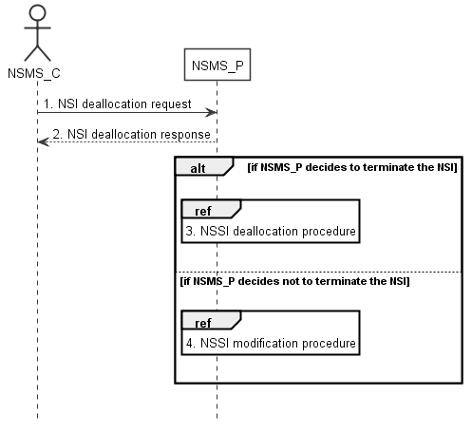

Figure 7.4-1: NSI deallocation procedure

1) The network slice management service provider (NSMS_P) receives a NSI deallocation request (see DeallocateNsi operation defined in clause 6.5.3) from network slice management service consumer (NSMS_C) indicating that the NSI is no longer needed for the consumer.

2) The NSMS_P sends the NSI deallocation response (see DeallocateNsi operation defined in clause 6.5.3) to NSMS_C.

3) The NSMS_P may decide to terminate the NSI, then it invokes the NSSI deallocation procedure as described in clause 7.5.

4) The NSMS_P may decide not to terminate the NSI but to modify the NSI, then it invokes the NSI modification procedure as described in clause 7.6.

## 7.5 Procedure of NSSI deallocation

Figure 7.5-1 depicts the procedure of deallocating an NSSI by the network slice subnet management service provider to satisfy the NSSI deallocation request received from an authorized consumer.

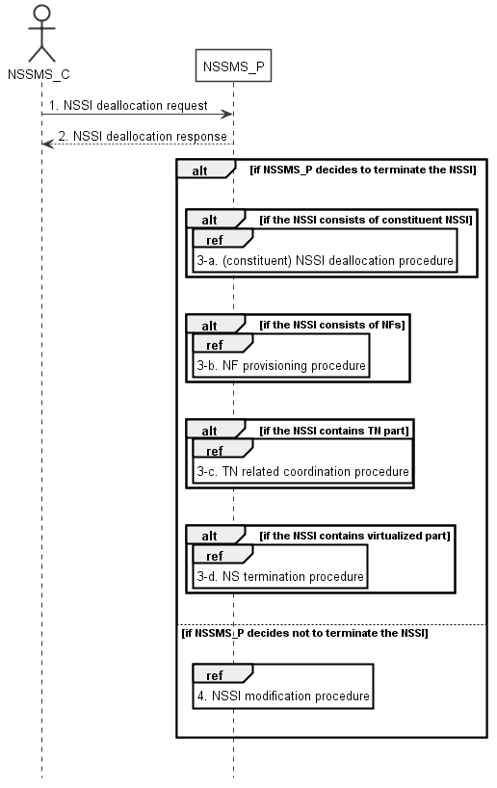

Figure 7.5-1: NSSI deallocation procedure

1) The network slice subnet management service provider (NSSMS_P) receives NSSI deallocation request (see DeallocateNssi operation defined in clause 6.5.4) from network slice subnet management service consumer (NSSMS_C).

2) NSSMS_P sends response (see DeallocateNssi operation defined in clause 6.5.4) of NSSI deallocation service to NSSMS_C.

3-a) NSSMS_P may decide to terminate the NSSI, it invokes (constituent) NSSI deallocation procedure as described in clause 7.5 if the NSSI consists of constituent NSSI.

3-b) NSSMS_P invokes NF deletion procedure as described in clause 7.12 or NF modification procedure as described in clause 7.11 if the NSSI consists of NFs.

3-c) NSSMS_P invokes TN related coordination procedure with responsible manager as described in clause 7.9 if the NSSI consists of TN part.

3-d) NSSMS_P invokes NS termination procedure if the NSSI contains virtualized part.

Note: NS termination procedure is described in TS 28.526 [7].

4) NSSMS_P may decide not to terminate the NSSI, it invokes NSSI modification procedure as described in clause 7.7.

## 7.6 Procedure of NSI Modification

The Figure 7.6-1 illustrates the procedure of modifying an existing NSI.

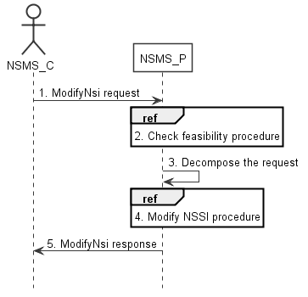

Figure 7.6-1: NSI Modification Request procedure

1) Network Slice Management Service Provider (NSMS_P) receives a ModifyNsi request (see modifyMOIAttributes operation defined in TS 28.532 [8]) from Network Slice Management Service Consumer (NSMS_C) with the management identifier of NSI and the new network slice related requirements (see ServiceProfile defined in clause 6.3.3 in TS 28.541[6]).

2) Based on the new network slice related requirements, NSMS_P invokes the feasibility check procedure. If the modification requirements can be satisfied, go to step 3), else go to step 5).

3) NSMS_P decomposes the NSI modification request into NSSI modification request(s), i.e., generating the new network slice subnet related requirements for each NSSI if needed.

4) NSMS_P, as the role of Network Slice Subnet Management Service Consumer (NSSMS_C), invokes the NSSI modification procedure.

5) NSMS_P sends NSI modification result (see modifyMOIAttributes operation defined in TS 28.532 [8]) to NSMS_C.

## 7.7 Procedure of NSSI Modification

The Figure 7.7-1 illustrates the procedure of modifying an existing NSSI.

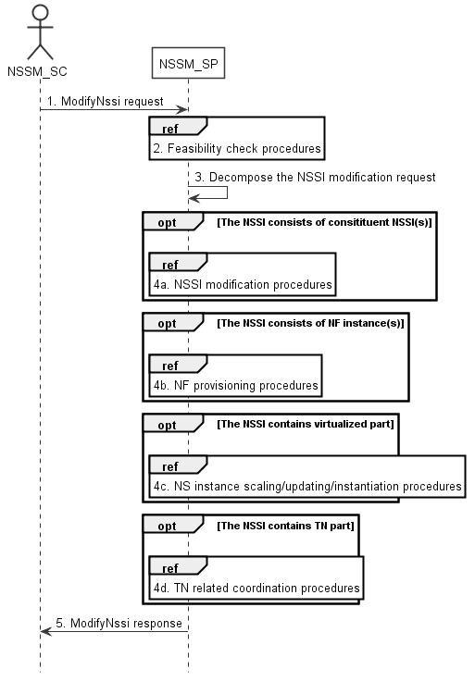

Figure 7.7-1: NSSI Modification Request procedure

1) Network Slice Subnet Management Service Provider (NSSM_SP) receives a ModifyNssi request (see modifyMOIAttributes operation defined in TS 28.532 [8]) from Network Slice Subnet Management Service Consumer (NSSM_SC) with the management identifier of NSSI and the new network slice subnet related requirements (see SliceProfile defined in clause 6.3.3 in TS 28.541[6]).

2) Based on the new network slice subnet related requirements, NSSM_SP invokes the feasibility check procedure. If the modification requirements can be satisfied, go to step 3), else go to step 5).

3) NSSM_SP decomposes the NSSI modification request into modification requests for each NSSI constituent.

4a) If the requested NSSI constituent is constituent NSSI, NSSM_SP invokes NSSI modification procedure as described in clause 7.7.

4b) If the requested NSSI constituent is NF instance, NSSM_SP invokes NF creation procedure as described in clause 7.10 or NF modification procedure as described in clause 7.11.

4c) If the NSSI contains the virtualized part, NSSM_SP invokes the NS instance scaling and/or NS instance updating and/or NS instance instantiation procedure as described in TS 28.526 [7].

4d) If the NSSI contains the TN part, NSSM_SP invokes the TN related coordination procedure as described in clause 7.9.

5) NSSM_SP sends NSSI modification results (see modifyMOIAttributes operation defined in TS 28.532 [8]) to NSSM_SC.

## 7.8 Procedure of Obtaining Network Slice Subnet Capability

### 7.8.1 Introduction

The clause illustrates possible procedures of obtaining network slice subnet capability information (e.g. supported maximum latency, supported capacity (e.g. maximum user number)) of NSSI(s) which can be provided by network slice subnet management service provider.

### 7.8.2 Querying Network Slice Subnet Capability Information

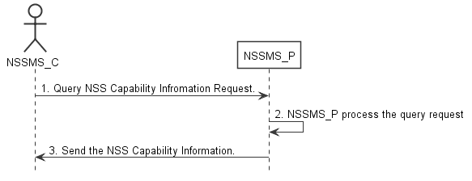

Figure 7.8-2: Procedure of querying network slice subnet capability information

1) Network Slice Subnet Management Service Consumer (NSSMS_C) wants to query the NSS capability information of the NSSI(s) which can be provided by corresponding Network Slice Subnet Management Service Consumer (NSSMS_P), NSSMS_C sends NSS capability querying request (see getMOIAttributes operation defined in TS 28.532 [8]) to NSSMS_P to obtain the NSS capability information of the NSSI(s) which can be provided by corresponding NSSMS_P.

2) NSSMS_P processes the NSS capability information querying request.

3) NSSMS_P sends the NSS capability information (e.g. supported maximum latency, supported capacity (e.g. user number)) of NSSI(s) that can be provided by itself (see getMOIAttributes operation defined in TS 28.532 [8]) to NSSMS_C.

|  |
| --- |
| **7th change** |

## 7.13 Procedure of reservation and checking feasibility of network slice

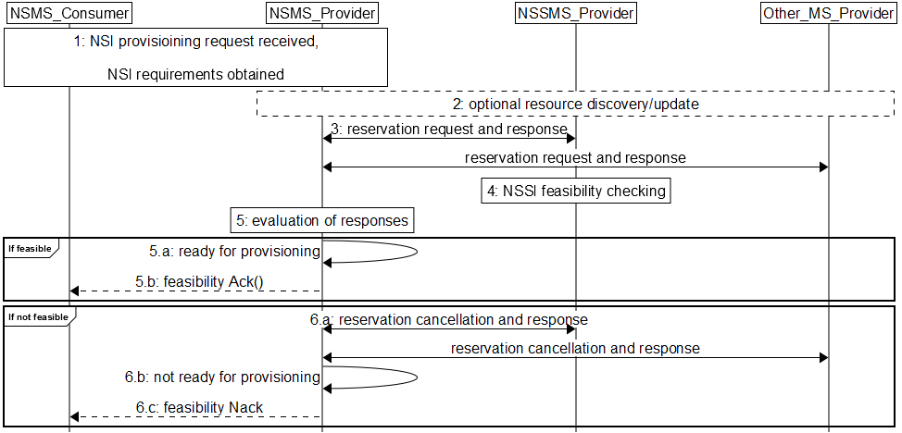

Figure 7.13-1 Network slice feasibility check procedure

1) Network Slice Management Service Provider (NSMS_Provider) receives a provisioning NSI request (e.g., AllocateNsi request (see AllocateNsi operation defined in clause 6.5.1), ModifyNsi request (see modifyMOIAttributes operation defined in TS 28.532 [8])) from Network Slice Management Service Consumer (NSMS_Consumer) with network slice related requirements (e.g. Area information, User Number, traffic demand, QoS Quality, whether the requested network slice could be shared).

2) [Optional] NSMS_Provider may request information and updates from NSSMS_Provider and Other_MS_Provider regarding the resources.

3) NSMS_Provider sends reservation requests to Network Slice Subnet Management Service Provider (NSSMS_Provider) and (if needed) Other Management Service Providers (Other_MS_Provider), e.g., MANO, TN manager. NSMS_Provider receives responses with information regarding allocated resources, e.g., their availability, identification information of reserved resources and so on.

4) A reservation request to NSSMS_Provider can trigger NSSI feasibility checking.

5) NSMS_Provider evaluates the responses to determine if the network slice requirements can be satisfied.

6) If feasible,

6.a) NSMS_Provider is ready for provisioning.

6.b) [Optional] Acknowledgement regarding reservation check results can be sent to NSMS_Customer.

7) If not feasible,

7.a) NSMS_Provider cancels reservations, optionally may receive acknowledgement.

7.b) NSMS_Provider is not ready for provisioning.

7.c) NSMS_Provider may send negative acknowledgement regarding results of reservation check to NSMS_Customer.

## 7.14 Procedure of reservation and checking feasibility of network slice subnet

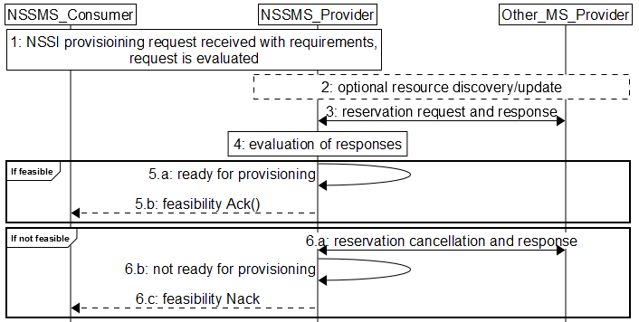

Figure 7.14-2 Network slice subnet feasibility check procedure

1) Network Slice Subnet Management Service Provider (NSSMS_Provider) receives a provisioning NSSI request (e.g., AllocateNssi request (see AllocateNssi operation defined in clause 6.5.2), ModifyNssi request (see modifyMOIAttributes operation defined in TS 28.532 [8])) from Network Slice Subnet Management Service Consumer (NSSMS_Consumer) with network slice subnet related requirements (e.g. Area information, User Number, traffic demand, QoS Quality, whether the requested network slice could be shared). The request is evaluated and initial resources to be allocated are identified.

2) [Optional] NSSMS_Provider may request information and updates from NSSMS_Provider and Other_MS_Provider regarding the resources.

3) NSSMS_Provider sends reservation requests to Other Management Service Providers (Other_MS_Provider), e.g., MANO, TN manager. NSSMS_Provider receives responses with information regarding reserved resources, e.g., their availability, identification information of reserved resources and so on.

4) NSSMS_Provider evaluates the responses to determine if the network slice subnet requirements can be satisfied.

5) If feasible:

5.a) NSSMS_Provider is ready for provisioning.

5.b) [Optional] Acknowledgement regarding reservation check results can be sent to NSSMS_Customer.

6) If not feasible,

6.a) NSSMS_Provider cancels reservations, optionally may receive acknowledgement.

6.b) NSSMS_Provider is not ready for provisioning.

6.c) NSSMS_Provider may send negative acknowledgement regarding results of reservation check to NSSMS_Customer.

## 7.15 Procedure of network slice capacity planning

The Figure 7.15-1 illustrates the procedure of capacity planning of network slices (including both NSIs and NSSIs).

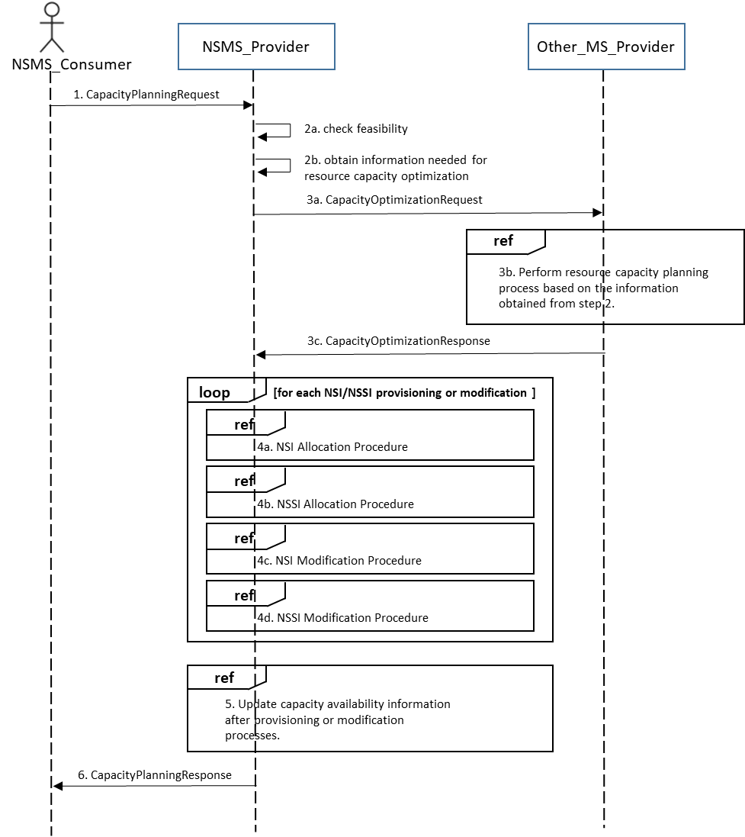

Figure 7.15-1: Network slice resource capacity planning procedure

1) Network Slice Management Service Provider (NSMS_P) receives CapacityPlanningRequest from Network Slice Management Service Consumer (NSMS_C).

2a) NSMS_P checks feasibility.

2b) NSMS_P obtains slice provisioning requirements, existing active or non-active NSI and/or NSSI resource information, and performance measurement data.

3a) NSMS_P requests network resource capacity optimization calculation to the Other_MS_Provider.

3b) Other_MS_Provider performs network resource capacity planning process based on the information obtained from step 2.

Other_MS_Provider can be a capability of NSMS_Provider or external management entities.

3c) Other_MS_Provider replies the result of network resource capacity optimization calculation in the form of the network resource capacity optimization objective. The result includes a set of NSI and/or NSSI provisioning and modification requirements.

4) NSMS_P proceeds with network slice (NSI and/or NSSI) provisioning or modification processes (loop of 4a – 4d) until it meets the network resource capacity optimization objective.

5) NSMS_P updates network capacity availability information after provisioning or modification processes.

6) NSMS_P returns the network resource capacity planning results to NSMS_C.

## 7.16 Procedure of allocating network with or without slicing for communication services

The Figure 7.16-1 illustrates the procedure of allocating network with or without slicing for communication services.

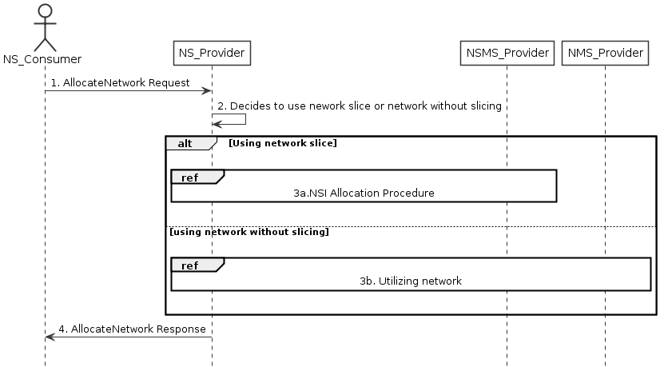

Figure 7.16-1 Allocating network with or without slicing for communication services

1) Network Service Provider (NS_Provider) receives AllocateNetwork request (see AllocateNetwork operation defined in clause 6.5.5) from Network Service Consumer (NS_Consumer). The received request includes network related service requirements (e.g. isolation, latency, coverage).

2) NS_Provider decides to use the network with or without slicing depending on these network related service requirements based on some internal admission control.

3) Based on the decision by NS_Provider:

3a) If NS_Provider decides to use a network with slicing, network slice allocation procedures in clause 7.2 follows. These procedures may result a new network slice to be created, or use an existing network slice with modification.

3b) If NS_Provider decides to use network without slicing, the network without slicing is utilized to satisfy the network related service requirements, there may be modification of the existing network or creation of a new network.

4) NS_Provider sends the AllocateNetwork response (see AllocateNetwork operation defined in clause 6.5.5) to NS_Consumer.

|  |
| --- |
| **8th change** |

### .1.2 Operation AllocateNsi

This operation is to allocate an NSI provided by the service provider, the NSI may be new or existing.

Table 8.1.2-1: Mapping of IS operation input parameters to SS equivalents (HTTP POST)

|  |  |  |  |  |
| --- | --- | --- | --- | --- |
| **IS operation parameter name** | **SS parameter location** | **SS parameter name** | **SS parameter type** | **Qualifier** |
| attributeListIn | request body | attributeListIn | LIST OF SEQUENCE< attribute name, attribute value > | M |

Table 8.1.2-2: Mapping of IS operation output parameters to SS equivalents (HTTP POST)

|  |  |  |  |  |
| --- | --- | --- | --- | --- |
| **IS operation parameter name** | **SS parameter location** | **SS parameter name** | **SS parameter type** | **Qualifier** |
| attributeListOut | response body | attributeListOut | LIST OF SEQUENCE< attribute name, attribute value > | M |
| status | response status codes | n/a | n/a | M |
| nSIId | response body | href | type:string, format: uri | M |

### 8.1.3 Operation AllocateNssi

This operation is to allocate an NSI provided by the service provider, the NSSI may be new or existing.

Table 8.1.3-1: Mapping of IS operation input parameters to SS equivalents (HTTP POST)

|  |  |  |  |  |
| --- | --- | --- | --- | --- |
| **IS operation parameter name** | **SS parameter location** | **SS parameter name** | **SS parameter type** | **Qualifier** |
| attributeListIn | request body | attributeListIn | LIST OF SEQUENCE< attribute name, attribute value > | O |

Table 8.1.3-2: Mapping of IS operation output parameters to SS equivalents (HTTP POST)

|  |  |  |  |  |
| --- | --- | --- | --- | --- |
| **IS operation parameter name** | **SS parameter location** | **SS parameter name** | **SS parameter type** | **Qualifier** |
| attributeListOut | response body | attributeListOut | LIST OF SEQUENCE< attribute name, attribute value > | M |
| status | response status codes | n/a | n/a | M |
| nSSIId | response body | href | type:string, format: uri | M |

### 8.1.4 Operation DeallocateNsi

This operation is to deallocate an NSI provided by the service provider, the NSI may be terminated or modified.

This operation does not support any input parameters.

Table 8.1.4-1: Mapping of IS operation output parameters to SS equivalents (HTTP DELETE)

|  |  |  |  |  |
| --- | --- | --- | --- | --- |
| **IS operation parameter name** | **SS parameter location** | **SS parameter name** | **SS parameter type** | **Qualifier** |
| status | response status codes | n/a | n/a | M |

### 8.1.5 Operation DeallocateNssi

This operation is to deallocate an NSSI provided by the service provider, the NSSI may be terminated or modified.

This operation does not support any input parameters.

Table 8.1.5-1: Mapping of IS operation output parameters to SS equivalents (HTTP DELETE)

|  |  |  |  |  |
| --- | --- | --- | --- | --- |
| **IS operation parameter name** | **SS parameter location** | **SS parameter name** | **SS parameter type** | **Qualifier** |
| status | response status codes | n/a | n/a | M |

|  |
| --- |
| **8th change** |

Annex A (informative):  
A network slice journey example

The Generic Slice Template (GST) ([9]) provides a standardized list of attributes that can be used to characterise different types of network slice. GST is generic and is not tied to any:

- Type of network slice

- Agreement between a Network Slice Customer (NSC) and a Network Slice Provider (NSP).

A Network Slice Type (NEST) is a GST filled with (ranges of) values. There may be two kinds of NESTs:

- Standardized NESTs (S-NEST), i.e. NESTs which character attributes are assigned (ranges of) values by SDOs, working groups, foras, etc. such as e.g. 3GPP, GSMA, 5GAA, 5G-ACIA, etc.;

- Private NESTs (P-NEST), i.e. NESTs which character attributes are assigned (ranges of) values by the Network Slice Providers, which are different from those assigned in S-NESTs.

Network Slice Providers can build their network slice product offering based on S-NESTs and/or their P-NESTs. For example, a Standardized Network Slice Type (S-NEST) NST-A, for which the attribute ‘Packet delay budget’ (see [x] – clause 3.4.26) value range is between 1 ms and 100 ms, is specified by 3GPP. Netwok Slice Provider Y may offer e.g. 3 products based on NST-A:

- Platinum NST-A based network slice product, where the attribute ‘Packet delay budget’ (see [x] – clause 3.4.26) value range is between 1 ms and 10 ms;

- Gold NST-A based network slice product, where the attribute ‘Packet delay budget’ (see [x] – clause 3.4.26) value range is between 11 ms and 50 ms;

- Silver NST-A based network slice product, where the attribute ‘Packet delay budget’ (see [x] – clause 3.4.26) value range is between 51 ms and 100 ms.

NSP Y’s customers can then order NSIsfrom Y’s product catalog, as depicted by Figure A.1.

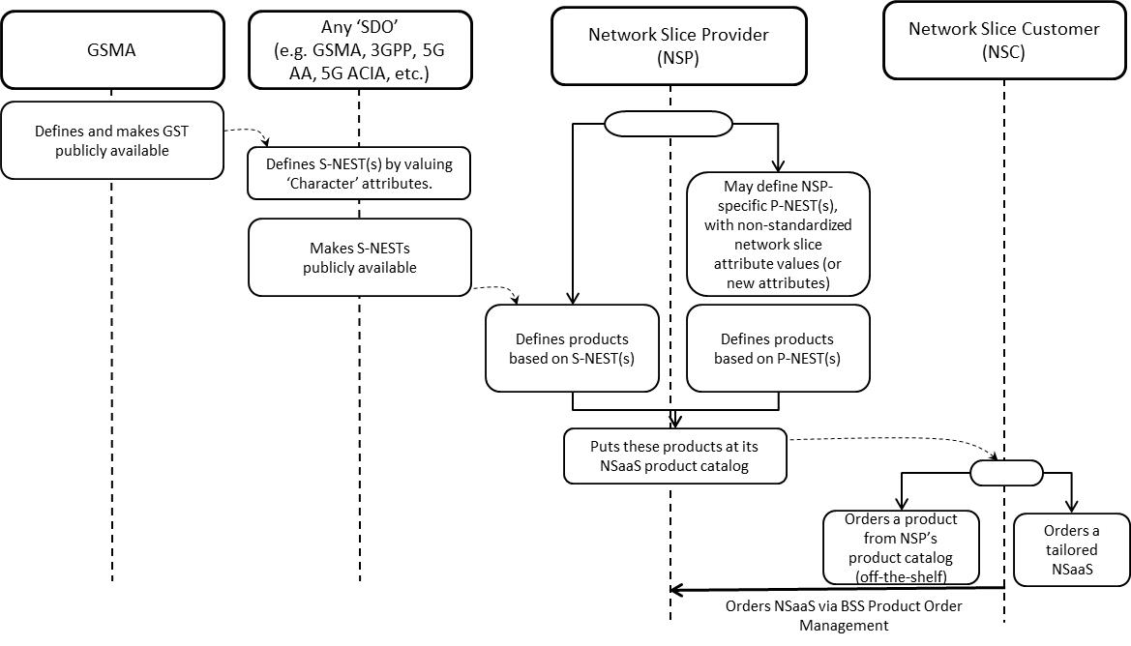

Figure A.1: From GST to S-(/P-)NEST based product ordering

1) A Network Slice Customer orders NSIto a Network Slice Provider, based on NSP’s product offering, by sending a request to NSP’ BSS

2) NSP’s BSS receives the request from NSC and translates NSC requirements into NSP technical parameter values

3) NSP’s BSS sends a request to NSP’s OSS to provide a network slice which fits NSC’s requirements (see Table 6.1-1)

4) NSP’s Network Slice Provisioning MnS either creates a new NSI or assigns an already existing NSI to NSC’s request

5) NSP’s Network Slice Provisioning MnS may have to request the Network Slice Subnet Provisioning MnS to provide a network slice subnet instance corresponding to the NSI (see Table 6.2-1)

6) NSP’s Network Slice Subnet Provisioning MnS may have to create one or more inner network slice subnet instances

7) NSP’s Network Function Provisioning MnS configures VNFs and/or PNFs (see Table 6.3-1).

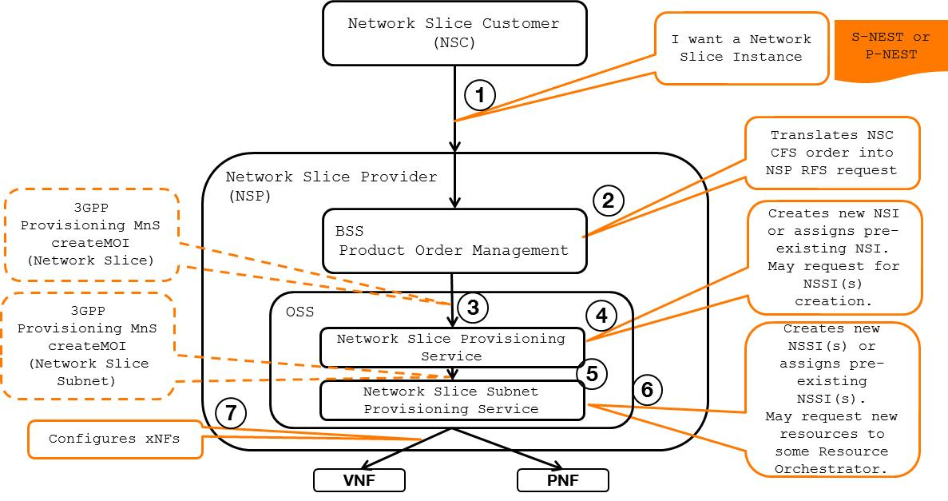

Figure A.2: Network Slice journey (NSaaS model) – high-level call flow

Depending on NSP’s product offering, NSC can order network slices spanning one or more network domains, e.g.:

- NSIcomposed of a RAN-only NSSI

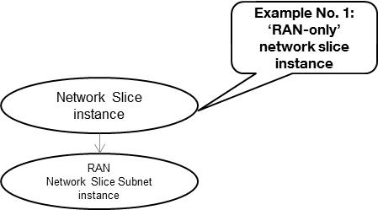

Figure A.3: RAN-only network slice subnet exposed as network slice

- NSIscomposed of a CN-only network slice subnet instance

- NSIcomposed of a RAN network slice subnet instance + Transport network slice subnet + CN NSSI

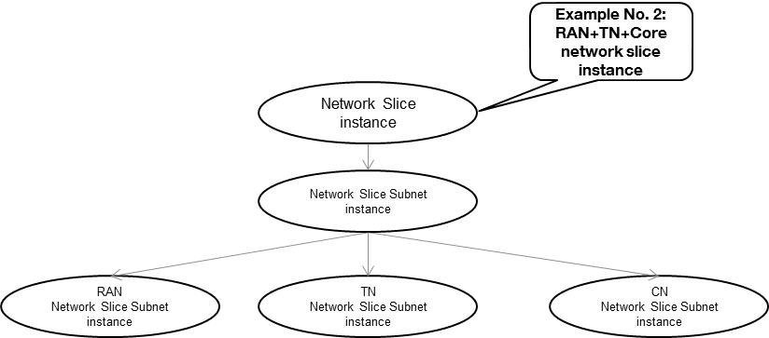

Figure A.4: RAN+TN+CN network slice subnets exposed as network slice

- NSSs composed of a RAN network slice subnet instance + CN NSSI + IMS NSSI

- or more, as shown below..

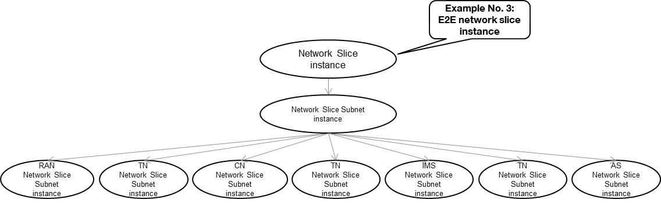

Figure A.5: RAN+TN+CN+TN+IMS+TN+AS network slice subnets exposed as network slice

|  |
| --- |
| **End of changes** |