3GPP TSG-SA5 Meeting #129e S5-201355

e-meeting, 24 February – 4 March 2020
CR-Form-v12.0
CHANGE REQUEST
 | 28.533 | CR | 0062 | rev | - | Current version: | 16.2.0
For HELP on using this form: comprehensive instructions can be found at
http://www.3gpp.org/Change-Requests.

Proposed change affects: | UICC apps |  | ME |  | Radio Access Network | X | Core Network | X

Title: | Add clause to describe control loop interactions
Source to WG: | Ericsson, Huawei
Source to TSG: | S5
Work item code: | COSLA |  |  |  |  |  | Date: |  |  | 14-02-2020
Category: | C |  |  |  |  |  | Release: |  |  | Rel-16
 | Use one of the following categories:  F (correction)  A (mirror corresponding to a change in an earlier release)  B (addition of feature),  C (functional modification of feature)  D (editorial modification)  Detailed explanations of the above categories can  be found in 3GPP TR 21.900. |  |  |  |  |  |  |  | Use one of the following releases:  Rel-8 (Release 8)  Rel-9 (Release 9)  Rel-10 (Release 10)  Rel-11 (Release 11)  Rel-12 (Release 12)  Rel-13 (Release 13)  Rel-14 (Release 14)  Rel-15 (Release 15)  Rel-16 (Release 16)
Reason for change: |  | For the work-item on communication service assurance the concept of control loops is introduced, using management services and functions to describe the interactions. The reader of 28.533 should be aware of this concept and find reference to the new TS’s
Summary of change: |  | - New references added  - New clause added to descrbe control loop enablers  - New clause added to describe interactions and callback between control loops  - Appendix added to give a deployment example
Consequences if not approved: |  | It may not be clear to the developer how the concept of control loops are connected to the overarching concept of management services, leading to misinterpretation and potential for faulty implementations.
Clauses affected: |  | Clause 2, New clause 5.1.X, new Appendix X
 |  | Y | N
Other specs |  |  | X | Other core specifications |  |  |  | TS/TR ... CR ...
affected: |  |  | X | Test specifications |  |  |  | TS/TR ... CR ...
(show related CRs) |  |  | X | O&M Specifications |  |  |  | TS/TR ... CR ...
Other comments:
This CR's revision history:

First change

2 References
The following documents contain provisions which, through reference in this text, constitute provisions of the present document.
- References are either specific (identified by date of publication, edition number, version number, etc.) or non-specific.
- For a specific reference, subsequent revisions do not apply.
- For a non-specific reference, the latest version applies. In the case of a reference to a 3GPP document (including a GSM document), a non-specific reference implicitly refers to the latest version of that document in the same Release as the present document.
[1] 3GPP TR 21.905: "Vocabulary for 3GPP Specifications".
[2] 3GPP TS 32.101: "Telecommunication management; Principles and high level requirements".
[3] 3GPP TS 28.530: "Management and orchestration of networks and network slicing; Concepts, use cases and requirements".
[4] 3GPP TS 28.541: "Management and orchestration of 5G networks; Network Resource Model (NRM); Stage 2 and stage 3".
[5] 3GPP TS 28.552: "Management and orchestration of 5G networks; Performance measurements and assurance data".
[6] 3GPP TS 28.554: "Management and orchestration of 5G networks; 5G End to end Key Performance Indicators (KPI)".
[7] 3GPP TS 32.425: "Telecommunication management; Performance Management (PM); Performance measurements Evolved Universal Terrestrial Radio Access Network (E-UTRAN)".
[8] 3GPP TS 28.531: "Management and orchestration of 5G networks; Provisioning; Stage 1".
[9] 3GPP TS 28.532: "Management and orchestration; Management services".
[10] 3GPP TS 28.500: "Telecommunication management; Management concept, architecture and requirements for mobile networks that include virtualized network functions"
[11] 3GPP TS 28.510; "Telecommunication management; Configuration Management (CM) for mobile networks that include virtualized network functions; Requirements".
[12] 3GPP TS 28.511; "Telecommunication management; Configuration Management (CM) for mobile networks that include virtualized network functions; Procedures".
[13] 3GPP TS 28.512; "Telecommunication management; Configuration Management (CM) for mobile networks that include virtualized network functions; Stage 2".
[14] 3GPP TS 28.513: "Telecommunication management; Configuration Management (CM) for mobile networks that include virtualized network functions; Stage 3".
[15] 3GPP TS 28.515; "Telecommunication management; Fault Management (FM) for mobile networks that include virtualized network functions; Requirements".
[16] 3GPP TS 28.516: "Telecommunication management; Fault Management (FM) for mobile networks that include virtualized network functions; Procedures".
[17] 3GPP TS 28.517: "Telecommunication management; Fault Management (FM) for mobile networks that include virtualized network functions; Stage 2".
[18] 3GPP TS 28.518: "Telecommunication management; Fault Management (FM) for mobile networks that include virtualized network functions; Stage 3".
[19] 3GPP TS 28.520: "Telecommunication management; Performance Management (PM) for mobile networks that include virtualized network functions; Requirements".
[20] 3GPP TS 28.521: "Telecommunication management; Performance Management (PM) for mobile networks that include virtualized network functions; Procedures".
[21] 3GPP TS 28.522: "Telecommunication management; Performance Management (PM) for mobile networks that include virtualized network functions; Stage 2".
[22] 3GPP TS 28.523: "Telecommunication management; Performance Management (PM) for mobile networks that include virtualized network functions; Stage 3".
[23] 3GPP TS 28.525: "Telecommunication management; Life Cycle Management (LCM) for mobile networks that include virtualized network functions; Requirements".
[24] 3GPP TS 28.526: "Telecommunication management; Life Cycle Management (LCM) for mobile networks that include virtualized network functions; Procedures".
[25] 3GPP TS 28.527: "Telecommunication management; Life Cycle Management (LCM) for mobile networks that include virtualized network functions; Stage 2".
[26] 3GPP TS 28.528: "Telecommunication management; Life Cycle Management (LCM) for mobile networks that include virtualized network functions; Stage 3".
[27] ETSI GS NFV 003: "Network Functions Virtualisation (NFV); Terminology for Main Concepts in NFV V1.3.1 (2018-01)".
[28] 3GPP TS 28.545: "Management and orchestration; Fault Supervision (FS)".
[29] ETSI GS ZSM 002: "Zero-touch Network and Service Management (ZSM); Reference Architecture V.1.1 (2019-08)".
[30] 3GPP TS 23.288: "Architecture enhancements for 5G System (5GS) to support network data analytics services".
[x] TS 28.535: "Management and orchestration; Management services for communication service assurance; Requirements"
[y] TS 28.536: "Management and orchestration; Management services for communication service assurance; Stage 2 and stage 3"

Second change

5 Architecture reference model

5.1 General concepts

5.1.1 Management service providers, consumers and exposure
The management services for a mobile network with or without network slicing may be produced by any entity. For example, it can be a Network Functions (NF), or network management functions. The entity may provide (produce) such management services as, for example, the performance management services, configuration management services and fault supervision services.
The management services can be consumed by another entity, which may in turn produce (expose) the service to other entities. Figure 5.1.1-1 shows an example of the management service X which is initially produced by the entity A which is an NF , then consumed by another entity B which is a network management function. Then entity B in turn exposes it to the entity C.
Figure 5.1.1-1. Example of producers and consumers of the management service
Figure 5.1.1-2 shows another example of the management service X which is produced by the entity A which is a NF, then entity B processes the information and produce management service Y and exposes it to the entity C.
Figure 5.1.1-2. Example of producers and consumers of management services

5.1.2 Interactions between management service producer and management service consumer
The interactions between the management service producer and management service consumer follows one of the two following paradigms:
- "Request-response": A management service producer is requested by a management service consumer to invoke an operation, which either performs an action or provides information or both. The management service producer provides response based on the request by management service consumer.
Figure 5.1.1.1: Request-response communication paradigm
- "Subscribe-notify": A management service consumer requests a management service producer to establish a subscription to receive network events via notifications, under the filter constraint specified in this operation.
Subscriptions can be created also by other means than by using such operation.
Figure 5.1.1.2: Subscribe-notify communication paradigm
NOTE: Example of a common aspect applicable to all management services is the use of notifications. For a management service to use notifications the management service consumer needs a subscription to notifications it is interested in. The management service consumer requests the creation of a subscription by sending a subscribe operation to the management service producer. To cancel a subscription the consumer sends an unsubscribe operation to the producer.

5.1.X Interactions to enable closed control loops
A closed control loop identifies the process steps and the entities that are controlled. The process steps are Monitor, Analyze, Decide and Execute as shown in Figure 5.1.X.1. Each process step is implemented by one or multiple management tasks. In the same figure the controlled entity is shown as Managed Entity and the closed control loop is imteracting with human operator or an operations system. The output of a process step provides input for the next process step. Once a closed loop is in operation, which means the closed control loop is set with a goal and triggered by the human operator or an operations system, The closed control loop controls certain aspects of the behaviour of the Managed Entity without manual intervention or intervention from an operations system. The closed control loop may report the progress or result of the closed control loop to the human operator or other operations system during the operation phase. The process steps of the closed control loop can be realized using the concepts of management services and management functions.
- The ‘Monitor’ step is responsible for collecting data from a managed entity.
- The ‘Analyse’ step is responsible for analysing and deriving insights (e.g. root cause or mitigation proposal) from collected available data.
- The ‘Decide’ step is responsible for deriving actions based on analytic result from the analyse step.
- The ‘Execute’ step is responsible for executing actions toward a managed entity.

Analyse
Monitor
Execute
Decide
Managed Entity
Human operator or other operations system

Figure 5.1.X-1: Interactions to ennable closed control loop steps

Third change

Annex X (informative) Example of a control loop pattern
Figure X.1 showns an example of a pattern of management services for control loopa, which applies to managed entities, showing the management data collection service, management data analytics service. decision service and an execute decision service..where

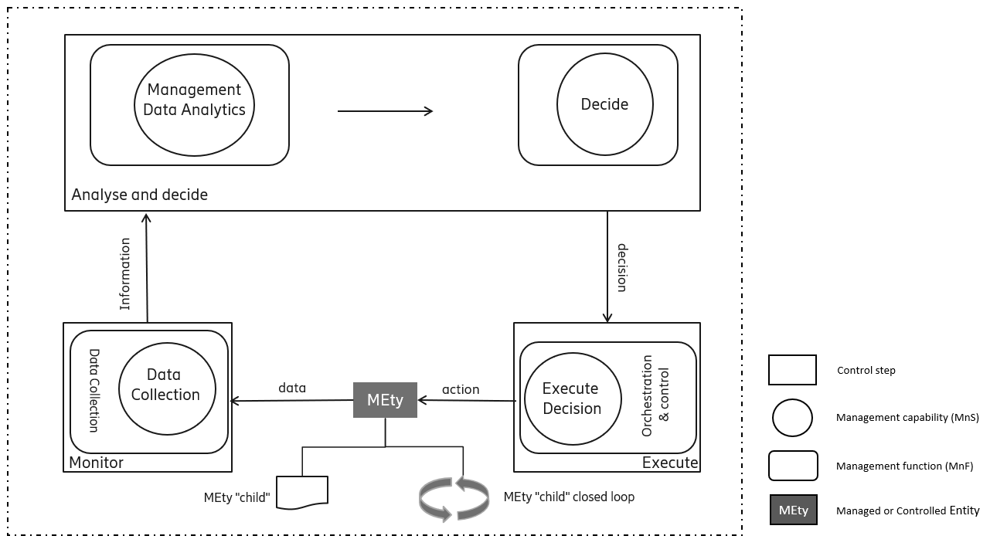
Figure X.1: Pattern for closed control loops
The pattern can be applied to any managed entitiy, details about the application of closed control loop for communication service assurance can be found in TS 28.535 [x] Management and orchestration of communication service assurance requirement [x] and stage 2 and stage 3 in TS 28.536 [y].

End of changes

