3GPP TSG-SA5 Meeting #129e S5-201321

e-meeting, 24 February – 4 March 2020
CR-Form-v11.4
CHANGE REQUEST
 | 28.533 | CR | 0061 | rev | - | Current version: | 16.2.0
For HELP on using this form: comprehensive instructions can be found at
http://www.3gpp.org/Change-Requests.

Proposed change affects: | UICC apps |  | ME |  | Radio Access Network | X | Core Network | X

Title: | Add the description of integration of ONAP VES Collector and 3GPP MnS
Source to WG: | Huawei
Source to TSG: | S5
Work item code: | ONAP3GPP |  |  |  |  |  | Date: |  |  | 2020-02-14
Category: | B |  |  |  |  |  | Release: |  |  | Rel-16
 | Use one of the following categories:  F (correction)  A (mirror corresponding to a change in an earlier release)  B (addition of feature),  C (functional modification of feature)  D (editorial modification)  Detailed explanations of the above categories can  be found in 3GPP TR 21.900. |  |  |  |  |  |  |  | Use one of the following releases:  Rel-8 (Release 8)  Rel-9 (Release 9)  Rel-10 (Release 10)  Rel-11 (Release 11)  Rel-12 (Release 12)  Rel-13 (Release 13)  Rel-14 (Release 14)  Rel-15 (Release 15)  Rel-16 (Release 16)
Reason for change: |  | The detailed description for integration of ONAP VES Collector and 3GPP MnS is endorsed in SA5#129 meeting (S5-197830 Discussion on potential ways for integration of ONAP and 3GPP MnS(s)). However, such information is missing in specification.
Summary of change: |  | Add the description for integration of ONAP VES Collector and 3GPP MnS in Annex.
Consequences if not approved:
Clauses affected: |  | Annex X(new)
 |  | Y | N
Other specs |  |  | X | Other core specifications |  |  |  | TS/TR ... CR ...
affected: |  |  | X | Test specifications |  |  |  | TS/TR ... CR ...
(show related CRs) |  |  | X | O&M Specifications |  |  |  | TS/TR ... CR ...
Other comments:

This CR's revision history:

1st Change

Annex X (informative): Management interactions with ONAP

X.1 Integration of 3GPP MnS(s) and ONAP VES Collector
3GPP management services (e.g. Performance Data File Report MnS, Fault Supervision Data Report MnS) can be consumed by the ONAP VES Collector. Figure X.1-1 illustrates the approach for both a 3GPP consumer and an ONAP VES Collector integrating with a 3GPP MnS producer in a way that preserves the independence of 3GPP-specified MnS(s) and the ONAP-specified VES.
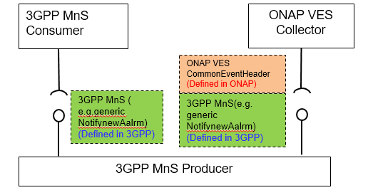
Figure X.1-1 Description for integration of ONAP VES Collector and 3GPP MnS(s)
3GPP specifies a complete MnS solution (illustrated as the green box in the above figure) for the communication between a 3GPP MnS Producer and 3GPP MnS Consumer. On the left side of the above figure is shown the case where a 3GPP MnS Producer communicates directly with a 3GPP MnS Consumer. On the right side is shown the case where the 3GPP MnS Producer communicates with the ONAP VES Collector, and in this case the 3GPP-defined MnS (illustrated as green box) becomes an opaque payload to an ONAP VES-compatible message.

End of Change

