3GPP TSG-SA5 Meeting #129e S5-201256rev1

e-meeting, 24 February – 4 March 2020

Source: Telefónica S.A.

Title: pCR 28.807 Network Slice as a Service in the management of PNI-NPN

Document for: Approval
Agenda Item: 6.6.2

1 Decision/action requested
The group is asked to discuss and agree on the text proposal.

2 References
[1] 3GPP TR 21.905: "Vocabulary for 3GPP Specifications".
[2] 3GPP TS 22.261: "Service requirements for next generation new services and markets; Stage 1".
[3] 3GPP TS 23.501: "System Architecture for the 5G System; Stage 2".
[4] 5G-ACIA White paper, 5G Non-Public Networks for Industrial Scenarios, July 31, 2019.
[5] 3GPP TS 23.003: "Numbering, addressing and identification".
[6] 3GPP TS 28.531: "Management and orchestration; Provisioning".
[7] 3GPP TS 28.530: "Concepts, use cases and requirements".

3 Rationale
It is proposed to include Network Slice as a Service as a service delivery model in the management of public network integrated NPN (PNI-NPN), when this NPN is supported by a PLMN provided network slice instance.

4 Detailed proposal
This document proposes the following changes in TR 28.807.
1st Change

2 References
The following documents contain provisions which, through reference in this text, constitute provisions of the present document.
- References are either specific (identified by date of publication, edition number, version number, etc.) or non-specific.
- For a specific reference, subsequent revisions do not apply.
- For a non-specific reference, the latest version applies. In the case of a reference to a 3GPP document (including a GSM document), a non-specific reference implicitly refers to the latest version of that document in the same Release as the present document.
[1] 3GPP TR 21.905: "Vocabulary for 3GPP Specifications".
[2] 3GPP TS 22.261: "Service requirements for next generation new services and markets; Stage 1".
[3] 3GPP TS 23.501: "System Architecture for the 5G System; Stage 2".
[4] 5G-ACIA White paper, 5G Non-Public Networks for Industrial Scenarios, July 31, 2019.
[5] 3GPP TS 23.003: "Numbering, addressing and identification".
[6] 3GPP TS 28.531: "Management and orchestration; Provisioning".
[7] 3GPP TS 28.530: "Concepts, use cases and requirements".
[X] 3GPP TS 28.541: “Management and Orchestration; 5G Network Resource Model (NRM); Stage 2 and stage 3”.

Next Change

4.3 Management of public network integrated NPN

4.3.1 NPN supported by network slice instance of a PLMN
A public network integrated NPN (PNI-NPN) can be made available by PLMNs, e.g. using one (or more) network slice instance(s). The existing network slicing functionalities apply as described in clause 5.15 of TS 23.501 [3].
From a management viewpoint, the provision of a slice instance can follow the Network Slice as a Service (NSaaS) principles as described in clause 4.1.6 of TS 28.530 [7]. Figure 4.3-1, as an example, illustrates how an MNO can rely on NSaaS capabilities (e.g. OAM, exposure) for the provisioning of a PNI-NPN to an industry vertical. This PNI-NPN, which is deployed across one PLMN and the vertical’s premises (e.g. factory), can be seen as an end-to-end network composed of two differentiated segments: one private, consisting of network functions deployed using private 5G network resources; and one public, consisting of network functions built upon public 5G network resources. Using the NSaaS approach:
- The public segment is made available by the PLMN in the form of a slice, and provisioned by the MNO using NSaaS. In this service provisioning, the MNO and the vertical play the roles of CSP-A and CSC-A, respectively.
- The vertical adds the private segment to the network slice obtained from the MNO. The resulting combination (PNI-NPN) is a new network slice. Following 3GPP Network Resource Model (NRM) [X], the PNI-NPN’s public segment can be modelled as a network slice subnet. In this case, the vertical plays the role of NOP-B.
- The vertical uses the network slice to provide services to his customer(s). In this case, the vertical and his customer(s) play the role of CSP-B and CSC-B, respectively.

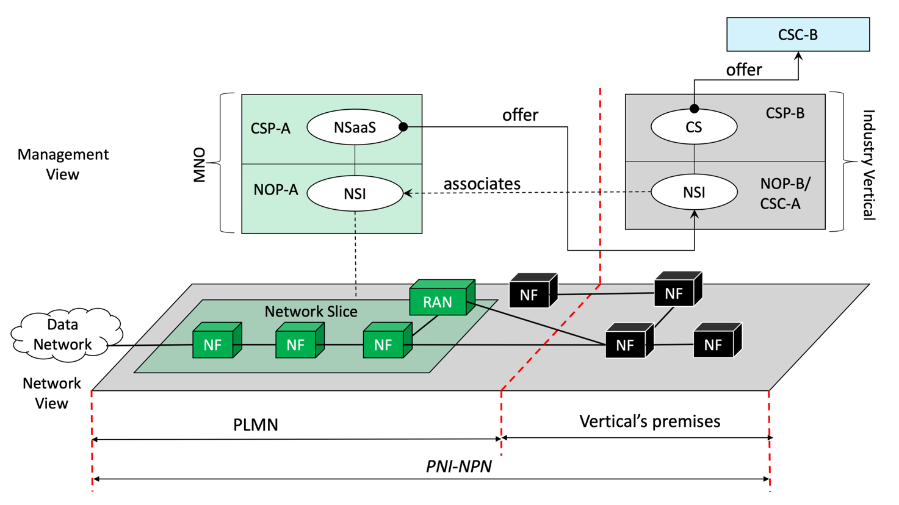

Figure 4.3-1: PNI-NPN provisioning with NSaaS

A Closed Access Group identifies a group of subscribers who are permitted to access one or more CAG cells associated to the CAG. A CAG is identified by a CAG Identifier which is unique within the scope of a PLMN ID, see clause 5.30.3.2 of TS 23.501 [3]. The management system of Public network integrated NPN takes charge of management of CAG Identifiers.
The PLMN operator can offer possibilities (e.g. exposed MnS to manage the network slice instance) for the NPN service provider to manage the NPN network slice instance according to TS 28.531 [6].

End of change

