**3GPP TSG SA WG4#129-e S4-241493**

**Online, 19th - 23rd August 2024**

**Agenda item:** 9.9

**Source:** China Mobile Com. Corporation

**Title:** [FS_Beyond2D] Work Plan V 0.3

**Document for** Agreement

# Introduction

The study item has the following objectives:

1. Identify and document beyond 2D formats, that are market-relevant within next few years, generated from established and emerging capturing systems (including cameras for spatial video capturing), contribution, and usable on display technologies (smartphones, VR HMDs, AR glasses, autostereoscopic and multiscopic displays).

NOTE 1: The work is expected to build upon and extend the findings documented in TR 26.928, TR 26.998 and TS 26.119.

2. Establish and document a set of beyond 2D video end-to-end reference scenarios, including real-time communication, streaming services, split rendering, and messaging and workflows (capturing, encoding, packaging, delivery, decoding, rendering, including general constraints on latency, as well as complexity) to support 3GPP network related delivery and devices leveraging the generation or display technologies. This includes identifying and defining relevant beyond 2D formats in the context of above workflows, and representation technologies to support delivery of these formats within 3GPP networks.

NOTE 2: Alignment with the generalized media delivery architecture defined in TS 26.501/506 is expected, primarily addressing reference points M2 and M4.

3. Prioritize the scenarios and the associated formats based on market relevance for further evaluation.

NOTE 3: The scenario priority will be determined as the first step following the agreement on the specification skeleton and scope.

4. Define concrete evaluation framework per scenario (test conditions, KPIs, Metrics, test sequences, agreed reference signals) based on the above prioritized reference scenarios, and evaluate the feasibility and performance of existing 3GPP codecs as well as potentially new codecs to support the scenarios.

NOTE 4: Reuse existing performance results from MPEG or other standard organizations, fitting in the evaluation framework defined in 3GPP may be considered and is recommended to be done. If there are no suitable existing performance results, communication with MPEG to ask for potential further evaluation on selected topics may be done, but 3GPP may also initiate the evaluation independently of MPEG.

1. Based on the findings in steps 1, 2, and 4 document (i) interoperability requirements, (ii) traffic characteristics and (iii) potential QoS optimizations or requirements, to support the above workflows and evaluate the feasibility of new formats with different services, considering the implementation constraints and performance indicators such as encoding, decoding, and rendering complexity, bandwidth utilization, and interoperability considerations.

NOTE 5: Network service, and end-device implementation constraints and complexity are expected to be considered when evaluating existing video profiles from 3GPP or other standards for their commercial feasibility in supporting beyond 2D video services over 5G/5G-A.

6. Based on the findings in steps 1, 2, 4 and 5, identify potential gaps or deficiencies of existing 3GPP codecs, and offer recommendations to potentially extend 3GPP video specifications and capabilities.

7. Identify potential areas for normative work as the next phase and communicate with other 3GPP WGs regarding relevant aspects related to the study to the extent needed.

2 Time Plan

The following time plan for the execution of the FS_Beyond2D study item objectives is proposed in the following table.

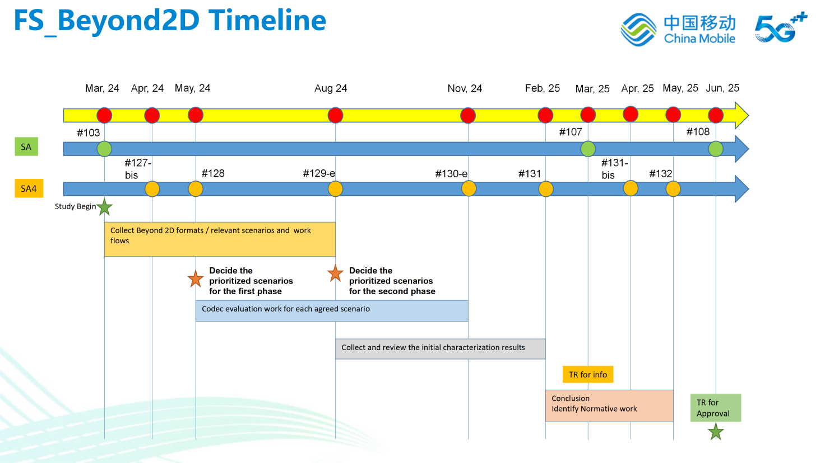

|  |  |  |
| --- | --- | --- |
| Meeting | **Feasibility Study on Beyond 2D Video** | **Completion Status** |
| **SA4#127 (29 January - 2 February 2024, Sophia-Antipolis, FR)** | Endorsed New Study Item on “ Study on Beyond 2D Video” in S4-240504 | - |
| **SA4 AH Telco on Rel-19 (29 February 2024, online)** | Agree New Study Item on “Study on Beyond 2D Video” in S4-240525 | - |
| **SA#103 (19 - 22 March 2024, FR)** | * Approve New Study Item on “Study on Beyond 2D Video” in SP-240479 | - |
| **SA4 Meeting #0-e (AH) Video SWG post 127 S4aV240002**  **(26th March 2024, online)** | * Initiate work on:   + Discuss and review Time Plan   + Discuss and review TR Skeleton   + Discuss and agree Scenario Template (Initial version) | Target 5%Real 2% |
| ~~SA4#127-bis-e (08 - 12 April 2024, online)~~ | Initiate work on:Identify and document beyond 2D formats, that are market-relevant within the next years, generated from established and emerging capturing systems (including cameras for spatial video capturing), contribution, and usable on display technologies (smartphones, VR HMDs, AR glasses, autostereoscopic and multiscopic displays).Establish and document a set of beyond 2D video relevant scenarios, including real-time communication, streaming services, split rendering, and messaging and workflows (capturing, encoding, packaging, delivery, decoding, rendering, including general constraints on latency, as well as complexity) to support 3GPP network related delivery and devices leveraging the generation or display technologies.Discuss the priority of agreed scenarios and associated formats for further evaluation, based on their market relevance.In order to progress the work, the following type of documents are expected to be progressed and agreed in the following priority:Time PlanSkeleton and Scope for TR 26.956Draft Scenarios/workflows and related video formatsOther type of documents are encouraged to be submitted but will be treated in lower priority | Target 10%Real 2% |
| **SA4 Meeting #0-e (AH) Video SWG post 127-bis S4aV240002** **(7th May 2024, online)** | Progress work on:Collecting and documenting Scenarios/workflows, and related B2D video formats.Offline Discussion on the definition of “market-relevance” for FS_Beyond2DDiscuss the priority of agreed scenarios and associated formats for further evaluation, based on their market relevance.Initial work on:Document existing VR Video Capabilities in 3GPPDiscuss the basic Beyond2D framework and evaluation methodologySubmission Deadline: May 6, 18:00 CEST | Target 15%Real 5% |
| SA4#128 (20 - 24 May 2024, Korea) | Progress work on:Collecting and documenting Scenarios/workflows, and related B2D video formats.Discuss the scenarios and associated formats for further evaluation, based on their market relevance.Discuss the indicators and criterias for Market-relevanceDiscuss the general workflow and evaluation frameworkDocumenting existing video capabilities for messagingBased on the agreed process above, agree on the following:General workflows and evaluation framework for beyond 2D video.Key indicators and optional information for pre-evaluating market-relevance.Document the scenarios and associated formats for ,Permanent DocumentFor each agreed scenario for PD:Define test conditions and evaluation framework per scenario.Collect and review initial test material, including test sequences, reference software tools and etc.Define performance metrics for each scenarios, communication with external groups, e.g., 5G-MAG MPEG,, to ask for potential metrics/ materials/ tools may be done.Evaluate the feasibility and performance of existing 3GPP codecs (H.265/HEVC) as well as potentially new codecs to support the scenarios. | Target 25%Real 10% |
| **Post SA4#128 AHG Video SWG Telco (Jun 25, 2024, 15:00 – 17:00 CEST, Host Qualcomm)** | Progress work on:Collecting and documenting Scenarios, and related B2D video formats.Document existing B2D capabilities in 3GPP servicesFor each agreed scenario for PD:Define test conditions and evaluation framework per scenario.Collect and review initial test material, including test sequences, reference software tools and etc.Define performance metrics for each scenarios, communication with external groups, e.g., 5G-MAG, MPEG, to ask for potential metrics/materials/tools may be done.Evaluate the feasibility and performance of existing 3GPP codecs (H.265/HEVC) as well as potentially new codecs to support the scenarios. | Target 30%Real 12% |
| **Post SA4#128 AHG Video SWG Telco (Jul 9, 2024, 15:00 – 17:00 CEST, Host Qualcomm)** | * Progress work on:   + Collecting and documenting Scenarios, and related B2D video formats.   + Continue working on documented scenarios, e.g., define test condition, collect test materials, define anchors, performance metrics etc. * Initiate work on:   + Decide prioritized scenarios based on market-relevance for evaluating   + Evaluate the feasibility of existing 3GPP codecs and potential new codecs to support the agreed scenarios. * Document the agreements into the draft TRs | Target 30%Real 12% |
| **Post SA4#128 AHG Video SWG Telco (Jul 23, 2024, 15:00 – 17:00 CEST, Host Qualcomm)** | * Progress work on:   + Collecting and documenting Scenarios, and related B2D video formats.   + Continue working on documented scenarios, e.g., define test condition, collect test materials, define anchors, performance metrics etc. * Initiate work on:   + Decide prioritized scenarios based on market-relevance for evaluating   + Evaluate the feasibility of existing 3GPP codecs and potential new codecs to support the agreed scenarios. * Document the agreements into the draft TRs | Target 30%Real 12% |
| SA4#129-e (19 - 23 August 2024, online) | Complete work on:Collecting and documenting Scenarios/workflows, and related B2D video formats.**Decide** the prioritized scenarios and associated formats for evaluation, based on their market relevance.Progress work on:For each agreed scenario:Define test conditions and evaluation framework per scenario.Collect and review test material, including test sequences, reference software tools and etc.Define performance metrics for each scenarios, communication with external groups, e.g., MPEG, to ask for potential metrics may be done.Evaluate the feasibility and performance of existing 3GPP codecs (H.265/HEVC) as well as potentially new codecs to support the scenarios.Initiate work on:Collect and review the initial characterization and evaluation results on the existing 3GPP codecs H.265/HEVC as well as potentially new codecs, and identify any open issues.Document interoperability requirements, traffic charactertistics and potential QoS optimization or requirements to support the above work flows.Evaluate the feasibility of new formats with different services, considering the implementation constraints and performance indicators such as encoding, decoding, and rendering complexity, bandwidth utilization, and interoperability considerations. | Target 40%Real % |
| Post SA4#129-e Video AHG telco (Oct 8, 2024, 15:00 – 17:00 CEST, Host: Qualcomm) | Progress work on:Defining representation formatFinalize the scenariosDiscuss scenarios and associated formats for evaluationSubmission deadline:15:00 CEST - October 7, 2024 | Target 60%Real % |
| Post SA4#129-e Video AHG telco (Oct 29, 2024, 15:00 – 17:00 CEST, Host: Qualcomm) | Progress work on:Defining representation formatFinalize the scenariosDiscuss scenarios and associated formats for evaluationSubmission deadline:15:00 CEST - October 28, 2024 | Target 60%Real % |
| SA4#130 (18 - 22 November 2024, Orlando) | Complete work on:For each agreed scenario:Define test conditions and evaluation framework per scenario.Collect and review test material, including test sequences, reference software tools and etc.Define performance metrics for each scenarios, communication with external groups, e.g., MPEG, to ask for potential metrics may be done.Evaluate the feasibility and performance of existing 3GPP codecs (H.265/HEVC) as well as potentially new codecs to support the scenarios.Progress work on:Collect and review the initial characterization results on the existing 3GPP codecs H.265/HEVC as well as potentially new codecs, and identify any open issues.Document interoperability requirements, traffic charactertistics and potential QoS optimization or requirements to support the above work flows.Evaluate the feasibility of new formats with different services, considering the implementation constraints and performance indicators such as encoding, decoding, and rendering complexity, bandwidth utilization, and interoperability considerations. | Target 75%Real % |
| SA4#131 (17 - 21 February 2025, Geneva) | Complete work on:Collect and review the initial characterization results on the existing 3GPP codecs H.265/HEVC as well as potentially new codecs, and identify any open issues.Document interoperability requirements, traffic charactertistics and potential QoS optimization or requirements to support the above work flows.Evaluate the feasibility of new formats with different services, considering the implementation constraints and performance indicators such as encoding, decoding, and rendering complexity, bandwidth utilization, and interoperability considerations.  * Identify gaps and deficiencies of existing 3GPP codecs, offering recommendations to enhance video specification and capabilities. * Initiate work on potential related normative work and conclusions. * Communicate with other 3GPP working groups and external organizations, if necessary. * Agree on TR 26.956 to be sent to SA plenary for information | Target 85%Real % |
| SA#107 (11 - 14 **March 2025**, **Korea**) | Present TR 26.956 to SA for information | Target 90%Real % |
| SA4#131-bis (7 - 11 April 2025, Online) | * Identify gaps and deficiencies of existing 3GPP codecs, offering recommendations to enhance video specification and capabilities. * Identify potential related normative work and conclusions. * Identify any remaining open issues.  Communicate with other 3GPP working groups and external organizations, if necessary. | Target 95%Real % |
| SA4#132 (19 - 23 May 2025, Japan) | * Complete work on identify potential related normative work and conclusions. * Complete all remaining open issues.  Agree on TR 26.956 to be sent to SA plenary for approval | Target 100%Real % |
| SA#108 (10 - 13 June 2025, China) | Send TR 26.956 to SA for Approval | - |

# Proposal

We propose the above Work Plan for the SA4 team's consideration.