**3GPP TSG SA WG4 Meeting #129-eS4-241449**

**Online August 19 2024- August 23 2024**

|  |  |  |  |  |  |  |  |  |
| --- | --- | --- | --- | --- | --- | --- | --- | --- |
| *CR-Form-v12.3* | | | | | | | | |
| **Pseudo CHANGE REQUEST** | | | | | | | | |
|  | | | | | | | | |
|  | **TR 26.822** | **CR** | **-** | **rev** | **-** | **Current version:** | **0.1.1** |  |
|  | | | | | | | | |
| *For* [***HE******LP***](http://www.3gpp.org/3G_Specs/CRs.htm#_blank)*on using this form: comprehensive instructions can be found at* [*http://www.3gpp.org/Change-Requests*](http://www.3gpp.org/Change-Requests)*.* | | | | | | | | |
|  | | | | | | | | |

|  |  |  |  |  |  |  |  |  |
| --- | --- | --- | --- | --- | --- | --- | --- | --- |
| ***Proposed change affects:*** | UICC apps |  | ME |  | Radio Access Network |  | Core Network |  |

|  |  |  |  |  |  |  |  |  |  |  |
| --- | --- | --- | --- | --- | --- | --- | --- | --- | --- | --- |
|  | | | | | | | | | | |
| ***Title:*** | [FS_5G_RTP] Key Issue #15 Description text update | | | | | | | | | |
|  |  | | | | | | | | | |
| ***Source to WG:*** | Huawei, Hisilicon | | | | | | | | | |
| ***Source to TSG:*** | SA WG4 | | | | | | | | | |
|  |  | | | | | | | | | |
| ***Work item code:*** | FS_5G_RTP_Ph2 | | | | |  | ***Date:*** | | | 7-8-2024 |
|  |  | | | |  | |  | | |  |
| ***Category:*** | **D** |  | | | | | ***Release:*** | | | 19 |
|  | *Use one of the following categories:* ***F*** *(correction)* ***A*** *(mirror corresponding to a change in an earlier release)* ***B*** *(addition of feature),* ***C*** *(functional modification of feature)* ***D*** *(editorial modification)*  Detailed explanations of the above categories can be found in 3GPP [TR 21.900](http://www.3gpp.org/ftp/Specs/html-info/21900.htm). | | | | | | | | *Use one of the following releases: Rel-8 (Release 8) Rel-9 (Release 9) Rel-10 (Release 10) Rel-11 (Release 11) … Rel-17 (Release 17) Rel-18 (Release 18) Rel-19 (Release 19)  Rel-20 (Release 20)* | |
|  |  | | | | | | | | | |
| ***Reason for change:*** | | Current KI #15 description is not clear and has some minor errors | | | | | | | | |
|  | |  | | | | | | | | |
| ***Summary of change:*** | | Update the text to clarify KI #15 | | | | | | | | |
|  | |  | | | | | | | | |
| ***Consequences if not approved:*** | | Unclear key issue description errors | | | | | | | | |
|  | |  | | | | | | | | |
| ***Clauses affected:*** | | 5.15 | | | | | | | | |
|  | |  | | | | | | | | |
|  | | **Y** | **N** |  | | | |  | | |
| ***Other specs*** | |  | **x** | Other core specifications | | | | TS/TR ... CR ... | | |
| ***affected:*** | |  | **x** | Test specifications | | | | TS/TR ... CR ... | | |
| ***(show related CRs)*** | |  | **x** | O&M Specifications | | | | TS/TR ... CR ... | | |
|  | |  | | | | | | | | |
| ***Other comments:*** | | The usage of data channel in 5G RTP may need some discussion if it is in scope or not | | | | | | | | |
|  | |  | | | | | | | | |
| ***This CR's revision history:*** | |  | | | | | | | | |

|  |
| --- |
| CHANGE 1 |

## 5.15 Key Issue #15: Media and metadata delivery over multiple sessions

### 5.15.1 Description

In XR communication, certain media and metadata types, e.g., avatar and associated animation data, can be transmitted over a WebRTC or IMS data channel.

At the same time, it may still be possible to have a UE-to-UE voice call, e.g., an MTSI call, as the required latency for voice may be lower.

SDP procedures take care of grouping appropriate media flows for synchronization and other functionalities within the same RTP session. However, the synchronization between and RTP-based and a non RTP-based media/metadata delivery requires further investigation. It needs to be studied how this can be achieved effectively. In addition, the case when media streams and metadata are delivered over different RTP sessions needs study.

Another use case where associated media may be sent over different RTP sessions are teleconferencing applications. The voice in this case maybe over a direct UE-to-UE communication (MTSI call), while other media (e.g., presentations, video) are delivered via a network media function. A high-level illustration is shown in Figure 5.15.1-1 below. Here the voice is delivered UE-to-UE, and the associated RTP session is shown as Session 3. The video from UE A to UE B is delivered via a network media function over two RTP sessions, Session 1 and Session 2. Depending on the use case and application requirements, the network media function may apply operations such as upscaling, merging video streams, or animation in case of avatar data.

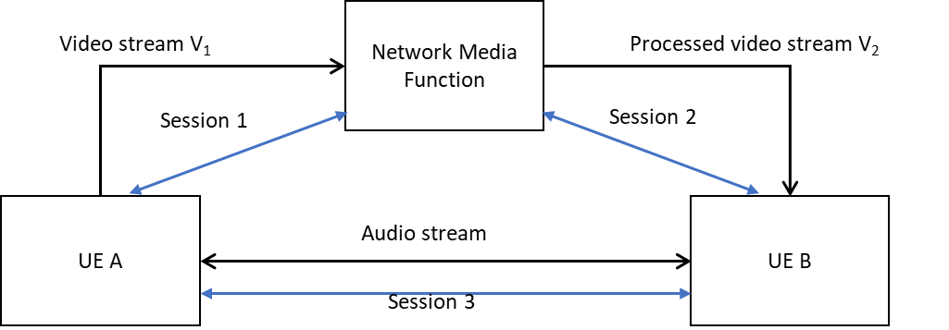

Figure 5.15.1-1: An example scenario with multiple media sessions.

In this key issue, it is proposed to study:

- Whether it is feasible (in terms of typical RTC use cases) to have media/metadata components that are sent over different paths, e.g., a UE-to-UE voice channel and a UE-MF-UE or AS/MF-to-UE channel for avatar data (sans audio).

- identify synchronization issues, if any

- identify session establishment issues, if any

- How to achieve cross-session referencing for XR media and metadata that are sent over different RTP sessions and data channels that don’t have common endpoints.

- e.g. SDP signalling description examples