3GPP TSG-S4 Meeting #129 S4-241685

Electronic Meeting, 19th August –23rd August 2024 revision of S4-241606
CR-Form-v12.0
CHANGE REQUEST
 | 26.510 | CR | 0007 | rev | 1 | Current version: | 18.0.2
For HELP on using this form: comprehensive instructions can be found at
http://www.3gpp.org/Change-Requests.

Proposed change affects: | UICC apps |  | ME | X | Radio Access Network |  | Core Network | X

Title: | [iRTCW] Metrics reporting configuration alignment with RTC
Source to WG: | InterDigital Communications, BBC
Source to TSG: | S4
Work item code: | iRTCW |  |  |  |  |  | Date: |  |  | 2024-06-19
Category: | F |  |  |  |  |  | Release: |  |  | Rel-18
 | Use one of the following categories:  F (correction)  A (mirror corresponding to a change in an earlier release)  B (addition of feature),  C (functional modification of feature)  D (editorial modification)  Detailed explanations of the above categories can  be found in 3GPP TR 21.900. |  |  |  |  |  |  |  | Use one of the following releases:  Rel-8 (Release 8)  Rel-9 (Release 9)  Rel-10 (Release 10)  Rel-11 (Release 11)  …  Rel-15 (Release 15)  Rel-16 (Release 16)  Rel-17 (Release 17)  Rel-18 (Release 18)
Reason for change: |  | TS 26.113 specifies the reporting of jitter duration and sync loss duration metrics by a Media Session Handler, triggered when these metrics pass configurable thresholds during an RTC session.  TS 26.510 specifies a client metrics reporting configuration as part of the metrics reporting provisioning API in the Maf_Provisioning service, later exposed to the Media Session Handler in Service Access Information using the Maf_SessionHandling service.  However, the client metrics reporting configuration is not aligned properly to provide threshold values information required to trigger reporting of these RTC QoE metrics in RTC Client.  Nor does the metrics reporting configuration allow geographic location filtering of metrics collection.
Summary of change: |  | Provided the threshold filter and geographic location filter information as part of the clientMetricsReporting‌Configurations object in:  - MetricsReportingConfiguration resource of provisioning service.  - ServiceAccessInformation resource of session handling service.
Consequences if not approved: |  | Misalignment in Rel-18 because TS 26.510 metrics collection and reporting feature does not support the needs of TS 26.113.
Q
Clauses affected: |  | 5.2.11.1, 5.3.5.1, 8.11.3.1 and 9.2.3.1
 |  | Y | N
Other specs |  |  | X | Other core specifications
affected: |  |  | X | Test specifications
(show related CRs) |  |  | X | O&M Specifications
Other comments:
This CR's revision history:

Code changes
The code changes associated with this Change Request are available for review at the following URL on 3GPP Forge:
https://forge.3gpp.org/rep/sa4/5gms_pro_ph2/-/merge_requests/23/diffs
The proposed changes are reproduced below for posterity.
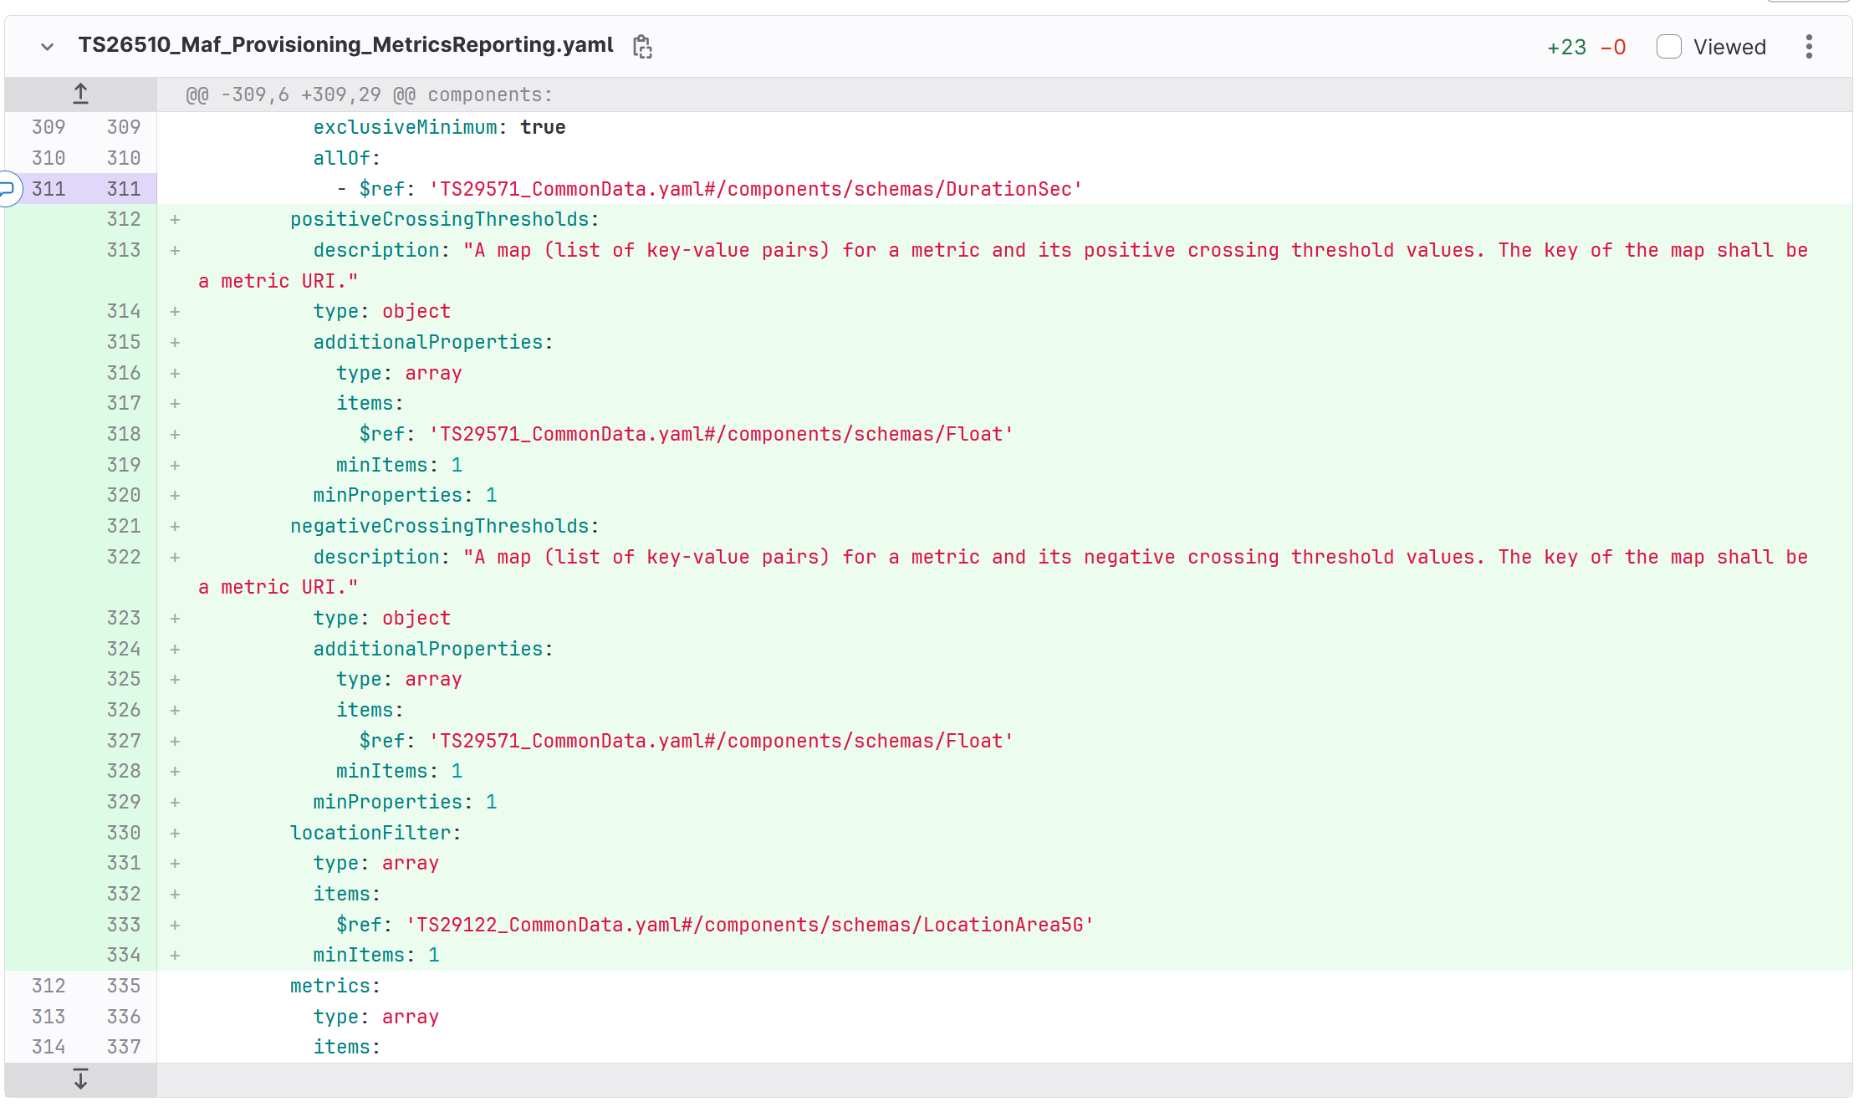
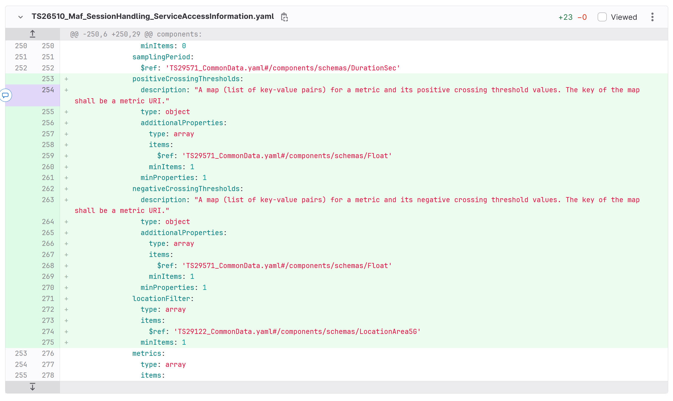

First change

5.2.11.1 General
These operations are used by the Media Application Provider at reference point M1 to provision QoE metrics reporting functionality associated with downlink or uplink media delivery. The Media Application Provider may provision several Metrics Reporting Configurations within the scope of a Provisioning Session with different properties which determine whether and how often the Media Session Handler submits QoE metrics reports to the Media AF as well as the format and contents of these reports. To this end, each Metrics Reporting Configuration shall specify a metrics scheme, which may be specified by 3GPP or by another party. The chosen metrics scheme URI is indicated in the scheme property of the Metrics Reporting Configuration. This clause defines the basic operations; more details are provided in clause 8.11.
A given Metrics Reporting Configuration is uniquely identified within the scope of its parent Provisioning Session by the metricsReportingConfigurationId property of the corresponding Metrics Reporting Configuration resource, as specified in clause 8.11.3.1.
Where metrics reporting is not required for the entire duration of a media delivery session, reportingStartOffset and/or reportingDuration parameters may additionally be specified for a Metrics Reporting Configuration indicating the portion of each media delivery session for which metrics reports are to be submitted by the Media Session Handler.
Where the reporting of a particular metric is required based on its value crossing specific thresholds:
- The positive‌Crossing‌Thresholds property may additionally be specified in a Metrics Reporting Configuration for one or more of the metrics present in the metrics property. When present, the Media Session Handler shall report a metric once when its value exceeds one of the threshold values indicated in the positive‌Crossing‌Thresholds property and shall not be reported again until it falls below that threshold and subsequently exceeds it.
- The negative‌CrossingThresholds property may additionally be specified in a Metrics Reporting Configuration for one or more of the metrics present in the metrics property. When present, the Media Session Handler shall report a metric once when its value falls below one of the threshold values indicated in the negative‌Crossing‌Thresholds property and shall not be reported again until it exceeds that threshold and subsequently exceeds it.
Where metrics are required to be collected only in certain geographic locations, the location‌Filter property may additionally be specified in a Metrics Reporting Configuration. When present, the Media Session Handler shall collect the metrics described by the metrics reporting configuration only when a device is located in one or more geographic locations specified in the location‌Filter property and shall report the collected metrics. When not present, the Media Session Handler shall collect and report the metrics regardless of the device’s geographic location.
HTTP responses for successful and operation-specific failure cases are specified in the following clauses. For all other failure cases, an HTTP response indicating a response code in accordance with clause 7.1.6 shall be returned to the API client. In all failure cases a message body in accordance with clause 7.1.7 shall be included in the response message.
Next change

5.3.5.1 Procedures
These procedures are used by the Media AS at reference point M3 or else by the Metrics Reporting functions of the Media Client and subsequently by the Media Session Handler at reference point M5 to submit a metrics report to one of the Media AF instances listed in the client metrics reporting configuration of the Service Access Information resource previously retrieved using the procedure in clause 5.3.2.3.
When the metrics collection and reporting feature is provisioned for a media delivery session using the operations specified in clause 5.2.11, one or more client metrics reporting configurations, each associated with a provisioned Metrics Reporting Configuration, shall be provided to the Media Session Handler in the Service Access Information. A given client metrics reporting configuration contains information including:
1. The subset of metrics from the provisioned metrics scheme to be collected and reported by the Media Client;
2. The frequency at which these metrics are to be sampled by the Media Client;
2a. Thresholds for certain metrics, the crossing of which drives their reporting by the Media Client;
2b. The Media Client locations where metrics collection is requested;
3. The proportion of media delivery sessions for which metrics reports are to be sent by the Media Session Handler;
4. The portion of the media session (represented by start offset and/or duration parameters) for which metrics reports are to be sent by the Media Session Handler if reporting is enabled for that media delivery session;
5. The interval at which metrics reports are to be sent by the Media Session Handler if reporting is enabled for a media delivery session; and
6. The Media AF address(es) to which metrics reports are to be sent.
Before a media delivery session is started, the Media Session Handler shall check if the Service Access Information includes any Metrics Reporting Configurations. If any such configurations are present, the Media Session Handler shall initiate the metrics reporting procedure for the media delivery session based on these configurations. During the media delivery session, the Media Session Handler shall periodically check if the Metrics Reporting Configurations are added to or removed from the Service Access Information and shall activate or deactivate the metrics reporting procedure as appropriate for the media delivery session in question. The Service Access Information indicating whether Metrics Reporting is provisioned for media delivery sessions is specified in clause 9.2.3.
Whenever a metrics report is produced for a given client metrics reporting configuration, the Media Session Handler shall reset its reporting interval timer for that configuration to the value of the clientMetrics‌Reporting‌Configurations[].‌reportingInterval property and it shall begin countdown of the timer again. Whenever the Media Session Handler terminates a media delivery session, it shall disable its reporting interval timer for all client metrics reporting configurations.
Details of the APIs supporting these procedures at reference points M3 and M5 are specified in clause 9.5.
HTTP responses for successful and operation-specific failure cases are specified in the following clauses. For all other failure cases, an HTTP response indicating a response code in accordance with clause 7.1.6 shall be returned to the API client. In all failure cases a message body in accordance with clause 7.1.7 shall be included in the response message.

Next change

8.11 Metrics Reporting provisioning API

8.11.3 Data model

8.11.3.1 MetricsReportingConfiguration resource
Table 8.11.3-1: Definition of MetricsReportingConfiguration resource
Property name | Type | Cardinality | Description
metricsReportingConfigurationId | ResourceId | 1..1 | An identifier for this Metrics Reporting Configuration assigned by the Media AF when the resource is created that is unique within the scope of the enclosing Provisioning Session.
sliceScope | array(Snssai) | 0..1 | The set of network slice(s) for which metrics collection and reporting shall be executed in connection with this metrics reporting configuration (see NOTE 1).  If present, the array shall identify at least one network slice.  If absent, metrics shall be collected and reported for media delivery sessions within the scope of the parent Provisioning Session regardless of network slice.
scheme | Uri | 0..1 | The QoE metrics scheme associated with this Metrics Reporting Configuration which indicates the required format of metrics reports.  The set of QoE metrics schemes valid for use in 5G Media Streaming along with their respective scheme identifiers is specified in clauses 4.7.5 and 7.8.1 of TS 26.512 [6].  The QoE metrics scheme valid for use in RTC along with its respective scheme identifier is specified in clause 15 of TS 26.113 [7].  Omitting this property signals to the Media AF that metrics reporting is currently disabled for the Provisioning Session in question.
dataNetworkName | Dnn | 0..1 | Identifies the Data Network which shall be used when sending metrics reports.  If not specified, the default Data Network shall be used.
reportingStartOffset | DurationSec | 0..1 | The time offset (expressed in seconds) from the start of a media delivery session when the Media Client is required to begin submitting metrics reports. The value shall not be negative.  If omitted, the value of this parameter is assumed to be zero, i.e., directing the Media Client to start reporting metrics from the start of the media delivery session.
reportingDuration | DurationSec | 0..1 | The period of time (expressed in seconds) measured relative to the reporting start point, after which the Media Client is required to stop reporting metrics. The value shall not be negative.  If set to zero, a single report shall be sent at reportingStartOffset.  If omitted, reporting is required to continue until the end of the media delivery session.
reportingInterval | DurationSec | 0..1 | The time interval between successive metrics reports to be sent by the Media Session Handler. The value shall be greater than zero.  If not specified, a single final report shall be sent after the media delivery session has ended.
samplePercentage | Percentage | 0..1 | The proportion of media delivery sessions for which QoE metrics shall be reported, expressed as a floating-point value between 0.0 and 100.0.  If not specified, reports shall be sent for all media delivery sessions.
urlFilters | array(string) | 0..1 | If present, a non-empty list of Media Entry Point URL patterns for which QoE metrics shall be reported.  If not specified, reporting shall be done for all media delivery sessions initiated within the scope of the parent Provisioning Session.
samplingPeriod | DurationSec | 1..1 | The time interval the Media Client should wait between sampling the QoE metrics specified by this Metrics Reporting Configuration. The value shall be greater than zero.
positive‌Crossing‌Thresholds | map(Uri -> array(Float)) | 0..1 | If present, a non-empty map of QoE metrics to their respective threshold values.  - The index of the associative array shall be the fully-qualified term identifier URI of a metric specified in annex E of TS 26.512 [6] or annex C of TS 26.113 [7].  - The value of each associative array member shall be an array of floating-point threshold values.  A metric in this associative array shall be reported once when its value exceeds one of the associated threshold values, and shall not be reported again until it falls below that threshold and subsequently exceeds it.
negative‌Crossing‌Thresholds | map(Uri -> array(Float)) | 0..1 | If present, a non-empty map of QoE metrics and their respective threshold values.  - The index of the associative array shall be the fully-qualified term identifier URI of a metric specified in annex E of TS 26.512 [6] or annex C of TS 26.113 [7].  - The value of each associative array member shall be an array of floating-point threshold values.  A metric in this associative array shall be reported once when its value falls below one of the associated threshold values, and shall not be reported again until it exceeds that threshold and subsequently falls below it.
location‌Filter | array(LocationArea5G) | 0..1 | A list of one or more locations (see NOTE 2) where QoE metrics collection is required. When present a Media Client shall collect the metrics only when it is located in these locations and shall report them according to the other properties of the enclosing resource.  If omitted, QoE metrics are to be collected and reported regardless of the UE location.
metrics | array(Uri) | 0..1 | If present, a non-empty list of QoE metrics, each indicated using a fully-qualified term identifier from a controlled vocabulary, which shall be collected and reported by the Media Client.  A controlled vocabulary of QoE metrics shall be specified by each QoE metrics scheme for use with this property.  If omitted, the complete (or default, as applicable) set of metrics associated with the specified metrics scheme shall be collected and reported.
NOTE 1: The Snssai data type is specified in TS 29.571 [33].
NOTE 2: The LocationArea5G data type is specified in TS 24.558 [14].

Next change

9.2.3 Data model

9.2.3.1 ServiceAccessInformation resource type
The data model for the ServiceAccessInformation resource is specified in table 9.2.3.1-1 below. Different properties are present in the resource depending on the type of Provisioning Session from which the Service Access Information is derived (as indicated in the provisioningSessionType property) and this is specified in the Applicability column.
Table 9.2.3.1-1: Definition of ServiceAccessInformation resource
Property name |  |  | Type | Cardinality | Description | Applicability
provisioningSessionId |  |  | ResourceId | 1..1 | Unique identification of the M1 Provisioning Session. | All types
provisioningSession‌Type |  |  | Provisioning‌Session‌Type | 1..1 | The type of Provisioning Session. | All types.
locationReporting |  |  | boolean | 1..1 | If true, the Media Session Handler is required to provide UE location data in Dynamic Policy interactions (see clause 9.3.3.1), Network Assistance interactions (see clause 9.4.3.1), QoE metrics reporting interactions (see clause 9.5.3) and consumption reporting interactions (see clause 9.6.3.2).  Shall be set false if the locationReporting parameter is omitted from the ProvisioningSession, as specified in table 8.2.3.1-1. | All types.
notificationURL |  |  | AbsoluteURL | 0..1 | A URL to the MQTT channel, nominated by the Media AF, over which notifications are to be sent by the Media AF (see clause 10.2). | All types.
streamingAccess |  |  | object | 0..1 | Present if Content Hosting or Content Publishing is provisioned in the parent Provisioning Session. | MS_DOWNLINK,  MS_UPLINK
 | entryPoints |  | array(M5‌Media‌Entry‌Point) | 0..1 | A list of alternative Media Entry Points for the Media Client to choose between.
 |  | locator | AbsoluteUrl | 1..1 | Populated from information in the Content Hosting Configuration or Content Publishing Configuration as specified in clause 8 of TS 26.512 [6].  For downlink media streaming, either a pointer to a document at reference point M4 that defines a media presentation (e.g. a DASH MPD) whose resources are mapped to a content ingest configuration at reference point M2, or else the URL of a single media resource (e.g. an MP4 asset) available for download at reference point M4 that is mapped to reference point M2 by a Content Hosting Configuration. In both cases, the contentType property shall also be present.  For uplink media streaming, either a pointer to a document at reference point M4 that defines a media presentation (e.g. a DASH MPD) whose resources are mapped to an egest configuration at reference point M2 (in which case the contentType property shall also be present), or else the URL of a path at reference point M4 the sub-resources of which are mapped to reference point M2 by a Content Publishing Configuration (in which case the protocol property shall also be present).
 |  | contentType | string | 1..1 | The MIME content type of resource at locator.  This property shall be mutually exclusive with protocol.
 |  | protocol | Uri | 1..1 | A fully-qualified term identifier URI that identifies the media delivery protocol at reference point M4 for this Media Entry Point.  This property shall be mutually exclusive with contentType.  The controlled vocabulary of media delivery protocols at this reference point is specified in clause 10 of TS 26.512 [6].
 |  | profiles | array(Uri) | 0..1 | An optional list of conformance profile URIs with which this Media Entry Point is compliant.  If present, the array shall contain at least one item.
 | eMBMS‌Service‌Announcement‌Locator |  | AbsoluteUrl | 0..1 | A pointer to an eMBMS User Service Announcement document.
 | mbs‌External‌Service‌Identifier |  | string | 0..1 | The external service identifier of an MBS User Service.
rtcClientConfiguration |  |  | object | 0..1 | Present if real-time media communication (RTC) is provisioned. | RTC
 | stunEndpoints |  | array(M5‌Endpoint‌Access) | 0..1 | An array of one or more trusted STUN service endpoints for use as ICE candidates. If present, the RTC Client shall use one of the listed servers for RTC-based media delivery sessions within the scope of provisioning‌SessionId.  If the credentials sub-property was not provisioned at reference point M1, the Media AF shall populate this with a set of credentials unique to the requesting Media Client.
 | turnEndpoints |  | array(M5‌Endpoint‌Acess) | 0..1 | An array of one or more trusted TURN service endpoints for use as ICE candidates. If present, the RTC Client shall use one of the listed servers for RTC-based media delivery sessions within the scope of provisioning‌SessionId.  If the credentials sub-property was not provisioned at reference point M1, the Media AF shall populate this with a set of credentials unique to the requesting Media Client.
 | swapEndpoints |  | array(M5‌Endpoint‌Access) | 0..1 | An array of one or more trusted WebRTC Signalling Function service endpoints that support the SWAP protocol. If present, the RTC Client shall use one of the listed servers for RTC-based media delivery sessions within the scope of provisioning‌SessionId.  If the credentials sub-property was not provisioned at reference point M1, the Media AF shall populate this with a set of credentials unique to the requesting Media Client.
clientConsumptionReporting‌Configuration |  |  | object | 0..1 | Present if consumption reporting is activated for this Provisioning Session. | MS_DOWNLINK,  RTC
 |  | reportingInterval | DurationSec | 0..1 | The time interval, expressed in seconds, between consumption report messages being sent by the Media Session Handler. The value shall be greater than zero.  When this property is omitted, a single final report shall be sent immediately after the media streaming session has ended.
 |  | serverAddresses | array(AbsoluteUrl) | 1..1 | A list of Media AF addresses (URLs) where the consumption reporting messages are sent by the Media Session Handler. (See NOTE 1).  Each address shall be an opaque base URL, following the format specified in clause 7.1.3 up to and including the {apiVersion} path element.
 |  | accessReporting | boolean | 1..1 | Indicates whether the Media Session Handler is required to supply consumption reporting units whenever the access network changes during a media delivery session.  Shall be set false if the accessReporting parameter is omitted from the Consumption‌Reporting‌Configuration, as specified in table 8.12.3.1-1.
 |  | samplePercentage | Percentage | 1..1 | The percentage of media delivery sessions that shall send consumption reports, expressed as a floating-point value between 0.0 and 100.0.  Shall be set to 100.0 if the samplePercentage parameter is omitted from the Consumption‌Reporting‌Configuration, as specified in table 8.12.3.1-1.
dynamicPolicyInvocation‌Configuration |  |  | object | 0..1 | Present if Policy Templates have been provisioned in the parent Provisioning Session and at least one of them is in the READY state. | MS_DOWNLINK,  MS_UPLINK,  RTC
 | serverAddresses |  | array(AbsoluteUrl) | 1..1 | A list of Media AF addresses (URLs) which offer the APIs for dynamic policy invocation sent by the Media Session Handler. (See NOTE 1.)  Each address shall be an opaque base URL, following the format specified in clause 7.1.3 up to and including the {apiVersion} path element.
 | policyTemplateBindings |  | array(object) | 1..1 | A list of duples, each one binding an external reference to a Policy Template resource identifier.
 |  | externalReference | string | 1..1 | Additional identifier for this Policy Template, unique within the scope of its Provisioning Session, that can be cross-referenced with external metadata about the media streaming session.  Example: "HD_Premium".
 |  | policyTemplateId | ResourceId | 1..1 | The resource identifier of a Policy Template tagged with externalReference that is in the READY state.
 |  | pduSetMarking | boolean | 0..1 | If true, indicates that PDU Set marking applies to Dynamic Policy Instances based on policyTemplateId.  Default value false if omitted.
 |  | bdtWindows | array(BDTWindow) | 0..1 | A list of Background Data Transfer time windows during which the application may request the activation of a Background Data Transfer policy by instantiating the Policy Template identified by policyTemplateId. The actual usage quotas for data volume and bit rate are determined by the Media AF upon instantiation of the Policy Template by the Media Session Handler.  BDTWindow is specified in clause 7.3.3.14.
 | sdfMethods |  | array(SdfMethod) | 1..1 | A list of Service Data Flow description methods, e.g. 5-tuple, TOS, 2-tuple, etc., which should be used by the Media Session Handler to describe the Service Data flows at reference point M2 for media delivery sessions.
clientMetricsReporting‌Configurations |  |  | array(object) | 0..1 | Present if QoE metrics reporting is provisioned in the parent Provisioning Session.  If present, contains one or more client metrics reporting configurations. | MS_DOWNLINK,  MS_UPLINK,  RTC
 | metricsReporting‌ConfigurationId |  | ResourceId | 1..1 | The identifier of this metrics reporting configuration, unique within the scope of the parent Provisioning Session.  The value shall be the same as the corresponding identifier provisioned at reference point M1 (see clause 8.11.3.1).
 | serverAddresses |  | array(AbsoluteUrl) | 1..1 | A list of Media AF addresses to which metrics reports shall be sent. (See NOTE 1).  Each address shall be an opaque base URL, following the format specified in clause 7.1.3 up to and including the {apiVersion} path element.
 | sliceScope |  | array(Snssai) | 0..1 | The set of network slice(s) for which metrics collection and reporting shall be executed in connection with this metrics reporting configuration (see NOTE 2).  If present, the array shall identify at least one network slice.  If absent, metrics shall be collected and reported for media delivery sessions within the scope of the parent Provisioning Session regardless of network slice.
 | scheme |  | Uri | 1..1 | A URI identifying the metrics scheme that metrics reports shall use (see clause 5.2.11).  The set of QoE metrics schemes valid for use in 5G Media Streaming along with their respective scheme identifiers is specified in clauses 4.7.5 and 7.8.1 of TS 26.512 [6].  The QoE metrics scheme valid for use in RTC along with its respective scheme identifier is specified in clause 15 of TS 26.113 [7].
 | dataNetworkName |  | Dnn | 0..1 | The name of the Data Network which shall be used to send metrics reports.  If not specified, the default Data Network shall be used.
 | reportingStartOffset |  | DurationSec | 0..1 | The time offset (expressed in seconds) from the start of a media delivery session when the Media Client is required to begin submitting metrics reports.  If omitted, the value of this parameter is assumed to be zero, i.e., directing the Media Client to start reporting metrics from the start of the media delivery session.
 | reportingDuration |  | DurationSec | 0..1 | The period of time (expressed in seconds) measured relative to the reporting start point, after which the Media Client is required to stop reporting metrics.  If omitted, reporting is required to continue until the end of the media delivery session.
 | reportingInterval |  | DurationSec | 0..1 | The time interval, expressed in seconds, between metrics reports being sent by the Media Session Handler. The value shall be greater than zero.  When this property is omitted, a single final report shall be sent immediately after the media streaming session has ended.
 | samplePercentage |  | Percentage | 1..1 | The percentage of media delivery sessions that shall report QoE metrics, expressed as a floating-point value between 0.0 and 100.0.
 | urlFilters |  | array(string) | 0..1 | A non-empty list of Media Entry Point URL patterns for which QoE metrics shall be reported. The format of each pattern shall be a regular expression as specified in [36].  If not specified, reporting shall be done for all media delivery sessions.
 | samplingPeriod |  | DurationSec | 1..1 | The time interval the Media Client should wait between sampling the QoE metrics specified by this metrics reporting configuration.
 | positive‌Crossing‌Thresholds |  | map(Uri -> array(Float)) | 0..1 | If present, a non-empty map of QoE metrics to their respective threshold values.  - The index of the associative array shall be the fully-qualified term identifier URI of a metric specified in annex E of TS 26.512 [6] or annex C of TS 26.113 [7].  - The value of each associative array member shall be an array of floating-point threshold values.  A metric in this associative array shall be reported once when its value exceeds one of the associated threshold values, and shall not be reported again until it falls below that threshold and subsequently exceeds it.
 | negative‌Crossing‌Thresholds |  | map(Uri -> array(Float)) | 0..1 | If present, a non-empty map of QoE metrics to their respective threshold values.  - The index of the associative array shall be the fully-qualified term identifier URI of a metric specified in annex E of TS 26.512 [6] or annex C of TS 26.113 [7].  - The value of each associative array member shall be an array of floating-point threshold values.  A metric in this associative array shall be reported once when its value falls below one of the associated threshold values, and shall not be reported again until it exceeds that threshold and subsequently falls below it.
 | location‌Filter |  | array(LocationArea5G) | 0..1 | A list of one or more locations (see NOTE 3) where QoE metrics collection is required. When present a Media Client shall collect the metrics only when it is located in these locations and shall report them according to the other properties of the enclosing client metrics reporting configuration.  If omitted, QoE metrics are to be collected and reported regardless of the UE location.
 | metrics |  | array(Uri) | 0..1 | A list of one or more QoE metrics, each indicated by a fully-qualified term from a controlled vocabulary, which shall be reported.  If omitted, the complete (or default if applicable) set of metrics associated with the specified scheme shall be collected and reported.
networkAssistance‌Configuration |  |  | object | 0..1 | Present if Network Assistance is provisioned in the parent Provisioning Session. | MS_DOWNLINK,  MS_UPLINK,  RTC
 | serverAddresses |  | array(AbsoluteUrl) | 1..1 | A list of Media AF addresses (URLs) that offer the APIs for AF-based Network Assistance at reference point M5. (See NOTE 1.)  Each address shall be an opaque URL, following the format specified in clause 7.1.3 up to and including the {apiVersion} path element.
client‌EdgeResources‌Configuration |  |  | object | 0..1 | Present only for Provisioning Sessions with client-driven edge computing management mode provisioned. | MS_DOWNLINK,  MS_UPLINK,  RTC
 | eligibilityCriteria |  | Edge‌Processing‌Eligibility‌Criteria | 0..1 | Conditions for activating edge resources for media delivery sessions in the scope of the parent Provisioning Session. (See clause 7.3.3.10.)
 | easDiscoveryTemplate |  | EAS‌Discovery‌Template | 1..1 | A template for the EAS discovery filter that shall be used by the EEC to discover and select a Media EAS instance to serve media delivery sessions at reference point M4 in the scope of the parent Provisioning Session. (See clause 9.2.3.3.)
 | easRelocation‌Requirements |  | M5EAS‌Relocation‌Requirements | 0..1 | EAS relocation tolerance and requirements.  If absent, the EEC shall assume that relocation is tolerated by all Media EAS instances in the scope of the parent Provisioning Session. (See clause 9.2.3.4.)
NOTE 1: In deployments where multiple instances of the Media AF expose the Media Session Handling APIs at reference point M5, the 5G System may use a suitable mechanism (e.g., HTTP load balancing or DNS-based host name resolution) to direct requests to a suitable Media AF instance.
NOTE 2: The Snssai data type is specified in TS 29.571 [33].
NOTE 3: The LocationArea5G data type is specified in TS 24.558 [14].

End of changes

