3GPP SA4#129-e S4-241587r01
Online, 19th – 23rd August 2024 Revision of S4-241252
CR-Form-v12.0
Pseudo CHANGE REQUEST
 | 26.804 | CR | 0013 | rev | 3 | Current version: | 18.1.0
For HELP on using this form: comprehensive instructions can be found at
http://www.3gpp.org/Change-Requests.

Proposed change affects: | UICC apps |  | ME |  | Radio Access Network |  | Core Network | X

Title: | [FS_AMD] Multi-Access with ATSSS: Addition of CMMF
Source to WG: | Dolby Sweden AB
Source to TSG: | S4
Work item code: | FS_AMD |  |  |  |  |  | Date: |  |  | 2024-08-13
Category: | B |  |  |  |  |  | Release: |  |  | Rel-19
 | Use one of the following categories:  F (correction)  A (mirror corresponding to a change in an earlier release)  B (addition of feature),  C (functional modification of feature)  D (editorial modification)  Detailed explanations of the above categories can  be found in 3GPP TR 21.900. |  |  |  |  |  |  |  | Use one of the following releases:  Rel-10 (Release 10)  Rel-11 (Release 11)  Rel-12 (Release 12)  Rel-13 (Release 13)  Rel-14 (Release 14)  Rel-15 (Release 15)  Rel-16 (Release 16)  Rel-17 (Release 17)  Rel-18 (Release 18)
Reason for change:
Summary of change: |  | Addition of CMMF as a candidate solution
Consequences if not approved:
Clauses affected: |  | 5.15.6.1
 |  | Y | N
Other specs |  |  | X | Other core specifications
affected: |  |  | X | Test specifications
(show related CRs) |  |  | X | O&M Specifications
Other comments:
This CR's revision history:

* * * * First change* * * *

5.15.1.2 Non-ATSSS multi-access
UEs connected to multiple access networks (whether they be a 3GPP and non-3GPP network, multiple disjoint 3GPP networks, etc.) inherently have the capability to deploy and utilize multi-access techniques without lower-layer support such as ATSSS. The use of a multipath transport protocols such as MPTCP or MPQUIC is one approach to enable multi-access media delivery. However, this approach requires implementation of the protocol(s) on both UE and Application Server. Another method to enable multi-access media delivery is to use an approach similar to that described in clause 5.19.1.3 where CMMF [CMMF – reference included within CR adding clause 5.19] is employed to enable efficient simultaneous use of the available access networks. The benefit of this approach is that the Application Server can remain agnostic of the UEs’ use of multiple access networks. In either case, traffic steering and routing across the appropriate network is performed using existing functionality in both the UE and network. Multiple TCP and/or QUIC connections are setup where each is bound to a different UE network interface (each with an assigned IP address appropriate to the interfaces’ network). An Application Server may transmit media over one access network or another by sending the media over appropriate TCP and/or QUIC connection.

* * * * Second change * * * *

5.15.2.1 Multi-access media delivery without using ATSSS
In this scenario, based on the description in clause 5.15.1.2, the Media Stream Handler in the 5GMS Client is connected (either directly or via functions within the UE) to multiple data, or access, networks (e.g., an unmanaged Wi-Fi network and the 5G network). The client requests media streaming content from one or more 5GMS Application Servers. The 5GMS Client may choose to switch between access networks or use multiple simultaneously (a Client may setup multiple HTTP/TCP clients/connections where each are bound to different access network UE network interfaces allowing it to deterministically request and receive content over the appropriate access network(s)). This allows the client to distribute network load across access networks, optimise costs, as well as improve QoS.
The client’s Media Session Handler discovers the URL of each Application Server from Media Entry Points provided in Service Access Information, acquired either from the 5GMS Application Function (AF) at reference point M5, or else obtained from the 5GMS Application Provider via reference point M8.
Figure 5.15.2.1-1 shows the client communicating with a single Application Server through different data networks. Neither data network has direct communication with its peers. The 5GMS AS communicates (minimally) with the Application Provider at reference point M2 and with the 5GMS AF (not depicted) via reference point M3. In some scenarios, the 5GMS Client and 5GMS AS may use lower-layer functionality and/or functions to manage multi-access media delivery. In these cases, a single reference point M4 may be split among multiple access networks such that the 5GMS Client and 5GMS AS are unaware of the use of multi-access delivery.

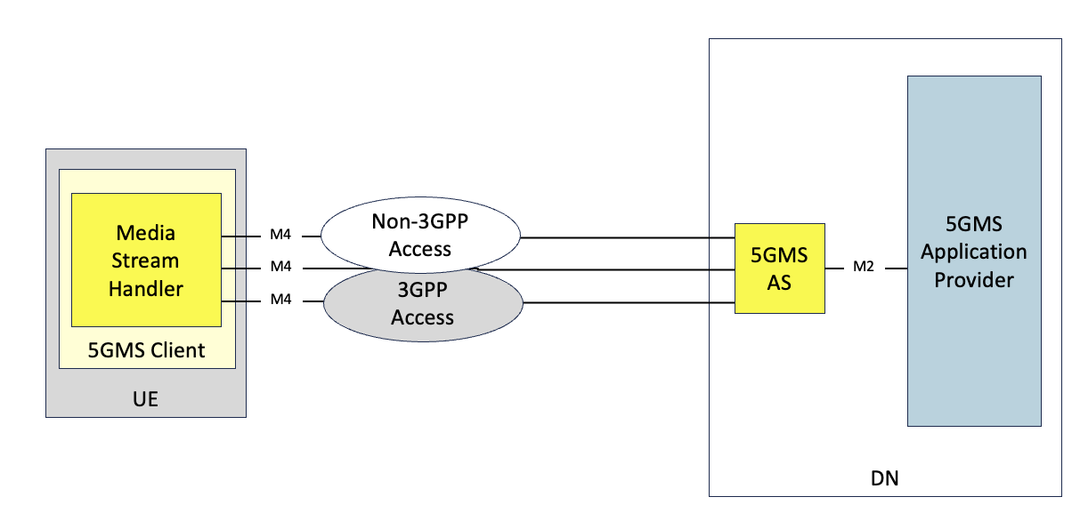
Figure 5.15.2.1-1: Multi-access media delivery without using ATSSS

* * * * Third change (all new text)* * * *

5.15.6 Candidate solutions
Editor’s Note: Candidate solutions for identified key issue.

5.15.6.1 Multi-access media delivery using CMMF
This candidate solution includes approaches where a 5GMSd Client accesses and downloads, via reference point M4d, CMMF-encoded media objects [CMMF – reference included within CR adding clause 5.19], and possibly original source media (e.g., MPEG-DASH or HLS media segments), over multiple access networks simultaneously from a single 5GMSd Application Server. CMMF (discussed in detail within clause 5.19.6.3) enables multi-access capabilities through application-layer implementations of the 5GMSd Client without requiring lower-layer (e.g., network, transport, etc.) multi-access integrations.
In this solution, multiple different CMMF-encoded bitstreams/objects (or representations) of the source media are stored/cached within a single 5GMSd Application Server. A CMMF-enabled 5GMSd Client requests and downloads a different CMMF-encoded representation of the required original source media over each of the access networks available to it. These (potentially partially) received CMMF bitstreams/objects are decoded by the 5GMSd Client yielding the required original source content once enough information has been received over all of the available access networks.
Unlike other multi-access technologies such as MPTCP, MPQUIC, ATSSS, etc., the responsibility to setup, request, and steer the delivery of content across each available access network may be left to the application layer (e.g., Media Player). For example, a Media Player may setup multiple HTTP clients where each are bound to a different network interface (each assigned with an IP address appropriate to that network). Requests to a single Application Server for different CMMF-encoded representations (or stripes) of the original source media are sent from each of the HTTP clients over the different access networks. The Application Server’s response to each of these requests will be routed appropriately over each access network following standard network-layer/IP routing rules and proceedures.
As mentioned above, traffic steering over each access network may be performed by the application layer (e.g., Media Player); and multiple policies can be defined/implemented based on the desired outcome. For example, a best-effort policy may envolve downloading as much CMMF-encoded content from each available access network until the Media Player can successfully decode the required media. Networks that have lower latency, higher bandwidth, etc. will naturally contribute more to the download than those with higher latency, lower bandwidth, etc. Another policy may preference delivery of content from one access network over another. In this case, the Media Player may choose to throttle the requests of CMMF-encoded content made to the Application Server over one access network so that the majority of the download is completed on the other(s).
Integration of CMMF within the 5GMS system is discussed in detail within clause 5.19.6.3.

* * * * End of changes * * * *

