3GPP TSG-SA WG4 Video SWG #127 S4-240xxx
Sophia-Antipolis, France, 29 Jan. – 2 Feb. 2024

Source: Dolby Germany GmbH
Title: Permanent Document for FS_FGS (Feasibility Study for Film Grain Synthesis)
Version: 1.3.1
Agenda Item: 9.8
Document for: Agreement
Work Item information:
Work Item Name | FS_FGS (Feasibility Study for Film Grain Synthesis)
Acronym | FS_FGS
Unique ID | 1000016
Target release | Rel-18

Source details:
Rapporteur | Name | Brian Lee
 | Company | Dolby Laboratories Inc.
 | Email | Brian.lee@dolby.com
Editor | Name
 | Company
 | Email

Revision history:
Version | Date | Meeting | Subject/Comment
1.3.1 | 2024-01-31 | SA4#127 | Added InterDigital contribution during SA4#127
1.3 | 2024-01-31 | SA4#127 | Updated with agreed contributions from Apple, InterDigital during SA4#127
1.2 | 2024-01-24 | SA4#127 | Updated with additional text from Dolby
1.1.1 | 2024-01-13 | Post SA4#126 | Updated with additional tests from Dolby and text
1.0.1. | 2023-11-16 | SA4#126 | Updated with additional text
1.0.0 | 2023-08-24 | SA4#125 | Initial Submission

Contents
Contents 2
1 Introduction 3
2 Proposed Scenario and evaluation framework 3
3 Considerations on UE requirements 5
4 Communication with JVET 5
Annex FGS Testing Methodology and Results

Introduction
3GPP SA4 has decided to maintain a permanent document for the above referred study item, which will keep track of the ongoing tasks required to complete the study item objectives as defined here. More specifically, 3GPP SA4 intends to:
- Define motivating use cases and scenarios for the use of Film Grain synthesis in 5G video services.
- Document relevant existing Film Grain Synthesis technologies that are not included in 3GPP today.
- Provide evaluation, using the HEVC standard, of the benefits/drawbacks of any corresponding solutions, including the film grain characteristics SEI message (ITU-T H.274). Such an evaluation may include information on performance results, complexity and implementation aspects, interoperability, system integration, etc. following the example of TR26.955 based on certain selected or newly defined scenarios.
- Use the characterization framework in TR26.955, when possible, and extend it, when necessary, i.e. with subjective tests results.
- Study and identify relevant UE requirements for consistent usability of the technology.
- Collaborate with MPEG/JVET and other organizations to ensure broad interoperability on film grain synthesis technologies across different ecosystems.
- Identify relevant interoperability and system level aspects to potentially support film grain synthesis.
- Identify if any new normative work would be justified and, if so, provide relevant conclusions.

This study will be done in collaboration with other organizations as needed, e.g. JVET, MPEG, CTA WAVE, 5G-MAG, DASH-IF etc.
The approved WID can be found here: SP-230539 New SID on Feasibility Study on Film Grain Synthesis

Contributions to the SA4 3GPP FGS work
In order to evaluate the performance and to justify any potential benefits of film grain synthesis technologies for video compression, a qualitative and quantitative analysis on what would be the costs and benefits of using such technologies would be needed.
Section 2.1 documents new content that could be used for the purpose of evaluating film grain synthesis technologies and provides some information on the content characteristics. Section 2.2 describes a film grain synthesis tool contributed by Interdigital, named as the “FGC SEI message designer”, which focuses on one film grain synthesis technology, i.e. the film grain characteristics (FGC) SEI message and the underlying film grain synthesis technologies it supports, and permits the design and visualization of film grain synthesis parameters in the context of that technology. The synthesis tool connected to the graphical user interface to test the film grain parameters supports other metadata formats, but the GUI currently only exercices the FGC SEI in frequency filtering mode.Section 2.3 provides some suggestions on how to achieve interoperability using the FGC SEI message while Section 2.4 proposes new scenarios that could be added in TR26.955 for the evaluation of film grain synthesis technologies and provides some preliminary results as information to the group.

  - Compressibility analysis of film grain test sequence
    - Overview

This contribution presents a compression performance analysis of the film grain content that was introduced in JVET-AF0262 [3] and which was generated using the Ground Truth [1] method. The test material includes scenes taken from the OpenMovie project “Tears of Steel” and other captured content encompassing a wide range of video characteristics. For each scene there exist 27 variants, a relatively noise-free version referred to as the “ground truth”, and 26 additional versions that add film grain noise of different characteristics on top of the ground truth version. These variants were created to enable the evaluation and design of different video processing techniques and compression algorithms in the presence of film grain noise. A complete list is shown in Table 1.
Table 1: Noise Variants used
# | Noise name | Type | Film | Color | Comments
0 | FP_16_grayscale | Template | 16mm | Grayscale
1 | FP_35_grayscale | Template | 35mm | Grayscale
2 | FP_35_digital_grayscale | Template | 35mm | Grayscale | C.A.
3 | FP_35_real_grayscale | Template | 35mm | Grayscale
4 | FP_35_real_texture_grayscale | Template | 35mm | Grayscale
5 | FP_35_soft_grayscale | Template | 35mm | Grayscale
6 | FP_8_grayscale | Template | 8mm | Grayscale
7 | FP_fine_grayscale | Template |  | Grayscale
8 | FP_fine_texture_grayscale | Template |  | Grayscale
9 | FP_organic_grayscale | Template |  | Grayscale
10 | FP_16_color | Template | 16mm | Color
11 | FP_35_color | Template | 35mm | Color
12 | FP_35_digital_color | Template | 35mm | Color | C.A.
13 | FP_35_real_color | Template | 35mm | Color
14 | FP_35_real_texture_color | Template | 35mm | Color
15 | FP_35_soft_color | Template | 35mm | Color
16 | FP_8_color | Template | 8mm | Color
17 | FP_fine_color | Template |  | Color
18 | FP_fine_texture_color | Template |  | Color
19 | FP_organic_color | Template |  | Color
20 | EF_Native_0_3 | Dynamic | N/A | Grayscale | Final Cut
21 | EF_Native_0_6 | Dynamic | N/A | Grayscale | Final Cut
22 | EF_Granularity_St64_Si64_B4 | Dynamic | N/A | Grayscale | Granularity/Blend
23 | EF_Granularity_St128_Si128_B4 | Dynamic | N/A | Grayscale | Granularity/Blend
24 | EF_Granularity_St64_Si64 | Dynamic | N/A | Grayscale | Granularity/SoftLight
25 | EF_Granularity_St128_Si128 | Dynamic | N/A | Grayscale | Granularity/SoftLight
Note: C.A. => Contains Compression Artifacts

There has been some interest in using such content for different experiments in JVET and MPEG. However, given the number of film grain variants for each scene, it is also highly desirable to define a process of selecting for each scene only a subset of “representative” film grain variants. This could lead to better focus and reduce the complexity of such experiments. This contribution provides a preliminary compression analysis for all the scenes and their film grain variants, which could be used for such selection process. Compression was performed using the x265 HEVC encoder [4], which is a popular open source HEVC compliant video encoder, and in particular using the libx265 encoding library included in the FFmpeg [5] project.
It is expected that film grain would make each scene more complex to encode given its spatial and temporal impact on the content, compared to the ground truth reference. The impact on compression could then be analyzed to determine a metric of complexity for each film grain noise type added on each scene, which could then be used to characterize such noise. Such information could also be further augmented by additional experiments, e.g. by evaluating the performance of denoising on each noise type as discussed in [6].
    - Encoding Configurations
JVET-AF0262 [3] presented 20 new scenes to JVET, 11 from the OpenMovie project “Tears of Steel” and 9 from a newly created test set, named as the “Gregory Set”, which could be freely used for a variety of experiments and evaluations by the standardization and research community. For each scene there exist 27 variants, a “ground truth” variant that is relatively noise free, and 26 film grain variants that were produced using the ground truth version as a basis.
To evaluate the coding behavior of each scene and film grain variant we have used the x265 HEVC encoder using a fixed QP configuration. In particular, the following encoding parameters, within the FFmpeg framework, were used:

ffmpeg -y -f rawvideo -loglevel error -pix_fmt yuv420p10le -psnr -tune psnr -qp-mode 0 -c:v libx265 -x265-params b-adapt=0:gop-lookaghead=0:rc-lookahead=25 -qp -codec=hevc -preset=slow -pass=1

This configuration generates bitstreams with the Main 10 profile, using single slice per frame, with a max coding unit size of 64x64 and a minimum CU size of 8x8. Additionally, it uses a max TU size of 32x32, with I, P and B coded frames are coded using a hierarchical structure with P frames repeating every 5th frame and a pyramid height of 3. Additionally, a constant quantizer is used to achieve rate control, which, although may not be the most efficient in terms of coding efficiency, ensures that every frame would be encoded with the same quantization parameter. We did not explore further on how to adjust the QP parameter according to the coding structure used. The QP range tested is [ 6, 13, 20, 27, 34, 41, 48 ]. The slow preset was used to provide better compression.
In this test we only evaluated coding performance, especially since we did not have a homogeneous coding environment and did not collect any statistics about the encoding time of each test. Such information, however, may also be useful for evaluating further each film grain variant.
For each encoding we collected the resulting bitrate and the PSNR metric compared to its input source. Given that, it should be highlighted that the PSNR values for different noise variant of the same scene should not be directly compared since they do not correspond to the same input. Instead, such numbers can be seen as an indicator of the complexity of each variant. In particular, it is expected that more complex noise variants added onto a scene will result in possibly lower PSNR and higher bitrate than a less complex noise variant. This information can then be used to characterize each noise variant for each scene.
To make it easier to compare the different noise variants we also introduce an additional metric computed as:
Di,QP=log10(Bitrate(i,QP))+MSE(i,QP)
Where Bitrate(i,QP) and MSE(i,QP) are the total bitrate and overall luma component mean square error for a clip i resulting by encoding this clip with a quantization value equal to QP. This metric allows us to more easily rank the different noise variants.
Then the complexity for a variant can be computed as:
Complexityi=QP∈{6, 13, 20, 27,34, 41, 48}D(i,QP)
    - Evaluation results and conclusion
Detailed evaluation results are provided in the Annex (Annex subsection 1). Given this evaluation the contribution concludes that the statistics generated demonstrate the impact of film grain noise on the compression of a scene. Such statistics could be used to characterize each film grain variant and could be considered when selecting test content and film grain variants for any experiments one may wish to conduct in the context of film grain synthesis technology evaluation.

  - Film grain characteristics SEI message capabilities and a tuning tool
    - Introduction
This contribution introduces a tool that can be used to evaluate a particular film grain synthesis technology, i.e. the Film Grain Characteristics (FGC) SEI message, that is currently supported in video coding standards such as HEVC. A tool, which highlights and demonstrates the capabilities of the FGC SEI message, that includes also a film grain synthesizer is introduced. In particular, the following FGC SEI functionalities are demonstrated using this tool:
- model parameters fitting the grain shape and strength, and
- local variation of both shape and strength, as observed on real film.

    - FGC SEI message designer

JVET (joint ISO/IEC and ITU-T expert group) is conducting active work on Film grain synthesis technologies. Software packages are made available in the “JVET AHG Film Grain Technologies” gitlab repository (https://vcgit.hhi.fraunhofer.de/jvet-ahg-fgt). This repository includes film grain synthesis related software, which is either independent or not yet merged into any JVET reference software (e.g. the HM).
A recent addition in this repository is the “FGC SEI message designer”, a graphical interactive tool that can help to edit an FCG SEI message configuration file, and can be used in applications where the automatic estimation of film grain is either not practical or needs to be refined. It can also be used to export a graphical representation of film grain parameters, e.g. for use in a document, for subjective assessments, and to demonstrate and validate the capabilities of the FGC SEI message.
This tool was implemented as a single python script and connected to a film grain synthesizer. The tool was added to the “VFGS” software repository (https://vcgit.hhi.fraunhofer.de/jvet-ahg-fgt/vfgs) rather than in an independent repository. External dependencies are matplotlib and numpy.
The tool is also available from the InterDigital github (https://github.com/InterDigitalInc/VersatileFilmGrain), which is in fact its primary source.
The film grain synthesizer available in the same repository and connected to the graphical tool is intended to be hardware friendly. It is mentioned that the software was initially designed as a hardware model with clearly separated hardware and firmware layers, and that it can interoperate with different grain models and metadata formats. However, it was also commented that this interoperability is not yet exercised by the graphical tool but there is an intent to include this functionality in a future revision.
    - Description of the tool
      - Graphical display and edit

Figure 1 reproduces the main window of the tool, with arbitrary default film grain parameters when no configuration file is loaded yet.
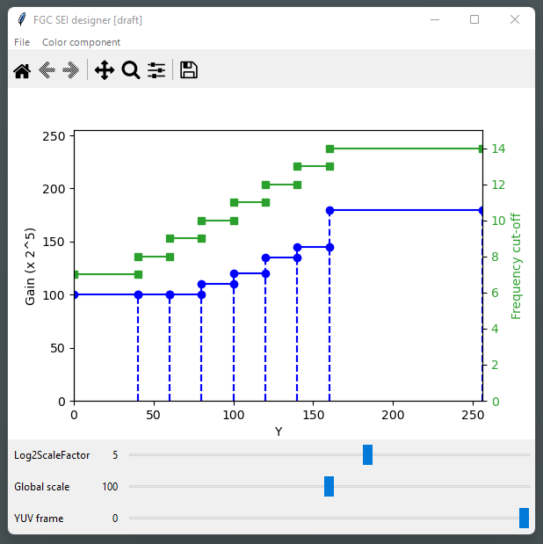
Figure 1 – Main tool window
An FGC SEI message configuration file can be loaded and saved through the “File” menu. Currently, only the frequency-filtering mode of the FGC SEI message is supported. The syntax used in the configuration file is the same as that in the HM; there is a direct mapping between the interactive plot and the FGC SEI message model parameters.
The color component is selected from the “color component” menu.
Intensity interval boundaries, gain levels, and frequency cutoffs can be click-dragged. An interval is removed when it is reduced to zero-length, and is split by a double-click.
      - Example configuration import / export
Figure 2 is an example film grain parameter representation exported with the FGC SEI message designer tool, using the CrowRun.cfg file that was used for the expert viewing experiments reported in JVET-AD0382 [1]. The graphical export is provided by the “save as” feature of matplotlib (the floppy disk icon of the toolbar in Figure 1).

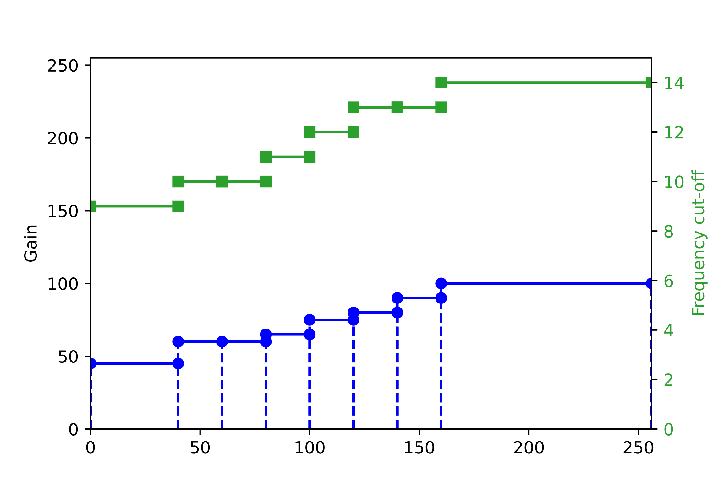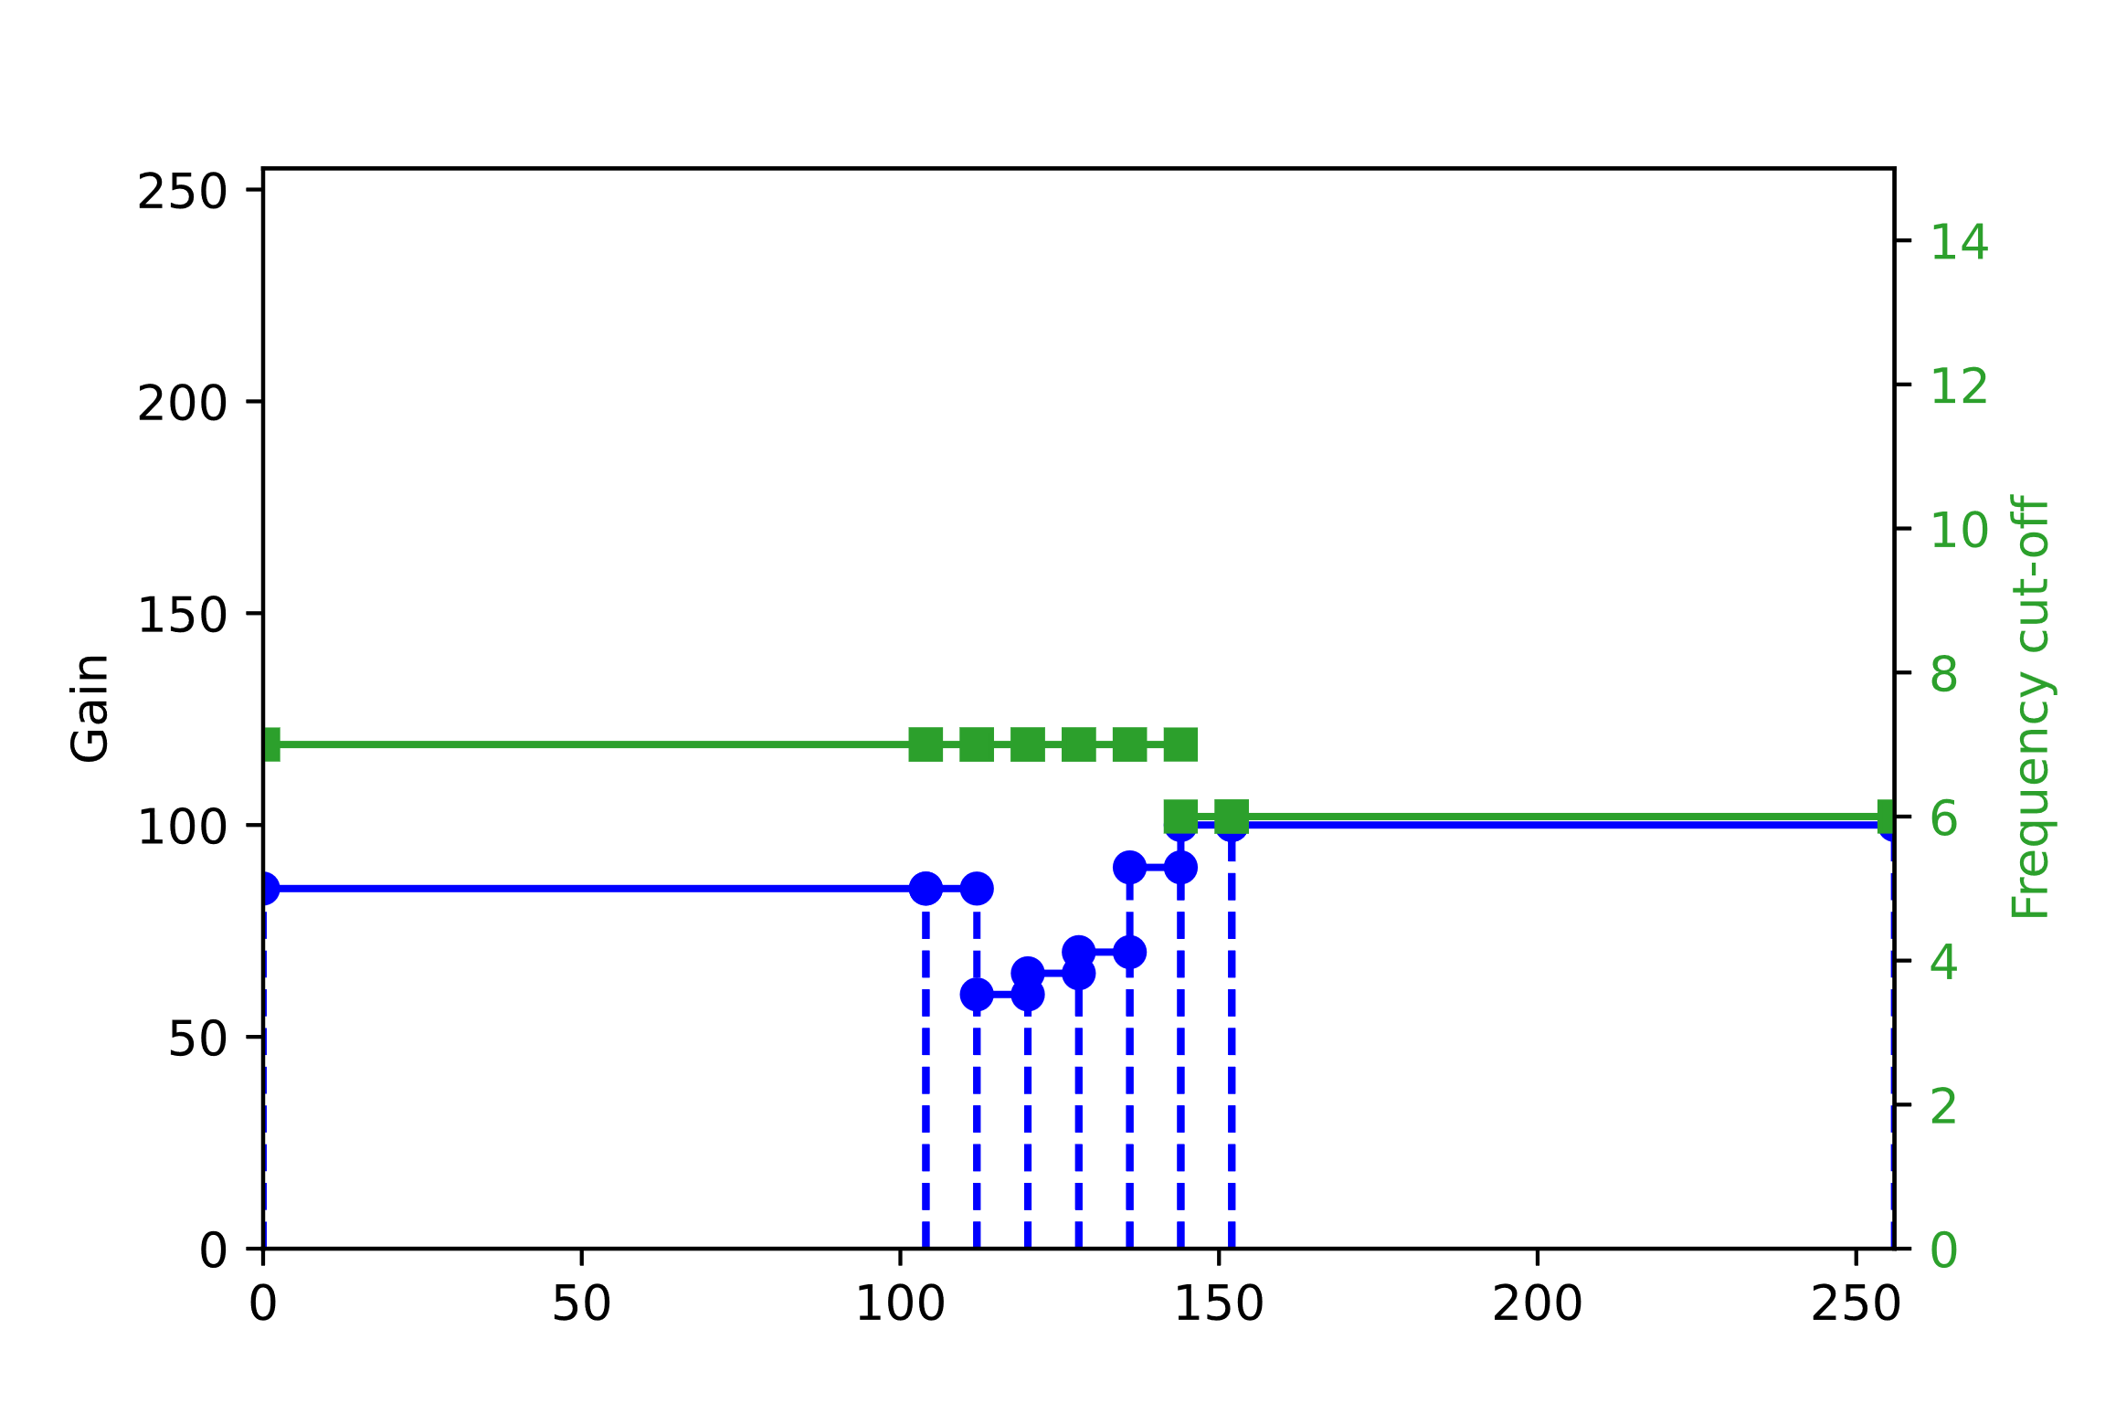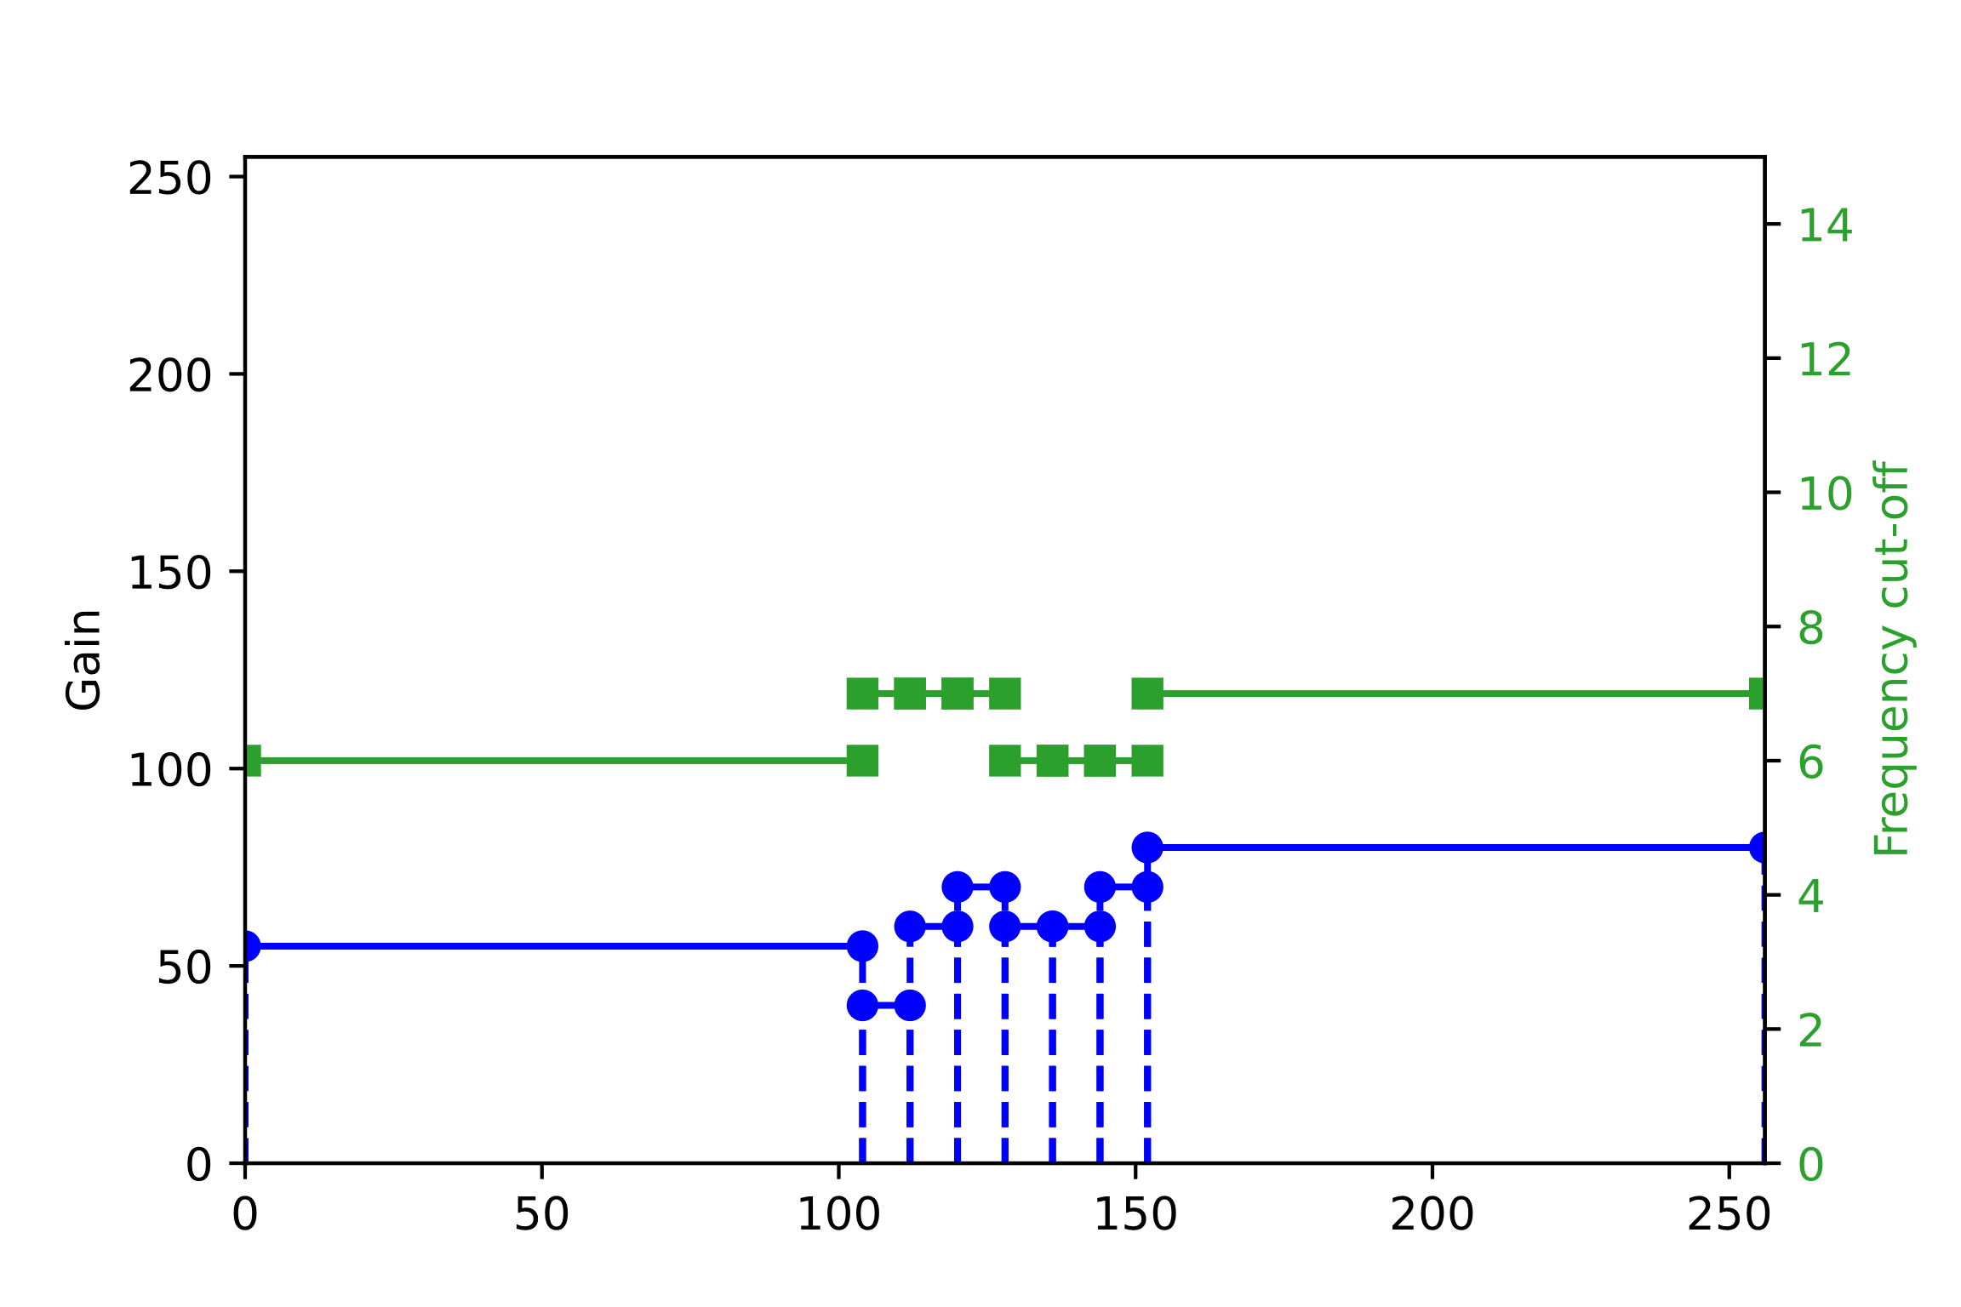
Figure 2 – Film grain parameters used for CrowdRun in JVET-AD0382 [1]
(Luma, Cb, and Cr from top to bottom and left to right)
Notes:
- The horizontal axis corresponds to a target image sample value (or “intensity”), normalized to 8-bits.
- Here, log2ScaleFactor is equal to 4, which means that the gain axis is scaled down by 2^4 = 16 for an 8-bit target image (for a 10-bit target image, it is scaled down by 4 times less).

      - Tool chain for experimentation
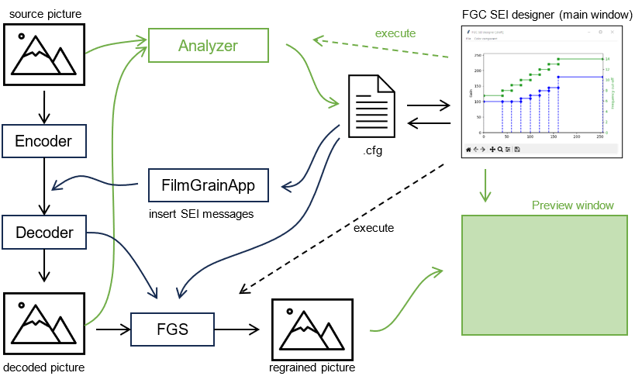
Figure 3 – Film grain experimental tool chain
Figure 3 depicts a tool chain that could be used to experiment with film grain synthesis, including the graphical tool described here. Items in green are still under construction.
The FGC SEI message designer tool is connected to an external film grain synthesizer, so that immediate feedback of the adjustments made can be reflected on a test video (the dashed “execute” arrow in Figure 3). A YUV viewer has to be used to watch the result until the preview window is available.
The configuration can also be saved and used in the FilmGrainApp program provided with the HM (and the VTM) to insert the FGC SEI messages in a bitstream.
Further future work would include the following aspects:
- The estimation of initial parameters when provided with a source video/picture and a clean/denoised variant (by e.g. connecting an external analyzer);
- The support of the auto-regressive mode, and potentially translations between Frequency Filtering (FF) and Auto-regressive (AR) modes;
- A visualization window that could be used to compare the source, clean/denoised, and re-grained pictures.
Further information on this tool is provided in the Annex.
  - Interoperability of the FGC SEI message
    - Film Grain Characteristics SEI message
This contribution provides some recommendations on how to best ensure the interoperability of the FGC SEI message.

In particular, it is commented that the FGC SEI message can convey film grain characteristics through parameters of a film grain statistical mode. That mode is either based on spatial frequency cutoffs or 2D auto-regressive filter coefficients.
The FGC SEI is based on a few common parameters, like the color space and model kind (frequency filtering or auto-regressive) used and a set of independent intensity intervals. Such intervals define:
- their boundaries (range of color component value)
- and
- a full set of model parameters, impacting both the grain strength and shape.
It is thus possible to vary both grain strength and pattern (shape, size, sharpness, coarseness) of each interval.
This is illustrated in Figure 1 via the use of the FGC SEI designer tool [x] and justified by the variability of grain observed on real film as illustrated in Figure 2 and Figure 3.
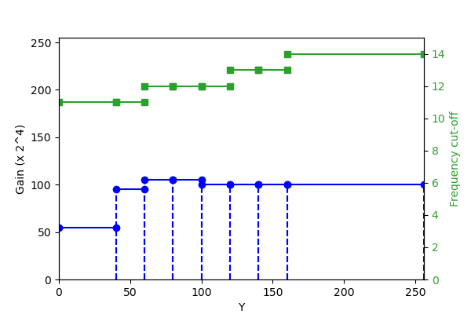
Figure 1 – Example intervals and parameters

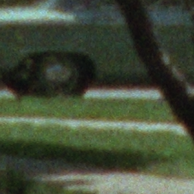
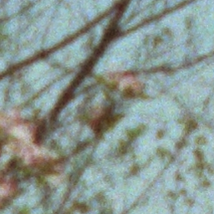
Figure 2 – Example crops of a 1963 35mm negative film scan (around 7500 ppi / 150 lpm)
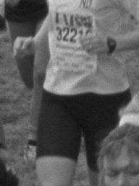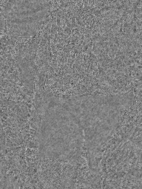
Figure 3 – Grain variability on an example film (at around 3000 dpi / 60 lpm)
Left: luma – Right: luma grain

    - Use of the FGC SEI message with a fixed grain pattern implementation

To enable the use of the FGC SEI Message with implementations that only support fixed grain pattern, the following can be considered:
As intervals are fully independent and can be transmitted in any order the following considerations need to be made:
- Transmit in the first position an interval that carries the grain pattern parameters (AR coefficients, or frequency cutoff) that are deemed as giving a good representation on average for the entire picture.
- Transmit intervals in order of the importance of the grain pattern.
Conversion of FF to AR parameters:
- The conversion of frequency-filtering parameters to auto-regressive coefficients can be implemented with pre-computed AR coefficients tuned to give visually similar results. Since the range of values of the frequency cutoffs is likely to be limited to the 3 to 14 range, the number of the AR coefficient sets is small.
Fixed grain shape implementations may generate a grain template based on the first interval and can use the parameters of the remaining intervals to modulate the amplitude of the grain.
Implementations with a limited number of grain patterns (e.g. under 8 or 10) may create templates based on the first intervals up to the maximal number they can support and can use the gain parameter of the remaining intervals to modulate the amplitude of the closest template.
  - Proposed additions to TR26.955 for FGS scenarios

This proposal introduced additions to the test scenarios specified in TR26.955, primarily focused on the evaluation of film grain synthesis technologies. Preliminary and unverified analysis of some tests using these proposed additions is included in the Annex.

# | Parameter | Definition
1 | Scenario name | Film Grain Synthesis Scenario
2 | Motivation for the scenario | Study, test and analyze the effect of film grain synthesis applied to varied test scenarios encoded with H.265/HEVC, in order to ascertain whether there is benefit in (1) preservation of artistic intent and/or (2) masking artifacts / saving bitrate, while maintaining visual acuity, etc.
3 | Description of the scenario | Film grain can be unavoidably lost by a conventional video compression workflow as shown in Figure 1. High frequency grain in the source content ($x$) can be either completely or partially lost due to quantization/resizing in adaptive streaming or broadcast applications, in which case the resulting decoded output $\tilde{x}$ could be void of the artistic effect of grain intended in the source. Even if grain is partially preserved at high bitrates, overall coding efficiency is poor as the grain is not spatially or temporally correlated, which can negatively impact the coding characteristics of the scene.  In the case of the Film Grain Preservation Workflow, as per Figure 2, the source video ($x$) is input to a denoising process that outputs a video sequence from which noise or film grain is attenuated or removed. A film grain parameterization process then compares the source and denoised videos to determine film grain model parameter values, which relate to the variance, spatial frequency characteristics, colour correlation, and other statistical characteristics of the film grain. The process of denoising followed by the film grain model parameter estimation is commonly referred to as the film grain analysis process. After these processes are performed, the denoised video is then encoded and the film grain model parameter values are either signalled in the coded bitstream ($y_{dn}$) or provided to the decoder by some external means.  On the decoder side, the film grain model parameter values are parsed and input to a film grain synthesis process that generates simulated film grain and blends the grain with the decoded video ($\tilde{x_{dn}}$) to output decoded video with simulated film grain ($\tilde{x_{g}}$).
4 | Supporting companies and 3GPP members
5 | Source format properties  - Spatial resolutions  - Chroma Format  - Chroma Subsampling  - Aspect ratios  - Frame rates  - Colour space formats  - Transfer Characteristics  - Bit depth  - Other signal properties | 1920x1080, 3840x2160  YUV  420P  16: 9  24, 29.97, 30 ,59.94 ,60  ITU-R BT.709 or BT.2020  BT.709, PQ  8, 10
6 | Encoding and decoding constraints and settings: Typical encoding constraints and settings such as  - Relevant Codec and Codec Profile/Levels according to TS26.116 and TS26.511.  - Random access frequency  - Error resiliency requirements  - Bitrates and quality requirements  - Bitrate parameters (CBR, VBR, CAE, HRD parameters)  - ABR encoding requirements (switching frequency, etc.)  - Latency requirements and specific encoding settings  - Encoding context: real-time encoding, on device encoding, cloud-based encoding, offline encoding, etc.  - Required decoding capabilities | HEVC/H.265  Main Profile & Main10 Profile, Level 5.3  HM version used: HM 18.0  https://vcgit.hhi.fraunhofer.de/jvet/HM/-/tags/HM-18.0  Detailed configuration parameters are listed in Annex  Constant QP (CQP) Random Access configurations were used for all the tests. CQP values for MOS tests were done as to meet following typical operating bit rates:  - 1080p60: 1Mbps to 4Mbps  - 2160p60: 6Mbps to 18Mbps  - 2160p24: 2Mbps to 9Mbps  Nearest rate matching CQP values were chosen for the MOS subjective evaluation tests to assess benefits of grain in preservation of artistic intent.  HM CQP streams and relevant FGC SEI configuration files for each test are also provided in separate zip file.  HM decoder which supports film grain synthesis as per specified frequency domain filter FGC SEI is used to decoder and output grain synthesized video.
7 | Performance Metrics and Requirements  - A clear definition on how the performance needs to be evaluated including metrics, etc addressing the main KPIs of the scenario.  - Objective measures such as PSNR, VMAF, etc, may be used.  - Subjective evaluation is not excluded and may be done, but needs commitment | Subjective Metrics  - MOS (pairwise method with hidden reference)  - Relative Grading (A v/s B method)  - JND (Just Noticeable Difference) method
8 | Interoperability Considerations for the application  - Streaming with DASH/HLS/CMAF  - RTP based delivery | The following media formats have been tested and validated for FGS interoperability.  - MP4  - MPEG-DASH  - HLS
9 | Test Sequences  - A set of selected test sequences that are provided by the proponents in order to do the evaluation. They should cover a set of source format properties | Preserving Artistic Intent  Scenario FHD  - BQTerrace 1920x1080 60fps  - OldTownCross 1920x1080 50fps  - InToTree 1920x1080 50fps  Scenario 4K-TV  - Crowdrun 3840x2160 60fps  - Tears of Steel 3840x1714 10bit 24fps (4 Scenes x 2 FG patterns per scene)  Scene_004_FG_03  Scene_004_FG_22  Scene_044_FG_03  Scene_044_FG_22  Scene_062_FG_16  Scene_062_FG_24  Scene_101_FG_21  Scene_101_FG_24  It has been reported in S4-231787 that there is the new “ground truth-based” film grain material available, that was generated using the “Tears of Steel” open movie and new content captured by Apple. Such material can be used for investigating methods on film grain analysis, synthesis, and quality evaluation among others.  (Proposal is to put this text to TR26.955 Sec.6.7.3)
10 | Detailed test conditions:  - Provides a proposal for detailed test conditions, for example based on a reference software together with the sequences and configuration parameters. | After denoising the content, HEVC software encoders and decoders with film grain analysis and synthesis support, respectively, are used to assess the performance of film grain modelling:  - Denoiser: The ffmpeg ‘nlmeans’ filter is used to denoise the source content before encoding.  - FFmpeg version: ffmpeg-v6.0  - ffmpeg-6.0.tar.gz  Sample Command  ./ffmpeg -f rawvideo -pix_fmt yuv420p -s:v 1920x1080 -I ../InToTree_1080p50.yuv -vf nlmeans=3.5:5:3:9:7 InToTree_nlmeans_3.5_5_3_9_7.yuv;  Note: FFmpeg denoiser is not used for denoising Tears of Steel content as the ground truth data (denoised) was provided by Apple.  - Film grain analysis algorithm: The frequency filtering analysis algorithm in the HM-18.0 reference encoder is used to model the grain parameters to be inserted in the FGC SEI message. FGC SEI messages are inserted only at IRAP pictures.  - Film grain synthesis algorithm: The SMPTE RDD5 based Frequency filtering grain synthesis algorithm in the HM-18.0 reference decoder is used for blending the synthesized film grain with the decoded video  - Browser player with FGS support: For Subjective evaluation, Ittiam HEVC FGS web browser player is used as it supports SMPTE RDD5 based frequency film grain synthesis using the FGC SEI messages embedded in HEVC bitstream. The player is built using optimized HEVC Decoder and FGS library (libfgs) which produces bit accurate output with HM Decoder.  The Player is tested to be bit accurate with HM + FGS (using same picture display number based seed). HM Decoder and Player will have the same output and either can be used for testing. Player can enable playback of streams with FGS on different clients where there are limitations for YUV based playback.  - https://demo.ittiam.com/demo/i265_fgs/
11 | External Performance data
12 | Additional Information

In order to kick off evaluation, initial focus should be on the following:
- 5 Source format properties
- 7 Performance Metrics and Requirements
- 9 Test Sequences
- 10 Detailed test conditions

Note that the evaluation does not necessarily have to be as detailed as in TR 26.955, relying on external performance data is good. However, it should be possible to understand if and how the information fits into the 3GPP relevant use cases. Repeatability should also be considered. If JVET completes such an evaluation, this would be preferable.

3 Considerations on UE requirements
In a possible specification for requirements, what could be done is the following:
- 3GPP Film grain synthesis reference process (possibly by reference to JVET)
- Process to verify "not having perceptually significant differences" to 3GPP Film grain synthesis reference process (possibly by reference to JVET)
- Receiver Requirements:
  - Either
    - 3GPP Film grain synthesis reference process implemented, or
    - not having perceptually significant differences to 3GPP Film grain synthesis reference process
  - making sure that available receiver implementations meet the receiver requirements
- In 3GPP, this could be a new specification or an Annex to an existing specification TS 26.116

4 Communication with JVET
It is agreed to send an LS to JVET informing them of our intent to evaluate the impact of FGS on our 3GPP scenarios listed in this study.
This LS is intended to request information on their ongoing activity with AG5 on similar evaluation in order to see if they can meet our timeline.
This clause is a placeholder for information we want to share with JVET and our requests.
- Inform JVET on the study item on Film Grain Synthesis (list the objectives or point to/attach the SID)
- Inform JVET on our timeline justified by the intent to meet release18 for normative work.
- Explain to JVET the type of evaluations that we will conduct in SA4
- Ask JVET if they have similar activities planned/ongoing/done and see if they can share results (or by when).
At the 3GPP SA4 #125 meeting, LS (S4-231587) is sent to JVET (ISO/IEC JTC1 SC29 WG5) before the Oct. 2023 JVET meeting as m65645 and a response statement is generated from the October MPEG/JVET meeting (S4-231648, 3GPP SA4 #126). This LS response from JVET was noted at 3GPP SA4 #126.

================================================================================

ANNEX: FGS Testing Methodology and Results

[Compressibility analysis of Film Grain test sequences – test results]

Simulation Results
Figure 1 through Figure 11 show the rate distortion plots for all different scenes and their noise variants. It can be seen that, all noise variants, as expected, result in a worse rate-distortion trade-off compared to the ground truth method. It can also be seen that for all cases, variants FG21-FG25 seem to be the most complex to encode, with especially variant FG25 resulting always in the worst coding performance. The v1 of this document presents results for Tears of Steel.
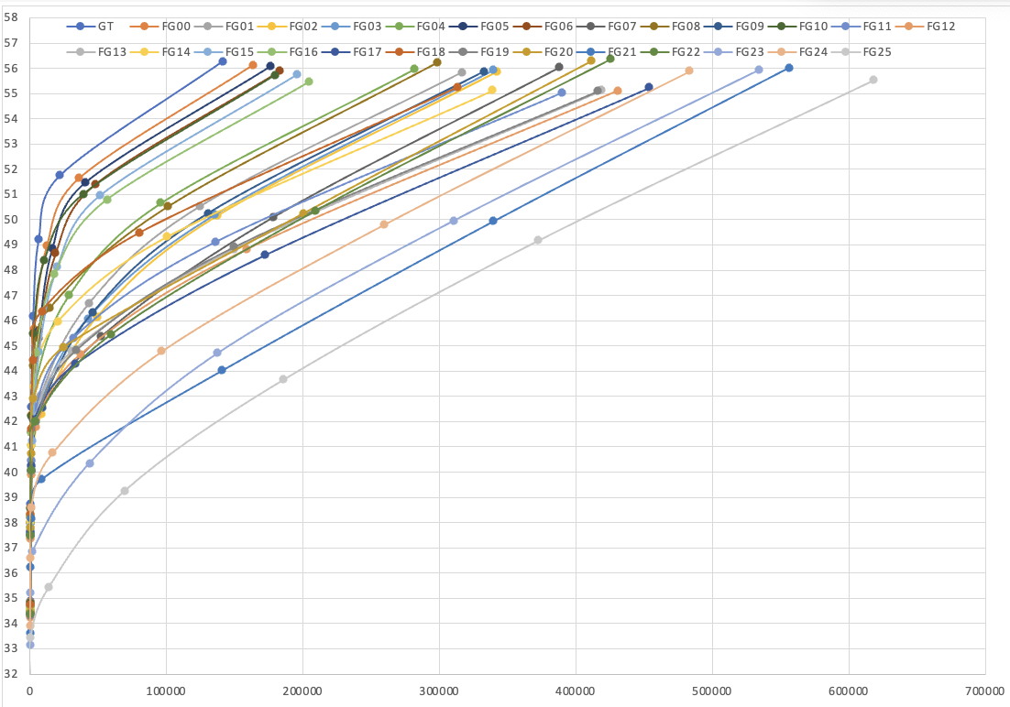
Figure 1. Rate distortion performance for all variants for the Tears of Steel “ToS” Scene 004

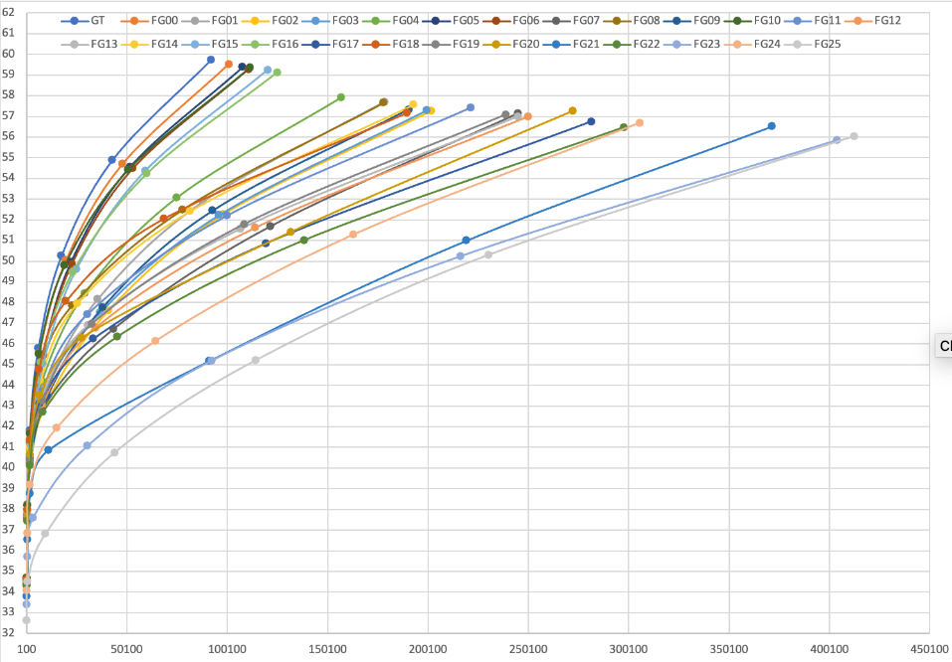
Figure 2. Rate distortion performance for all variants for the Tears of Steel “ToS” Scene 021

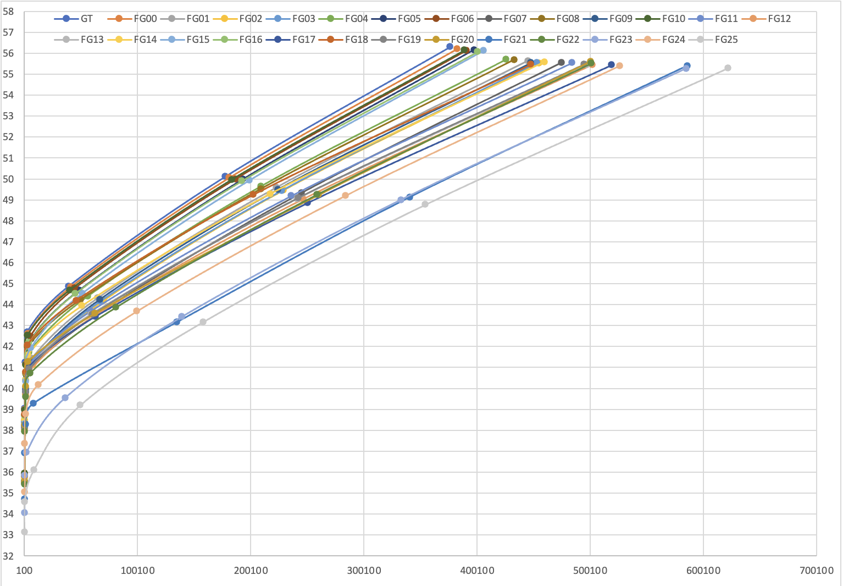
Figure 3. Rate distortion performance for all variants for the Tears of Steel “ToS” Scene 023
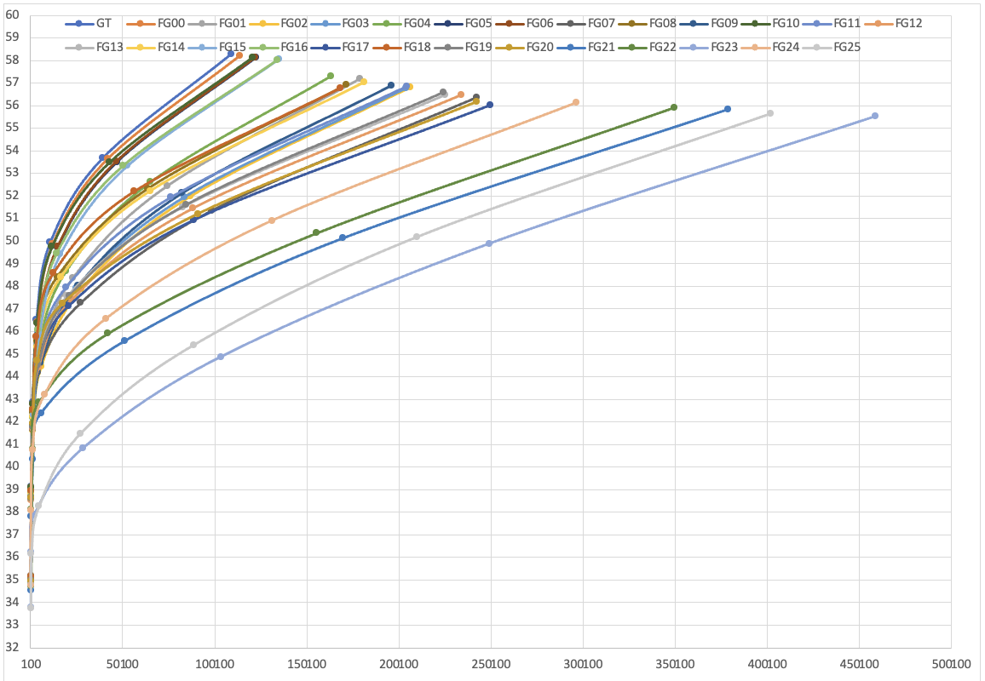
Figure 4. Rate distortion performance for all variants for the Tears of Steel “ToS” Scene 029
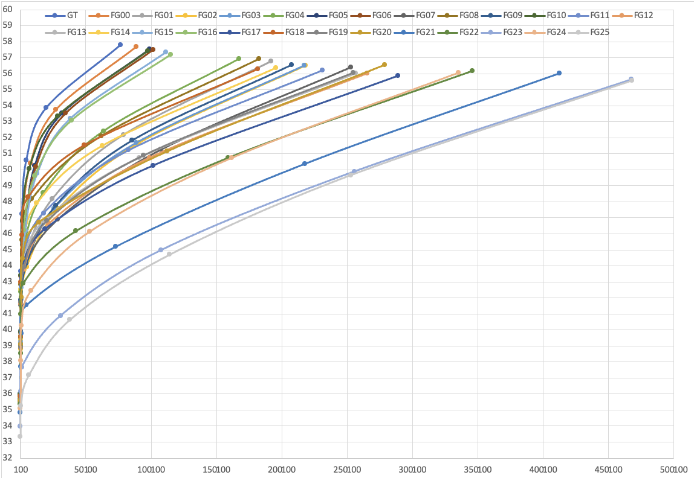
Figure 5. Rate distortion performance for all variants for the Tears of Steel “ToS” Scene 030
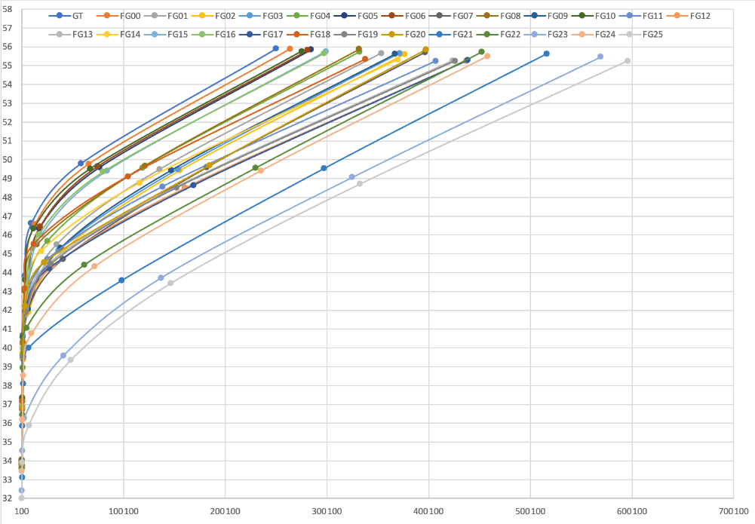
Figure 6. Rate distortion performance for all variants for the Tears of Steel “ToS” Scene 044
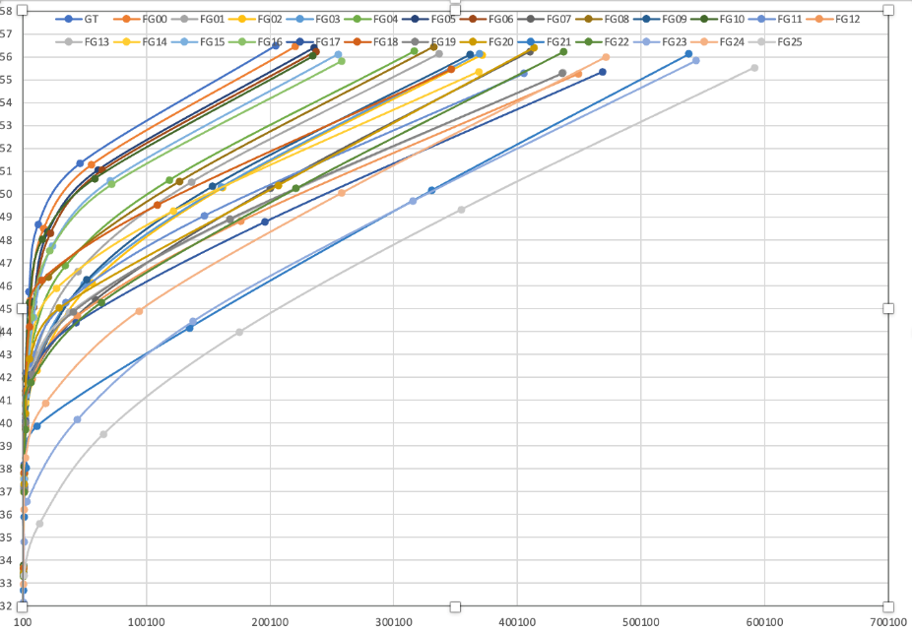
Figure 7. Rate distortion performance for all variants for the Tears of Steel “ToS” Scene 046
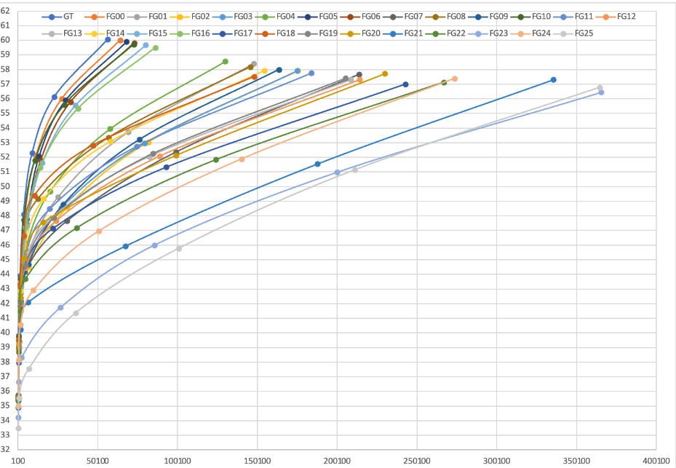
Figure 8. Rate distortion performance for all variants for the Tears of Steel “ToS” Scene 062
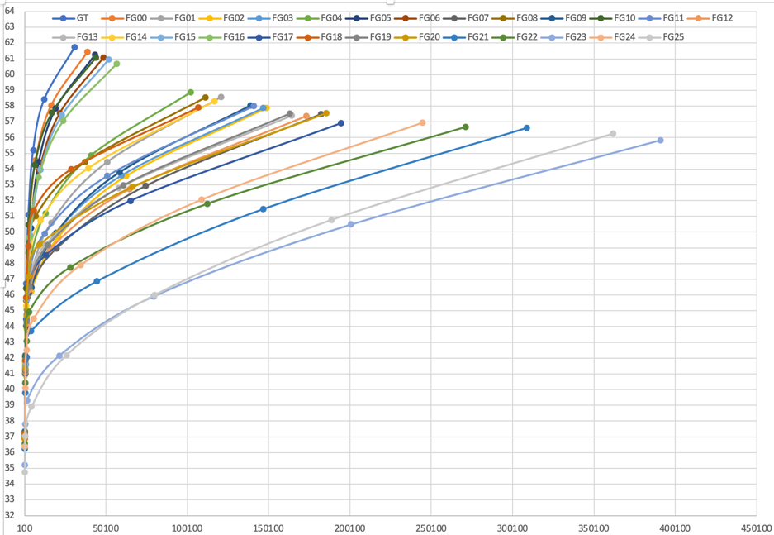
Figure 9. Rate distortion performance for all variants for the Tears of Steel “ToS” Scene 101
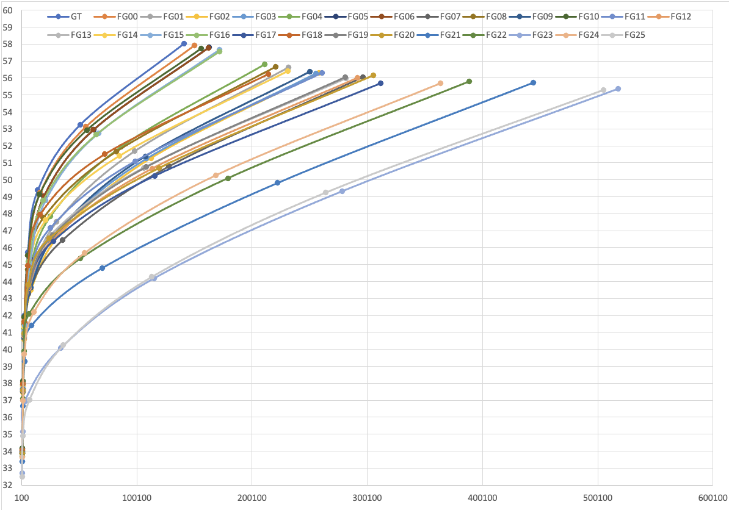
Figure 10. Rate distortion performance for all variants for the Tears of Steel “ToS” Scene 135
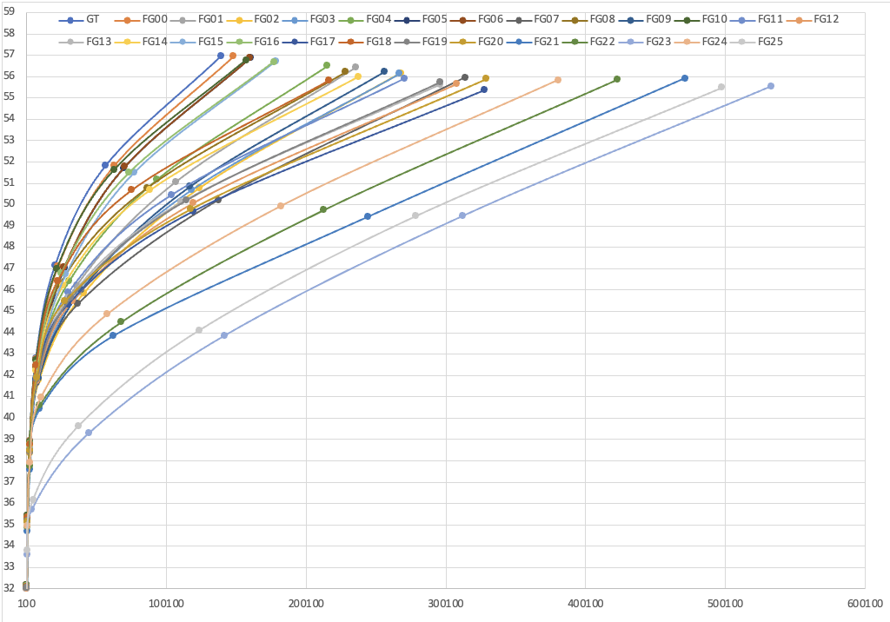
Figure 11. Rate distortion performance for all variants for the Tears of Steel “ToS” Scene 136
Figure 12 through Figure 22 show the performance of the average PSNR with the average bitrate for all variants for Tears of Steel.
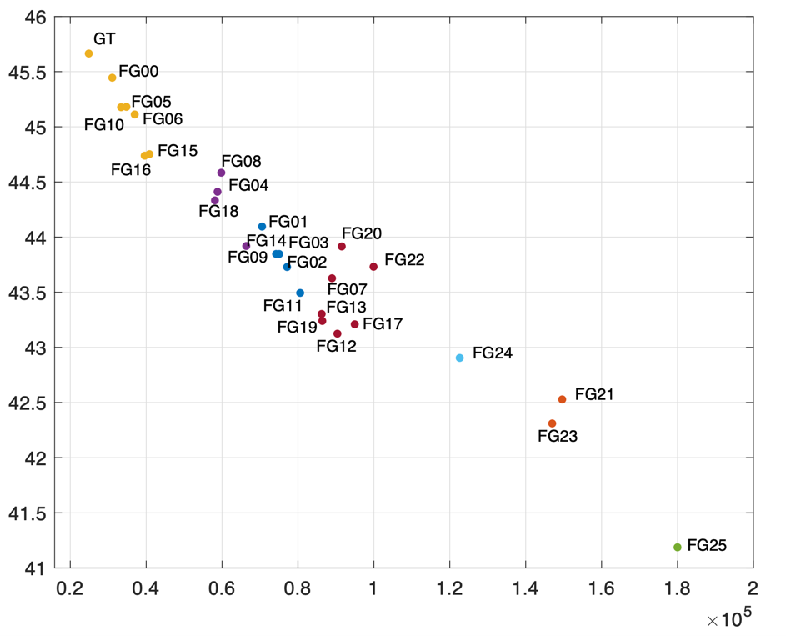
Figure 12. Avg PSNR vs. Avg. Bitrate for all variants for the Tears of Steel “ToS” Scene 004
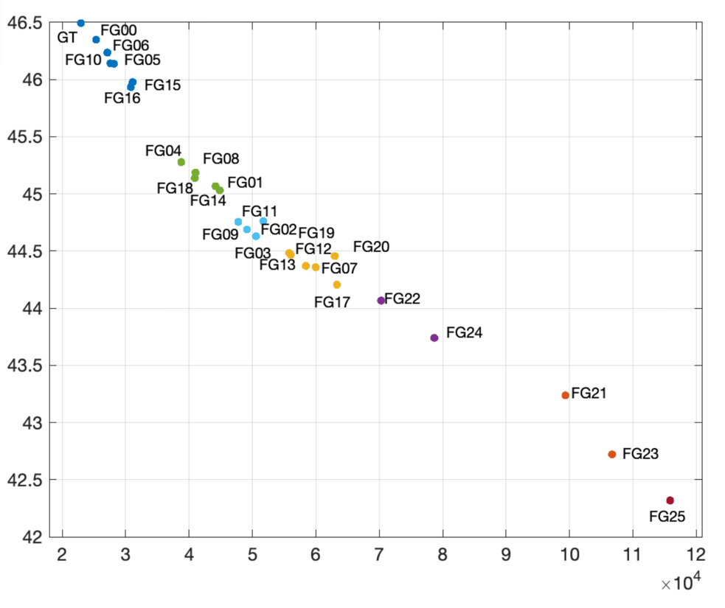
Figure 13. Avg PSNR vs. Avg. Bitrate for all variants for the Tears of Steel “ToS” Scene 021

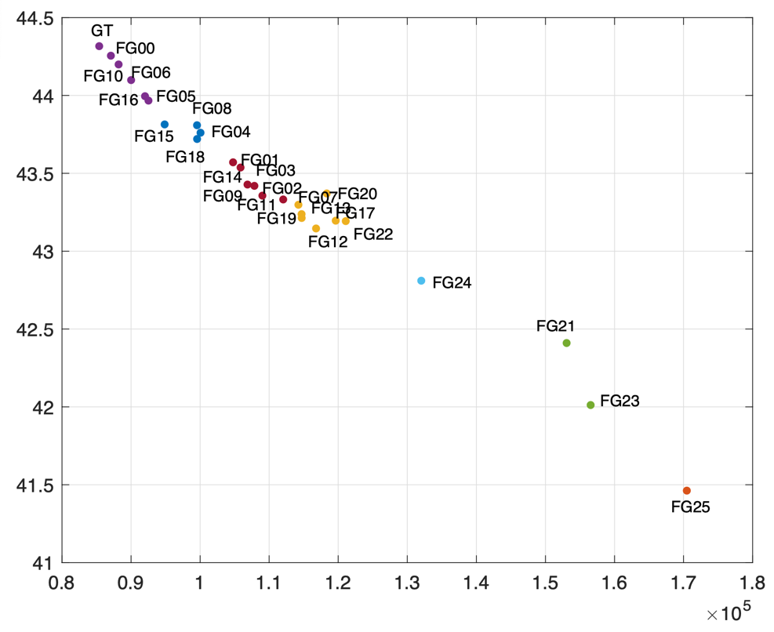
Figure 14. Avg PSNR vs. Avg. Bitrate for all variants for the Tears of Steel “ToS” Scene 023

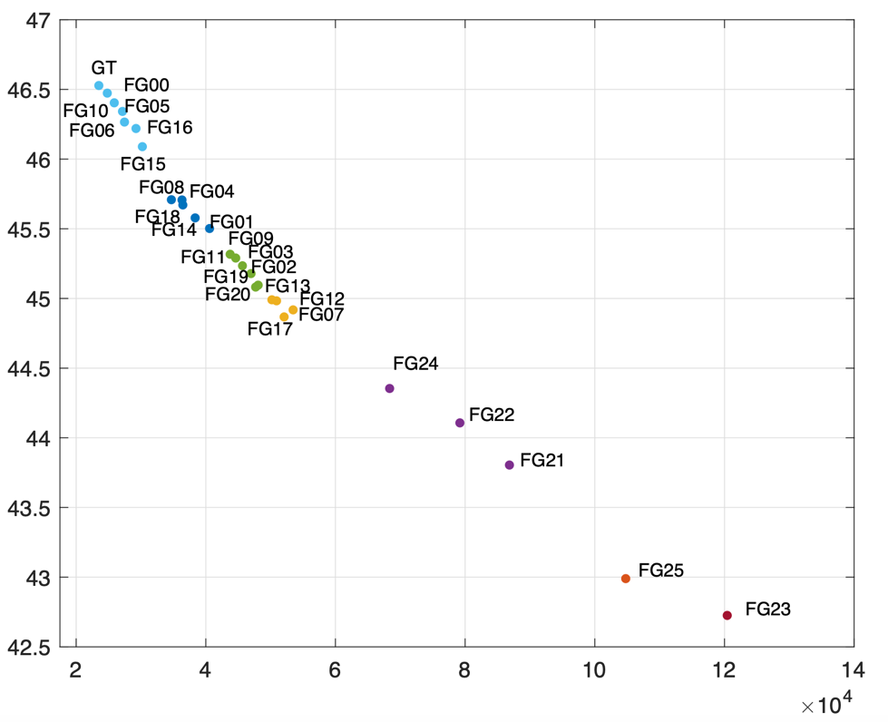
Figure 15. Avg PSNR vs. Avg. Bitrate for all variants for the Tears of Steel “ToS” Scene 029
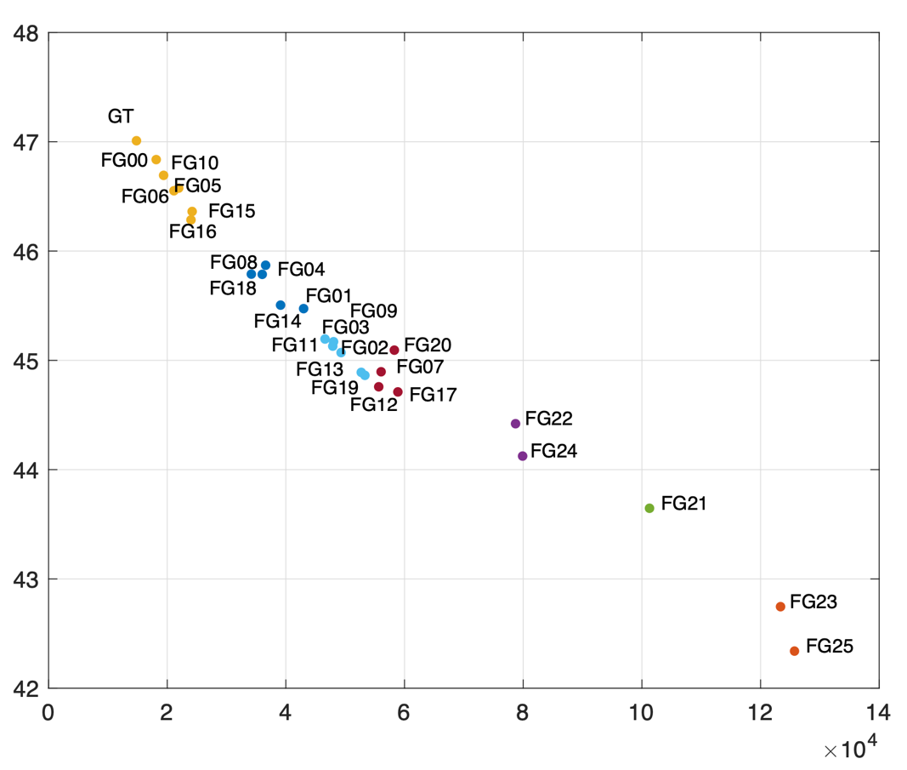
Figure 16. Avg PSNR vs. Avg. Bitrate for all variants for the Tears of Steel “ToS” Scene 030

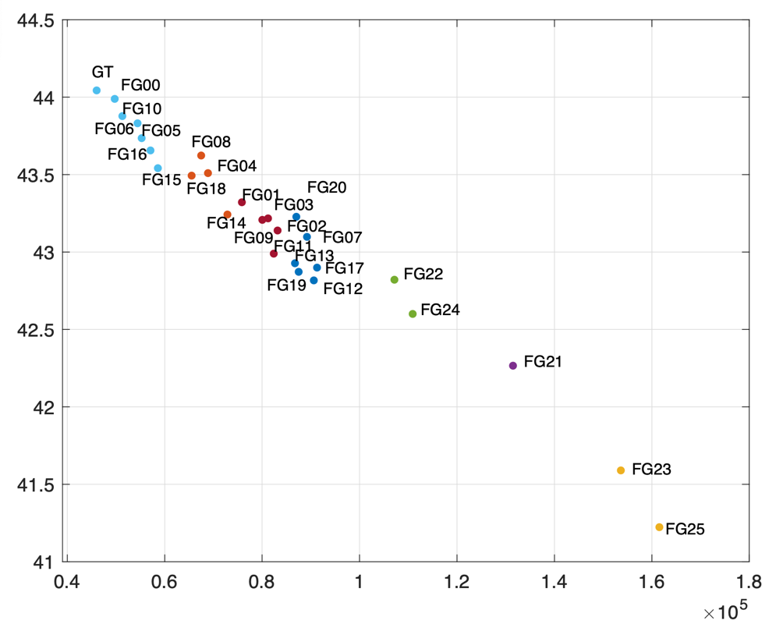
Figure 17. Avg PSNR vs. Avg. Bitrate for all variants for the Tears of Steel “ToS” Scene 044

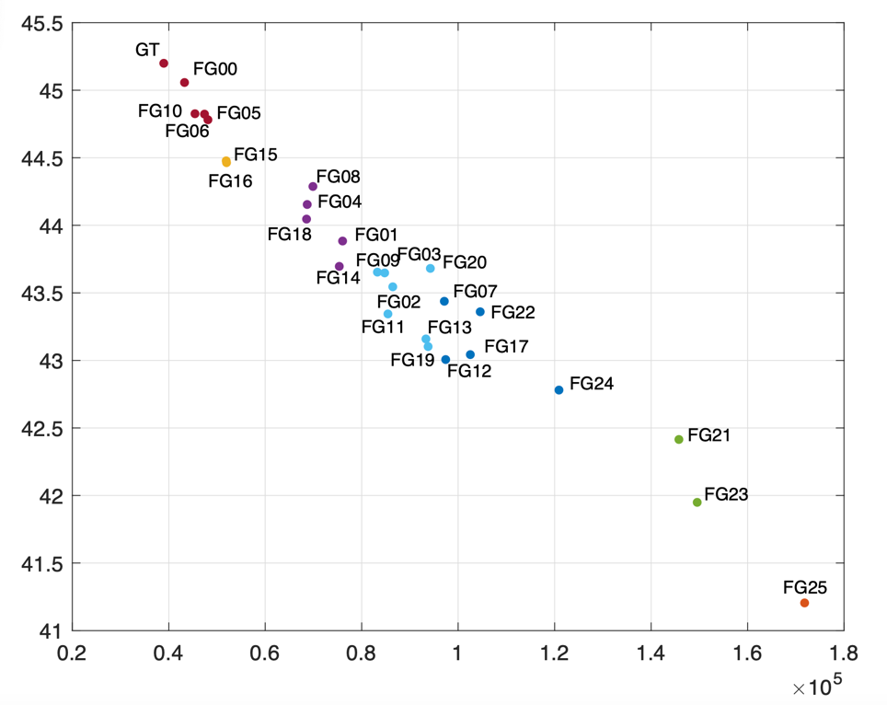
Figure 18. Avg PSNR vs. Avg. Bitrate for all variants for the Tears of Steel “ToS” Scene 046
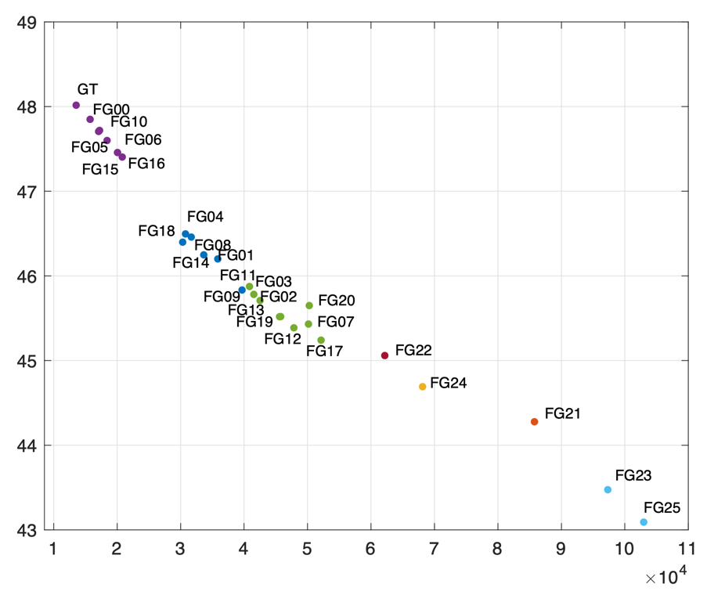
Figure 19. Avg PSNR vs. Avg. Bitrate for all variants for the Tears of Steel “ToS” Scene 062
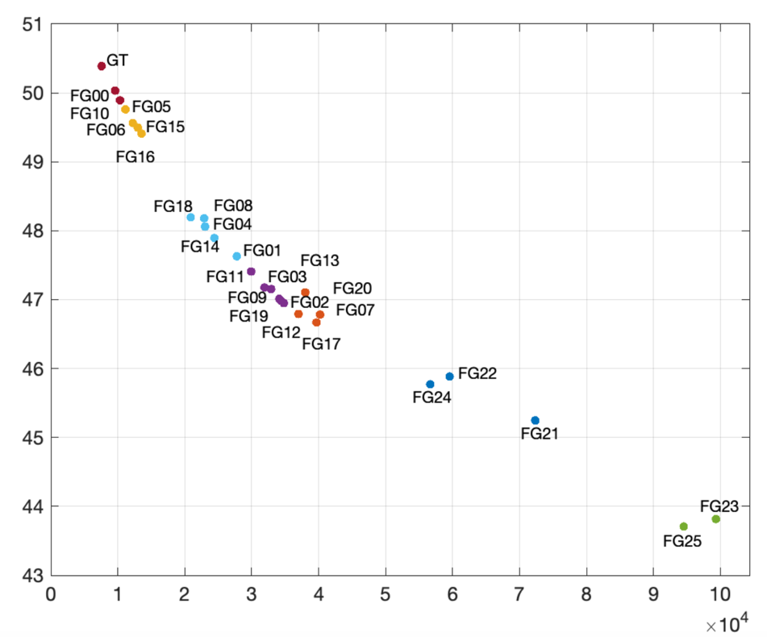

Figure 20. Avg PSNR vs. Avg. Bitrate for all variants for the Tears of Steel “ToS” Scene 101
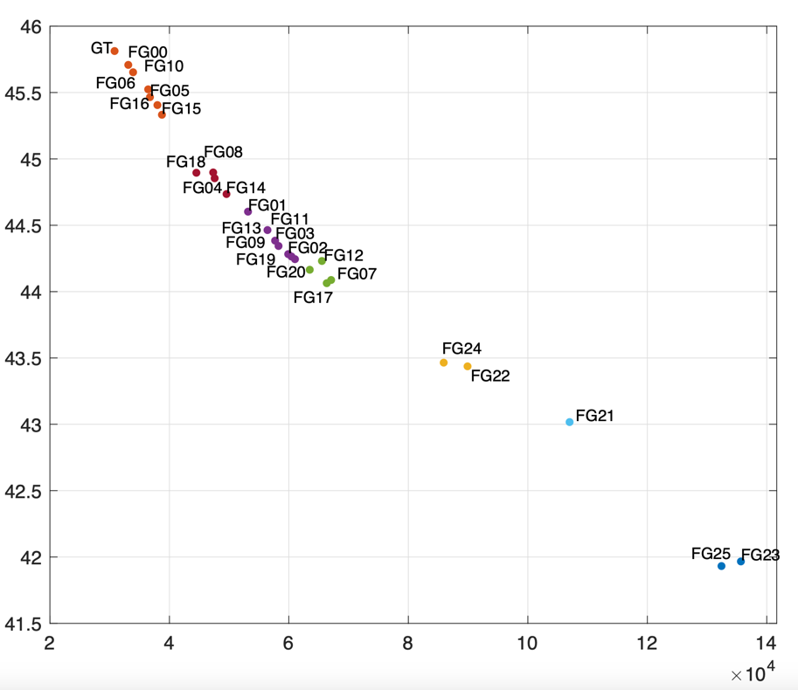
Figure 21. Avg PSNR vs. Avg. Bitrate for all variants for the Tears of Steel “ToS” Scene 135
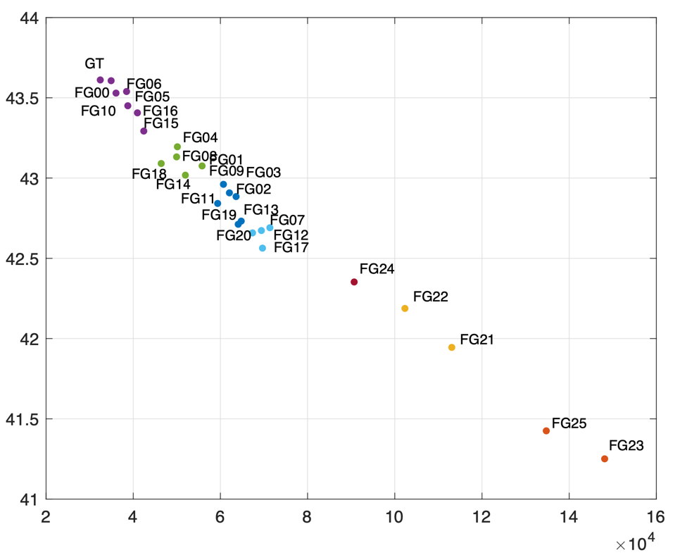
Figure 22. Avg PSNR vs. Avg. Bitrate for all variants for the Tears of Steel “ToS” Scene 136
Figure 23 through Figure 33 show the complexity ratio for each variant i compared to the ground truth, computed by dividing average Complexity(i) by Complexity(0), where Complexity(0) corresponds to the complexity value, as defined in Section 3, for the ground truth variant.
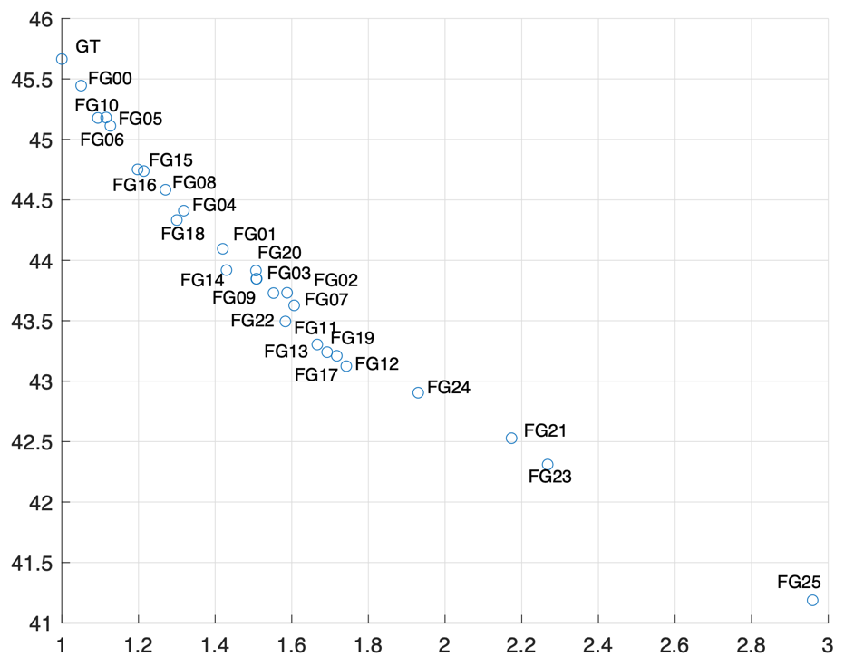
Figure 23. Avg PSNR vs. Avg. complexity for all variants for the Tears of Steel “ToS” Scene 004
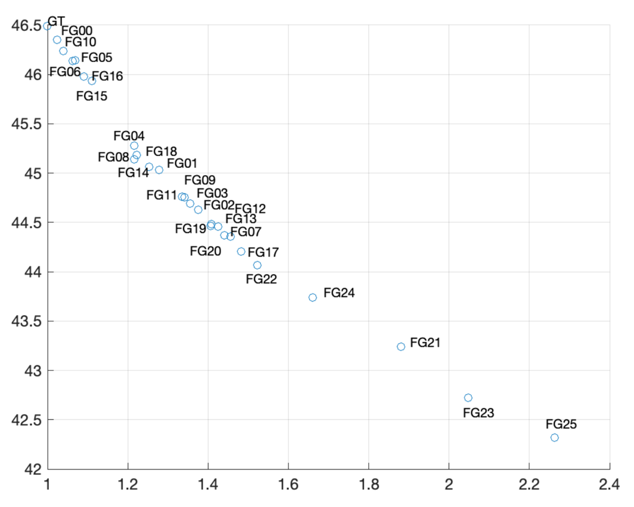
Figure 24. Avg PSNR vs. Avg. complexity for all variants for the Tears of Steel “ToS” Scene 021

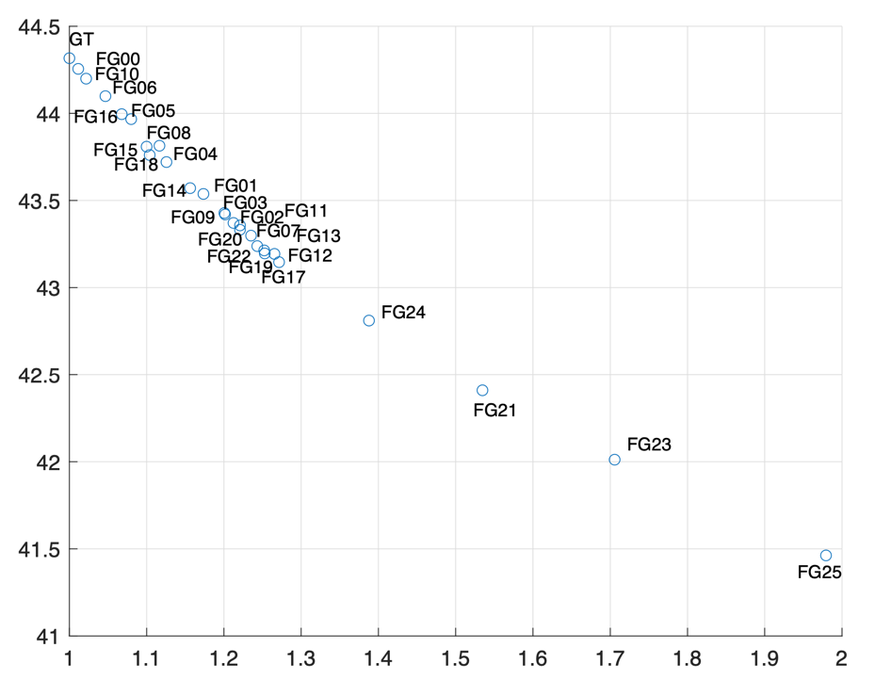
Figure 25. Avg PSNR vs. Avg. complexity for all variants for the Tears of Steel “ToS” Scene 023

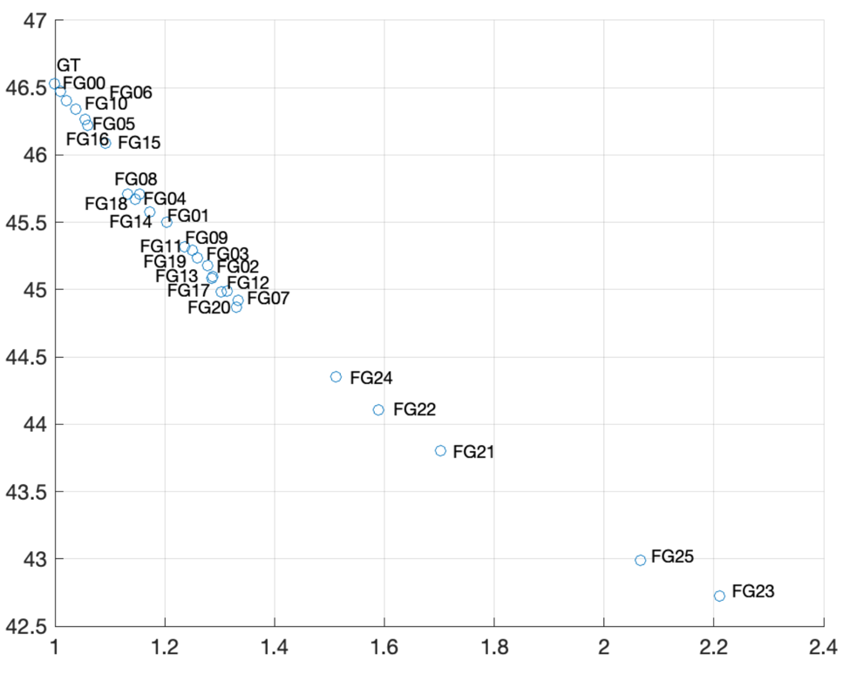
Figure 26. Avg PSNR vs. Avg. complexity for all variants for the Tears of Steel “ToS” Scene 029

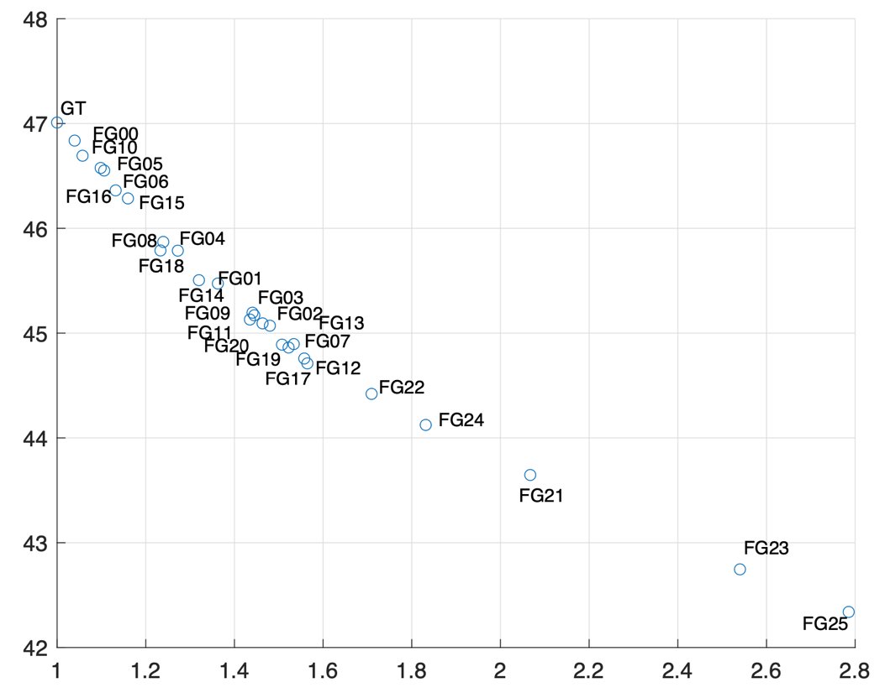
Figure 27. Avg PSNR vs. Avg. complexity for all variants for the Tears of Steel “ToS” Scene 030

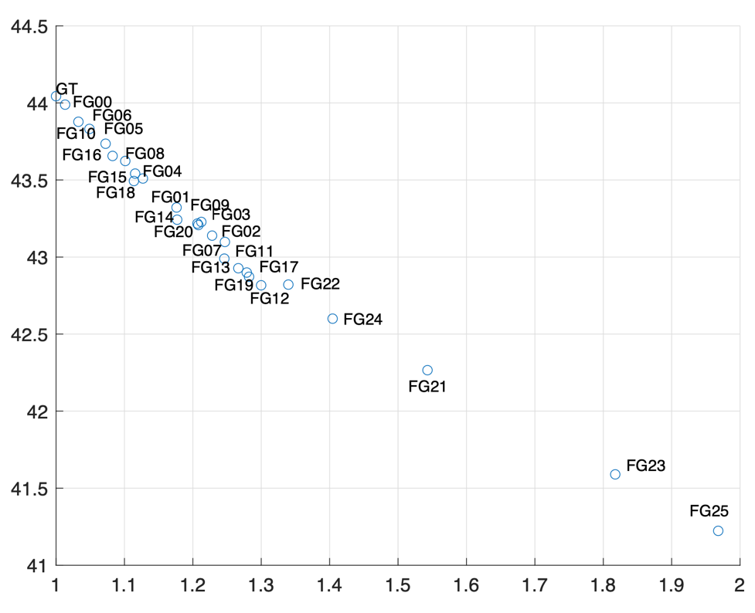
Figure 28. Avg PSNR vs. Avg. complexity for all variants for the Tears of Steel “ToS” Scene 044

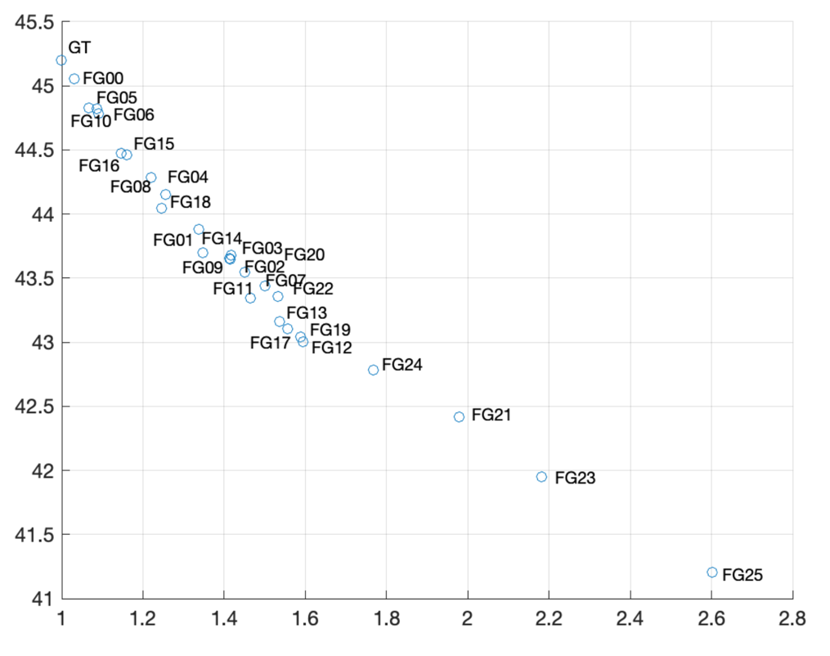
Figure 29. Avg PSNR vs. Avg. complexity for all variants for the Tears of Steel “ToS” Scene 046
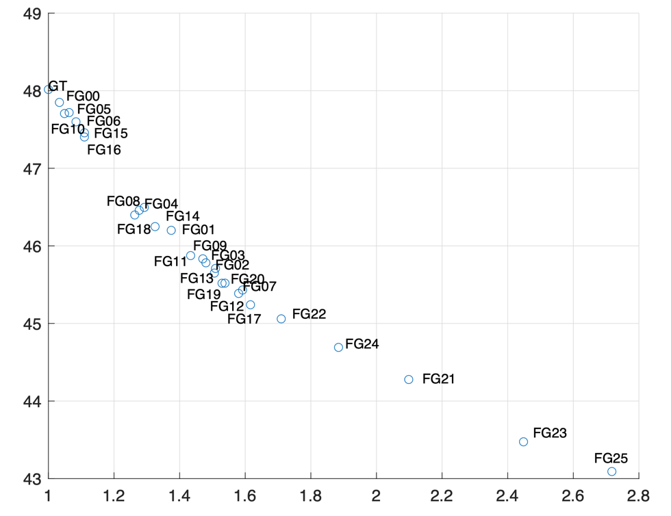
Figure 30. Avg PSNR vs. Avg. complexity for all variants for the Tears of Steel “ToS” Scene 062
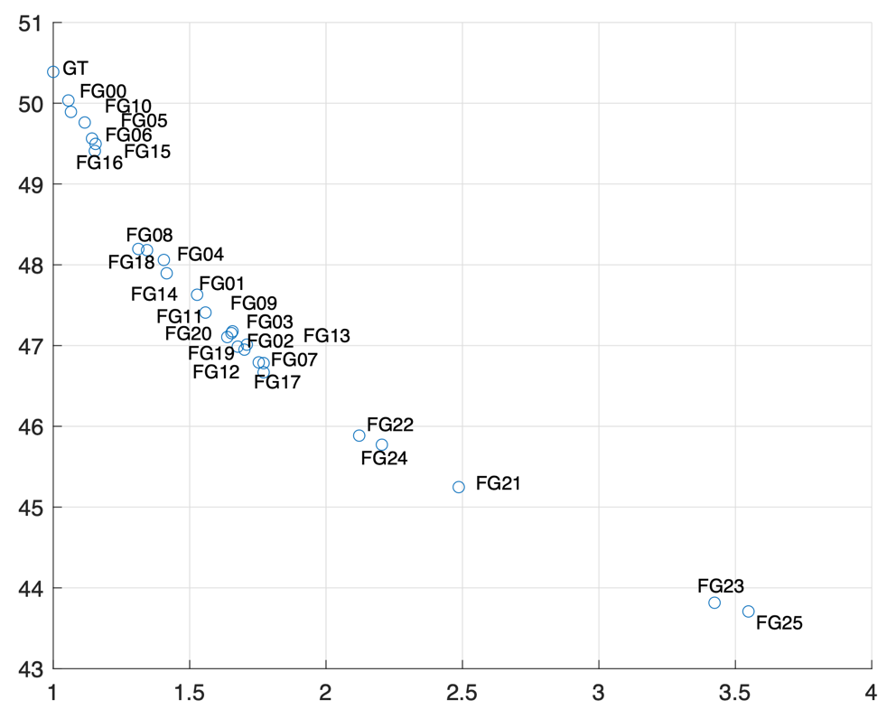

Figure 31. Avg PSNR vs. Avg. complexity for all variants for the Tears of Steel “ToS” Scene 101

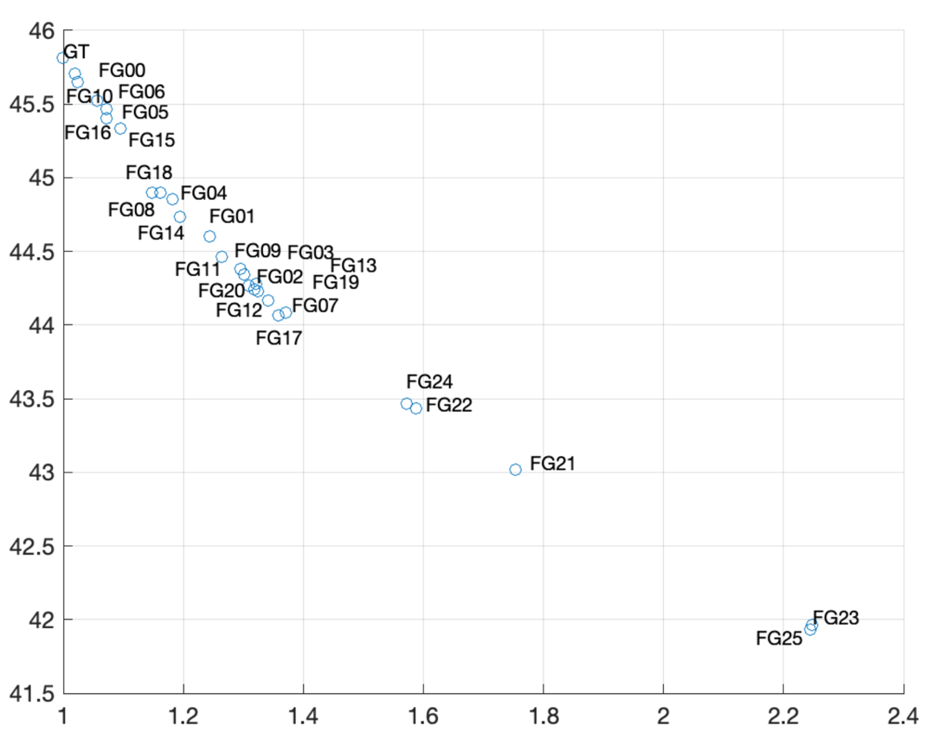
Figure 32. Avg PSNR vs. Avg. complexity for all variants for the Tears of Steel “ToS” Scene 135
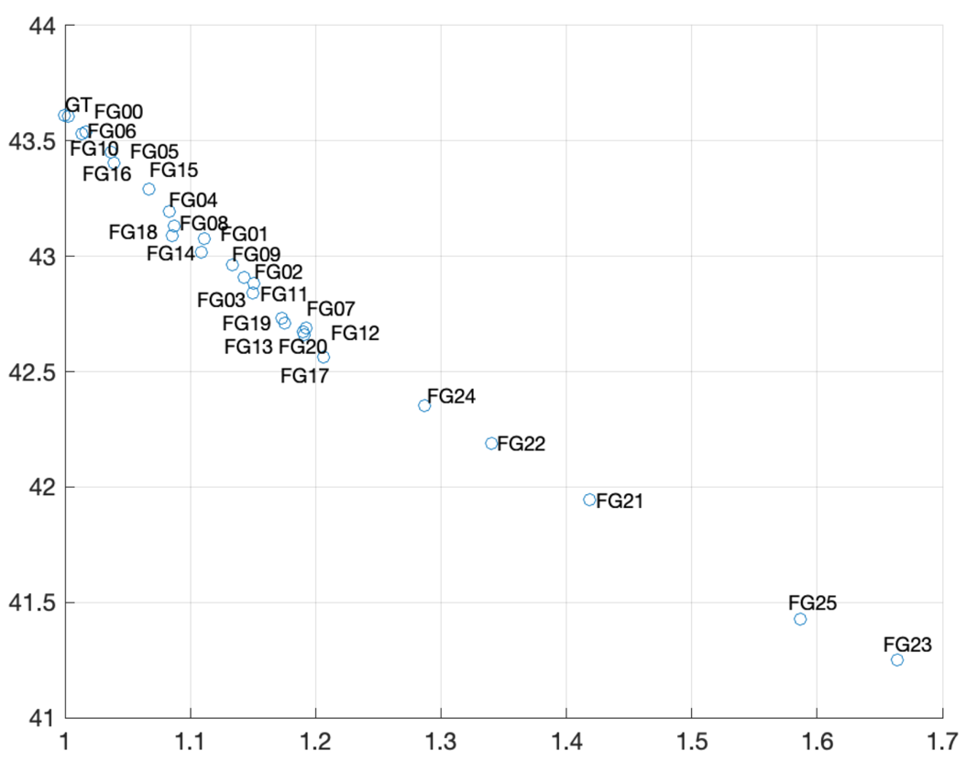
Figure 33. Avg PSNR vs. Avg. complexity for all variants for the Tears of Steel “ToS” Scene 136
The above figures show that several variants exhibit rather similar compressibility behavior. We could utilize this similarity to reduce the variants that could be evaluated for different applications. In particular, one can observe from these that several noise variants seem to be exhibiting similar compressibility behavior. Table 2 through Table 4 provide an initial grouping of all noise variants using K-means clustering. It should be noted that compressibility, however, is also impacted by the spatial and/or temporal characteristics of the original video. This can be seen by the fact that some noise variants may sometimes have been characterized as being of “Low complexity” and others as being of “Moderate complexity”. It may be prudent to also consider such characteristics when selecting the variant to be used for any experiments.
It is interesting to note that in several instances the coloured version of a noise variant, e.g. FG 11 vs FG 1 and FG 18 vs FG 8, is classified in a more complex category. This is not unexpected since such variants now include noise not only in the luma channel but also in the coloured channels, making the content potentially more complicated to encode. Therefore, we should encourage the group, when selecting content, not to immediately reject one of these variants just solely on the fact of both of them being based on the same grain type but look at also other characteristics of each scene and their variants.
Table 2. Possible Low Complexity film grain noise variants for Tears of Steel
Scene004 | 5, 6, 10
Scene021 | 5, 6, 10, 15, 16
Scene023 | 6, 10
Scene029 | 5, 6, 10, 15, 16
Scene030 | 5, 6, 10, 15, 16
Scene044 | 5, 6, 10,16
Scene046 | 5, 6, 10
Scene062 | 5, 6, 10, 15, 16
Scene101 | 1, 2, 3, 4, 5
Scene135 | 10
Scene136 | 5, 6, 10, 16
Table 3. Possible Moderate Complexity film grain noise variants for Tears of Steel
 | Moderate0 | Moderate1 | Moderate2
Scene004 | 4, 8, 15, 16, 18 | 1, 2, 3, 7, 9, 11, 14, 20, 22 | 12, 13, 17, 19
Scene021 | 1, 3, 4, 8, 9, 11, 14, 18 | 2, 7, 12, 13, 17, 19, 20, 22 | 24
Scene023 | 1, 4, 5, 8, 14, 15, 16, 18 | 2, 3, 7, 9, 11, 12, 13, 17, 19, 20, 22 | 24
Scene029 | 1, 4, 8, 14, 18 | 2, 3, 7, 9, 11, 12, 13, 17, 19, 20 | 22, 24
Scene030 | 1, 4, 8, 14, 18 | 2, 3, 7, 9, 11, 12, 13, 17, 19, 20 | 22, 24
Scene044 | 1, 4, 8, 14, 15, 18 | 2, 3, 7, 9, 11, 12, 13, 17, 19, 20 | 22, 24
Scene046 | 4, 8, 15, 16, 18 | 1, 2, 3, 7, 9, 11, 14, 20 | 12, 13, 17, 19, 22, 24
Scene062 | 1, 4, 8, 11, 14, 18 | 2, 3, 7, 9, 12, 13, 17, 19, 20, 22 | 24
Scene101 | 6, 7, 8, 9, 10, 11, 12, 13 | 14, 15, 16, 17, 18, 19, 20, 21 | 22
Scene135 | 5, 6, 15, 16 | 4, 8, 14, 18 | 1, 2, 3, 7, 9, 11, 12, 13, 17,19, 20
Scene136 | 1, 4, 8, 9, 14, 15, 18 | 2, 3, 7, 11, 12, 13, 17, 19, 20 | 22, 24

Table 4. Possible High Complexity film grain noise variants for Tears of Steel
 | Complex0 | Complex1 | Complex2
Scene004 | 24 | 21, 23 | 25
Scene021 | 21 | 23 | 25
Scene023 | 21 | 23 | 25
Scene029 | 21 | 25 | 23
Scene030 | 21 | 23 | 25
Scene044 | 21 | 23 | 25
Scene046 | 21 | 23 | 25
Scene062 | 21 | 23 | 25
Scene101 | 23 | 24 | 25
Scene135 | 22, 24 | 21 | 23, 25
Scene136 | 21 | 25 | 23

Figure 34 through Figure 41 show the rate distortion plots for all different scenes and their noise variants for Gregory sequences. Similar analysis as for the ToS sequences is done in Figure 42 through Figure 57 and in Table 5 through Table 7.
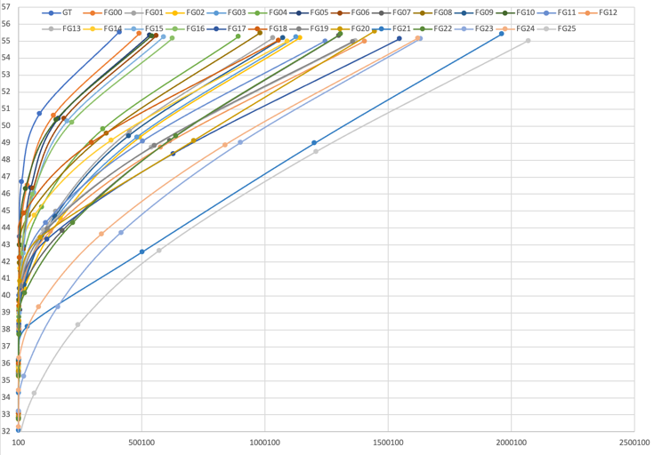
Figure 34. Rate distortion performance for all variants for the EggMixing

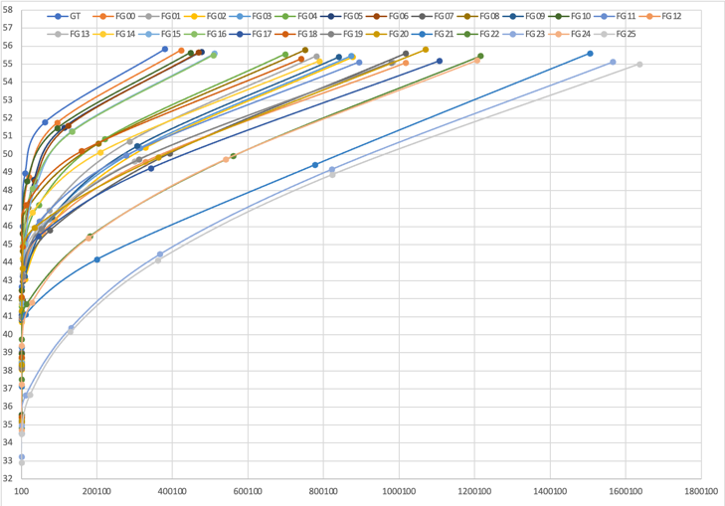
Figure 35. Rate distortion performance for all variants for the ForestFocus

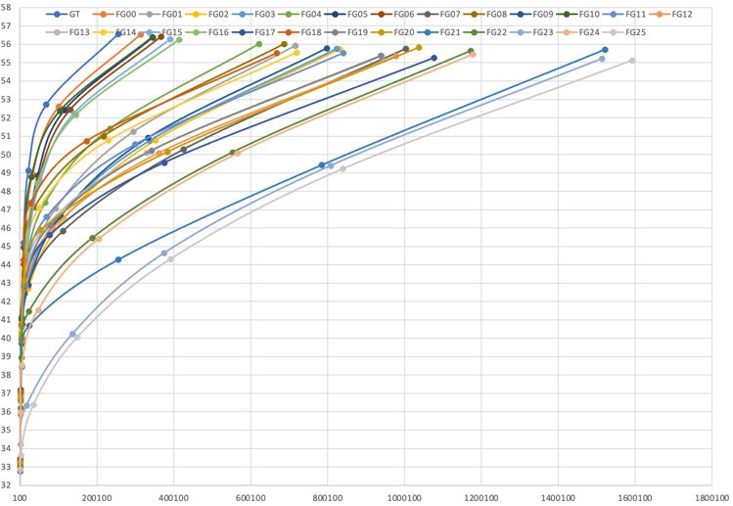
Figure 36. Rate distortion performance for all variants for the ForestZoom

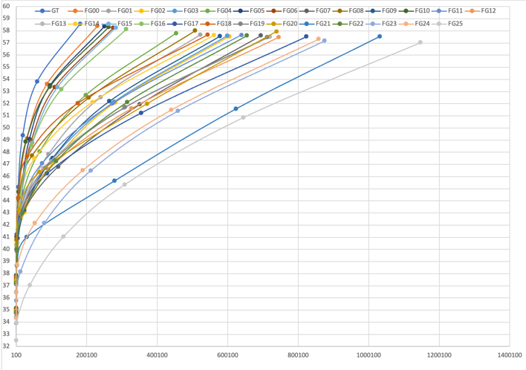
Figure 37. Rate distortion performance for all variants for the GoldenGatePan

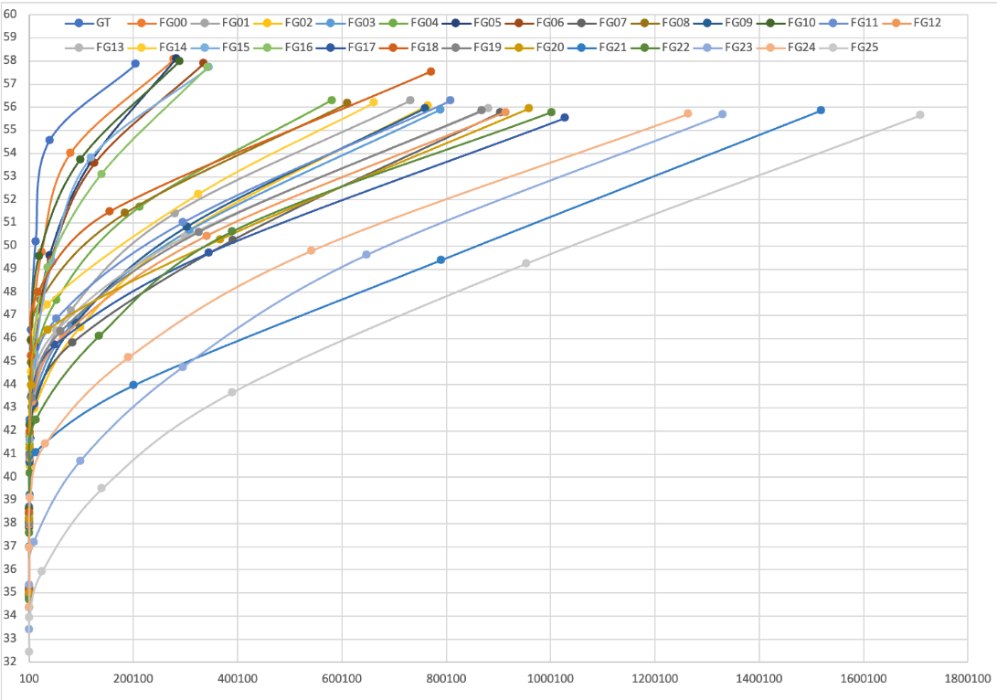
Figure 38. Rate distortion performance for all variants for the GoldenGateBridge
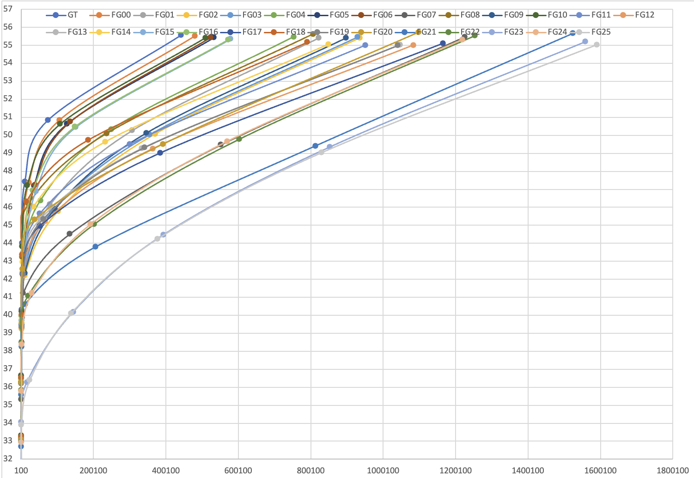
Figure 39. Rate distortion performance for all variants for the Hiker

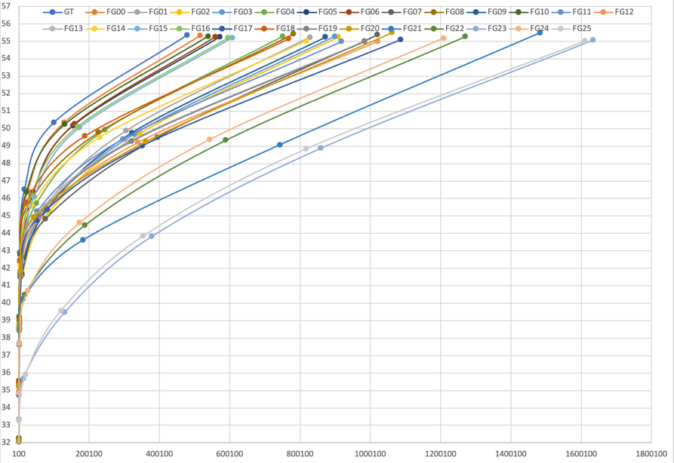
Figure 40. Rate distortion performance for all variants for the IntoTheWoods

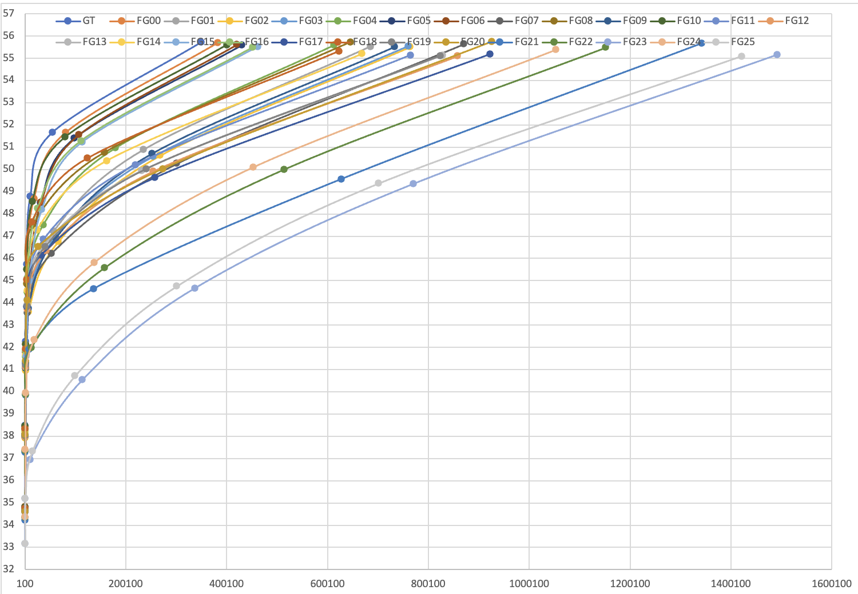
Figure 41. Rate distortion performance for all variants for the TwirlingUmbrella

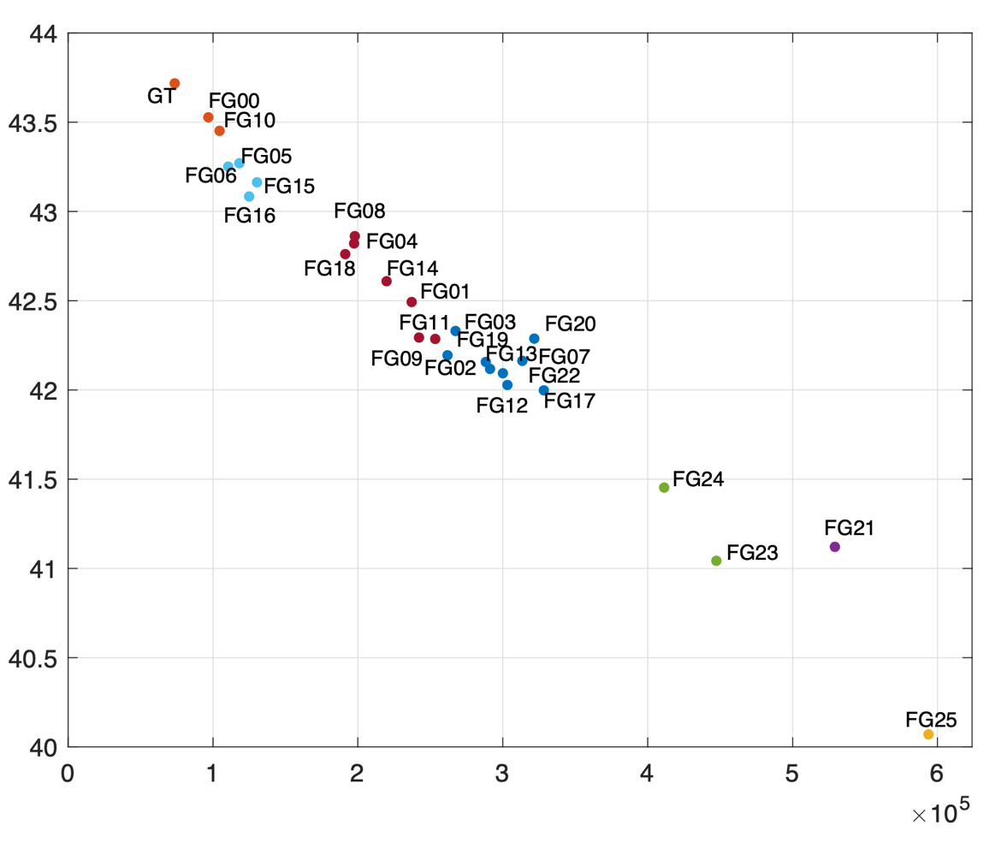
Figure 42. Avg PSNR vs. Avg. Bitrate for all variants for the EggMixing
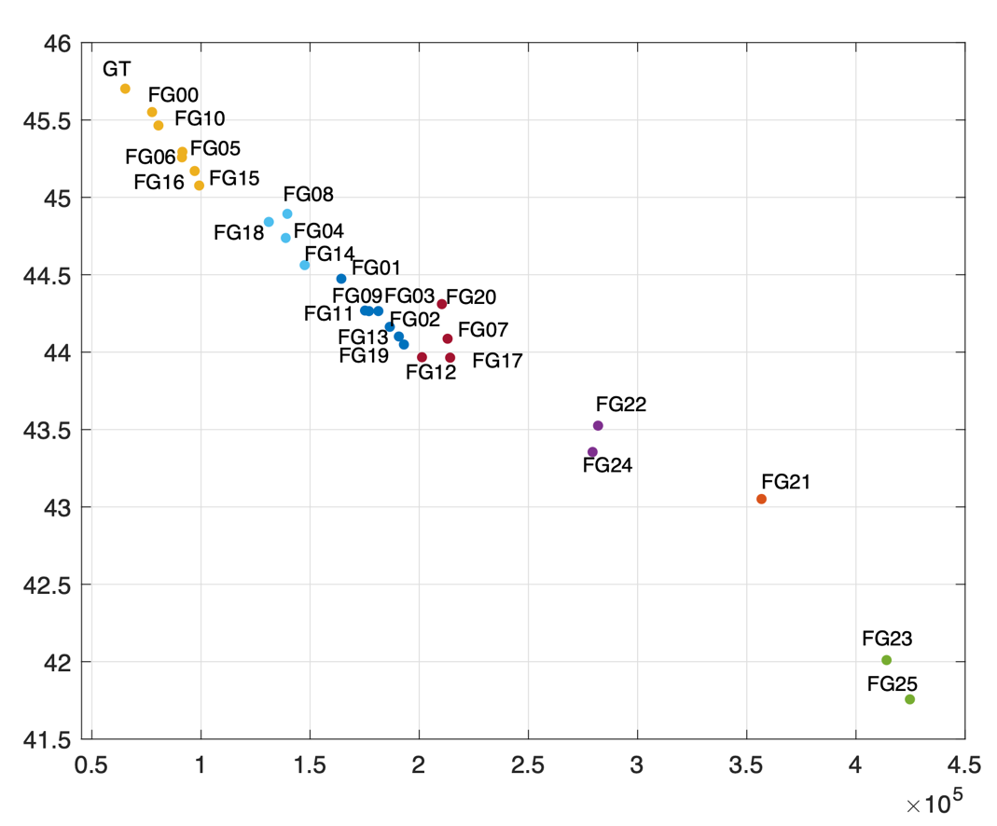
Figure 43. Avg PSNR vs. Avg. Bitrate for all variants for the ForestFocus

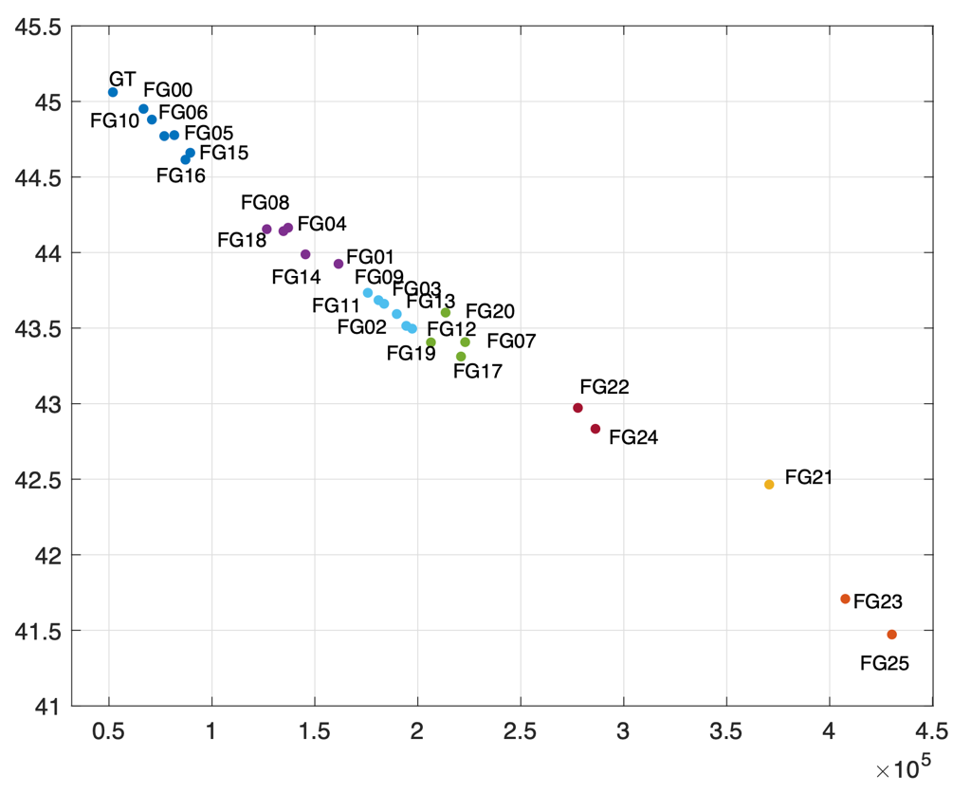
Figure 44. Avg PSNR vs. Avg. Bitrate for all variants for the ForestZoom

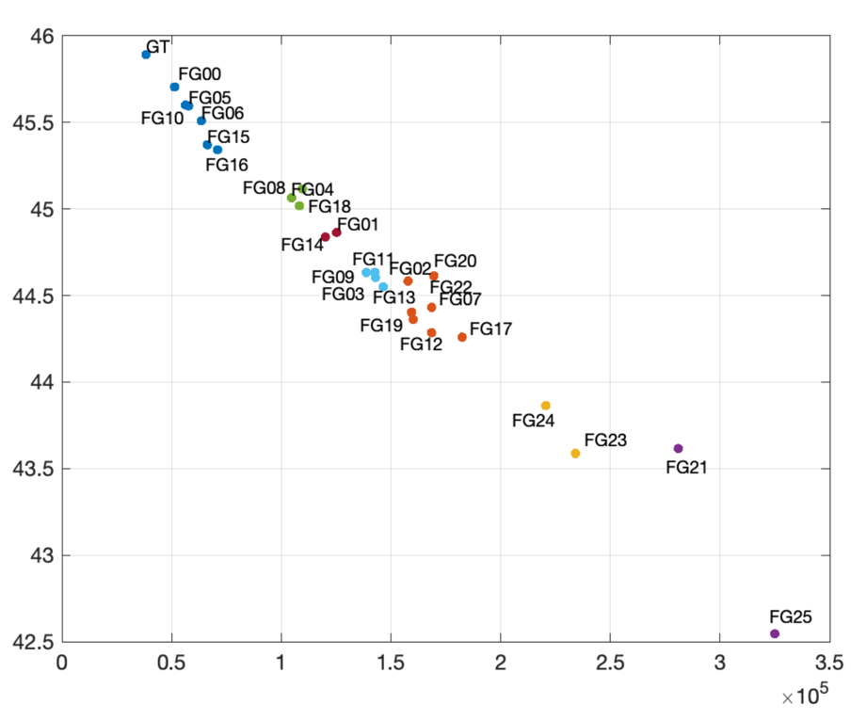
Figure 45. Avg PSNR vs. Avg. Bitrate for all variants for the GoldenGatePan

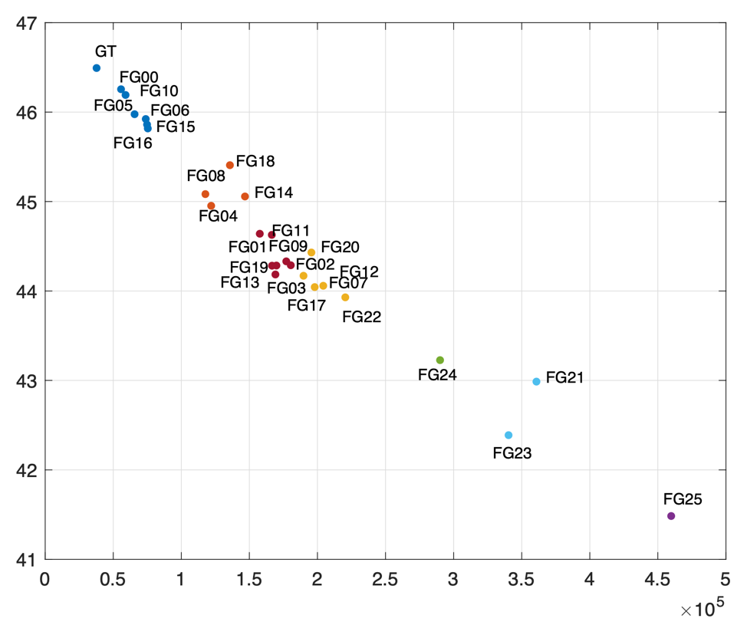
Figure 46. Avg PSNR vs. Avg. Bitrate for all variants for the GoldenGateBridge

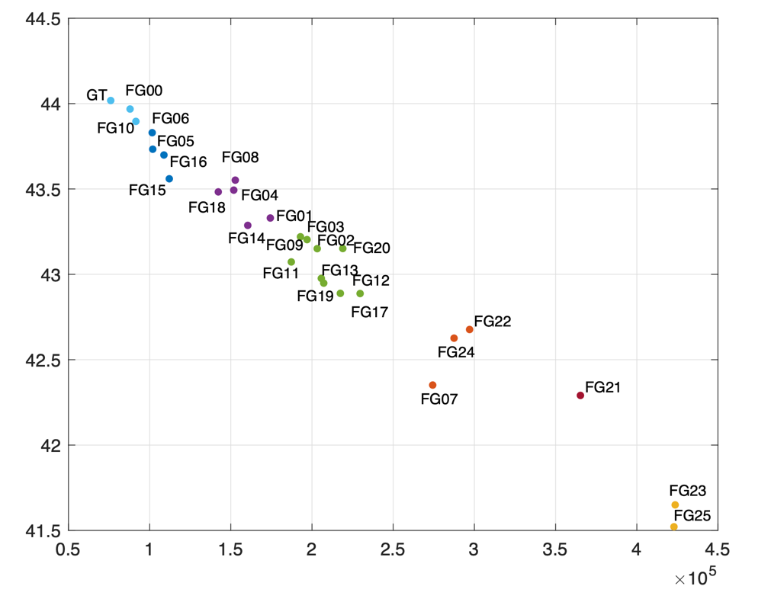
Figure 47. Avg PSNR vs. Avg. Bitrate for all variants for the Hiker

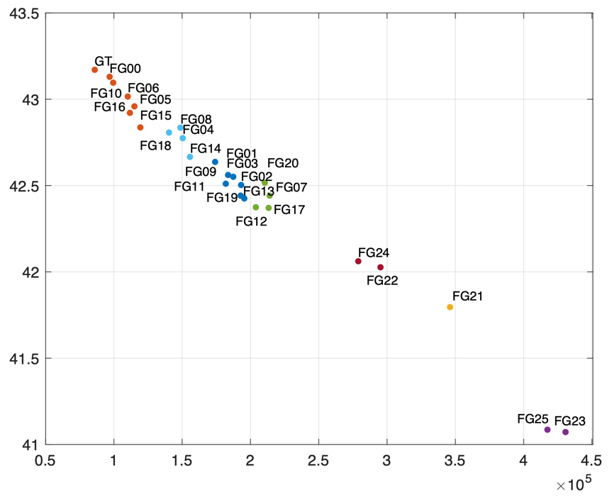
Figure 48. Avg PSNR vs. Avg. Bitrate for all variants for the IntoTheWood
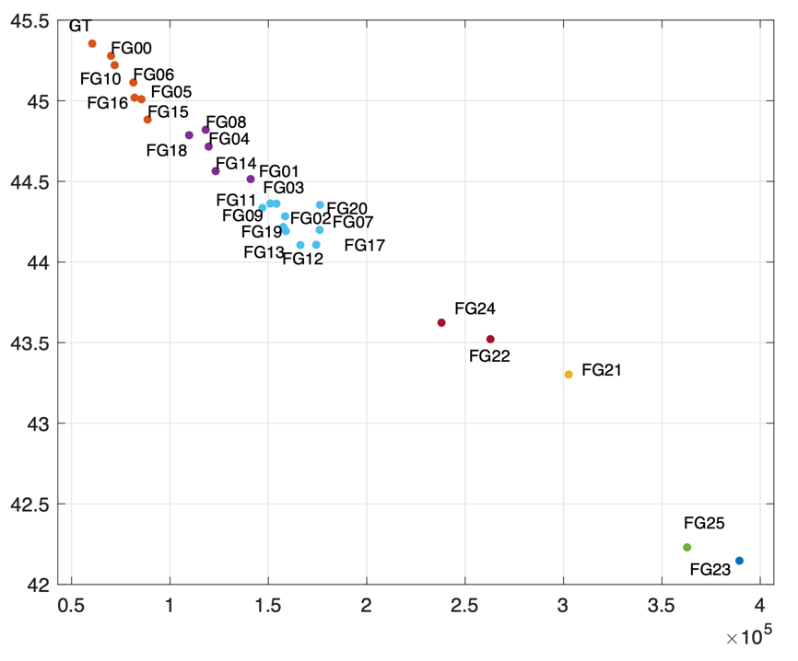
Figure 49. Avg PSNR vs. Avg. Bitrate for all variants for TwirlingUmbrella

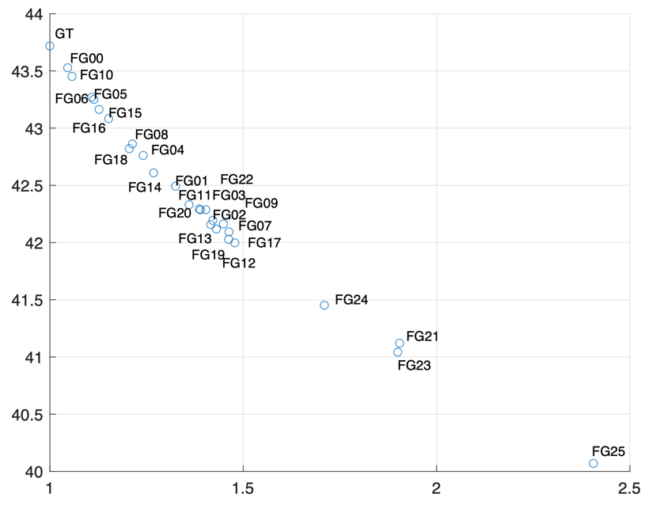
Figure 50. Avg PSNR vs. Avg. complexity for all variants for the EggMixing

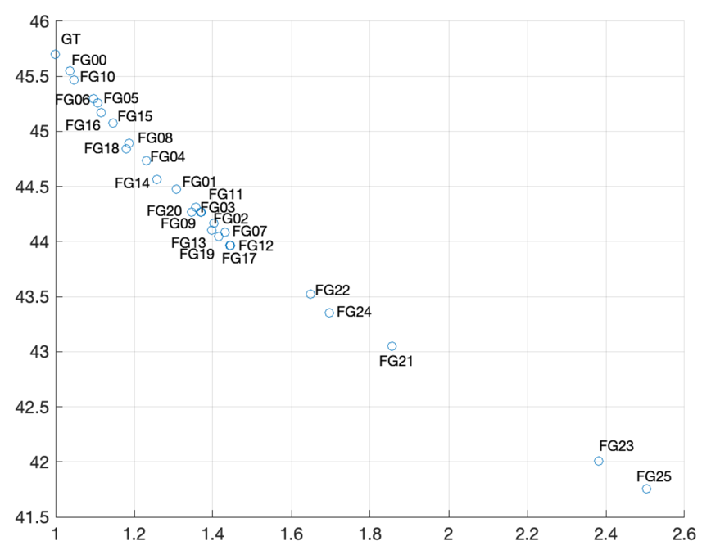
Figure 51. Avg PSNR vs. Avg. complexity for all variants for the ForestFocus

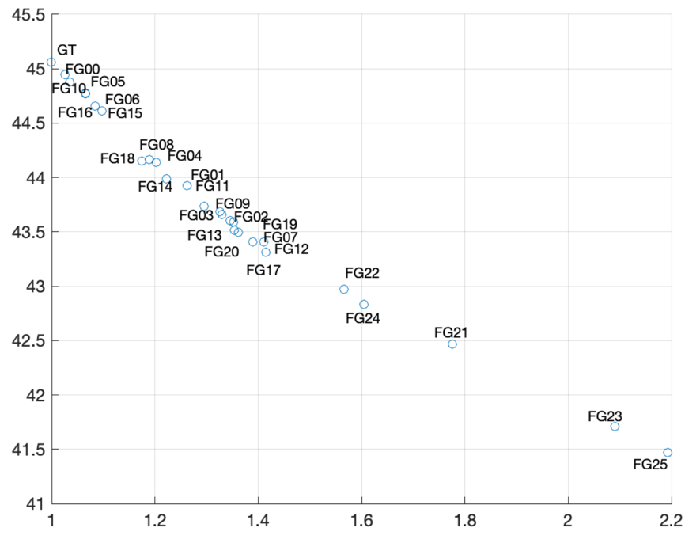
Figure 52. Avg PSNR vs. Avg. complexity for all variants for the ForestZoom

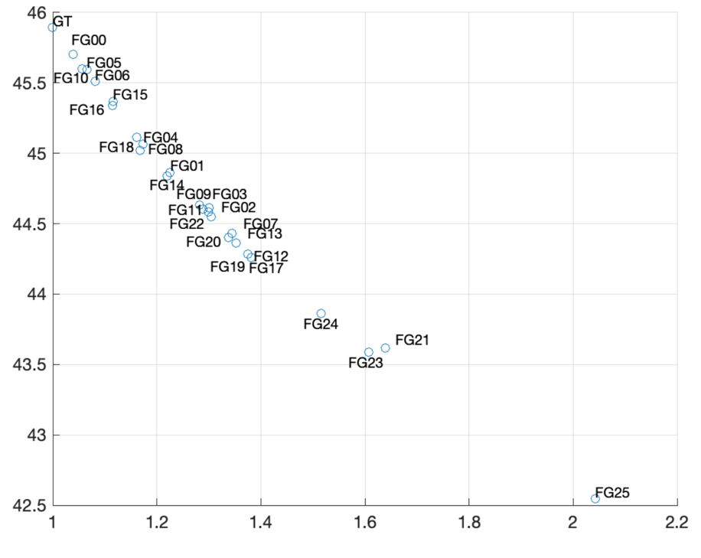
Figure 53. Avg PSNR vs. Avg. complexity for all variants for the GoldenGatePan

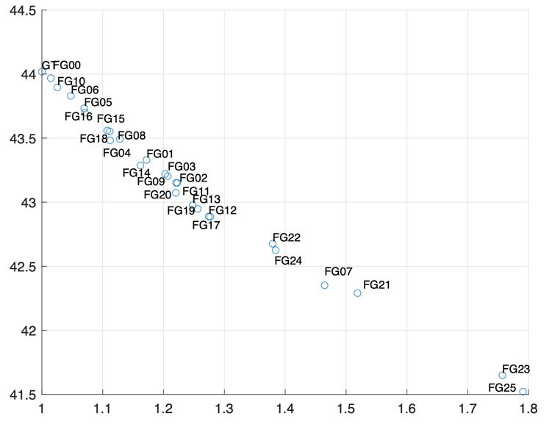
Figure 54. Avg PSNR vs. Avg. complexity for all variants for the GoldenGateBridge

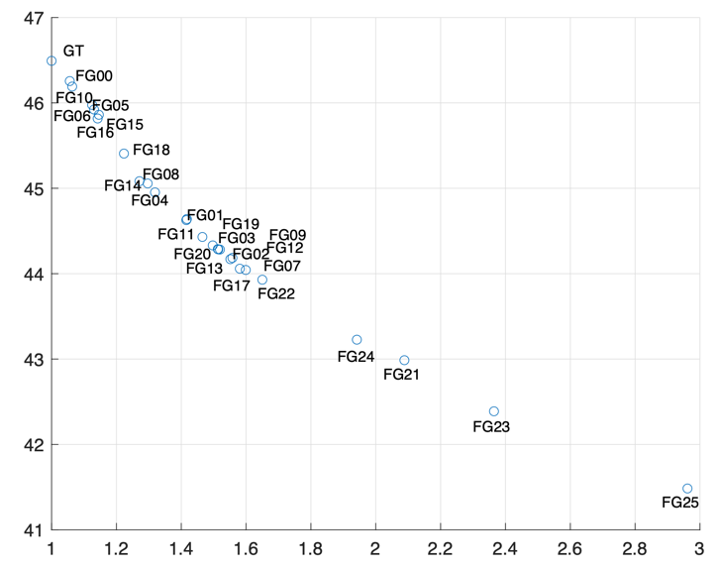
Figure 55. Avg PSNR vs. Avg. complexity for all variants for the Hiker

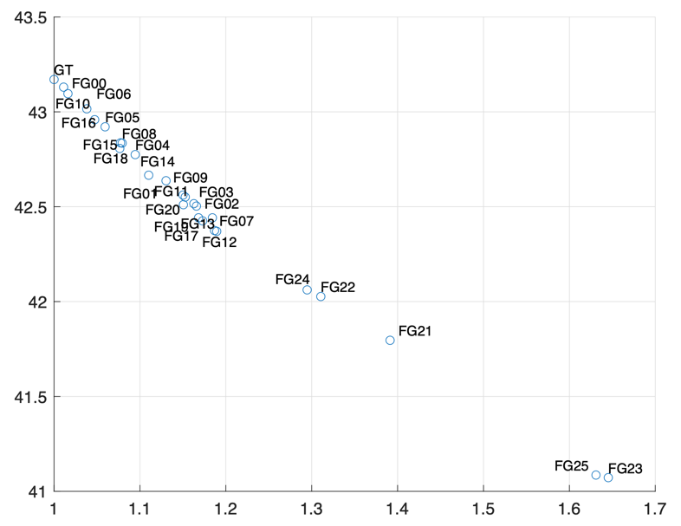
Figure 56. Avg PSNR vs. Avg. complexity for all variants for the IntoTheWoods

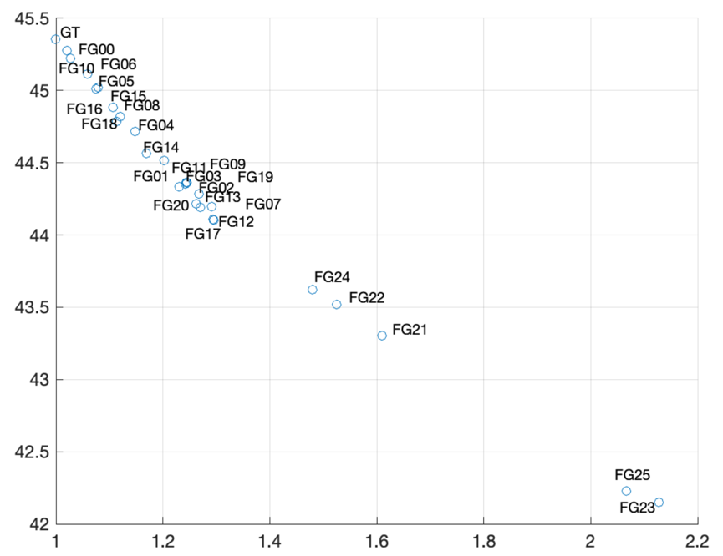
Figure 57. Avg PSNR vs. Avg. complexity for all variants for the TwirlingUmbrella

Table 5. Possible Low Complexity film grain noise variants for Gregory
EggMixing | 10
ForestFocus | 5, 6, 10, 16
ForestZoom | 5, 6, 10, 15, 16
GoldenGatePan | 5, 6, 10, 15, 16
GoldenGateBridge | 5, 6, 10, 15, 16, 18
Hiker | 6, 10
IntoTheWoods | 10
TwirlingUmbrella | 6, 10

Table 6. Possible Moderate Complexity film grain noise variants for Gregory sequences
 | Moderate0 | Moderate1 | Moderate2
EggMixing | 4, 5, 6, 8, 15, 16, 18 | 1, 3, 9, 11, 14 | 2, 7, 12, 13, 17, 19, 20, 22
ForestFocus | 4, 8, 14, 15, 18 | 1, 2, 3, 7, 9, 11, 12, 13, 17, 19, 20 | 22, 24
ForestZoom | 1, 4, 8, 14, 18 | 2, 3, 7, 9, 11, 12, 13, 17, 19, 20 | 22, 24
GoldenGatePan | 1, 4, 8, 14, 18 | 2, 3, 9, 11, 20, 22 | 7, 12, 13, 17, 19
GoldenGateBridge | 1, 4, 8, 11, 14 | 2, 3, 7, 9, 12, 13, 17, 19, 20, 22 | 24
Hiker | 4, 5, 8, 15, 16, 18 | 1, 2, 3, 9, 11, 14, 20, 22 | 12, 13, 17, 19
IntoTheWoods | 4, 8, 15, 16, 18 | 4, 8, 14, 15, 18 | 22, 24
TwirlingUmbrella | 5, 6, 16 | 1, 4, 14 | 2, 3, 7, 9, 11, 12, 13, 17, 19, 20

Table 7. Possible High Complexity film grain noise variants for Gregory sequences
 | Complex0 | Complex1 | Complex2
EggMixing | 24 | 21, 23 | 25
ForestFocus | 21 | 23 | 25
ForestZoom | 21 | 23 | 25
GoldenGatePan | 24 | 21, 23 | 23
GoldenGateBridge | 21 | 23 | 25
Hiker | 24 | 7, 21 | 23, 25
IntoTheWoods | 1, 2, 3, 7, 9, 11, 12, 13, 17, 19, 20 | 21 | 23, 25
TwirlingUmbrella | 22, 24 | 21 | 23, 25

References
- D. Podborksi, B. Williams, L. Levinson, R. Molholm, A. M. Tourapis, “Creation of New Film Grain Content using a Ground Truth Approach”, JVET-AD0369, 30th JVET meeting, Antalya, TR, 21-28 April 2023.
- Apple Inc, “On the availability of new film grain content”, S4-231787, 3GPP TSG-SA WG4 Meeting #126, Chicago, USA
- D. Ugur, D. Podborksi, A. M. Tourapis, “New Film Grain Material based on a Ground Truth approach”, JVET-AF0262, 32nd JVET meeting, Hannover, DE, 13–20 October 2023.
- x265 HEVC encoder, https://github.com/videolan/x265
- FFMPEG reference software, https://ffmpeg.org/
- D. Podborski, D. Ugur, A. M. Tourapis, “Evaluating Denoising methods in the context of Film Grain Analysis/Synthesis”, JVET-AE0251, 31st JVET meeting, Geneva, CH, 11-19 July 2023.

Examples of use of the FGC SEI designer tool
- Example of use
  - Prepare original and degrained/decoded videos
The tool can interactively test film grain synthesis on a degrained video. This is done by automatically running the vfgs film grain synthesizer every time anything changes in the GUI. The test video is specified using the [File / Load YUV (clean)] menu, shown in Figure 4.
The degrained/clean video can be a decoded video without having to use any specific denoiser, since encoders likely remove grain by themselves. We suggest selecting a quality level (QP) where image quality is still very good but grain is removed in most pictures (see next section for more details). QP 26 for HM (or VTM) encodings, for example.
The temporary parameters are saved in __preview.cfg and result of film grain synthesis is output in the __preview_3840x2160_8b.yuv file in the current directory. The original and regrained images can be compared in a YUV viewer, preferably one that refreshes display upon file changes, so that the results of a change in GUI can be seen immediately.
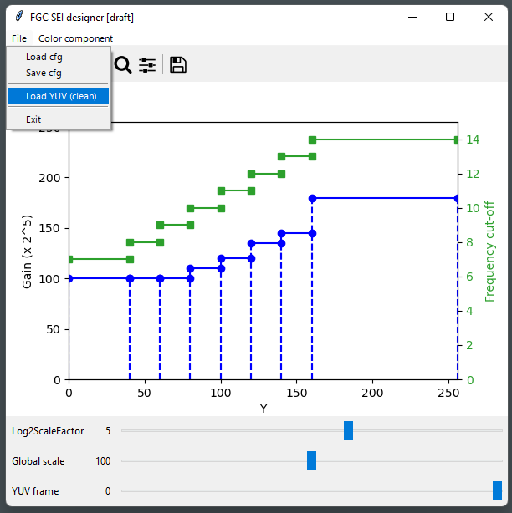
Figure 4 – Loading a test video file

1.2. Select a decoded picture for study
Grain may not be completely removed in all decoded pictures; for example some grain can remain on Intra pictures, and some badly impaired grain (visually annoying) can be present in the first temporal layers (e.g. Intra + 16, 8, 24), as illustrated in Figure 5.
A totally clean picture can be selected for easy grain estimation by comparison with the source, or one where grain is badly impaired to observe how synthetic grain magically removes the problem, as show in Figure 6.
The relevant test frame is selected with the slider on the bottom of the window, as shown in Figure 7.
Figure 5 – Example decoded video at POC #0, #16, #8, #11
Figure 6 – Example of how grain synthesis hides impaired grain
Left: decoded; right: decoded + grain synthesis
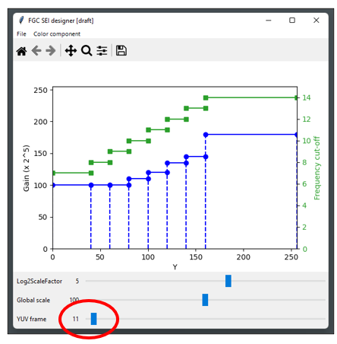
Figure 7 – Selecting the test frame using the slider

1.3. Focus on a light area, tune amplitude and size
The experimentation can start with a flat configuration, for example load « Gaussian-1s.cfg » (using [File / Load cfg] menu), first focusing on luma, on a light area with a good amount a grain (e.g. sky, or white surface).
Then Log2ScaleFactor slider can be adjusted to 4 for example, and the gain (blue curve) can be dragged to match original grain amplitude. There is no need to be very precise at this stage, however it can be observed that the eye is rather sensitive to variations of grain amplitude; Figure 9 illustrates grain synthesis strength setting either 20% too low or too strong compared to the estimated sweet spot.
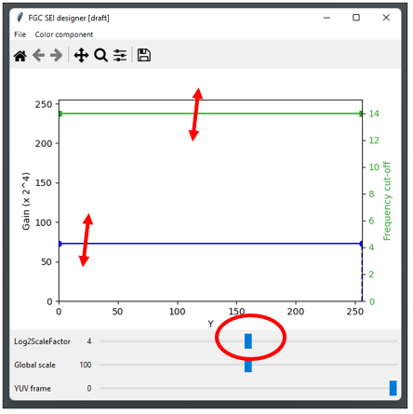
Figure 8 – Adjusting log2ScaleFactor, grain strength and size

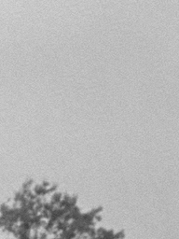
Figure 9 – Tuning grain strength
Left: original - Middle: synthesis, too low – Right: synthesis, too strong
Then, the green curve can be adjusted (grain bandwidth or size) to best match original. This is more difficult to get right; it may help to use 100% and 200% viewing scales, and compare the grains themselves (difference between grainy and clean images). Amplitude may need to be refined at the same time, since reducing the bandwidth also reduces the total energy of synthesized grain.
The grain seed can be changed by touching the YUV frame slider on the bottom if the grain pattern needs to be changed.
On this example, we keep 14 for the light area as it looks right (grain is very fine here).
Figure 10 – Tuning grain size
Left: original - Right: synthesis, too large
  - Split interval and focus on a darker area
In Figure 12, it can be observed that the parameters tuned for the light area do not work on darker areas. This illustrates the interest of the FGC SEI, that can adapt mode parameters to light level.
The interval can be split by double-click, then one sub-interval can be disabled by right-click, and interval boundary can be dragged to isolate an area of interest (e.g. dark clothes), as explained in Figure 11.
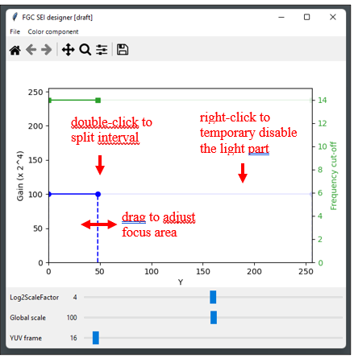
Figure 11 – Splitting interval and adjusting focus on a dark area
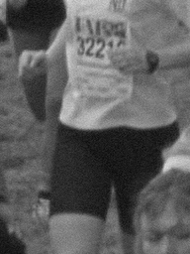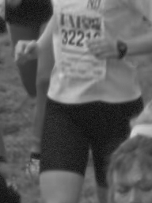
Figure 12 – Focusing on a dark area
Left: original – Middle: wrong parameters – Right: dark area isolated
Observing the grain pattern of the original (by difference with decoded) in Figure 13, it is evident that grain is both less strong and smoother/coarser in the dark. Grain amplitude (blue curve) and size (green curve) are then dragged to match original on the area under study, with the result shown in Figure 14.
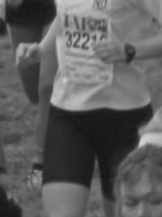
Figure 13 – Tuning grain on a dark area
Left: original – Middle: original grain – Right: dark area tuned
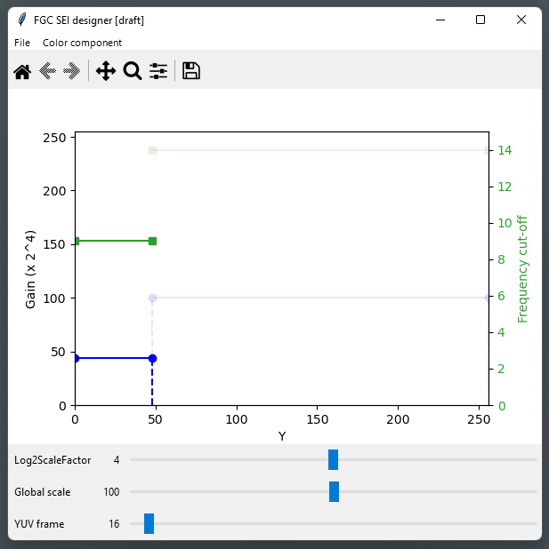
Figure 14 – Parameter adjustment for dark area

  - Create more intervals, and repeat on chroma
The reach the result shown in section 2.2, more work is needed: refine intervals (iterative split and tuning), and repeat the process on each chroma channel.
It is noted that sometimes, the grain is not fully consistent over the picture for a given intensity interval, and a compromise has to be found. This might be caused by film warping, or color space. It is then recommended to check the settings on the whole picture, out of the focus areas that were used for tuning.
- Concluding remarks
A graphical tool to display and adjust film grain parameters was presented, to encourage and ease the experimentation with film grain synthesis technologies, and to demonstrate the capabilities of the FGC SEI message in conjunction with a hardware-friendly implementation. In particular, the following FGC SEI message functionalities are demonstrated: mode parameters fitting the grain shape and strength, and local variation of both shape and strength, as observed on real film, and this contribution highlights the benefit of these functions.
This tool also enables interactive visual testing, that may be interesting for the “grain fidelity” aspect.

- References
[1] JVET-AD0382, Results of expert viewing for testing of FGC SEI message, M. Wien (RWTH Aachen University), April 2023.

[Proposed additions to TR26.955 for FGS scenarios– Preliminary test results]
FGS workflow for preserving artistic intent
Film grain can be unavoidably lost by conventional video compression workflows, as shown in Figure 1. The high frequency grain in the source content ($x$) can be either completely or partially lost due to quantization/resizing in adaptive streaming or broadcast applications, and the resulting decoded output $\tilde{x}$ may be void of the artistic effect of the grain intended in source. Even if grain is partially preserved at high bitrates, overall coding efficiency may be poor as film grain is not spatially or temporally correlated, impacting the coding characteristics of the scene and a significant number of bits may be needed to achieve an acceptable coding and at the same time preserve the film grain.

Figure 1 HEVC workflow without film grain
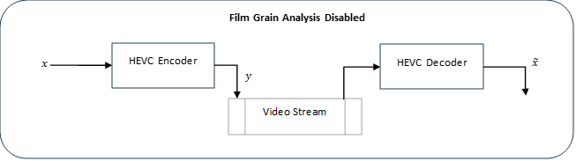

The following notations are used for the film grain preservation workflow depicted in Figure 2:
- $x$ is the source video (uncompressed)
- $x_{dn}$is the denoised source video.
- $y_{dn}$is the compressed bitstream of the denoised video.
- $\tilde{x_{dn}}$ is the decoded denoised video.
$\tilde{x_{g}}$ is the grain synthesized video, using, for example, the FGC SEI message parameters.

Figure 2 HEVC film grain modeling and synthesis workflow
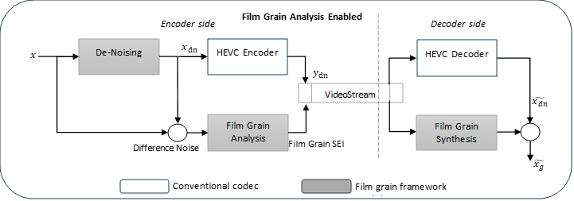
Quality Evaluation Methods for FGS
To assess the benefits of grain characterization and synthesis for preserving artistic intent two independent subjective quality verification tests were recently conducted. It is noted that these tests were performed per Dolby Laboratory direction & lacks endorsement by 3GPP SA4. The first test used the MOS scoring method and used 14 test subjects/viewers, while the second test used the A-B Preference method and used 11 test subjects. It should be noted that it is commonly recommended that for a subjective test to be reliable a higher number of test subjects, i.e. >=25. In addition, encodings were performed without the consideration of subjective optimization tools or quantization matrices, which can have a significant impact especially in the presence of film grain in the content. Therefore, one should be cautious in making any conclusions based on these tests given their limitations.

Subjective Performance Evaluation Methods
- MOS Scoring Method
  - ITU-T_Rec. P.190 based subjective performance evaluation method (pair-wise testing with hidden reference). This method is a category judgement where the test sequences are presented one at a time and are rated independently on a category scale (1 to 10). The present test procedure must include a reference version of each test sequence shown as any other test stimulus.
Test Site | On-site
Display, size, connection  (resolution setting) | Samsung 65” S95B, HDMI (3840×2160)
Viewing distance | 2 viewers sitting at 1.5H, 1 viewer standing at 1.6H
Viewing angle | ±75°, 90° (at screen center)
Total number of viewers | 14 (4female, 10 male)

- A-B Preference Method
  - The test sequences were evaluated using a 5-score scale, the 5 scores (A>>B, A>B, A==B, A<B, A<<B) were mapped to the values (3, 1, 0, -1, -3) and the random A-B assignment was reverted. In the comparison of the compressed sequences with and without FGS, positive numbers indicate that the FGS version was scored higher.
Test Site | On-site
Display, size, connection  (resolution setting) | Samsung 65” S95B, HDMI (3840×2160)
Viewing distance | 2 viewers sitting at 1.5H, 1 views standing at 1.6H
Viewing angle | ±75°, 90° (at screen center)
Total number of viewers | 14 (4 female, 10 male)

Scenario FHD Test Results (Subjective)

[Rapporteur’s note 31 Jan. 2024 : Samsung commented that the confidence level overlap is too great & the bitrate range is limited to mid/low bitrates to confidently tell if FGS shows clear benefits.]

BQTerrace Observations
- 7 out of 14 viewers have given higher or same rating for FGA enabled streams across all bitrates.
- 3 out 14 viewers failed to detect the hidden reference.
- Higher confidence intervals indicate high variability in viewer ratings.
- Although the confidence intervals overlap, the overlap is less than 50% of the interval range. The lower end of the FGA enabled confidence interval is consistently higher than the FGA disabled MOS score.

OldTownCross Observations
- 7 out of 14 viewers have given higher or same rating for FGA enabled streams across all bitrates.
- 2 out 14 viewers failed to detect the hidden reference.
- Confidence interval overlap is minimal indicating the ratings are consistently favoring FGS.

InToTree Observations
- 6 out of 14 viewers have given higher or same rating for FGA enabled streams across all bitrates.
- Only 1 out 14 viewers failed to detect the hidden reference.
- MOS difference between FGS and No_FGS is narrow in this content.
- For the two lower rate points, the lower end of FGA enabled confidence interval is higher than the FGA disabled MOS score.
Scenario 4K-TV Test Results (Subjective)

CrowdRun Observations
- 10 out of 14 viewers have given higher or same rating for FGA enabled streams across all bitrates.
- Only 1 out 14 viewers failed to detect the hidden reference.
- The Confidence Interval (CI) overlap is negligible for the higher rate points of 10Mbps and 19Mbps indicating the rating are consistently favoring FGS in these operating rates. Surprisingly, the lowest rate point has significant CI overlap. The higher spatial and temporal complexity of crowd run content makes it difficult to preserve details at these low rates and could lead to annoying artifacts which could outweigh benefit of synthesized grain.

Tears of Steel Subjective Test Results

Scene004 FG 03 Observations
- 10 out of 14 viewers have given higher or same rating for FGA enabled streams across all bitrates.
- 3 out 14 of viewers failed to detect the hidden reference.
- Except for the highest rate point, confidence interval overlap is minimal indicating the ratings are consistently favoring FGS.

Scene004 FG 22 Observations
- 6 out of 14 viewers have given higher or same rating for FGA enabled streams across all bitrates.
- Only 1 out of 14 viewers failed to detect the hidden reference.
- Although the confidence intervals overlap, the overlap is less than 50% of the interval range. The lower end of the FGA enabled confidence interval is consistently higher than the FGA disabled MOS score.

Scene044 FG 03 Observations
- 9 out of 14 viewers have given higher or same rating for FGA enabled streams across all bitrates.
- All 14 viewers detected the hidden reference successfully.
- Confidence interval overlap is minimal indicating the rating are consistently favoring FGS.

Scene044 FG 22 Observations
- 9 out of 14 viewers have given higher or same rating for FGA enabled streams across all bitrates.
- Only 1 out of 14 viewers failed to detect the hidden reference.
- Except for the lowest rate point, confidence interval overlap is minimal indicating the ratings are consistently favoring FGS.

Scene062 FG 16 Observations
- 12 out of 14 viewers have given higher or same rating for FGA enabled streams across all bitrates.
- All 14 viewers detected the hidden reference successfully.
- Higher confidence intervals indicates varied ratings of viewers.

Scene062 FG 24 Observations
- 8 out of 14 viewers have given higher or same rating for FGA enabled streams across all bitrates.
- Only 1 out of 14 viewers failed to detect the hidden reference.
- Higher confidence intervals indicates high variability in viewer ratings.

Scene101 FG 21 Observations
- 8 out of 14 viewers have given higher or same rating for FGA enabled streams across all bitrates.
- All 14 viewers detected the hidden reference successfully.
- MOS difference between FGS and No_FGS is narrow in this content.
- The lower end of the FGA enabled confidence interval is consistently higher than the FGA disabled MOS score.

Scene101 FG 24 Observations
- 10 out of 14 viewers have given higher or same rating for FGA enabled streams across all bitrates.
- All 14 viewers detected the hidden reference successfully.
- Confidence interval overlap is minimal indicating the rating are consistently favoring FGS.
Summary remarks from proponent for Dolby FGS subjective test results for preserving artistic intent
- Results of subjective quality assessment for preserving artistic intent indicate a potentially significant visual benefit by applying film grain synthesis for improving the visual quality of a compressed video sequence.
- In the evaluated set of bitrates, gains are specifically observed for mid- to low-bitrate ranges.
- At low bitrates, the capability of preserving artistic intent by FGS is higher. The FGS enabled MOS for all sequences is always better than FGS disabled.
- It is observed that the impact of FGS is strongly dependent on the test sequence.
- The distance of the MOS curves indicates significant quality improvements for these sequences with FGS.
  - OldTownCross
  - TOS - Scene044 FG 03
  - TOS - Scene004 FG 03
  - TOS - Scene044 FG 22
- Following sequences show tendency towards quality improvement with FGS but the confidence intervals overlap across rate points is high.
  - BQTerrace
  - TOS – Scene062 FG 16
  - TOS – Scene062 FG 24

FGS workflow for masking coding artifacts
Film grain technology can also be used as a mechanism for masking artifacts that may have been introduced during the coding process. This process could even be used on content that did not originally contain film grain. In particular, film grain could potentially help in improving the subjective quality by subtly masking artifacts such as blockiness, banding, and blurred textures at low bitrates.

Figure 3 HEVC workflow for film grain estimation for masking coding artifacts
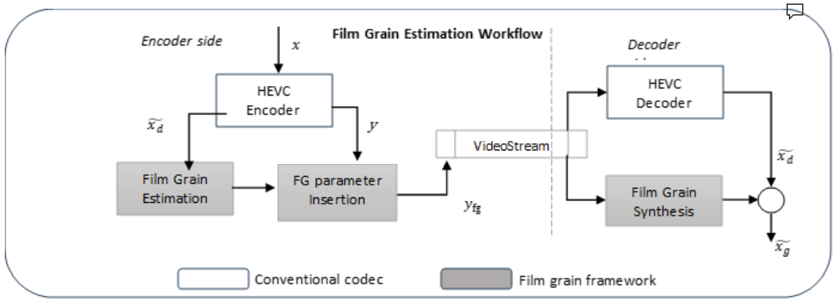
The following notations are used for the film grain estimation for masking coding artifacts workflow that is depicted in Figure 3:
- $x$ is the source video (uncompressed)
- $y_{fg}$is the compressed bitstream that also includes some Film Grain parameters, e.g. based on the Film Grain Characteristics SEI message.
- $\tilde{x_{d}}$ is the decoded video.
- $\tilde{x_{g}}$ is the grain synthesized video based on the film grain parameters included in the bitstream.
As in the previous test, no subjective optimization was used when encoding the test content.
Subjective Test Results A|B Method with DMOS
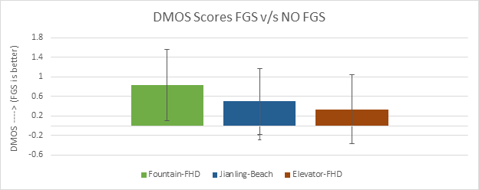

Scenario | Sequence | FPS | Resolution | Bitrate selection (kbps) | Frames
Full-HD | Elevator-FHD.yuv | 59.94 | 2048x1080 | 4608 | 432
Full-HD | Fountain-FHD.yuv | 59.94 | 2048x1080 | 12288 | 600
Gaming | Jianling-Beach | 60 | 1920x1080 | 5120 | 600

Just Noticeable Difference (JND) Subjective Test Method
[Rapporteur’s note 31 Jan. 2024: Apple commented that the JND methodology is not established as a suitable way to test for FGS benefits – the results are not agreeable. Instead it is suggested that 3GPP SA4 waits for JVET FGS TR work to be completed and reference the results from there. Therefore there is no agreement on the JND test results.]

In experimental psychology, the term Just Noticeable Difference (JND) means the amount of something that must be changed in order for a difference to be noticeable, such that it may be detected at least 50% of the time. This is applied in various sensation and perception studies. In the context of the film grain, this JND method may be used for either to test for artistic intent or for masking visual artifacts.
The JND objective test measures these two things depending on the use case via side by side comparison:
- Preservation of artistic intent: measure the difference between the clean reference and the reference video with added FGS,
- Applying film grain to mask coding artifacts: find the highest compression level, adjusted by QP, at which point the coding artifacts become noticeable with and without added FGS.

 | Without film grain synthesis | With film grain synthesis
Reference | true lossless quantization | true lossless quantization with film grain synthesis
Test | compressed at various QPs in [18, 42] | compressed at various QPs in [18, 42] with film grain synthesis
  - If the video file size is not limited, just use the original reference video. If the video size needs to be small, use QP=4 for the reference video.
  - Keep the QP the same between the video with / without FGS applied.
The steps of this JND test method are as follows:
- Initial stimulus: set at lowest quality. Initial ΔQP set at 8.
- When a subject provides a correct response (i.e., there is difference between the two videos or the reference video looks better than the test video), the QP value is decreased by ΔQP.
- When a subject makes an incorrect response (i.e., no difference between the two videos or the test video looks better than the reference video), the QP value is increased by ΔQP.
- How we determine the value of ΔQP:
  - The initial ΔQP is set to 8.
  - Keep the previous ΔQP when the same response follows an earlier response. That is, an incorrect response after earlier incorrect response, or a correct response after a previous correct response occurs.
  - ΔQP is reduced to half of the previous ΔQP, when an incorrect response occurs after a correct response or vice versa.
  - The chart below illustrates an example of adaptive QP adjustment according to a subject’s response.
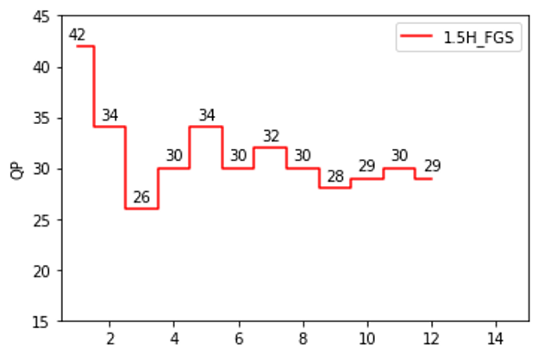
  - This process stops when it reaches either of the stopping conditions below:
    - 4 times of upward and downward pattern then arrive at QP=1 step size,
    - When the number of responses reach the maximum trial number of responses. (This maximum number is TBD)
  - The JND threshold value is determined as the last correct response. For example in the chart above the JND threshold value corresponds to the last point in the chart.
  - Prior to the above test, a training session is needed; the best set of examples showing significant difference and no difference using all test sequences will be presented to the test subject.
    - 2 different types of comparison
      - Both the reference and the test are FG-free. The other set is for the reference and the text material both to have FGS added.
      - There is no direct side by side comparison between the clean (no FG) and the video with FG.
      - The order of the test videos is randomized. The playback time for each sample video is 10 seconds.
- Viewing test conditions:
- Test Site | On-site (for 4K resolution)
Display, size, connection  (resolution setting) | Samsung 65” S95B, HDMI (3840×2160)
Viewing distance | 1 viewer sitting at 1.5H
Viewing angle | ±75°, 90° (at screen center)
Total number of viewers | 17

Test Site | On-site (for 1080p resolution)
Display, size, connection  (resolution setting) | DELL 29” TV/ Monitor, HDMI (1920x1080)
Viewing distance | 1 viewer sitting at 1.5H
Viewing angle | ±75°, 90° (at screen center)
Total number of viewers | 17

(Comments from Apple) This is a very complex and time-consuming test. I would suggest deleting this whole section. It seems unnecessary unless there is a strong recommendation from the group in using this.

Maybe if you want to add it you can say that “It was proposed to maybe consider a JND based test also for the evaluation of the performance of FGS technologies. Such tests have not yet been verified of their performance or usefulness, while concerns were also raised about their complexity. “

then it might be okay to include this here since this is just informational.
(Comments from Samsung) Agreed. In addition, this test has not been widely used for subjective evaluations.
(Rapporteur’s note Nov. 2023: the JND test results will be added after SA4 #126 and shared at a forthcoming Video SWG AhG meeting. The intent is to use some of the FG content that Apple has kindly made available.
JND Test Results

BQTerrace- JND Test Observations
- 14 out of 17 viewers rated FGS JND QP higher than NO_FGS, indicating the perceivable difference point has moved to lower bitrate with FGS.
- 3 out 17 viewers have rated FGS JND_QP equal of lower than NO_FGS.
- The table below illustrates potential bitrate savings of FGS for BQTerrace 1080p content at JND QP points. The bitrate at average JND_QP of FGS enabled BQ Terrace is significantly lower than the bitrate at average JND QP without grain analysis and synthesis.
Content | JND_QP | Average Bitrate
BQTerrace | 20 | 37.69 Mbps
BQTerrace_FG | 24 | 9.32 Mbps

InToTree- JND Test Observations
- All 17 viewers rated FGS JND QP higher than NO_FGS, indicating the perceivable difference point has moved to lower bitrate with FGS.
- 8 out 17 viewers have rated FGS JND_QP a minimum of 5QP lower than NO_FGS.
- The table below illustrates potential bitrate savings of FGS for InToTree 1080p content at JND QP points. The bitrate at average JND_QP of FGS enabled InToTree is significantly lower than the bitrate at average JND QP without grain analysis and synthesis.
Content | JND_QP | Average Bitrate
InTo_Tree | 18 | 36.99 Mbps
InTo_Tree_FG | 23 | 9.92 Mbps

OldTownCross- JND Test Observations
- All 17 viewers rated FGS JND QP higher than NO_FGS, indicating the perceivable difference point has moved to lower bitrate with FGS.
- 8 out 17 viewers have rated FGS JND_QP a minimum of 5QP lower than NO_FGS.
- The table below illustrates potential bitrate savings of FGS for OldTownCross 1080p content at JND QP points. The bitrate at average JND_QP of FGS enabled OldTownCross is significantly lower than the bitrate at average JND QP without grain analysis and synthesis.

Content | JND_QP | Average Bitrate
OldTownCross | 16 | 32.99 Mbps
OldTownCross_FG | 20 | 11.92 Mbps

Analysis of JND QP Difference
Box and Whisker Chart based analysis.

In this section the benefit of FGS is assessed by analyzing the difference of the FGS JND_QP and the NO_FGS JND_QP for each viewer. The JND_QP differences for 17 viewers are analyzed using a Box and Whisker chart for the three 1080p contents as shown in the above figure. The Box and Whisker chart depict following statistical aspects of JND_QP differences for each content:
- Median JND_QP difference (marked as X inside the box)
- Lower quartile (q1), Upper quartile (q3) range (marked by the colored boxes)
- Minimum and Maximum JND_QP difference (marked by lower and upper dash line)

Following conclusions can be drawn from the Box and Whisker chart of JND_QP difference:

- Median JND_QP difference is higher than 4 for all the three 1080p contents.
- The median JND_QP difference for each content is closer to the difference of average of JND_QPs depicted in earlier figures for all the 3 1080p contents.
- Lower quartile (q1) of JND_QP difference is higher than 2 for all the 3 1080p contents. Essentially more than 75% of the viewers have rated FGS JND_QP to be at least 2 higher than the NO_FGS JND_QP for all the 3 1080p contents.
- Higher quartile (q3) JND_QP difference is at least 6 for all the 3 1080p contents. Essentially 25% of the viewers have rated FGS JND_QP to be at least 6 higher than the NO_FGS JND_QP.

Dolby FGS Configuration parameters for encoding/decoding constraints & settings
#======== File I/O =====================
BitstreamFile : encoded.265
ReconFile : recon.yuv

#======== Profile ================
Profile : main / main10

#======== Unit definition ================
MaxCUWidth : 64 # Maximum coding unit width in pixel
MaxCUHeight : 64 # Maximum coding unit height in pixel
MaxPartitionDepth : 4 # Maximum coding unit depth
QuadtreeTULog2MaxSize : 5 # Log2 of maximum transform size for
# quadtree-based TU coding (2...6)
QuadtreeTULog2MinSize : 2 # Log2 of minimum transform size for
# quadtree-based TU coding (2...6)
QuadtreeTUMaxDepthInter : 3
QuadtreeTUMaxDepthIntra : 3

#======== Coding Structure =============
IntraPeriod : 32 # Period of I-Frame ( -1 = only first)
DecodingRefreshType : 1 # Random Accesss 0:none, 1:CRA, 2:IDR, 3:Recovery Point SEI
GOPSize : 16 # GOP Size (number of B slice = GOPSize-1)
ReWriteParamSetsFlag : 1 # Write parameter sets with every IRAP

IntraQPOffset : -3
LambdaFromQpEnable : 1 # see JCTVC-X0038 for suitable parameters for IntraQPOffset, QPoffset, QPOffsetModelOff, QPOffsetModelScale when enabled
# Type POC QPoffset QPOffsetModelOff QPOffsetModelScale CbQPoffset CrQPoffset QPfactor tcOffsetDiv2 betaOffsetDiv2 temporal_id #ref_pics_active #ref_pics reference pictures predict deltaRPS #ref_idcs reference idcs
Frame1: B 16 1 0.0 0.0 0 0 1.0 0 0 0 2 2 -16 -32 0
Frame2: B 8 1 -4.8848 0.2061 0 0 1.0 0 0 1 2 3 -8 -24 8 1 8 3 1 1 1
Frame3: B 4 4 -5.7476 0.2286 0 0 1.0 0 0 2 2 4 -4 -20 4 12 1 4 4 1 1 1 1
Frame4: B 2 5 -5.90 0.2333 0 0 1.0 0 0 3 2 5 -2 -18 2 6 14 1 2 5 1 1 1 1 1
Frame5: B 1 6 -7.1444 0.3 0 0 1.0 0 0 4 2 5 -1 1 3 7 15 1 1 6 1 0 1 1 1 1
Frame6: B 3 6 -7.1444 0.3 0 0 1.0 0 0 4 2 5 -1 -3 1 5 13 1 -2 6 1 1 1 1 1 0
Frame7: B 6 5 -5.90 0.2333 0 0 1.0 0 0 3 2 4 -2 -6 2 10 1 -3 6 0 1 1 1 1 0
Frame8: B 5 6 -7.1444 0.3 0 0 1.0 0 0 4 2 5 -1 -5 1 3 11 1 1 5 1 1 1 1 1
Frame9: B 7 6 -7.1444 0.3 0 0 1.0 0 0 4 2 4 -1 -7 1 9 1 -2 6 0 1 1 1 1 0
Frame10: B 12 4 -5.7476 0.2286 0 0 1.0 0 0 2 2 3 -4 -12 4 1 -5 5 0 1 1 1 0
Frame11: B 10 5 -5.90 0.2333 0 0 1.0 0 0 3 2 4 -2 -10 2 6 1 2 4 1 1 1 1
Frame12: B 9 6 -7.1444 0.3 0 0 1.0 0 0 4 2 5 -1 -9 1 3 7 1 1 5 1 1 1 1 1
Frame13: B 11 6 -7.1444 0.3 0 0 1.0 0 0 4 2 4 -1 -11 1 5 1 -2 6 0 1 1 1 1 0
Frame14: B 14 5 -5.90 0.2333 0 0 1.0 0 0 3 2 3 -2 -14 2 1 -3 5 0 1 1 1 0
Frame15: B 13 6 -7.1444 0.3 0 0 1.0 0 0 4 2 4 -1 -13 1 3 1 1 4 1 1 1 1
Frame16: B 15 6 -7.1444 0.3 0 0 1.0 0 0 4 2 4 -1 -3 -15 1 1 -2 5 1 1 1 1 0

#=========== Motion Search =============
FastSearch : 1 # 0:Full search 1:TZ search
SearchRange : 384 # (0: Search range is a Full frame)
ASR : 1 # Adaptive motion search range
MinSearchWindow : 96 # Minimum motion search window size for the adaptive window ME
BipredSearchRange : 4 # Search range for bi-prediction refinement
HadamardME : 1 # Use of hadamard measure for fractional ME
FEN : 1 # Fast encoder decision
FDM : 1 # Fast Decision for Merge RD cost

#======== Quantization =============
QP : 22 # Quantization parameter(0-51)
MaxDeltaQP : 0 # CU-based multi-QP optimization
MaxCuDQPDepth : 0 # Max depth of a minimum CuDQP for sub-LCU-level delta QP
DeltaQpRD : 0 # Slice-based multi-QP optimization
RDOQ : 1 # RDOQ
RDOQTS : 1 # RDOQ for transform skip
SliceChromaQPOffsetPeriodicity: 0 # Used in conjunction with Slice Cb/Cr QpOffsetIntraOrPeriodic. Use 0 (default) to disable periodic nature.
SliceCbQpOffsetIntraOrPeriodic: 0 # Chroma Cb QP Offset at slice level for I slice or for periodic inter slices as defined by SliceChromaQPOffsetPeriodicity. Replaces offset in the GOP table.
SliceCrQpOffsetIntraOrPeriodic: 0 # Chroma Cr QP Offset at slice level for I slice or for periodic inter slices as defined by SliceChromaQPOffsetPeriodicity. Replaces offset in the GOP table.

#=========== Deblock Filter ============
LoopFilterOffsetInPPS : 1 # Dbl params: 0=varying params in SliceHeader, param = base_param + GOP_offset_param; 1 (default) =constant params in PPS, param = base_param)
LoopFilterDisable : 0 # Disable deblocking filter (0=Filter, 1=No Filter)
LoopFilterBetaOffset_div2 : 0 # base_param: -6 ~ 6
LoopFilterTcOffset_div2 : 0 # base_param: -6 ~ 6
DeblockingFilterMetric : 0 # blockiness metric (automatically configures deblocking parameters in bitstream). Applies slice-level loop filter offsets (LoopFilterOffsetInPPS and LoopFilterDisable must be 0)

#=========== Misc. ============
InternalBitDepth : 8 # codec operating bit-depth

#=========== Coding Tools =================
SAO : 1 # Sample adaptive offset (0: OFF, 1: ON)
AMP : 1 # Asymmetric motion partitions (0: OFF, 1: ON)
TransformSkip : 1 # Transform skipping (0: OFF, 1: ON)
TransformSkipFast : 1 # Fast Transform skipping (0: OFF, 1: ON)
SAOLcuBoundary : 0 # SAOLcuBoundary using non-deblocked pixels (0: OFF, 1: ON)

#=========== TemporalFilter =================
TemporalFilter : 1 # Enable/disable GOP Based Temporal Filter
TemporalFilterPastRefs : 4 # Number of past references for temporal prefilter
TemporalFilterFutureRefs : 4 # Number of future references for temporal prefilter
TemporalFilterStrengthFrame8 : 0.95 # Enable filter at every 8th frame with given strength
TemporalFilterStrengthFrame16 : 1.5 # Enable filter at every 16th frame with given strength, longer intervals has higher priority

#============ Slices ================
SliceMode : 0 # 0: Disable all slice options.
# 1: Enforce maximum number of LCU in an slice,
# 2: Enforce maximum number of bytes in an 'slice'
# 3: Enforce maximum number of tiles in a slice
SliceArgument : 1500 # Argument for 'SliceMode'.
# If SliceMode==1 it represents max. SliceGranularity-sized blocks per slice.
# If SliceMode==2 it represents max. bytes per slice.
# If SliceMode==3 it represents max. tiles per slice.

LFCrossSliceBoundaryFlag : 1 # In-loop filtering, including ALF and DB, is across or not across slice boundary.
# 0:not across, 1: across

#============ PCM ================
PCMEnabledFlag : 0 # 0: No PCM mode
PCMLog2MaxSize : 5 # Log2 of maximum PCM block size.
PCMLog2MinSize : 3 # Log2 of minimum PCM block size.
PCMInputBitDepthFlag : 1 # 0: PCM bit-depth is internal bit-depth. 1: PCM bit-depth is input bit-depth.
PCMFilterDisableFlag : 0 # 0: Enable loop filtering on I_PCM samples. 1: Disable loop filtering on I_PCM samples.

#============ Tiles ================
TileUniformSpacing : 0 # 0: the column boundaries are indicated by TileColumnWidth array, the row boundaries are indicated by TileRowHeight array
# 1: the column and row boundaries are distributed uniformly
NumTileColumnsMinus1 : 0 # Number of tile columns in a picture minus 1
TileColumnWidthArray : 2 3 # Array containing tile column width values in units of CTU (from left to right in picture)
NumTileRowsMinus1 : 0 # Number of tile rows in a picture minus 1
TileRowHeightArray : 2 # Array containing tile row height values in units of CTU (from top to bottom in picture)

LFCrossTileBoundaryFlag : 1 # In-loop filtering is across or not across tile boundary.
# 0:not across, 1: across

#============ WaveFront ================
WaveFrontSynchro : 0 # 0: No WaveFront synchronisation (WaveFrontSubstreams must be 1 in this case).
# >0: WaveFront synchronises with the LCU above and to the right by this many LCUs.

#=========== Quantization Matrix =================
ScalingList : 0 # ScalingList 0 : off, 1 : default, 2 : file read
ScalingListFile : scaling_list.txt # Scaling List file name. If file is not exist, use Default Matrix.

#============ Lossless ================
TransquantBypassEnableFlag : 0 # Value of PPS flag.
CUTransquantBypassFlagForce: 0 # Force transquant bypass mode, when transquant_bypass_enable_flag is enabled

#============ Rate Control ======================
RateControl : 0 # Rate control: enable rate control
TargetBitrate : 1000000 # Rate control: target bitrate, in bps
KeepHierarchicalBit : 2 # Rate control: 0: equal bit allocation; 1: fixed ratio bit allocation; 2: adaptive ratio bit allocation
LCULevelRateControl : 1 # Rate control: 1: LCU level RC; 0: picture level RC
RCLCUSeparateModel : 1 # Rate control: use LCU level separate R-lambda model
InitialQP : 0 # Rate control: initial QP
RCForceIntraQP : 0 # Rate control: force intra QP to be equal to initial QP

