3GPP TSG-SA WG4 Meeting #127 S4-240173

Sophia-Antipolis, France, 29 January - 2 February 2024
CR-Form-v12.0
PSEUDO CHANGE REQUEST
 | 26.966 | CR | - | rev | - | Current version: | 1.0.0
For HELP on using this form: comprehensive instructions can be found at
http://www.3gpp.org/Change-Requests.

Proposed change affects: | UICC apps |  | ME | X | Radio Access Network |  | Core Network

Title: | [FS_HEVC_Profiles] Updates on HEVC Evaluations
Source to WG: | Apple Inc.
Source to TSG:
Work item code: | FS_HEVC_Profiles |  |  |  |  |  | Date: |  |  | 2024-01-20
Category: | B |  |  |  |  |  | Release: |  |  | 18
 | Use one of the following categories:  F (correction)  A (mirror corresponding to a change in an earlier release)  B (addition of feature),  C (functional modification of feature)  D (editorial modification)  Detailed explanations of the above categories can  be found in 3GPP TR 21.900. |  |  |  |  |  |  |  | Use one of the following releases:  Rel-8 (Release 8)  Rel-9 (Release 9)  Rel-10 (Release 10)  Rel-11 (Release 11)  Rel-12 (Release 12)  Rel-13 (Release 13)  Rel-14 (Release 14)  Rel-15 (Release 15)  Rel-16 (Release 16)
Reason for change: |  | Some incompatibilities to subjective testing identified in SA4#126.
Summary of change: |  | Improved description and reference to EVP, some results reproduced.
Consequences if not approved: |  | The issues identified related to EVP will remain.
Clauses affected: |  | 2, 5.1.4.2, 5.2.4.2, 6.2.3.2
 |  | Y | N
Other specs |  |  | X | Other core specifications |  |  |  | TS/TR ... CR
affected: |  |  | X | Test specifications |  |  |  | TS/TR ... CR ...
(show related CRs) |  |  | X | O&M Specifications |  |  |  | TS/TR ... CR ...
Other comments:
This CR's revision history: |  | Based on the comments in Ad hoc call, updated the figures.

* * * First Change * * * *

2 References
The following documents contain provisions which, through reference in this text, constitute provisions of the present document.
- References are either specific (identified by date of publication, edition number, version number, etc.) or non-specific.
- For a specific reference, subsequent revisions do not apply.
- For a non-specific reference, the latest version applies. In the case of a reference to a 3GPP document (including a GSM document), a non-specific reference implicitly refers to the latest version of that document in the same Release as the present document.
[1] 3GPP TR 21.905: "Vocabulary for 3GPP Specifications".
[2] ISO/IEC 14496-10:2022: "Information technology — Coding of audio-visual objects — Part 10: Advanced video coding"
[3] ISO/IEC 23008-2:2015: "Information technology — High efficiency coding and media delivery in heterogeneous environments — Part 2: High efficiency video coding"
[3] 3GPP TR 26.905: "Mobile stereoscopic 3D video".
[4] 3GPP TS 26.247: "Transparent end-to-end Packet-switched Streaming Service (PSS); Progressive Download and Dynamic Adaptive Streaming over HTTP (3GP-DASH)".
[5] 3GPP TS 26.244: "Transparent end-to-end packet switched streaming service (PSS); 3GPP file format (3GP)".
[6] 3GPP TS 26.214: "IP Multimedia Subsystem (IMS); Multimedia Telephony; Media handling and interaction".
[7] 3GPP TS 26.218: "Virtual Reality (VR) profiles for streaming applications"
[8] 3GPP TS 26.347: "Multimedia Broadcast/Multicast Service (MBMS); Protocols and codecs"
[9] Vetro, Anthony. "Frame compatible formats for 3D video distribution." In 2010 IEEE International Conference on Image Processing, pp. 2405-2408. IEEE, 2010.
[10] Hannuksela, Miska M., Ye Yan, Xuehui Huang, and Houqiang Li. "Overview of the multiview high efficiency video coding (MV-HEVC) standard." In 2015 IEEE International Conference on Image Processing (ICIP), pp. 2154-2158. IEEE, 2015.
[11] ISO/IEC JTC1/SC29/WG11 MPEG2011 M22746, "AVC/MVC anchor coding for MFC", November 2011, Geneva, Switzerland.
[12] ISO/IEC JTC1/SC29/WG11 N16050, "MV-HEVC Verification Test Report", San Diego, US, Feb. 2016.
[13] ISO/IEC 14496-15:2022, "Information technology — Coding of audio-visual objects — Part 15: Carriage of network abstraction layer (NAL) unit structured video in the ISO base media file format"
[14] "HTTP Live Streaming (HLS) authoring specification for Apple devices," https://developer.apple.com/documentation/http-live-streaming/hls-authoring-specification-for-apple-devices
[15] "ISO Base Media File Format and Apple HEVC Stereo Video Format additions," Version 0.9 (Beta) June 21, 2023
[16] "Apple HEVC Stereo Video," Interoperability Profile Version 0.9 (Beta) June 21, 2023
[17] Delbracio, Mauricio, Damien Kelly, Michael S. Brown, and Peyman Milanfar. "Mobile computational photography: A tour." Annual Review of Vision Science 7 (2021): 571-604.
[18] Camera & Imaging Products Association (CIPA) "Production, Shipment of Digital Still Camera January, January-January in 2017," 2016
[19] "Smartphones vs Cameras: Closing the gap on image quality," https://www.dxomark.com/smartphones-vs-cameras-closing-the-gap-on-image-quality/
[20] Joint Video Team (JVT) of ISO/IEC MPEG & ITU-T VCEG JVT-I018, "Color format downconversion for test sequence generation," 2003.
[21] Joint Video Team (JVT) of ISO/IEC MPEG & ITU-T VCEG JVT-I019, "Color format upconversion for video display," 2003.
[22] ISO/IEC 23008-12:2022: "Information technology - MPEG systems technologies - Part 12: Image File Format".
[23] ISO/IEC 14496-12:2022: "Information technology — Coding of audio-visual objects — Part 12: ISO base media file format".
[24] "Using HEIF or HEVC media on Apple devices," https://support.apple.com/en-us/HT207022
[25] "HEIF Imaging," https://source.android.com/docs/core/camera/heif
[26] ITU-T Recommendation T.81: "Information technology; Digital compression and coding of continuous-tone still images: Requirements and guidelines".
[27] 3GPP TR 26.948: "Study on video enhancements in 3GPP multimedia services"
[28] HTTP Live Streaming (HLS) Authoring Specification for Apple Devices, https://developer.apple.com/documentation/http_live_streaming/http_live_streaming_hls_authoring_specification_for_apple_devices
[29] Samira Afzal, Vanessa Testoni, Christian Esteve Rothenberg, Prakash Kolan, Imed Bouazizi, “A holistic survey of multipath wireless video streaming”, Journal of Network and Computer Applications, 212: 103581 (2023)
[30] ISO/IEC JTC1/SC29/WG11 N16051, "SHVC verification test report", February 2016, San Diego, USA.
[31] ISO/IEC JTC1/SC29/WG11 N16268, "Supplemental SHVC verification test report", June 2016, Geneva, CH.
[32] 3GPP TR 26.955: "Video codec characteristics for 5G-based services and applications"
[33] ISO/IEC 23000-19:2020, "Information technology — Multimedia application format (MPEG-A) — Part 19: Common media application format (CMAF) for segmented media"
[34] ISO/IEC JTC1/SC29/WG03 N01026, "Preliminary WD of ISO/IEC 23000-19 AMD New Structural CMAF Brand Profile", October 2023, Hannover, Germany.
[35] Recommendation ITU-R BT.2095-1 "Subjective assessment of video quality using expert viewing protocol (2016-2017) ", 06/2017.
[36] ISO/IEC JTC1/SC29/WG03 N01033, "Technology under consideration on CMAF", October 2023, Hannover, Germany.

* * * Next Change * * * *

5.1.4.2 Subjective performance evaluation
Recommendation ITU-R BT.2095-1 Subjective assessment of video quality using expert viewing protocol [35] describes the method to subjectively assess video quality by means of the expert viewing protocol (EVP), with the participation of a reduced number of viewers, all selected among experts in the relevant video processing area. This methodology has been used in JVET for the assessment of multiview video codec performance. The EVP visual evaluation protocol is specified in detail in [35] with the following main features:
- 9 experts participate as viewers in each EVP session,
- The “unimpaired” Source video Clip (SRC) is shown once, followed by two Processed Video Sequences (PVSs),
- Experts are required to compare the PVS with the SRC, and to rate them separately.

* * * Next Change * * * *

5.2.4.2 Subjective performance evaluation

Same considerations are made as in clause 5.1.4.2, i.e. relying on previous strategy adopted by JVET for assessment of multiview video codec performance by using EVP [35].
* * * Next Change * * * *

6.2.3.2 Codec performance evaluation based on existing results
The objective and subjective performance results comparing MVC, Simulcast HEVC (each view is coded independently) with MV-HEVC are documented in [12]. The test sequences used for this evaluation are 1080p 8-bit 4:2:0 either 25 or 30 Hz. IPP encoding is used to generate the results. The objective results demonstrate significant performance improvements achieved by MV-HEVC against both MVC and simulcast HEVC, demonstrated by the Bjøntegaard Delta (BD) bitrates table reproduced here:
Test Sequence | BD-rate reduction of MV-HEVC [%] relative to
 | MVC | Simulcast HEVC
S03: Undo_Dancer | -45.7 | -38.7
S04: GT_Fly | -52.9 | -41.0
S13: Band06 | -43.3 | -31.7
S14: BMX | -60.6 | -25.6
Average | -50.6 | -34.2

Hence at least 30% performance gains were observed against simulcast HEVC. The corresponding subjective tests using “Expert Viewing Protocol” (EVP) verified the objective gains via MOS for all the sequences above. For example, the results for the sequences "Undo Dancer" and "BMX" are copied in the following, other results in [12] follow these results similarly.
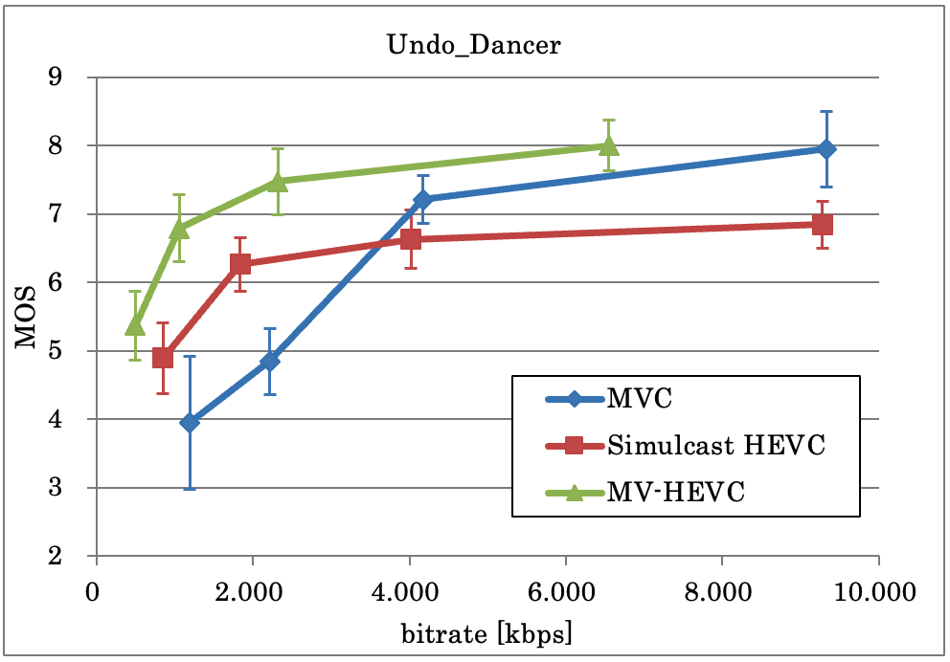
Figure 6.2.3.2-1: EVP results for sequence "Undo Dancer" [12]
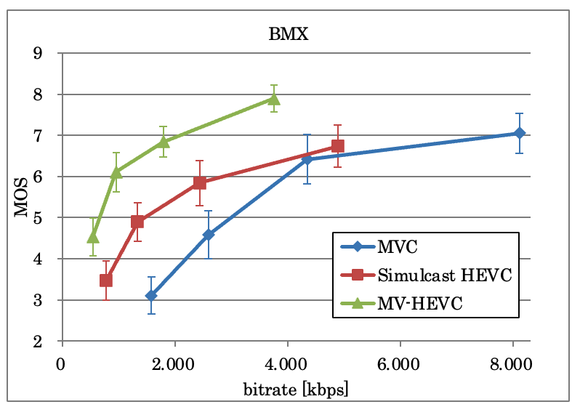
Figure 6.2.3.2-1: EVP results for sequence "BMX" [12]
Although no formal evaluation exists for the Multiview Main 10 profile of MV-HEVC, considering the large gains achieved as noted above, it is expected that it’s performance should be similar to what is demonstrated for 8-bit content, aligned with the findings on 2D video codecs in 3GPP TR 26.955[XX], clause X.Y.
Editor's note: Further documentation of comparison with frame-packing is FFS.

* * * End of Changes * * * *

