3GPP TSG SA WG4#127 S4-240170

Sophia-Antipolis, France, 29th Jan-2nd Feb, 2024
CR-Form-v12.2
PSEUDO CHANGE REQUEST
 | 26.812 | CR | pseudo | rev | - | Current version: | 1.0.0
For HELP on using this form: comprehensive instructions can be found at
http://www.3gpp.org/Change-Requests.

Proposed change affects: | UICC apps |  | ME | X | Radio Access Network |  | Core Network

Title: | [FS_ARMRQoE] pCR on conclusions of ARMRQoE
Source to WG: | China Unicom, Huawei
Source to TSG: | S4
Work item code: | FS_ARMRQoE |  |  |  |  |  | Date: |  |  | 23-01-2024
Category: | B |  |  |  |  |  | Release: |  |  | Rel-18
 | Use one of the following categories:  F (correction)  A (mirror corresponding to a change in an earlier release)  B (addition of feature),  C (functional modification of feature)  D (editorial modification)  Detailed explanations of the above categories can  be found in 3GPP TR 21.900. |  |  |  |  |  |  |  | Use one of the following releases:  Rel-8 (Release 8)  Rel-9 (Release 9)  Rel-10 (Release 10)  Rel-11 (Release 11)  …  Rel-16 (Release 16)  Rel-17 (Release 17)  Rel-18 (Release 18)  Rel-19 (Release 19)
Reason for change: |  | There are no other inputs from other 3GPP/non-3GPP specifications (e.g. MeCar) on Metrics Observation Points, conclusions and the recommendations on existing QoE metrics are presented to complete the SI.
Summary of change: |  | - Propose the conclusions and recommendations for this study.
Consequences if not approved: |  | AR/MR QoE SI is not completed.
Clauses affected: |  | 6.3.7, 9 (new)
 |  | Y | N
Other specs |  |  | X | Other core specifications |  |  |  | TS/TR ... CR ...
affected: |  |  | X | Test specifications |  |  |  | TS/TR ... CR ...
(show related CRs) |  |  | X | O&M Specifications |  |  |  | TS/TR ... CR ...
Other comments:
This CR's revision history:

1stChange

6.3.7 Spatial Anchors and Trackables

6.3.7.1 Background
To establish the pose of the virtual objects in the user real environment, the concept of AR anchoring has been defined based on trackable and spatial anchor entities.
A trackable [24] is a real-world object that can be tracked by the XR runtime. Each trackable provides a local reference space, also known as a trackable space, in which an AR anchor can be expressed.
An AR anchor [24], called an anchor or spatial anchor in this document, is a real-world pose in a trackable space. Each spatial anchor provides a local reference space, also known as an anchor space, in which the pose of a virtual asset can be expressed.
NOTE: the definitions of trackable and anchor should be aligned with those in 3GPP TS 26.119.
Figure 6.3.7.1-1 illustrates an AR anchoring example. A trackable (2D marker type) provides a local reference space. The spatial anchor refers to this trackable. A virtual asset (virtual chest) is attached to this anchor.
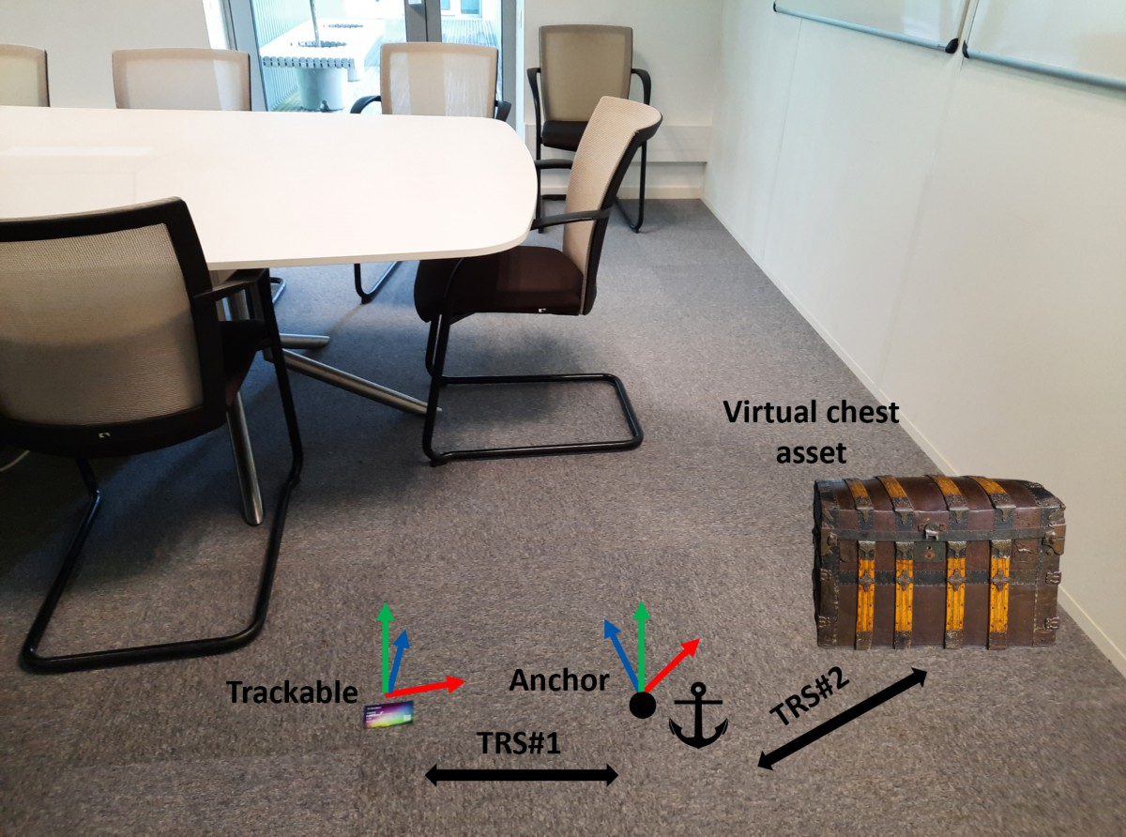
Figure 6.3.7.1-1: Spatial relationships between trackable, spatial anchor and virtual asset

END of 1st Change

2ndChange

9 Conclusions and Recommendations

In this TR, the available information from other organizations (e.g. ITU-T, IEEE, MPEG group) are collected, and the relevant observed information based on the AR/MR QoE reference model/observation points are discussed and presented based on OpenXR specification [22]. Based on the information observed in the observation points, many AR/MR QoE metrics are introduced, e.g. registration latency, tracking pose prediction error, etc. All AR/MR QoE metrics introduced in this study are measurable and some of them are implementable based on the OpenXR implementation. For the AR/MR QoE metrics introduced in this study, they may be used by normative work in order to perform the AR/MR QoE measurements and reporting for subsequent optimizations, e.g. reporting to the 5G network for network optimization.
Based on the details in the above, the following next step is proposed as below:
If the value of “Normative work proposed” column in below Table 9-1 is “yes”, then it is proposed to specify the corresponding AR/MR QoE metrics in TS 26.119. The column also adds a reference in the report, where this implementability and relation to the impact on the user experience is provided. Otherwise the implementability and the impact on the user experience need further studies.

Table 9-1: Identify the implementability and impact to user experience of QoE metrics
QoE metrics | Metrics definition | Implementable, e.g. based on openXR | Impact to user experience | Normative work proposed | Comment
Registration latency | see clause 6.3.1 | yes  see clause 8 | yes  see clause 8 | Y | Implementability are proved with openXR specs, impacts on users’ experience are easily observed
Scene startup latency and Interaction latency | see clause 6.3.2 | yes  see clause 8 | yes  see clause 8 | Y | Implementability are proved with openXR specs, impacts on users’ experience are easily observed
Pose error and time error | see clause 6.3.5.1 | yes  see clause 6.3.5.3 | yes  see clause 8 | Y | Implementability are proved with openXR specs, impacts on users’ experience are easily observed
ACD | see clause 6.3.7.4 | yes  see clause 6.3.7.4.1 | yes  see clause 8 | Y | Implementability are proved with openXR specs, impacts on users’ experience are easily observed
ADRP | see clause 6.3.7.5 | yes  see clause 6.3.7.5.1 | yes  see clause 8 | Y | Implementability are proved with openXR specs, impacts on users’ experience are easily observed
Device related QoE metrics | see clause 6.3.6.1 | yes  see clause 6.3.6.1 and 6.2.1.2 | yes  see clause 8 | Y | Implementability are proved with openXR specs, impacts on users’ experience are easily observed
Tracking pose prediction error | see clause 6.3.3 | For further study | For further study | For further study | Implementability and impacts on users’ experience needs further studies.
Pose correction error | see clause 6.3.8.1 | For further study | For further study | For further study | Implementability and impacts on users’ experience needs further studies.
AUR | see clause 6.3.7.6 | For further study | For further study | For further study | Implementability and impacts on users’ experience needs further studies.

The metrics may be reported for QoE proposal including QoE metrics considered to have the need for normative work in the above table, as well as one way delay RTT.
END of 2nd Change

