**3GPP TSG SA WG4#127 S4-240079**

**Sophia-Antipolis, France, 29th Jan- 2nd Feb 2024**

|  |  |  |  |  |  |  |  |  |
| --- | --- | --- | --- | --- | --- | --- | --- | --- |
| *CR-Form-v12.0* | | | | | | | | |
| **PSEUDO CHANGE REQUEST** | | | | | | | | |
|  | | | | | | | | |
|  | **26**.**813** | **CR** |  | **rev** |  | **Current version:** | **0.2.1** |  |
|  | | | | | | | | |
| *For* [***HE******LP***](http://www.3gpp.org/3G_Specs/CRs.htm#_blank)*on using this form: comprehensive instructions can be found at* [*http://www.3gpp.org/Change-Requests*](http://www.3gpp.org/Change-Requests)*.* | | | | | | | | |
|  | | | | | | | | |

|  |  |  |  |  |  |  |  |  |
| --- | --- | --- | --- | --- | --- | --- | --- | --- |
| ***Proposed change affects:*** | UICC apps |  | ME |  | Radio Access Network |  | Core Network | **X** |

|  |  |  |  |  |  |  |  |  |  |  |
| --- | --- | --- | --- | --- | --- | --- | --- | --- | --- | --- |
|  | | | | | | | | | | |
| ***Title:*** | **Updates on Reference Architecture** | | | | | | | | | |
|  |  | | | | | | | | | |
| ***Source to WG:*** | China Mobile Com. Corporation | | | | | | | | | |
| ***Source to TSG:*** | SA4 | | | | | | | | | |
|  |  | | | | | | | | | |
| ***Work item code:*** | FS_AVATAR | | | | |  | ***Date:*** | | | 2024-01-29 |
|  |  | | | |  | |  | | |  |
| ***Category:*** | **B** |  | | | | | ***Release:*** | | |  |
|  | *Use one of the following categories:* ***F*** *(correction)* ***A*** *(mirror corresponding to a change in an earlier release)* ***B*** *(addition of feature),* ***C*** *(functional modification of feature)* ***D*** *(editorial modification)*  Detailed explanations of the above categories can be found in 3GPP [TR 21.900](http://www.3gpp.org/ftp/Specs/html-info/21900.htm). | | | | | | | | *Use one of the following releases: Rel-8 (Release 8) Rel-9 (Release 9) Rel-10 (Release 10) Rel-11 (Release 11) Rel-12 (Release 12)* *Rel-13 (Release 13) Rel-14 (Release 14) Rel-15 (Release 15) Rel-16 (Release 16)* | |
|  |  | | | | | | | | | |
| ***Reason for change:*** | | Avatars are widely used in commercial and business activities. Therefore, avatar authorization is essential to mitigate potential copyright disputes that may arise as digital identities circulate on the internet. As outlined in SA1 TR 22.856 UC 5.24 and FS_AVATAR TR document UC 4, the 5G system needs to support management and authorization of avatar usage rights. | | | | | | | | |
|  | |  | | | | | | | | |
| ***Summary of change:*** | | Provides updates on the reference architecture to address avatar authorization requirements that have been documented in UC 4. | | | | | | | | |
|  | |  | | | | | | | | |
| ***Consequences if not approved:*** | | Incomplete TR | | | | | | | | |
|  | |  | | | | | | | | |
| ***Clauses affected:*** | | 7 | | | | | | | | |
|  | |  | | | | | | | | |
|  | | **Y** | **N** |  | | | |  | | |
| ***Other specs*** | |  |  | Other core specifications | | | | TS/TR ... CR ... | | |
| ***affected:*** | |  |  | Test specifications | | | | TS/TR ... CR ... | | |
| ***(show related CRs)*** | |  |  | O&M Specifications | | | | TS/TR ... CR ... | | |
|  | |  | | | | | | | | |
| ***Other comments:*** | |  | | | | | | | | |
|  | |  | | | | | | | | |
| ***This CR's revision history:*** | |  | | | | | | | | |

# Introduction

Avatars are widely used in commercial and business activities. Therefore, avatar authorization is essential to mitigate potential copyright disputes that may arise as digital identities circulate on the internet. It is especially relevant to avatar identification and authorization requirements documented in UC4 (clause 5.4). The 5G system shall be able to:

– Support identify an avatar and map the avatar with a subscriber.

– Support management and authorization of avatar usage right.

– The ability to identify the subscriber who has the right to use an avatar.

|  |
| --- |
| **Start of Change 1** |

## 7 Reference Architecture

The following figure depicts the reference Architecture for Avatar:

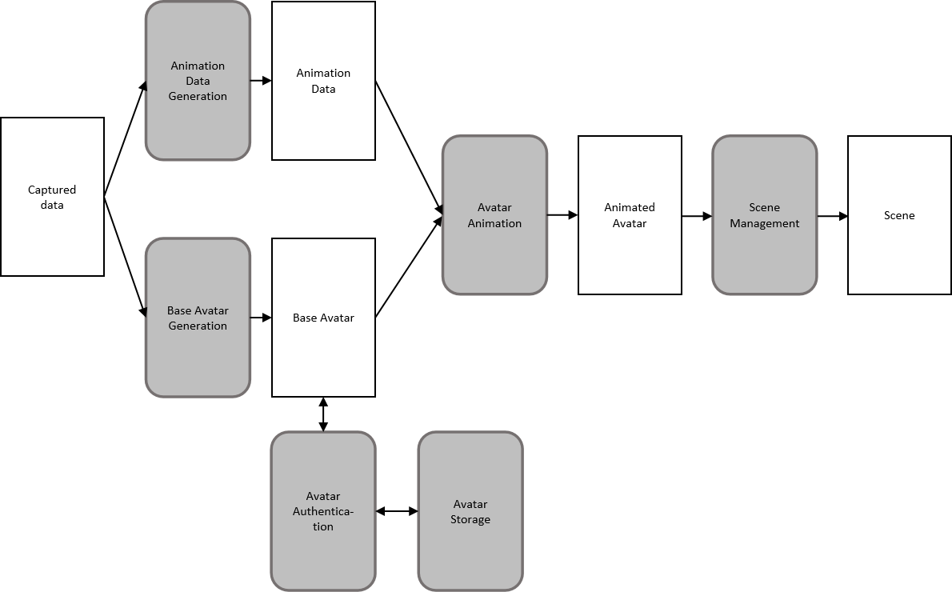

Figure 11. Avatar Reference Architecture

The identified Avatar functions are:

* **~~Avatar Authentication:~~** ~~an entity that supports management and authorization of avatar usage rights, This entity may be offered by the 5G System or a 3rd part entity. The Avatar Authentication should be able to map and identify the individuals or an enterprise who have the right to use an avatar.~~
* **Avatar Storage**: an entity that offers storage of base Avatars. This entity may be offered by the 5G System, a 3rd party entity, or the local storage of the user’s devices. The Avatar Storage ensures proper access to the base Avatar and any related data, including authorization of avatar usage rights The Authentication functionality should be able to map and identify the ownership of an avatar.
* **Avatar Animation:** depending on the Avatar representation format, this entity retrieves the base Avatar, receives representation format-specific animation data streams, and performs the Avatar animation to produce the animated Avatar that will be used in the rendering process.   
  [Note that some animation approaches may not need to rely on the 3D base avatar, instead they directly produce rendered 2D view of the Avatar.]
* **Scene Management**: creates and composes the shared 3D scene for all participants. It integrates a description of the user’s Avatar and updates its position and orientation based on the user’s pose. The updated scene is shared with all participants.
* **Animation data generation:** generating animation data from raw signals. The raw signals may come from cameras, microphones, and specialized motion capturing devices, etc. For example, through the current functional element, the video captured by the camera can be converted into facial feature points, and the audio captured by the microphone can be converted into text, etc.
* **Base Avatar Generation:** generates the Base Avatar from the inputs such as captured video from camera and other sensors information. Note that this might be done online or offline.

|  |
| --- |
| **End of Change 1** |