3GPP TSG-SA4 Meeting # 127 S4-240370
Revision of S4-240161

Sophia-Antipolis, FR, 29th Jan - 2nd Feb 2024
CR-Form-v12.2
PSEUDO CHANGE REQUEST
 | 26.264 | CR | pseudo | rev | - | Current version: | 0.3.0
For HELP on using this form: comprehensive instructions can be found at
http://www.3gpp.org/Change-Requests.

Proposed change affects: | UICC apps |  | ME | X | Radio Access Network |  | Core Network | X

Title: | pCR on terminal architecture
Source to WG: | ZTE
Source to TSG: | S4
Work item code: | IBACS |  |  |  |  |  | Date: |  |  | 1-2-2024
Category: | C |  |  |  |  |  | Release: |  |  | Rel-18
 | Use one of the following categories:  F (correction)  A (mirror corresponding to a change in an earlier release)  B (addition of feature),  C (functional modification of feature)  D (editorial modification)  Detailed explanations of the above categories can  be found in 3GPP TR 21.900. |  |  |  |  |  |  |  | Use one of the following releases:  Rel-8 (Release 8)  Rel-9 (Release 9)  Rel-10 (Release 10)  Rel-11 (Release 11)  …  Rel-16 (Release 16)  Rel-17 (Release 17)  Rel-18 (Release 18)  Rel-19 (Release 19)
Reason for change: |  | Improve AR-MTSI architecture and corresponding description.
Summary of change: |  | Updating the figure of AR-MTSI based terminal architecture referring to XR baseline client defined in TS 26.119 for AR communication.  - adding arrow between audio post-processor and decoder  - adding XR runtime as a key function component  - simplifying pre-processor and post-processor, and adding new path between them  - adding new path from sensor to data channel  Adding some text for key function components corresponding to the updated figure.
Consequences if not approved: |  | AR-MTSI architecture is not complete, and some information is missing
Clauses affected: |  | 4.2
 |  | Y | N
Other specs |  |  | X | Other core specifications |  |  |  | TS/TR ... CR ...
affected: |  |  | X | Test specifications |  |  |  | TS/TR ... CR ...
(show related CRs) |  |  | X | O&M Specifications |  |  |  | TS/TR ... CR ...
Other comments:
This CR's revision history:

- Change

4.2 Terminal architecture
The detailed XR client architecture is not in the scope of this specification. The functional components of an AR-MTSI client in terminal with AR capabilities are shown in Figure 4.2.1. The XR baseline client architecture can be found in [3]. The pre/post-processor component in terminal provides AR capabilities for processing output of peripherals and the input/output of encoders/decoders, which may include:
- XR runtime
- Scene manager
- Presentation engine
- XR source management
The AR-MTSI client has XR Runtime capabilities for rendering AR experience, e.g., spatial localization and mapping, etc., and can support local AR rendering and network-assisted split-rendering based on client’s capabilities. A UE may support multiple microphones, cameras or sensors.

An AR-MTSI client supports the protocol stack of a basic MTSI client as described in clause 4.2 of [2]. For the specific AR communication instance, AR-MTSI client can select different IMS media channel to delivery AR data to IMS network or peer UE. In general, AR media components with real-time characteristics are transported via RTP session and AR metadata is transported via data channel or RTP session with AR media.
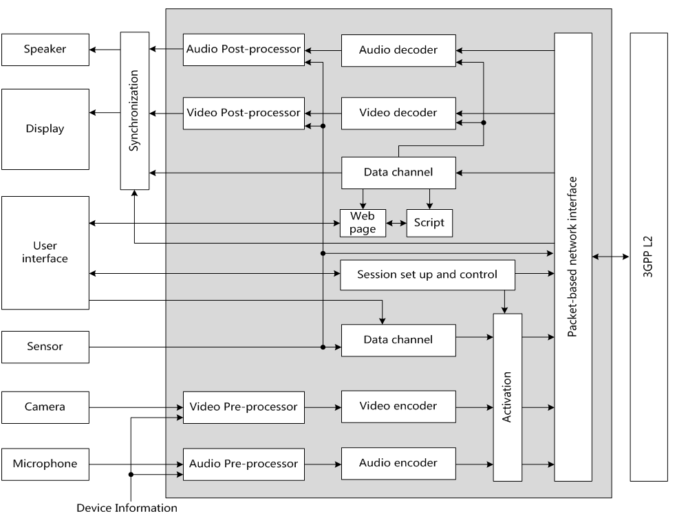

Figure 4.2.1: Functional components of an AR-MTSI client in terminal

- Change

