3GPP TSG-SA4 Meeting #127 S4-240331

Sophia-Antipolis, France, 29th Jan 2024 - 2nd Feb 2024 revision of S4-240049
CR-Form-v12.2
CHANGE REQUEST
 | 26.131 | CR | 0088 | rev | 3 | Current version: | 18.0.0
For HELP on using this form: comprehensive instructions can be found at
http://www.3gpp.org/Change-Requests.

Proposed change affects: | UICC apps |  | ME | X | Radio Access Network |  | Core Network

Title: | SWB frequency masks for headset UE, desktop hands-free UE, and handheld hands-free UE
Source to WG: | HEAD acoustics GmbH
Source to TSG:
Work item code: | eUET |  |  |  |  |  | Date: |  |  | 2024-01-30
Category: | B |  |  |  |  |  | Release: |  |  | Rel-18
 | Use one of the following categories:  F (correction)  A (mirror corresponding to a change in an earlier release)  B (addition of feature),  C (functional modification of feature)  D (editorial modification)  Detailed explanations of the above categories can  be found in 3GPP TR 21.900. |  |  |  |  |  |  |  | Use one of the following releases:  Rel-8 (Release 8)  Rel-9 (Release 9)  Rel-10 (Release 10)  Rel-11 (Release 11)  …  Rel-16 (Release 16)  Rel-17 (Release 17)  Rel-18 (Release 18)  Rel-19 (Release 19)
Reason for change: |  | For headset UE (receive only), desktop hands-free UE, and handheld hands-free UE, currently no tolerance masks are defined for frequency response measurements in SWB mode. Defining these performance requirements is part of the work item eUET.
Summary of change: |  | Limits for frequency masks in SWB mode are introduced.
Consequences if not approved: |  | For headset UE (receive only), desktop hands-free UE, and handheld hands-free UE are lacking performance requirements for frequency response measurements.
Clauses affected:
 |  | Y | N
Other specs |  |  | X | Other core specifications |  |  |  | TS/TR ... CR ...
affected: |  |  | X | Test specifications |  |  |  | TS/TR ... CR ...
(show related CRs) |  |  | X | O&M Specifications |  |  |  | TS/TR ... CR ...
Other comments:
This CR's revision history: |  | S4-231778 – Initial proposal, submitted for SA4#126.  S4-231974 – Agreed as basis for further work at SA4#126 plenary.  S4-240049 – Submitted for SA4#127 with some corrections

4.3 Acoustical interfaces
The following classes of acoustical interface are considered in this specification:
- Handset UE including softphone UE used as a handset;
- Headset UE including softphone UE used with headset;
- Desktop-mounted hands-free UE including softphone UE with external loudspeaker(s) used in hands-free mode; UEs with integrated loudspeakers in hands-free mode are excluded from this UE class.
- Hand-held hands-free UE including softphone UE with internal loudspeaker(s) used in hands-free mode.
(See definition of softphone in Clause 3.1)
Vehicle Mounted Hands-free UE is out of scope. In case performance evaluations are planned for Vehicle Mounted Hands-free UE, test setup, methods and requirements specified in Recommendation ITU-T P.1100 [21] (for NB), P.1110 [22] (for WB) or P.1120 [23] (for SWB and FB) can be used.
The requirements and performance objectives for a softphone UE shall be derived according to the following rules:
- When using a softphone UE as a handset: requirements and performance objectives shall correspond to handset mode.
- When using a softphone UE with headset: requirements and performance objectives shall correspond to headset mode.
- When using a softphone UE in hands-free mode:
- When using internal loudspeaker(s), requirements and performance objectives shall correspond to hand-held hands-free.
- When using external loudspeaker(s), requirements and performance objectives shall correspond to desktop-mounted hands-free.

7.4.2.2 Headset UE receiving
The sensitivity/frequency characteristics shall be as follows:
The receiving sensitivity frequency response, measured either from the digital interface to the DRP with diffuse-field correction or from the SS audio input (analogue or digital input of the reference speech encoder of the SS) to the DRP with diffuse-field correction, shall be within a mask, which can be drawn with straight lines between the breaking points in table 21 on a logarithmic (frequency) - linear (dB sensitivity) scale.
Table 21: Headset receiving sensitivity/frequency requirement mask
Frequency (Hz) | Upper limit (dB) | Lower limit (dB)
100 | [5-6]
200 | [5…6] | [-10 … -8]
250 | [5…6] | [-6 … -5]
1000 | [5…6] | [-6 … -5]
2000 | [5…8] | [-6 … -5]
8000 | [5…8] | [-6 … -5]
12500 | [5…8] | [-12 … -11]
16000 | [5…8]
NOTE 1: All sensitivity values are expressed in dB on an arbitrary scale.
NOTE 2: Values within [] are provisional and expected to be confirmed, revised or removed based on future studies.

It is recommended as a performance objective that the receiving sensitivity/frequency response be within the mask which can be drawn with straight lines between the breaking points in table 22.
Table 22: Headset receiving sensitivity/frequency objective mask
Frequency (Hz) | Upper limit (dB) | Lower limit (dB)
100 | [4]
200 | [4] | [-4]
250 | [4] | [-4]
1000 | [4] | [-4]
2000 | [4] | [-4]
8000 | [4] | [-4]
12500 | [4] | [-7]
16000 | [4]
NOTE 1: All sensitivity values are expressed in dB on an arbitrary scale.
NOTE 2: Values within [] are provisional and expected to be confirmed, revised or removed based on future studies.

TBD
Figure 17: Headset receiving sensitivity/frequency masks
Compliance shall be checked by the relevant test described in TS 26.132.

7.4.3 Desktop hands-free UE sending
The sending sensitivity frequency response from the MRP to the SS audio output (digital output of the reference speech decoder of the SS) shall be as follows:
The sending sensitivity frequency response shall be within the mask which can be drawn with straight lines between the breaking points in table 23 on a logarithmic (frequency) - linear (dB sensitivity) scale.
Table 23: Desktop hands-free sending sensitivity/frequency requirement mask
Frequency (Hz) | Upper limit (dB) | Lower limit (dB)
100 | [0...5]
200 | 5 | -5
8000 | 5 | -5
12500 | 5 | -10
16000 | 5
NOTE 1: All sensitivity values are expressed in dB on an arbitrary scale.
NOTE 2: Values within [] are provisional and expected to be defined as single values based on future studies.

It is recommended as a performance objective that the sending sensitivity/frequency response be within the mask which can be drawn with straight lines between the breaking points in table 24.
Table 24: Desktop hands-free sending sensitivity/frequency objective mask
Frequency (Hz) | Upper limit (dB) | Lower limit (dB)
100 | [0…4]
200 | 4 | -4
8000 | 4 | -4
12500 | 4 | -6
16000 | 4
NOTE 1: All sensitivity values are expressed in dB on an arbitrary scale.
NOTE 2: Values within [] are provisional and expected to be confirmed, revised or removed based on future studies.

TBD

Figure 18: Desktop hands-free sending sensitivity/frequency masks

Compliance shall be checked by the relevant test described in TS 26.132.

7.4.4 Desktop hands-free UE receiving
The receiving sensitivity frequency response from the SS audio input (analogue or digital input of the reference speech encoder of the SS) to the free-field shall be as follows:
The receiving sensitivity frequency response shall be within the mask which can be drawn with straight lines between the breaking points in table 25 on a logarithmic (frequency) - linear (dB sensitivity) scale.
Table 25: Desktop hands-free receiving sensitivity/frequency requirement mask
Frequency (Hz) | Upper limit (dB) | Lower limit (dB)
125 | 8
200 | 8 | -9
250 | 8 | -9
315 | 7 | -6
400 | 6 | -6
8 000 | 6 | -6
12 500 | 6 | -9
16 000 | 6
NOTE:
All sensitivity values are expressed in dB on an arbitrary scale.

It is recommended as a performance objective that the receiving sensitivity frequency response be within the mask which can be drawn with straight lines between the breaking points in table 26 on a logarithmic (frequency) - linear (dB sensitivity) scale.
Table 26: Desktop hands-free receiving sensitivity/frequency objective mask
Frequency (Hz) | Upper limit (dB) | Lower limit (dB)
100 | 6
200 | 6 | -9
250 | 6 | -6
315 | 6 | -6
12 500 | 6 | -6
16 000 | 6
NOTE 1: All sensitivity values are expressed in dB on an arbitrary scale.

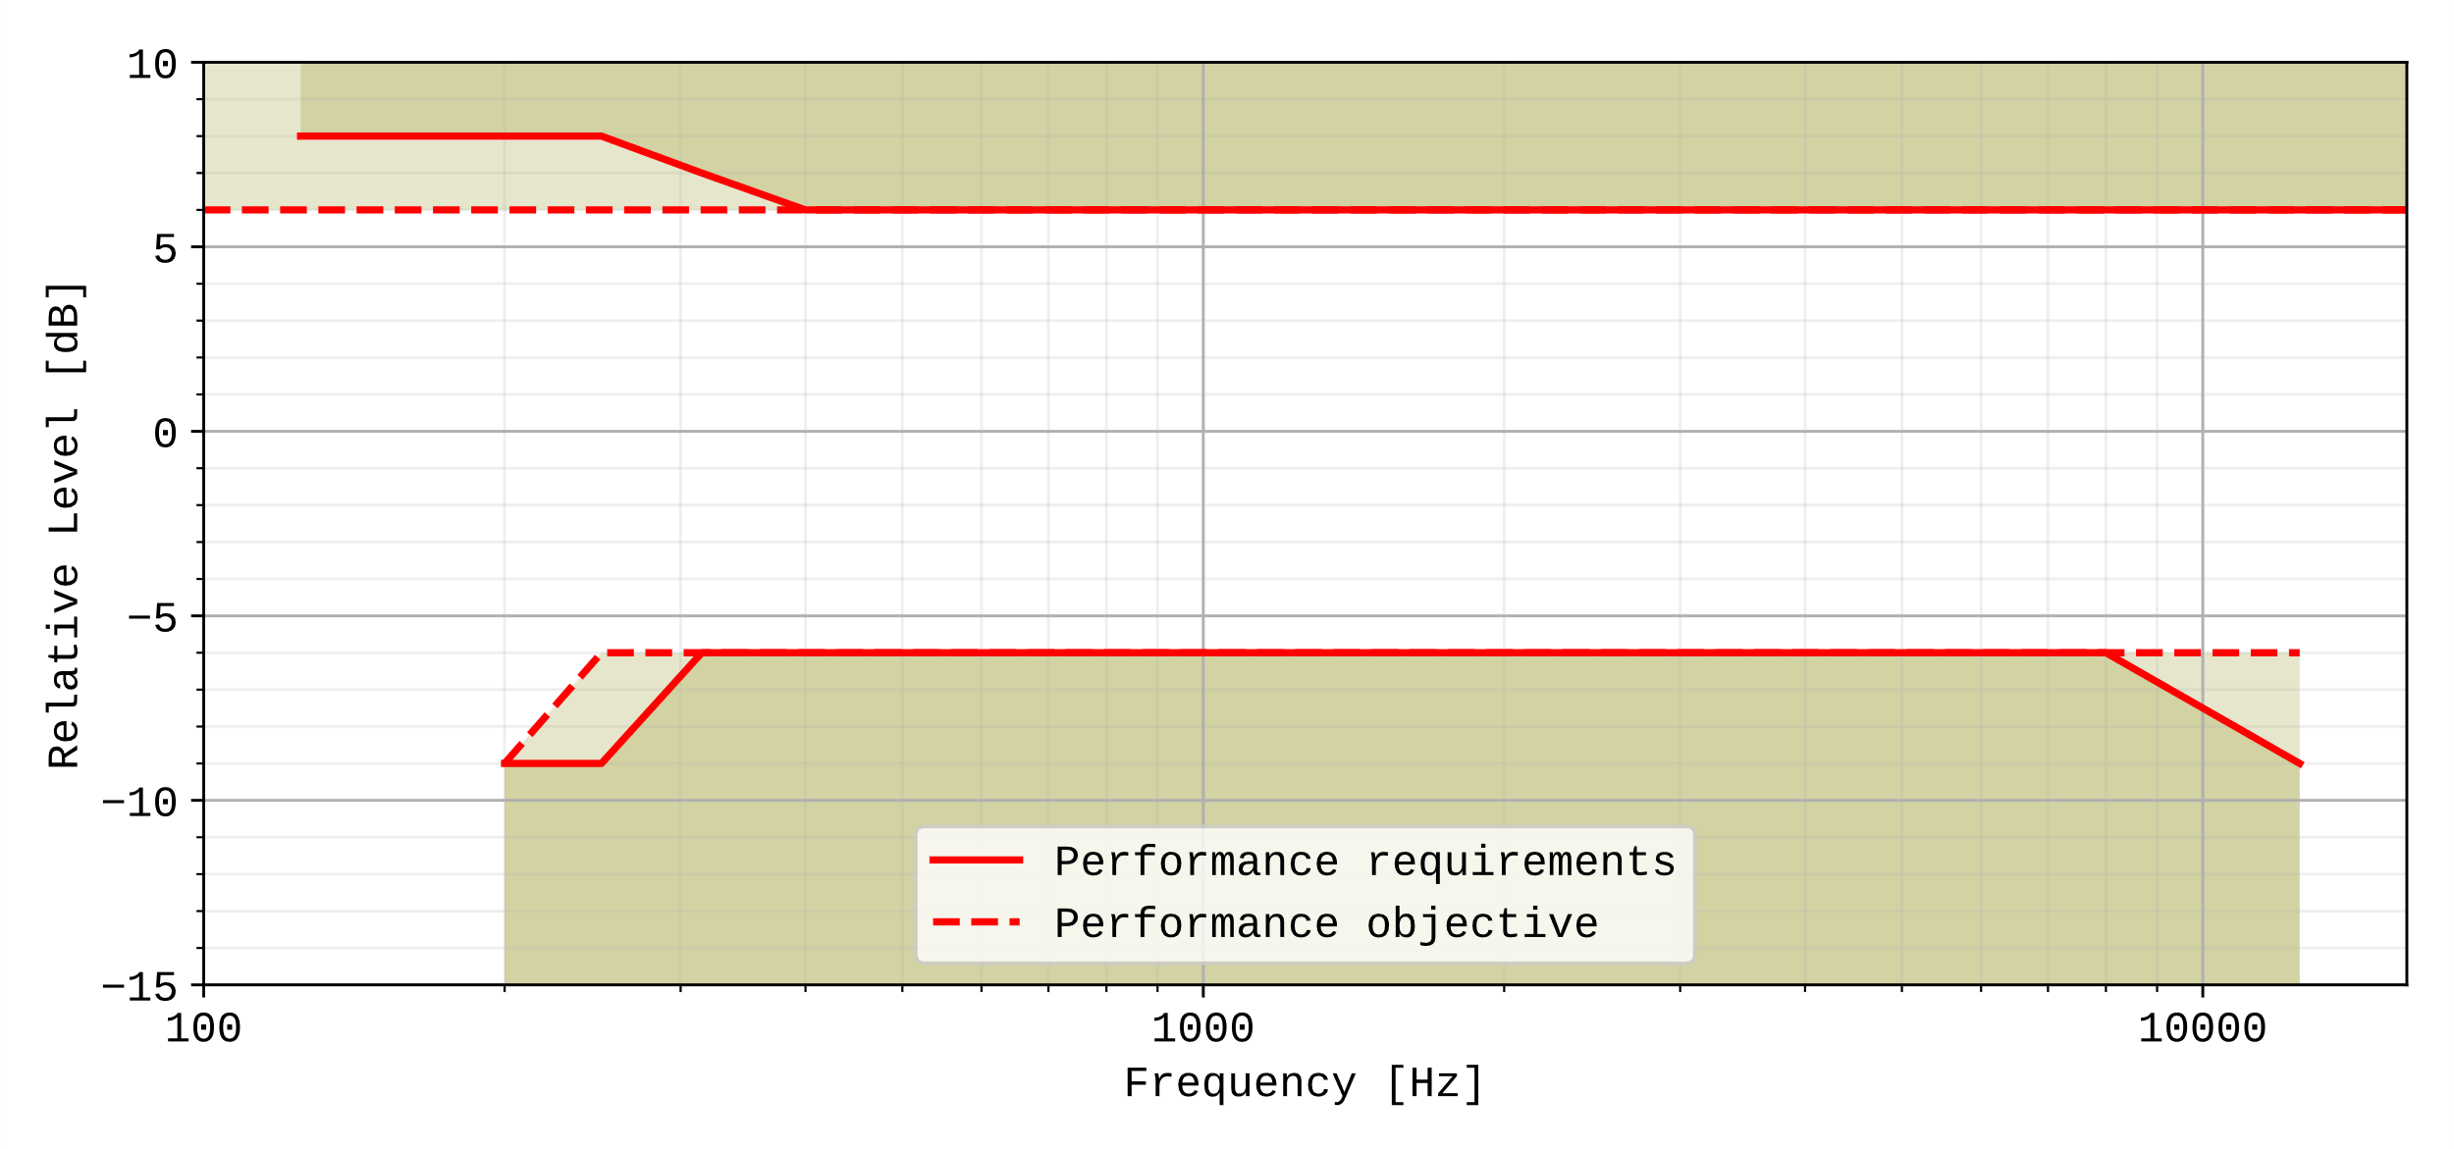

Figure 19: Desktop hands-free receiving sensitivity/frequency masks
Compliance shall be checked by the relevant test described in TS 26.132.

7.4.5 Hand-held hands-free UE sending
The sending sensitivity frequency response from the MRP to the SS audio output (digital output of the reference speech decoder of the SS) shall be as follows:
The sending sensitivity frequency response shall be within the mask which can be drawn with straight lines between the breaking points in table 27 on a logarithmic (frequency) - linear (dB sensitivity) scale.
Table 27: Hand-held hands-free sending sensitivity/frequency requirement mask
Frequency (Hz) | Upper limit (dB) | Lower limit (dB)
100 | [0...5]
200 | [4...5] | [-5...-4]
8000 | [4...5] | [-5...-4]
12500 | [4...5] | [-10…-6]
16000 | [4...5]
NOTE 1: All sensitivity values are expressed in dB on an arbitrary scale.
NOTE 2: Values within [] are provisional and expected to be defined as single values based on future studies.

It is recommended as a performance objective that the sending sensitivity/frequency response be within the mask which can be drawn with straight lines between the breaking points in table 28.
Table 28: Hand-held hands-free sending sensitivity/frequency objective mask
Frequency (Hz) | Upper limit (dB) | Lower limit (dB)
100 | [0…3]
200 | [3…4] | [-4…-3]
8000 | [3…4] | [-4…-3]
12500 | [3…4] | [-6…-5]
16000 | [3…4]
NOTE 1: All sensitivity values are expressed in dB on an arbitrary scale.
NOTE 2: Values within [] are provisional and expected to be confirmed, revised, or removed, based on future studies.

TBD
Figure 20: Hand-held hands-free sending sensitivity/frequency masks

Compliance shall be checked by the relevant test described in TS 26.132.

7.4.6 Hand-held hands-free UE receiving
The receiving sensitivity frequency response from the SS audio input (analogue or digital input of the reference speech encoder of the SS) to the free-field shall be as follows:
The receiving sensitivity frequency response shall be within the mask which can be drawn with straight lines between the breaking points in table 29 on a logarithmic (frequency) - linear (dB sensitivity) scale.
Table 29: Hand-held hands-free receiving sensitivity/frequency requirement mask
Frequency (Hz) | Upper limit (dB) | Lower limit (dB)
100 | 6
630 | 6 | [-12…-6]
800 | 6 | -6
8 000 | 6 | -6
12 500 | 6 | -12
16 000 | 6
NOTE 1: All sensitivity values are expressed in dB on an arbitrary scale.
NOTE 2: Values within [] are provisional and expected to be confirmed, revised, or removed, based on future studies.

It is recommended as a performance requirement that the receiving sensitivity frequency response be within the mask which can be drawn with straight lines between the breaking points in table 30 on a logarithmic (frequency) - linear (dB sensitivity) scale.
Table 30: Hand-held hands-free receiving sensitivity/frequency objective mask
Frequency (Hz) | Upper limit (dB) | Lower limit (dB)
100 | [6] | []
400 | [6] | [-12…-6]
500 | [6] | [-6]
8 000 | [6] | [-6]
12 500 | [6] | [-12]
16 000 | [6]
NOTE 1: All sensitivity values are expressed in dB on an arbitrary scale.
NOTE 2: Values within [] are provisional and expected to be confirmed, revised, or removed, based on future studies.

TBD
Figure 21: Hand-held hands-free receiving sensitivity/frequency masks

Compliance shall be checked by the relevant test described in TS 26.132.

