**3GPP TSG-SA WG4 Meeting #127-bis-eS4-240650**

**E-meeting, 8 April - 12 April 2024**

**Source: Samsung Electronics Co., Ltd.**

**Title: [FS_AVATAR] On interoperability requirements**

**Agenda item: 9.8**

**Document for: Agreement**

**1. Introduction**

This contribution presents a discussion on interoperability requirements for FS_AVATAR.

**2. Discussion and proposal**

Discussions related to interoperability was triggered during the last SA4 #127 meeting in Sophia-Antipolis, in particular the introduction of format conversion and a possible recommendation of a common representation format.

The discussion on interoperability is coherent to considerations on the support of common avatar formats (including base avatar data formats and animation data formats) between two or more parties in a real time communication use case, as is the applicable to the use cases defined in TR 26.813.

In particular, the following on interoperability should be identified:

* Whether one format, or a list of formats as possible profiles for Avatar should be defined
* In the case that the two parties of a call do not support the same format, how to handle the transcoding of formats at a network entity such as an MF
* Mechanisms to enable the negotiation of format capabilities as listed above, between the two parties of a call

The ability for an MF to support the transcoding of any proprietary format is beyond that of standards scope – in the case that SA4 defines a list of different supported formats, this can be used as a guide for the transcoding requirements of an MF.

The figure below shows an example where caller A and caller B support different avatar formats, where after a call configuration, transcoding in the Media Function is configured according to the format capabilities of both callers.

3GPP defined avatar formats may define pairs of base avatar and animation data formats, or, depending on the format compatibility, may also define base avatar and animation data formats separately.

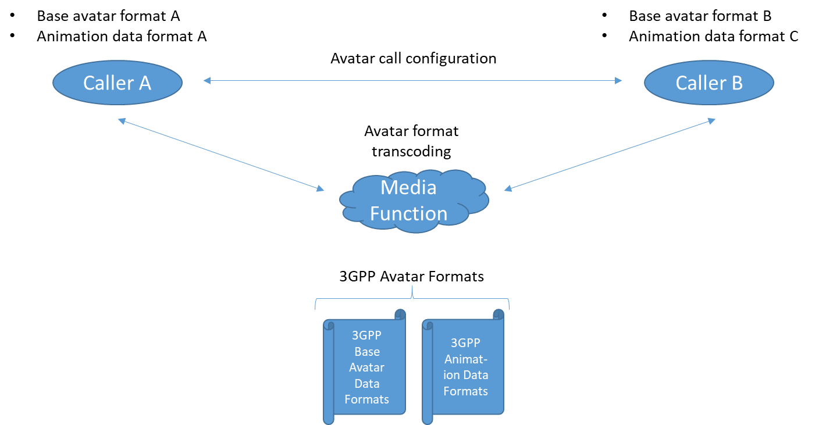

**3. Proposal**

It is proposed to include the following as discussion points related to interoperability requirements into the FS_AVATAR PD:

* A decision in defining formats as 3GPP supported formats for Avatar, and how these may be related to fallback formats.
* Depending on the outcome of the decision above, in the case that the two parties of a call do not support the same format, consider aspects related to the transcoding of formats at a network entity such as an MF
* Defining mechanisms to enable the negotiation of format capabilities, between the two or more parties of an avatar call