**Source: China Mobile**

**Title: [FS_ Beyond2D] Scenario: Free-viewpoint TV**

**Document for: Agreement**

**Agenda Item: 9.9**

1 Introduction

This document contains a scenario related to the Study Item of Beyond 2D Video ( FS_Beyond2D ) which is in document SP-240479.

2.Proposal

|  |
| --- |
| **1st Change** |

**1.Free-viewpoint TV**

**2.Motivation for the scenario**

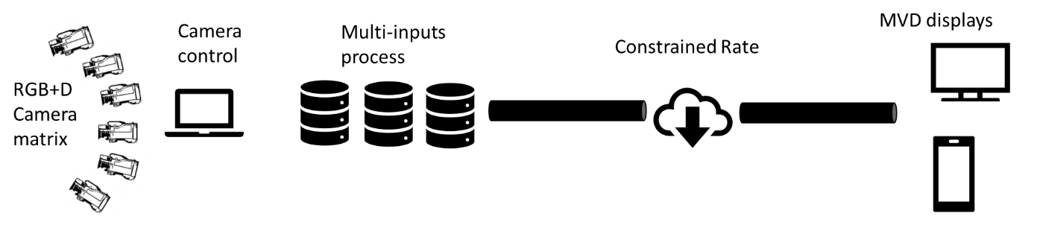

Free-viewpoint TV (FTV) is a scenario that allows viewing of a 3D world by freely changing the viewpoint, It uses multiple high-precision cameras to shoot multi-angle images synchronously at the millisecond level, with 6DoF (6-way freedom) experience, and has commercial value in sports events, TV programs, online education, advertising and marketing.

Multi-view video plus depth (MVD) is a phase of FTV which is the combination of video and associated depth maps. The depth maps provide disparities associated with every sample of the video that can be used to render arbitrary numbers of additional views via view synthesis.

1. **Description of the scenario**

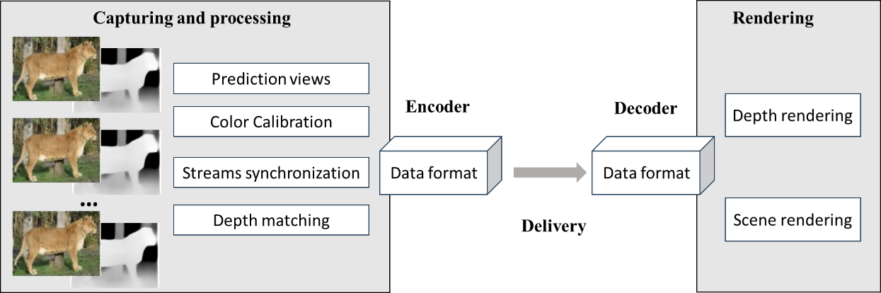

1. Capturing and processing: RGBD camera, color calibration, multi-stream synchronization, depth matching, video synthesis, prediction extra views
2. Encoding: texture map, depth map and camera parameters of independent point and dependent point.
3. Packaging and delivery: HTTP adaptive streaming (e.g. DASH/HLS).
4. Decoding: texture map, depth map and camera parameters
5. *Post-processing: none
6. Rendering: scene and depth rendering
7. General constraints on bandwidth: More views can tolerate better prediction error, but the bandwidth consumption will be greater. Therefore, the number of views should trade off prediction error and bandwidth.
8. **Supporting companies and 3GPP members**
9. **Source format properties**

For MVD source, the following information is considered to set test sequences. It includes texture format properties and depth format properties of source as

|  |  |
| --- | --- |
| Texture format properties | |
| Spatial resolutions | 4K for the whole video, and 720p or 540p for a single view at least. |
| Chroma Format: | Y’CbCr |
| Chroma Subsampling: | 4:2:0, 4:2:2, 4:4:4 |
| Aspect ratios: | 16:9 |
| Frame rates: | 30, 60 |
| Colour space formats: | BT.709 and above |
| Transfer Characteristics: | SDR, HDR |
| Bit depth | 10 |
| Viewpoints: | TBD |
| Other signal properties: | 1) positions and angles of cameras. 2) Disparity |

|  |  |
| --- | --- |
| Depth format properties | |
| Spatial resolutions | 4K for the whole video, and 720p or 540p for a single view at least. |
| Chroma Format: | Y’CbCr |
| Chroma Subsampling: | 4:2:0, 4:2:2, 4:4:4 |
| Aspect ratios: | 16:9 |
| Frame rates: | 30, 60 |
| Colour space formats: | BT.709 and above |
| Transfer Characteristics: | SDR, HDR |
| Bit depth | 8,16 |
| Viewpoints: | TBD |
| Other signal properties: | 1) positions and angles of cameras. 2) Disparity |

1. **Encoding and decoding constraints and settings**
2. **Performance Metrics and Requirements**
3. **Interoperability Considerations for the application**
4. **Test Sequences**
5. **Detailed test conditions**
6. **External Performance data**
7. **Additional Information**

|  |
| --- |
| **Change end** |