**Source: China Mobile Com. Corporation, ZTE**

**Title: [FS_Beyond2D] Scenario: Glasses-free 3D Live Streaming**

**Agenda item: 9.9**

**Document for: Discussion and Agreement**

## 1 Introduction

This proposal provides a scenario on “Glasses-free 3D Live Streaming”.

## 2 Discussion

## Scenario 1: Glasses-free 3D Live Streaming

The following aspects are considered for a scenario:

1. **Scenario name**

Glasses-free 3D Live Streaming

1. **Motivation for the scenario**

Live Streaming services can be deployed across various platforms, including social media platforms like YouTube Live, Facebook Live, and TikTok, as well as though e-commerce platforms such as eBay and Taobao [1]. It significantly impact marketing by providing a dynamic and interactive channel to directly connect markets and their target audiences in real time. In 2023, US livestream sales are projected to reach $50 billion, according to Coresight Research [2]. Despite this growth, traditional 2D live streaming has hit a bottleneck, to continue captivating users, it’s essential to explore a more immersive live streaming experience by incorporating beyond 2D video.

On the other hand, glasses-free 3D technology is relatively mature. It offers users a completely new level of visual realism and immersion. In 2024, the glasses-free 3D industry is anticipated for commercialization, with the global market valued at US$887.40 million in 2023 and projected to reach US$3.88 billion by 2033, expanding at phenomenal CAGR of 15.9% from 2023 to 2033[3].

1. **Description of the scenario**

Generic end-to-end workflow, alignment with TS 26.501/506 is expected:

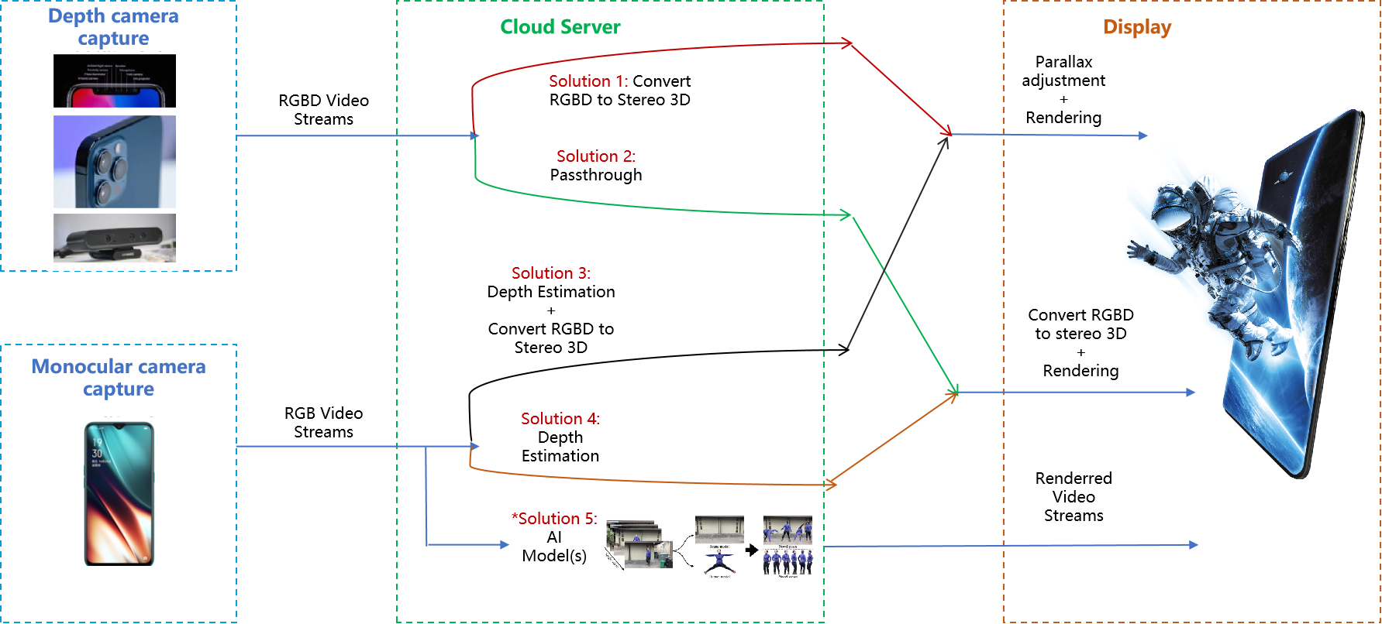

Pipeline for 2D-to-Stereo 3D conversion:

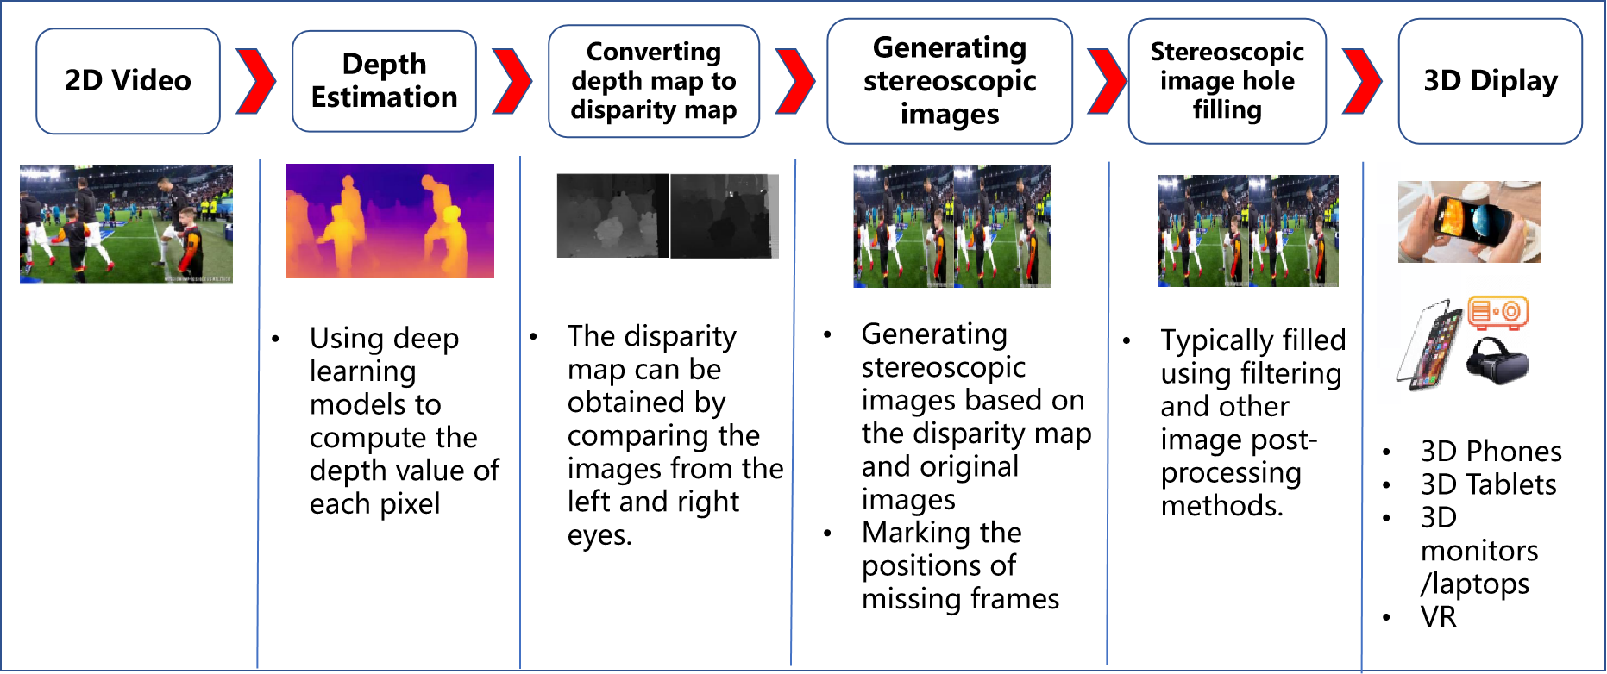

Beyond 2D video formats:

* RGBD
* RGB
* *AI-Generated representations: NeRF/3DGS (Under Investigation)

1. **Supporting companies and 3GPP members**

China Mobile

ZTE

1. **Source format properties**

[

|  |  |  |
| --- | --- | --- |
| **Parameter** | **Input stream (2D)** | **Output stream (3D)** |
| Spatial resolution | 1920*1080  2560*1600 | Full Width: 3840*1080  5120*1600  Full Height: 1920*2160  2560*3200  Half Width/Height: 1920*1080  2560*1600 |
| Chroma Format | Y’CbCr, RGB | Y’CbCr, RGB |
| Chroma Subsampling | 4:2:0 | 4:2:0 |
| Aspect ratios | 16:9  16:10 | 32:9  32:10  16:9  16:10 |
| Frame rates | 25, 30, 60,90,120 | 25, 30, 60,90,120 |
| Colour space formats | BT.709, BT.2020 | BT.709,BT.2020 |
| Transfer Characteristics | BT.709, BT.2020 | BT.709, BT.2020 |
| Bit depth | 8 bit | 8 bit |
| Viewpoints | 1 | 2 views for mobile phone  <tbd> |
| Other signal properties |  |  |

]

1. **Encoding and decoding constraints and settings**

[

|  |  |  |
| --- | --- | --- |
| **Parameter** | **Input streams (2D)** | **Output streams (3D)** |
| Relevant Codec and Codec Profile/Levels according to 3GPP TS (e.g., TS 26.119) | H.264/AVC Progressive  High Profile 4.2 | H.265/HEVC Main 10 Profile |
| Random access frequency | 1 second | 1 second |
| Error resiliency requirements | N/A | N/A |
| Bitrates and quality requirements | Constant bitrates ={4,8,12} Mbps | Constant bitrates ={4,8,12,24} Mbps |
| Bitrate parameters (CBR, VBR, CAE, HRD parameters) | 4Mbps ~ 12Mbps CBR | Half Width/Height: 4Mbps ~12Mbps  Full Width/Height: 8Mbps ~ 24Mbps  CBR |
| ABR encoding requirements (switching frequency, etc.) | N/A | N/A |
| Latency requirements and specific encoding settings | Low latency requirements | Low latency requirements |
| Encoding context: real-time encoding, on device encoding, cloud-based encoding, offline encoding, etc | Real-time encoding | Real-time encoding  Cloud-based encoding |
| Required decoding capabilities | H.264/AVC Progressive  High Profile 4.2 | H.265/HEVC Main 10 Profile |
| Synchronization requirements | N/A | <tbd> |

]

1. **Performance Metrics and Requirements**

PSNR, SSIM, SIM, BD-Rate, signal-to-noise ratio (SNR)

[Latency: 1s

Bandwidth: 100Mbit/s～1Gbit/s (evaluate the impact of the beyond 2D video representations on the bandwidth requirements of streaming with minuscule loss probabilities)]

1. **Interoperability Considerations for the application**

DASH, LL-HLS

RTP

WebRTC

1. **Test Sequences**

<TBD>

1. **Detailed test conditions**

<TBD>

1. **External Performance data**
2. Subjective Assessment Methods for 3D Video Quality, document ITU-T P.3D-sam, International Telecommunication Union, Geneva,Switzerland, Jul. 2015.

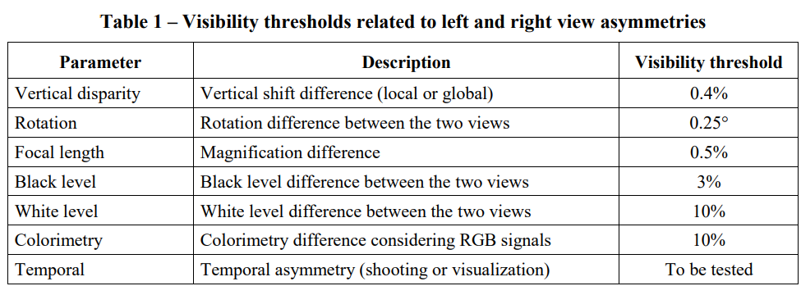

1. Assessment Methods of Visual Fatigue and Safety Guideline for 3D Video, document ITU-T J.3D-fatigue, International Telecommunication Union, Geneva, Switzerland, 2015.
2. Display Requirements for 3D Video Quality Assessment, document ITU-T J.3D-disp-req, International Telecommunication Union, Geneva, Switzerland, 2015.

<FFS>

1. **Additional Information**

<TBD>

## 3 Proposal

It is proposed to document this scenario to permanent document of TR 26.956.

## 4 References

[1] Wang, Y., Lu, Z., Cao, P. et al. How Live Streaming Changes Shopping Decisions in E-commerce: A Study of Live Streaming Commerce. Comput Supported Coop Work 31, 701–729 (2022). <https://doi.org/10.1007/s10606-022-09439-2>

[2] Coresight Research, “Inside the $50 billion shopping spree happening on livestreams.”, https://www.cnbc.com/video/2023/06/09/inside-the-50-billion-shopping-spree-happening-on-livestreams.html

[3] Fact. MR, “Glass-Free HD 3D Display Market”, https://www.factmr.com/report/286/glass-free-hd-3d-display-market