**3GPP TSG- Meeting #**

**Chicago, USA, 13th November 2023 - 17th November 2023**

|  |  |  |  |  |  |  |  |  |
| --- | --- | --- | --- | --- | --- | --- | --- | --- |
| *CR-Form-v12.2* | | | | | | | | |
| **PSEUDO CHANGE REQUEST** | | | | | | | | |
|  | | | | | | | | |
|  |  | **CR** |  | **rev** |  | **Current version:** |  |  |
|  | | | | | | | | |
| *For* [***HE******LP***](http://www.3gpp.org/3G_Specs/CRs.htm#_blank)*on using this form: comprehensive instructions can be found at* [*http://www.3gpp.org/Change-Requests*](http://www.3gpp.org/Change-Requests)*.* | | | | | | | | |
|  | | | | | | | | |

|  |  |  |  |  |  |  |  |  |
| --- | --- | --- | --- | --- | --- | --- | --- | --- |
| ***Proposed change affects:*** | UICC apps |  | ME | **X** | Radio Access Network |  | Core Network |  |

|  |  |  |  |  |  |  |  |  |  |  |
| --- | --- | --- | --- | --- | --- | --- | --- | --- | --- | --- |
|  | | | | | | | | | | |
| ***Title:*** |  | | | | | | | | | |
|  |  | | | | | | | | | |
| ***Source to WG:*** |  | | | | | | | | | |
| ***Source to TSG:*** |  | | | | | | | | | |
|  |  | | | | | | | | | |
| ***Work item code:*** |  | | | | |  | ***Date:*** | | |  |
|  |  | | | |  | |  | | |  |
| ***Category:*** |  |  | | | | | ***Release:*** | | |  |
|  | *Use one of the following categories:* ***F*** *(correction)* ***A*** *(mirror corresponding to a change in an earlier release)* ***B*** *(addition of feature),* ***C*** *(functional modification of feature)* ***D*** *(editorial modification)*  Detailed explanations of the above categories can be found in 3GPP [TR 21.900](http://www.3gpp.org/ftp/Specs/html-info/21900.htm). | | | | | | | | *Use one of the following releases: Rel-8 (Release 8) Rel-9 (Release 9) Rel-10 (Release 10) Rel-11 (Release 11) … Rel-16 (Release 16) Rel-17 (Release 17) Rel-18 (Release 18) Rel-19 (Release 19)* | |
|  |  | | | | | | | | | |
| ***Reason for change:*** | | Enable the processing of video-encoded depth maps for both IBACS and SR_MSE use cases.  Clause 6.8.1 “Support of RGBD content” from the MeCAR PD 9.0 was reused as basis for this pCR.  The related pCR for SR_MSE is S4-231872 and for IBCAS is S4-231874. | | | | | | | | |
|  | |  | | | | | | | | |
| ***Summary of change:*** | | The following changes are proposed:   * Definition of depth map * Definition of depth map coding and represntation * Information on the mapping between depth map and depth layer in OpenXR | | | | | | | | |
|  | |  | | | | | | | | |
| ***Consequences if not approved:*** | |  | | | | | | | | |
|  | |  | | | | | | | | |
| ***Clauses affected:*** | | 6.3, B.2.4 | | | | | | | | |
|  | |  | | | | | | | | |
|  | | **Y** | **N** |  | | | |  | | |
| ***Other specs*** | |  |  | Other core specifications | | | | TS/TR ... CR ... | | |
| ***affected:*** | |  |  | Test specifications | | | | TS/TR ... CR ... | | |
| ***(show related CRs)*** | |  |  | O&M Specifications | | | | TS/TR ... CR ... | | |
|  | |  | | | | | | | | |
| ***Other comments:*** | |  | | | | | | | | |
|  | |  | | | | | | | | |
| ***This CR's revision history:*** | |  | | | | | | | | |

CHANGE #1

## 6.3 Systems capabilities

### 6.3.1 Depth map capabilities

#### 6.3.1.1 General

Within an XR Session, the XR View may contain a depth layer in addition to the projected views as described in 4.1.2.2. Based on this depth layer, the XR Runtime can make use of this information to improve accuracy of the final rendered images. Another usage of depth maps is for representing volumetric content composed of two video sequences: a texture and a depth map video sequences, generally referred to as RGBD content.

#### 6.3.1.2 Definition of depth map and depth map sequence

In this specification, a depth map is defined as a mono channel image wherein each sample represents the distance between the surface of an object, point (A) and the camera centre (C), projected on the z-axis, which corresponds to the length of the segment (CA’) as depicted in Figure 6.3.1.1-1.

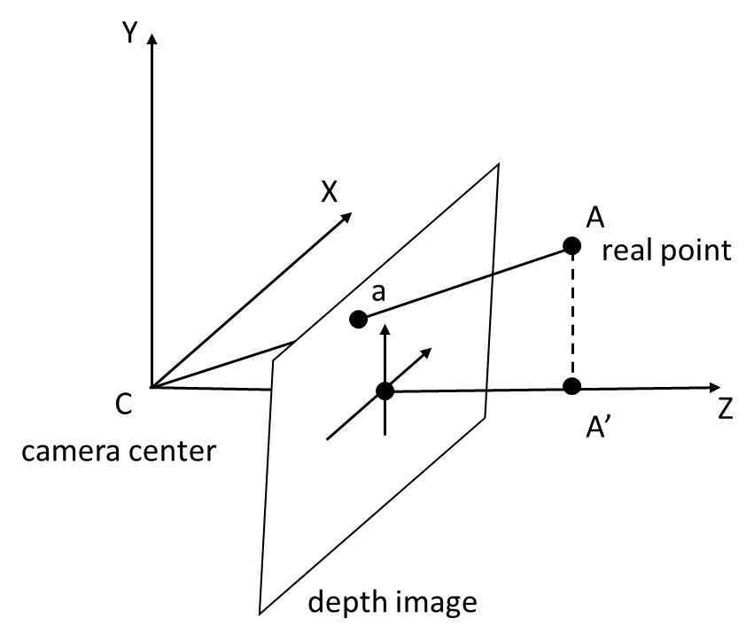

Figure 6.3.1.1-1 Depth map representation

A depth map sequence is a sequence of depth maps at different time instances.

#### 6.3.1.3 Coding of depth map sequences

A depth map sequence shall be encoded as a normalized depth map where the normalized values are comprised between a near and far depth values defining a depth range.

When the far depth value is greater than the near depth value, then the normalized value represents a depth value as defined by the Equation 6.3.1.3-1:

(Eq. 6.3.1.3-1)

When the near depth value is greater than the far depth value, then the normalized value represents as defined by the Equation 6.3.1.3-2.

(Eq. 6.3.1.3-2)

A depth map sequences shall be encoded as a single coded video sequence that is decodable by a decoder **HEVC-FullHD-Dec** capable as defined in clause 6.1.

The depth map information provides the mean to interpret the sample values of a depth map. Those information are defined by the object depthMapInformation and shall follow the format defined in Table 6.2.5-1.

Table 6.2.5-1 – Depth map information format

|  |  |  |  |
| --- | --- | --- | --- |
| Name | Type | Cardinality | Description |
| depthMapInformation | Object | 0..1 | An object providing information to interpret the sample values of a depth map image. |
| nearDepth | float | 1 | The positive distance in meters to the near depth value. |
| farDepth | float | 1 | The positive distance in meters to the far depth value. |

The depthMapInformation object shall be signalled in a HEVC bitstream using the depth representation information SEI message, defined in G.14.2.4 in the HEVC specification, with the following constraints:

* The nearDepth, respectively farDepth, corresponds to the ZNear variable, respectively ZFar variable.
* The value of the depth_representation_type syntax element shall be equal to 0 or 2.
* The depth representation information SEI message shall be associated with layer whose the nuh_layer_id equal to 0.
* The syntax elements d_min_flag and d_max_flag shall be equal to 0.
* The ZNear and ZFar values shall be expressed in meters.

CHANGE #2

#### B.2.4 Relation XrCompositionLayerDepthInfoKHR with depth maps format

The extension XR_KHR_composition_layer_depth defines an extra layer that can be submitted with the projection layer. This extra layer provides a depth image which can be used by the XR Runtime to produce the final display buffer.

To this end, the structure XrCompositionLayerDepthInfoKHR can be passed on by the application and is defined as shown below:

typedef struct XrCompositionLayerDepthInfoKHR {  
 XrStructureType type;  
 const void* next;  
 XrSwapchainSubImage subImage;  
 float minDepth;  
 float maxDepth;  
 float nearZ;  
 float farZ;  
} XrCompositionLayerDepthInfoKHR;

As defined in clause 6.3.1.3, a depth map stream carries the depth information via the HEVC depth representation information (DRI) SEI. Table B.2.4-1 provides the mapping between the variables associated with this SEI message and the OpenXR data structure to be generated from it.

Table B.2.4-1 – Mapping between XrCompositionLayerDepthInfoKHR and HEVC DRI SEI

|  |  |
| --- | --- |
| OpenXR variable | HEVC DRI SEI variable |
| minDepth | None, set to 0.0f |
| maxDepth | None, set to 1.0f |
| nearZ | ZNear |
| farZ | ZFar |

END OF CHANGES