Source: Nokia Corporation, Ericsson LM
Title: [IBACS] Generic IMS DC architecture to support AR communication

Document for: Discussion

Agenda Item: 10.6 IBACS

Discussion
Document S4aR230099 was agreed with minor modifications during the RTC SWG Telco on Oct 11, 2023. The agreed text now contains a copy of the architecture from TS 23.228. Since, copying the architectural diagram from another specification can create conflicts and unnecessary updates across specifications, we propose that we include only the reference in TS 26.264. Furthermore, a generic architecture based on TS 23.228 with emphasis on media aspects is proposed below to be used in the IBACS specification instead.

_____________________ Proposed Changes on S4aR230099__________________________

4.3 End-to-End Reference Architecture

The end-to-end architecture to support AR communication over IMS can be found in TS 23.228 Annex AC. The following figure is a simplified version showing the media functions within the scope of this specification.

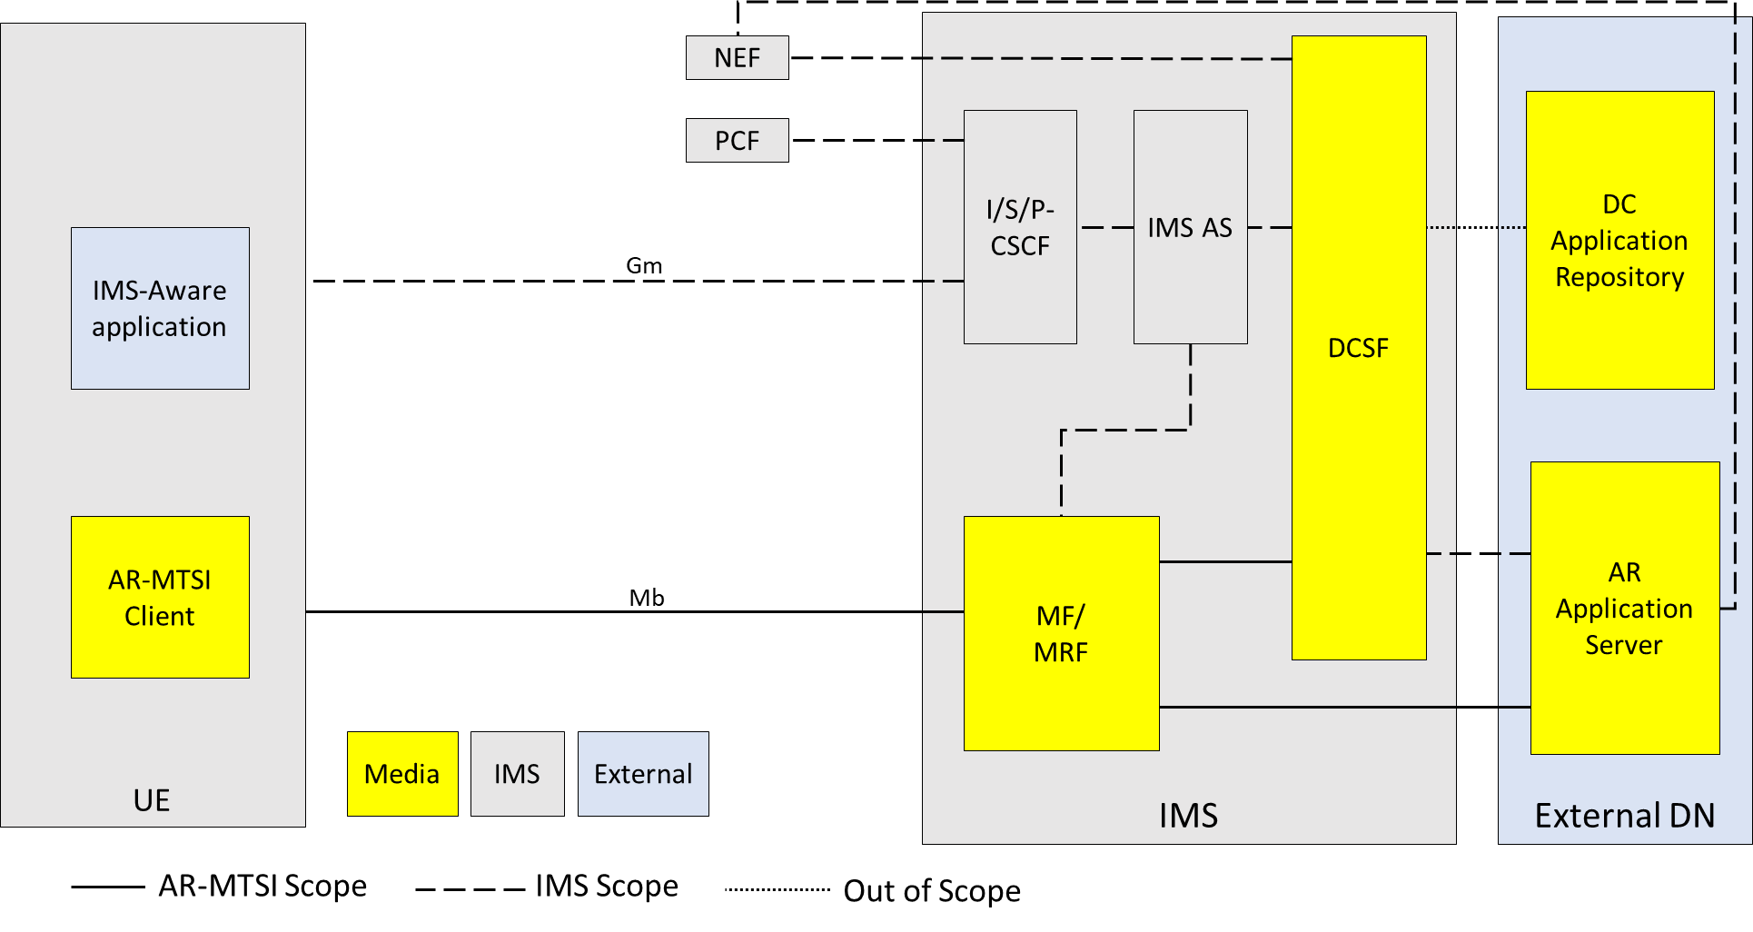
Figure 4.3.1: Generalized IMS DC Architecture to support AR communication
NOTE 1: General control-related elements over Gm interface, such as SIP signalling (TS 24.229 [x]), fall outside the scope of this specification, albeit parts of the session setup handling and session control for AR conversational media over Gm interface, such as the usage of SDP and setup and control of the individual media streams between clients, are defined in this specification.
NOTE 2: DC Application Repository may be in external DN but can also be in operator domain. The DC Application Repository holds the application(s) that can be used in AR communication sessions and is out of scope of 3GPP.

AR Application Server (AR AS):
- AR Application Server is responsible for AR service control related to AR communication, including AR session media control and AR media capability negotiation with the UE.
NOTE 3: AR Application Server is a specific DC Application Server and is out of scope of 3GPP.
NOTE 4: The UE can download the AR metadata from AR AS through application data channel.
DCSF:
- The DCSF receives event reports from the IMS AS, and decides whether AR service is allowed to be provided during the IMS session;

MF/MRF:
- Support AR conversational service by providing transcoding for terminals with limited capabilities. Additionally, the MF/MRF may collect spatial and media descriptions from UEs and create scene descriptions for symmetrical AR call experiences.
- Provide remote rendering for AR-MTSI clients in terminals with limited capabilities. For remote rendering the AR-MTSI client provides pose metadata as defined in clause x of [3] and clause 6 of this specification.
IMS AS:

- The IMS AS receives the media control instructions from the DCSF and accordingly interacts with the UE for connecting the UE's audio/video media termination to the MF/MRF [TS 23.228].

- Proposal
In accordance with IBACS TS 26.264 (S4-231531) and PD (S4-231489), it is proposed to add the generalized reference architecture based on IMS DC Architecture to TS 26.264.

