Title: Updates of test for stereo UE in ATIAS Pdoc
Source: Beijing Xiaomi Mobile Software Co., Ltd
Document for: Discussion & Agreement

Agenda Item: 7.6
- Introduction
This proposal is to update chapter 4.8 stereo test in ATIAS Pdoc
- Content
……
[
The following method(s) have been incorporated from [5]:

Spatial perception test for stereo UE in ATIAS

Definition

Central direction:
To create a central direction, interchannel time difference and interchannel level difference should small to avoid noticeable location shift.

Left\Right direction:
The left and right channels should have sufficient difference to make sound images located on the left or right. If the sound source comes from the left direction, the interchannel time difference>0 and\or interchannel level difference >0 in general and vice versa.

Test Conditions
Free-field propagation conditions
- The test environment shall contain a free-field volume, wherein free-field sound propagation conditions shall be observed.
- The free-field sound propagation conditions shall be observed down to a frequency of 200Hz

Test Configurations
Test signal：
Speech signal according to ITU-T Recommendation P.501 is used.
Editor’s Note: The influence of processing like echo cancel on stereo audio is still unclear. It should be careful about the differences caused by processing.

Sound source:
HAT and coaxial loudspeaker.
Editor’s Note: Since the UE is most used for speech service, and avoid phase different cause by x-way loudspeaker.

Setup for terminals
The setup is referred to TS 26.260 and TS 26.132[2-3]. Including the POI, reference point, etc.
Where the manufacturer gives conditions of use, these will apply for testing. If the manufacturer gives no other requirement, the DUT will be positioned according the reference usage of hand-held hands-free UE in TS 26.132 describing in the following block:

Measurement points:
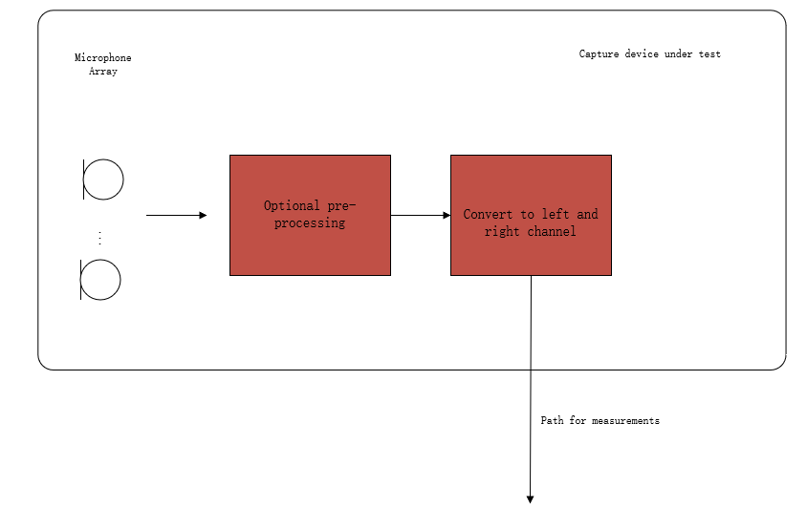
Figure 1: Audio capture block diagram for sending direction measurements
Editor’s Note: The test should represent what sound the user will get. Hence, the test operator doesn't need to calibrate the DUT. The result should include all the deviations between components in one device (like the sensitivity difference between a microphone array used in DUT) and deviations between different manufactured batches.

Measurement method
- The UE device under test is mounted in the free-field volume such that its reference point is on the axis of the sound source.
Repeat steps b-c) at -90, -30, 0, 30,90 degree :
- The sound source pointed directly toward the reference point of the DUT, measuring interchannel level difference and interchannel time difference.
- Change the angle between sound source and DUT.

Calculation of ILD and ITD

- The calculation of ILD and ITD is referred to Chapter 5.3.

Sound image (SI)
- Stereo audio only need to consider the left ,center and right direction , Elevation and rear positioning are not essential for stereo. There for the measurement only carry out on 0,±30,±90.

- Sound image indicates the perception location of the image. A sound image value less than zero indicates a position on the right side, while a value greater than zero signifies the left side. An sound image value of exactly zero represents the precise center.
- SI is a function of ITD and ILD as following:

SI=fILD,ITD
NOTE: The specific formula is tbd.

Source azimuth[deg] | requirement
-90 | ITD>-3ms^{*1}  SI<-[tbd]^{*2}
-30 | ITD>-3ms  and  SI<-[tbd]^{*3}
0 | -0.1ms< ITD<0.1ms  and  -1 dB< ILD<1 dB^{*4}
30 | ITD<3ms  and  SI>[tbd]
90 | ITD<3ms  SI>[tbd]
*1: The left and right channel will not be felt like two sound events.
*2: The sound from ±90 degree should have the sound image close to the edge.
*3: The sound from ±30 degree should have a clearly distinguish between the center positions.
*4: The sound from 0 degree should be precepted as center.
*5: The sound from left and right do not require the same performance, but should have the right direction

interchannel time difference =Delayleft-Delayright
interchannel level difference=Levelleft-Levelright

]
……

- Measurement data
We chose a mobile phone on market that can capture stereo audio for recording, we collected the test data and analysed the spatial perception.

3.1 Setup
Audio interface: ADI-2 DAC FS
Sound source: B&K TYPE 5128 HAT
Test sequence: 4 English test sentences (2 female, 2 male) according to ITU-T P.501 is used.

3.2 Result

3.1.1 ITD (ms)
 | -90 deg | -30 deg | 0 deg | 30 deg | 90 deg
female 1.wav | -0.71 | -0.21 | 0.00 | 0.25 | 0.65
female 2.wav | -0.71 | -0.21 | 0.00 | 0.29 | 0.65
male 1.wav | -0.73 | -0.21 | 0.00 | 0.27 | 0.69
male 2.wav | -0.71 | -0.23 | 0.00 | 0.27 | 0.69

3.1.2 ILD (dB)
 | -90 deg | -30 deg | 0 deg | 30 deg | 90 deg
female 1.wav | 3.94 | 3.37 | -0.03 | -3.38 | -3.61
female 2.wav | 3.35 | 1.91 | -0.02 | -2.12 | -3.72
male 1.wav | 4.19 | 2.93 | -0.03 | -3.42 | -4.26
male 2.wav | 3.86 | 2.72 | -0.01 | -2.97 | -3.88

Based on subjective perception, sound images from ±90 degrees are precepted near the edge, sound images from ±30 degrees have a clear distinction between centre positions, and sound images from 0 degree are perceived as cantered.
In this test, ITD and ILD have very regular features:
$${ITD}_{-90}{<ITD}_{-30}<{ ITD}_{0}<{ITD}_{30}<{ITD}_{90}$$
$${ILD}_{-90}>{ILD}_{-30}> {ILD}_{0}>{ILD}_{30}>{ILD}_{90}$$
${The value of ITD}_{0} and {ILD}_{0} is very close to 0$ which aligns with the effects of ITD and ILD on spatial perception.
- Conclusion
Chapter 2 of this proposal offers an updated version of ATIAS Pdoc Chapter 4.8, and Chapter 3 supplies the relevant test data derived from the applied testing methodology.

References
- S4-231418_Pdoc ATIAS-1 v0.5.0
- S4-230189: Add the spatial perception test for stereo UE in ATIAS, Xiaomi

