Source: HEAD acoustics GmbH

Title: UE classification and test structure for ATIAS

Document for: Agreement

# Introduction

The inputs made so far for the work item ATIAS mainly focused on proposals for new test methods and requirements for immersive communication terminals. Even though these technical discussions and preliminary agreed test methods in ATIAS-1 [1] are highly relevant for the update of TS 26.260 [2] and the upcoming new TS 26.261 [3], supplementary information and several definitions are still missing. In addition, most of the test methods collected in ATIAS‑1 focus on testing a certain IVAS codec mode rather than a certain UE type. The present document suggests several introductory clauses for ATIAS-1 (and/or an upcoming CR to TS 26.260) that define UE types and may help to group and better structure the existing, proposed and possibly new test methods.

# Definition of UE types

## Introduction

The definition of UE types for immersive communication terminals is not as clear and trivial as in the "traditional" test specifications 3GPP TS 26.131 [4] and TS 26.132 [5]. Due to the variety of new applications that are enabled by IVAS codec, it is expected that the capture and playback audio format might not necessarily be the same in send and receive direction. Thus, the classification of UE types should be defined as follows:

- The UE type is composed of "SND-UE-type" and "RCV-UE-type".

- The SND-UE-type is defined as the combination of a certain audio capturing mode (acoustic or electric) and an IVAS output format for transport.

- The RCV-UE-type is defined as the combination of an incoming IVAS transport format and a certain audio playback mode (acoustic or electric).

- Each audio capturing/playback mode corresponds to a specific physical test arrangement.

UEs might support multiple IVAS transport formats in send and receive direction, which are negotiated during call setup. At least one supported IVAS transport format shall be tested in both directions, which is selected according to the following priority:

1) Format specified by the manufacturer.

2) Preference of the UE, as indicated during negotiation in SDP.

3) Test operator selects format based on form factor and envisioned use case of the UE.

The IVAS transport format for both directions shall be documented in the test report. Other available supported formats may be tested as well to ensure best-possible compatibility with other UE types.

While the possible IVAS transport formats are already clearly defined, capturing/playback modes and corresponding interfaces were not yet discussed. The following subclauses suggest several UE type definitions, which might be applicable for SND and/or RCV. All UE type definitions with acoustical interfaces assume that microphones and loudspeakers/headset of the UE are either integrated into the device or that a device and any necessary additional equipment (like e.g., headset, microphone array, loudspeaker array) are associated to each other and bundled by the manufacturer.

NOTE: It is expected that many UEs supporting immersive audio will only provide an electrical interface, but not such associated equipment. In this case, the test setup according to clause 2.7 applies. However, to investigate the performance of the UE in combination with typical third-party equipment for certain applications, the test setups with acoustical interfaces described in the following subclauses may be used for this purpose.

The physical test arrangement used for UE testing in send and receive direction is in general specified by the manufacturer by:

- Referencing one of the following subclauses,

- Referencing a test arrangement from other standards (e.g., ITU-T P.340),

- Specifying an individual test arrangement.

In case no instructions on the test arrangement are provided by the manufacturer, the test operator shall select one based on the envisioned use case, form factor, etc. from either one of the following subclauses or from other standards. If no suitable test arrangement can be identified for certain UEs with acoustical interface, the test operator should set up an individual or modify an existing arrangement. In any case, the arrangement used for testing shall be described in the test report.

## Handset Mode (Send + Receive)

Not applicable for immersive communication due to the following reasons:

- A handset device is typically held close to the user's head, i.e., mouth and (a single) ear.

- RCV: Monaural listening cannot provide any spatial/immersive audio.

- SND: Even if the device provides multiple input microphones, it is always positioned close to the user's mouth, which does not allow to encode any spatial information into the uplink signal (for e.g., object-based audio format).

The EVS-Interop mono mode of IVAS should be tested according to 3GPP TS 26.131 [4] and TS 26.132 [5].

There might be some applications also in handset mode for some immersive audio formats, for example to capture ambient sound at the near end. Such scenarios are a kind of extension to the traditional mono telephony and are not excluded in general. However, so far, no test methods have been proposed for handset mode, thus it is suggested to leave out this mode for now.

## Headset Mode (Send + Receive)

The test setup for headset UE for send and receive directions is shown in Figure 1. It applies to all head-worn terminals, which are typically connected via wired or wireless link (e.g., analogue jack, Bluetooth, or USB) to a device with sufficient computation power (e.g., mobile phone). Optionally, the device might provide head tracking data that can be used for rendering audio in the receive direction.

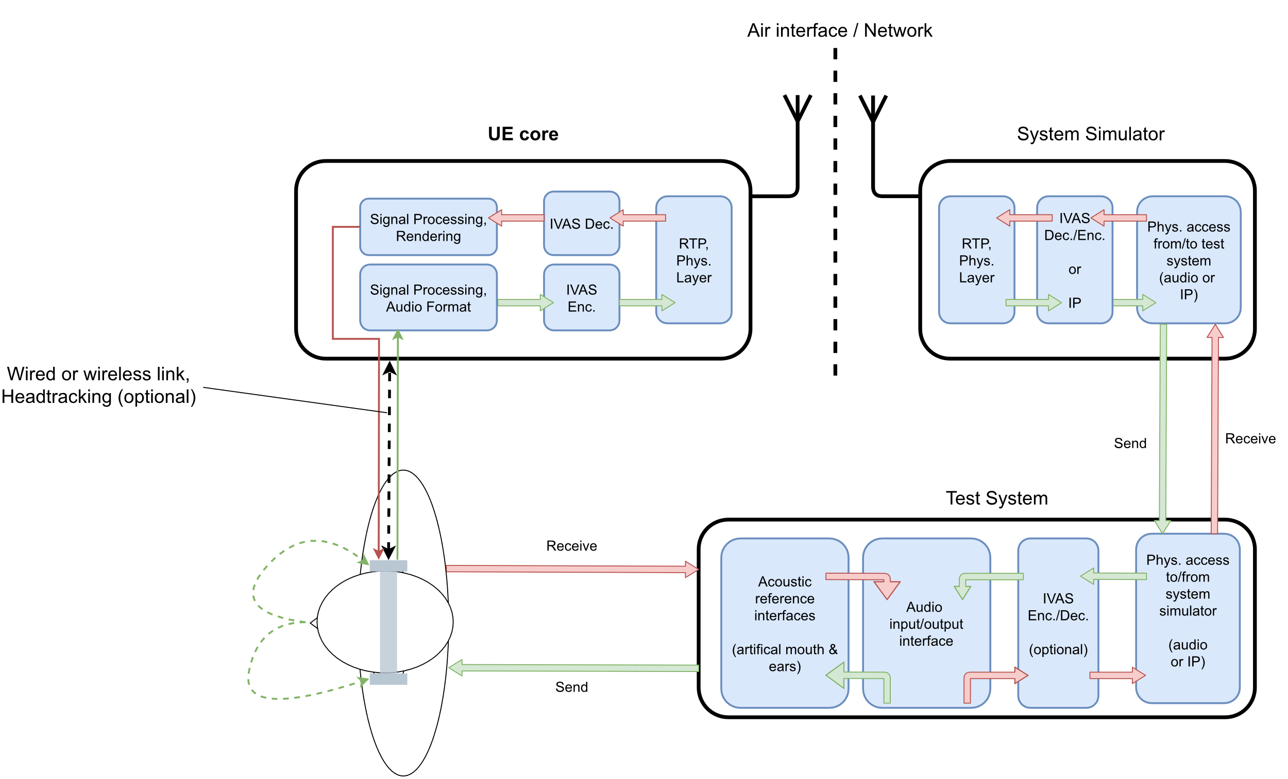

Figure : Headset UE and test equipment

## Handheld Mode (Send + Receive)

The test setup for handheld hands-free UE for send and receive directions is shown in Figure 2. It applies to all devices that can be held in front of the user.

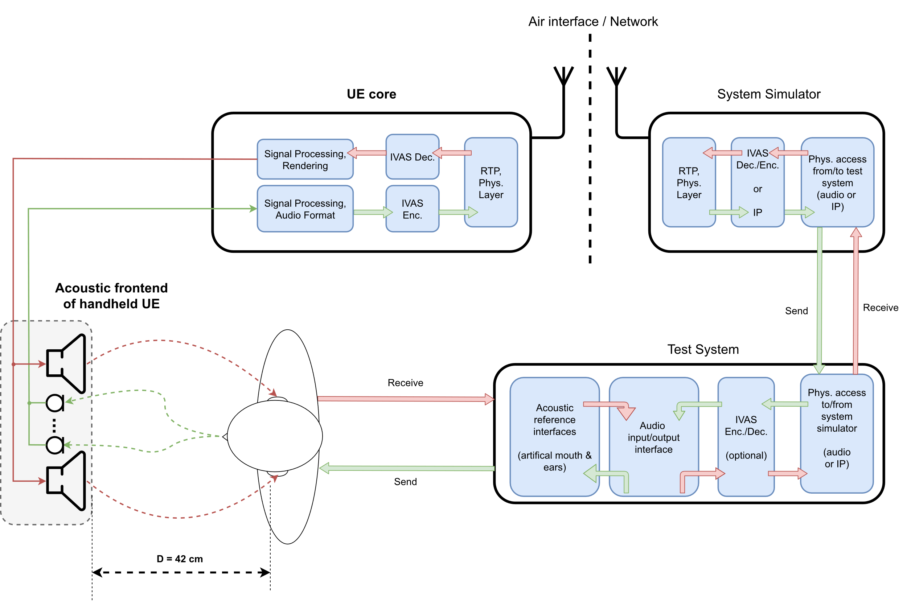

Figure : Handheld hands-free UE and test equipment

The distance D = 42 cm between HATS reference point (HRP) and center of the UE is used in TS 26.132 [5], but different geometries of this setup could also be considered (for e.g., multi-talker scenarios or speech from certain angles).

## Table-mounted Mode (Send + Receive)

The test setup for table-mounted hands-free UE for send and receive directions is shown in Figure 3. It applies to all hands-free devices that are intended for usage on tables (like e.g., conference devices). In contrast to handheld UE, the reflections of the table are explicitly included in the test setup.

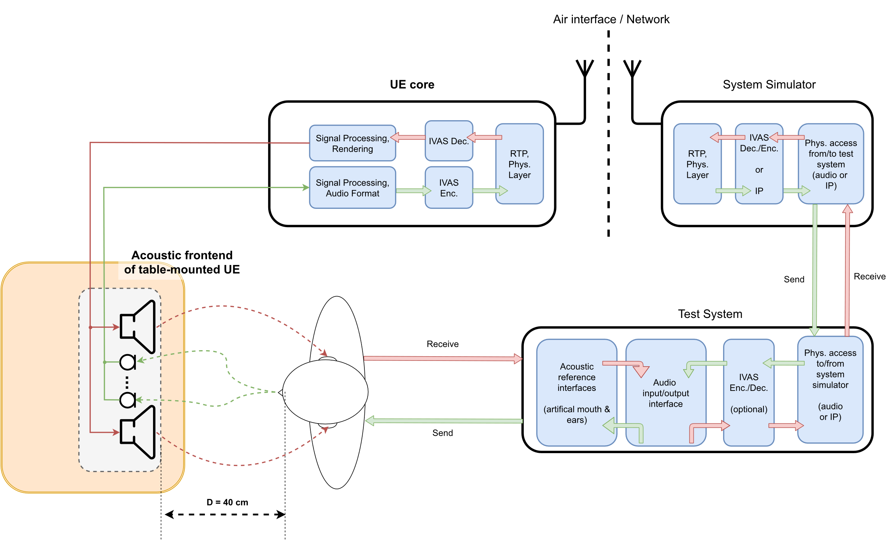

Figure : Table-mounted hands-free UE and test equipment

Figure 3 shows an example with a distance of D = 40 cm between front of the UE and lip reference plane, which corresponds to the desktop hands-free setup as specified in Recommendation ITU-T P.341 [6], which is also referenced in 3GPP TS 26.132 (width W = 40 cm, height H = 30 cm). In general, multiple sub-setups could be considered for this UE type, like e.g., the "group audio terminal" position (clause 4.2.4 of P.341 [6]) or the softphone/laptop-based setups 3GPP TS 26.132 [5].

NOTE: The term "table-mounted hands-free" is suggested here instead of "desktop hands-free", as used in e.g., TS 26.132. The intention for this is to explicitly address also different/larger setups like e.g., conferencing scenarios with multiple microphones and loudspeaker arrays.

## Loudspeaker Mode (Receive)

The test setup for loudspeaker hands-free UE for receive direction is shown in Figure 4. It applies to advanced (mostly larger) playback systems and/or in case the previous RCV-UE-types are not applicable to a certain device.

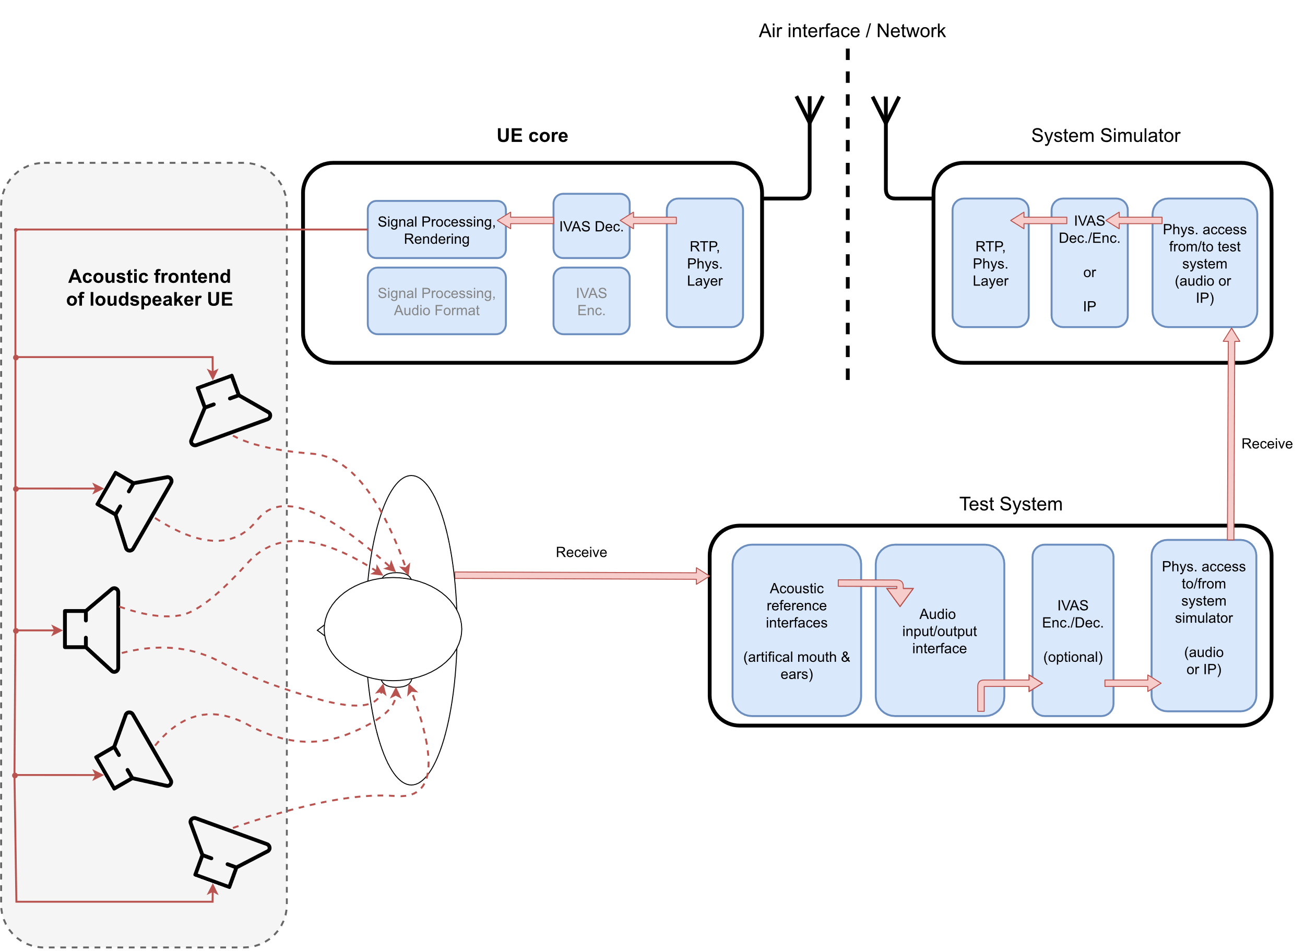

Figure : Loudspeaker hands-free UE and test equipment

## Electrical interface (Send + Receive)

The test setup for electrical interface UE for send and receive directions is shown in Figure 5. It applies to all devices that do not provide integrated or associated equipment for capturing and/or reproduction of immersive audio. Note that the interface is not necessarily digital (Bluetooth, USB, or digital audio interfaces), it could also be an analogue jack plug, which provides up to two channels in receive and also send direction (see Recommendation ITU-T P.382 [7]). Optionally, the device might provide an additional input for head tracking data that can be used for rendering the receive direction (format/hardware interface for further study…?).

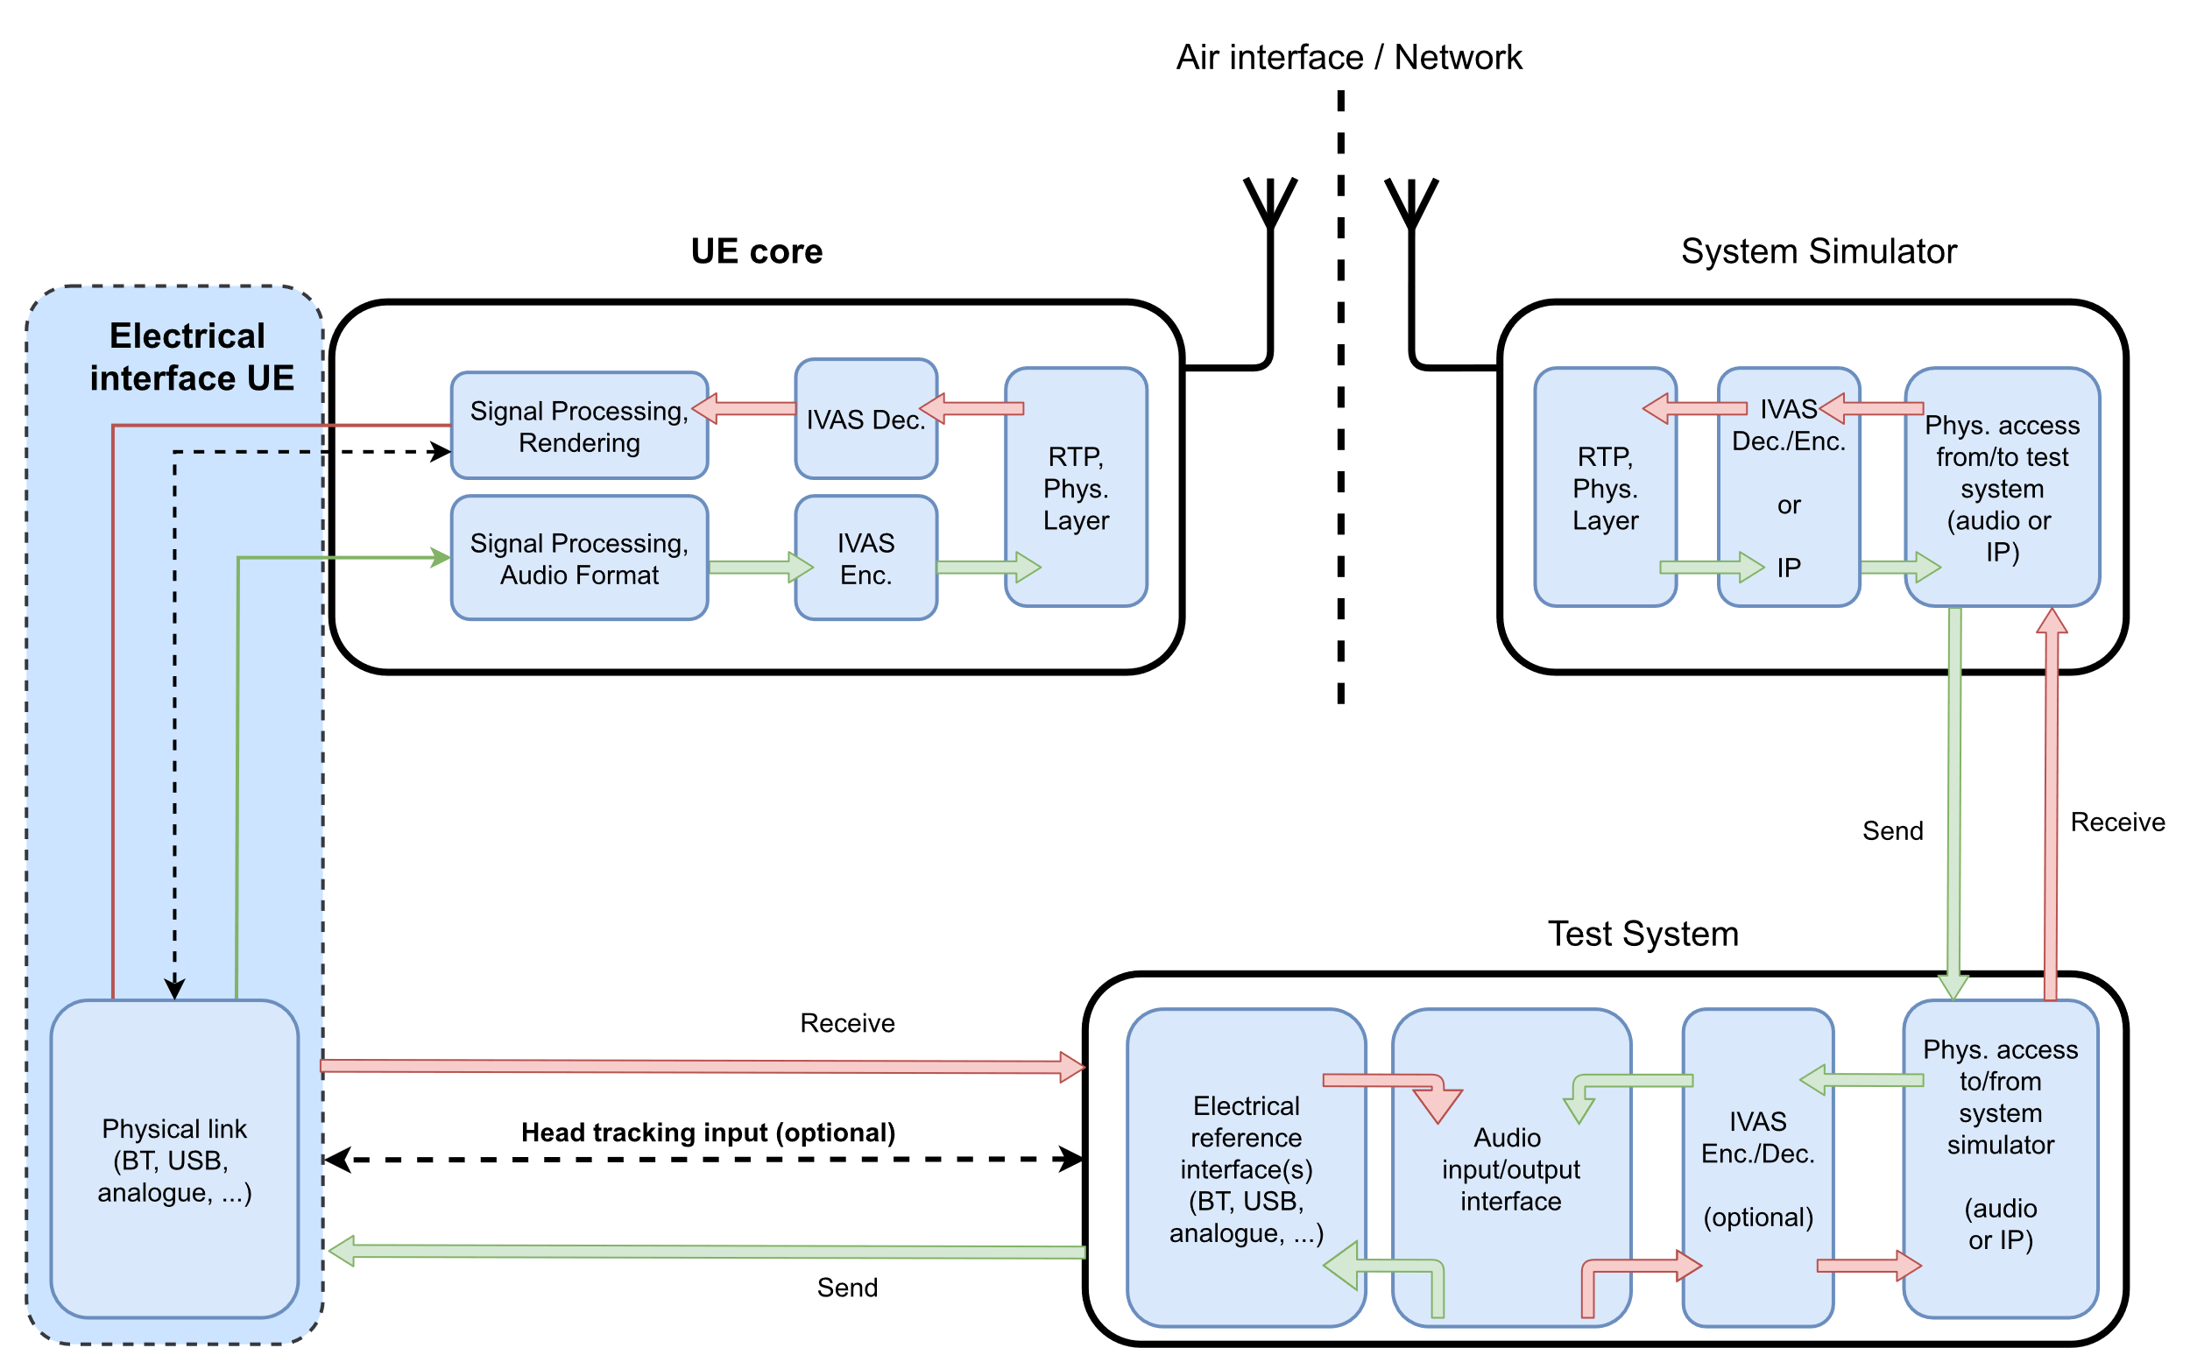

Figure : Electrical interface UE and test equipment

## Summary

The suggested UE types and their applicability are summarized in Table 1. Even though some of the acoustic configurations are composed of two or even more parts (like e.g., headset and mobile phone, loudspeaker system and mobile phone), these should always be tested jointly, if all parts are considered as associated by the manufacturer.

Table 1: Overview of UE configurations in send and receive direction

|  |  |  |  |
| --- | --- | --- | --- |
| Name | SND | RCV | Comment |
| Handset | **🗶** | **🗶** | No reasonable use case? |
| Headset | **✓** | **✓** | Optional: Headtracking in RCV |
| Handheld Hands-free | **✓** | **✓** | possibly define multiple distances for testing? |
| Table-mounted Hands-free | **✓** | **✓** | Table reflections relevant; possibly define multiple distances for testing? |
| Loudspeakers | **🗶** | **✓** | For advanced playback systems or as a generic mode if handheld or table-mounted do not apply. |
| Electrical interface | **✓** | **✓** | Suitable for all IVAS formats; analogue (max. 2 channels), USB, Bluetooth, …? Optional: Headtracking in RCV |

# Proposed structure for TS 26.260

For the finalization of the work item ATIAS, the content of ATIAS-1 (and possibly the proposed definitions of the present document) have to be integrated into the existing specification TS 26.260 [2]. This was originally an output of the work item LiQuImAS [8], where test methods for immersive audio systems were developed in a rather generic way and are in general also applicable for communication terminals in the scope of the ATIAS work item. However, the IVAS codec and its corresponding formats, rendering capabilities, etc. were not known at that time, which are important test parameters that should be defined. On the other hand, it seems rather difficult to modify the document in a way that …

a) the clause numbering remains consistent (in particular for adding new clauses on interfaces, definitions, codec modes, test setups, etc.),

b) the existing test methods remain valid for the device types considered in LiQuImAS , and

c) the clauses on new test methods for IVAS-based terminals are integrated seamlessly in the existing structure.

The source proposes the following for the upcoming structure of TS 26.260, which minimizes text duplication and redundancies:

- All existing test methods in clause 4 remain unchanged.

- Clause 4 should be renamed to: "Objective Test Methodologies for [Generic] Immersive Audio Systems".

- For IVAS-based terminals, a new clause 5 should be added: "Objective Test Methodologies for Immersive [Communication/Audio] Systems [IVAS-based]".

- In case a test method of clause 4 is found to be suitable for a test suite in clause 5, it can just be referenced ("test method according to clause 4.x.y") and complemented with IVAS-/ATIAS-specific definitions.

- One or more introductory clauses regarding test configurations/conditions/definitions, etc., are added under subclause 5.1, 5.2, etc. (such a subclause is currently missing in clause 4).

- After the introductory subclauses, test methods should be separated into send and receive direction (same as now in clause 4 and in ATIAS-1) and then grouped for each IVAS format (stereo, scene-/object-/channel-based, MASA). Each of this group then defines a test suite that can be run for a certain UE type (see section 2), if applicable.

NOTE: Detailed wording of terms marked in red are for discussion.

Example of proposed new structure in TS 26.260:

5 Objective Test Methodologies for Immersive Communication Systems (IVAS-based)

5.1 Test setups for terminals

5.2 Test conditions

5.3 [other general definitions?]

5.4 Test methods in the sending direction

5.4.1 Stereo

5.4.1.1 Stereo Test Method 1

[Description of test method]

The test method applies to UE configurations Headset, Handheld-hands-free, Table-mounted.

5.4.1.2 Stereo Test Method 2

[Description of test method]

The test method applies to UE configuration electrical interface only.

…

5.4.2 Object-based Audio

5.4.2.1 …

5.4.3 Scene-based Audio

5.4.3.1 …

5.4.4 Channel-based Audio

5.4.4.1 …

5.4.5 MASA

5.4.5.1 …

5.5 Test methods in the receiving direction

5.5.1 Stereo

5.5.1.1 …

5.5.2 Object-based Audio

5.5.2.1 …

5.5.3 Scene-based Audio

5.5.3.1 …

5.5.4 Channel-based Audio

5.5.4.1 …

5.5.5 MASA

5.5.5.1 …

# Conclusion

The source suggests considering the input of the present document for the next update of the permanent document ATIAS-1 [1] and/or the upcoming CR for TS 26.260 [2].

# References

|  |  |
| --- | --- |
| [1] | 3GPP S4-231418, „Permanent Document ATIAS-1:“. |
| [2] | 3GPP TS 26.260, „Objective test methodologies for the evaluation of immersive audio systems,“ Release-18. |
| [3] | 3GPP TS 26.261, „Terminal audio quality performance requirements for immersive audio services,“ Release-18. |
| [4] | 3GPP TS 26.131, „Terminal acoustic characteristics for telephony; Requirements,“ Release-17.1. |
| [5] | 3GPP TS 26.132, „Speech and video telephony terminal acoustic test specification,“ Release-17.1. |
| [6] | Recommendation ITU-T P.341, „Transmission characteristics for wideband digital loudspeaking and hands-free telephony terminals,“ 03/2011. |
| [7] | Recommendation ITU-T P.382, „Technical requirements and test methods for analogue wired multi-microphone headsets or headphones and corresponding universal interface of terminals,“ 03/2023. |
| [8] | 3GPP SP-170609, „New WID on Test Methodologies for the Evaluation of Perceived Listening Quality in Immersive Audio Systems (LiQuImAS),“ SA WG4, 2017. |