**3GPP TSG-SA WG4 Meeting #125 S4-231325 is revised to S4-231434**

**Meeting, 21 – 25 August 2023**

|  |  |  |  |  |  |  |  |  |
| --- | --- | --- | --- | --- | --- | --- | --- | --- |
| *CR-Form-v12.2* | | | | | | | | |
| **CHANGE REQUEST** | | | | | | | | |
|  | | | | | | | | |
|  | **26.565** | **pCR** |  | **rev** | **-** | **Current version:** | **0.5.0** |  |
|  | | | | | | | | |
| *For* [***HE******LP***](http://www.3gpp.org/3G_Specs/CRs.htm#_blank)*on using this form: comprehensive instructions can be found at* [*http://www.3gpp.org/Change-Requests*](http://www.3gpp.org/Change-Requests)*.* | | | | | | | | |
|  | | | | | | | | |

|  |  |  |  |  |  |  |  |  |
| --- | --- | --- | --- | --- | --- | --- | --- | --- |
| ***Proposed change affects:*** | UICC apps |  | ME | **x** | Radio Access Network |  | Core Network | **x** |

|  |  |  |  |  |  |  |  |  |  |  |
| --- | --- | --- | --- | --- | --- | --- | --- | --- | --- | --- |
|  | | | | | | | | | | |
| ***Title:*** | Editorial corrections on SR MSE architectures | | | | | | | | | |
|  |  | | | | | | | | | |
| ***Source to WG:*** | Nokia | | | | | | | | | |
| ***Source to TSG:*** | S4 | | | | | | | | | |
|  |  | | | | | | | | | |
| ***Work item code:*** | SR_MSE | | | | |  | ***Date:*** | | | 04-07-2023 |
|  |  | | | |  | |  | | |  |
| ***Category:*** | D |  | | | | | ***Release:*** | | | Rel-18 |
|  | *Use one of the following categories:* ***F*** *(correction)* ***A*** *(mirror corresponding to a change in an earlier release)* ***B*** *(addition of feature),* ***C*** *(functional modification of feature)* ***D*** *(editorial modification)*  Detailed explanations of the above categories can be found in 3GPP [TR 21.900](http://www.3gpp.org/ftp/Specs/html-info/21900.htm). | | | | | | | | *Use one of the following releases: Rel-8 (Release 8) Rel-9 (Release 9) Rel-10 (Release 10) Rel-11 (Release 11) … Rel-16 (Release 16) Rel-17 (Release 17) Rel-18 (Release 18) Rel-19 (Release 19)* | |
|  |  | | | | | | | | | |
| ***Reason for change:*** | | The latest version of TS 26.565 v 0.5.0 has some minor editorials. | | | | | | | | |
|  | |  | | | | | | | | |
| ***Summary of change:*** | | This CR proposes corrections to the Split management architecture and the User-Plane architecture. | | | | | | | | |
|  | |  | | | | | | | | |
| ***Consequences if not approved:*** | | Clause 5.1.3 and clause 5.1.5 will remain with errors leading to mis-interpretation of the existing text. | | | | | | | | |
|  | |  | | | | | | | | |
| ***Clauses affected:*** | | 5.1.3 and 5.1.5. | | | | | | | | |
|  | |  | | | | | | | | |
|  | | **Y** | **N** |  | | | |  | | |
| ***Other specs*** | |  | **x** | Other core specifications | | | | TS/TR ... CR ... | | |
| ***affected:*** | |  | **x** | Test specifications | | | | TS/TR ... CR ... | | |
| ***(show related CRs)*** | |  | **x** | O&M Specifications | | | | TS/TR ... CR ... | | |
|  | |  | | | | | | | | |
| ***Other comments:*** | |  | | | | | | | | |
|  | |  | | | | | | | | |
| ***This CR's revision history:*** | |  | | | | | | | | |

|  |
| --- |
| 1st Change |

### 5.1.2 Client Architecture

The client architectural breakdown is based on the client architecture in TS26.119 clause 5.1.

|  |
| --- |
| End of change |

|  |
| --- |
| 2nd Change |

### 5.1.3 End-to-End Architecture



Figure 5.1-3 – Split management architecture

As shown in Figure 5.1.3:

1. The 5G Application Providers (AP) provisions the split-rendering through RTC-1.

2. In the use cases in which the AP is involved in the media delivery, the RTC-2 interface is used for this purpose.

3.The communication between AF and SRS is through RTC-3. This interface is out of the scope of this document.

4. The signaling as well as the media delivery between SRC and SRS is though RTC-4.

5. The AF may provide the split-rendering information to the Media Session Handler defined by RTC-5, defined in TS26.506.

6. SRC in the UE discovers the application through RTC-6 and handles the XR runtime.

7. The SRC discovers the client media capabilities through the RTC-7 interface. This interface is out of the scope of this document.

8. The 5G Application and AP interact through RTC-8. This interface is out of the scope of this document.

|  |
| --- |
| End of change |

|  |
| --- |
| 3rd Change |

### 5.1.5 User Plane Architecture

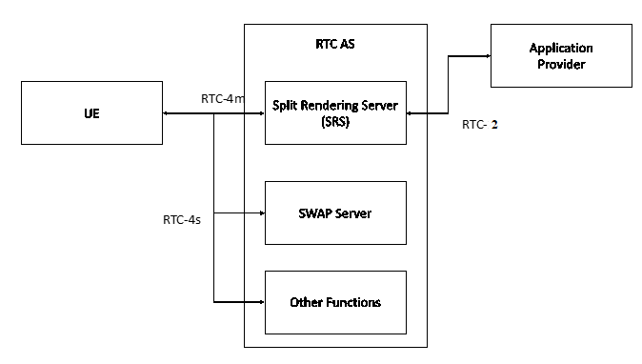

Figure 5.1-5 – User Plane Architecture for Split management architecture

|  |
| --- |
| End of change |

|  |
| --- |
| 4th Change |

### 5.2.2 Call flow for Split Rendering session setup

The split rendering operation can be described by the as depicted in the call flow in the Figure 5.2.2-1.



Figure 5.2.2-1 High-level call flow for split rendering session setup and operation

|  |
| --- |
| End of change |