**3GPP TSG-SA WG4 Meeting #125 S4-231328**

**Meeting, 21 – 25 August 2023**

|  |  |  |  |  |  |  |  |  |
| --- | --- | --- | --- | --- | --- | --- | --- | --- |
| *CR-Form-v12.2* | | | | | | | | |
| **CHANGE REQUEST** | | | | | | | | |
|  | | | | | | | | |
|  | **26.565** | **pCR** |  | **rev** | **-** | **Current version:** | **0.5.0** |  |
|  | | | | | | | | |
| *For* [***HE******LP***](http://www.3gpp.org/3G_Specs/CRs.htm#_blank)*on using this form: comprehensive instructions can be found at* [*http://www.3gpp.org/Change-Requests*](http://www.3gpp.org/Change-Requests)*.* | | | | | | | | |
|  | | | | | | | | |

|  |  |  |  |  |  |  |  |  |
| --- | --- | --- | --- | --- | --- | --- | --- | --- |
| ***Proposed change affects:*** | UICC apps |  | ME | **x** | Radio Access Network |  | Core Network | **x** |

|  |  |  |  |  |  |  |  |  |  |  |
| --- | --- | --- | --- | --- | --- | --- | --- | --- | --- | --- |
|  | | | | | | | | | | |
| ***Title:*** | RTC interfaces on SR MSE architectures | | | | | | | | | |
|  |  | | | | | | | | | |
| ***Source to WG:*** | Nokia | | | | | | | | | |
| ***Source to TSG:*** | S4 | | | | | | | | | |
|  |  | | | | | | | | | |
| ***Work item code:*** | SR_MSE | | | | |  | ***Date:*** | | | 04-07-2023 |
|  |  | | | |  | |  | | |  |
| ***Category:*** | C |  | | | | | ***Release:*** | | | Rel-18 |
|  | *Use one of the following categories:* ***F*** *(correction)* ***A*** *(mirror corresponding to a change in an earlier release)* ***B*** *(addition of feature),* ***C*** *(functional modification of feature)* ***D*** *(editorial modification)*  Detailed explanations of the above categories can be found in 3GPP [TR 21.900](http://www.3gpp.org/ftp/Specs/html-info/21900.htm). | | | | | | | | *Use one of the following releases: Rel-8 (Release 8) Rel-9 (Release 9) Rel-10 (Release 10) Rel-11 (Release 11) … Rel-16 (Release 16) Rel-17 (Release 17) Rel-18 (Release 18) Rel-19 (Release 19)* | |
|  |  | | | | | | | | | |
| ***Reason for change:*** | | The latest version of TS 26.565 v 0.5.0 has use-cases where the use of RTC interfaces is leveaged. However, the use RTC-interfaces may not needed under such context. | | | | | | | | |
|  | |  | | | | | | | | |
| ***Summary of change:*** | | This CR proposes modifications to RTC-4 and RTC-5 interfaces of the SR_MSE architecture. | | | | | | | | |
|  | |  | | | | | | | | |
| ***Consequences if not approved:*** | | clause 5.1.3, 5.1.5 and 5.2 may lead to mis-interpretation of text. | | | | | | | | |
|  | |  | | | | | | | | |
| ***Clauses affected:*** | | 5.1.3, 5.1.5, 5.2 | | | | | | | | |
|  | |  | | | | | | | | |
|  | | **Y** | **N** |  | | | |  | | |
| ***Other specs*** | |  | **x** | Other core specifications | | | | TS/TR ... CR ... | | |
| ***affected:*** | |  | **x** | Test specifications | | | | TS/TR ... CR ... | | |
| ***(show related CRs)*** | |  | **x** | O&M Specifications | | | | TS/TR ... CR ... | | |
|  | |  | | | | | | | | |
| ***Other comments:*** | |  | | | | | | | | |
|  | |  | | | | | | | | |
| ***This CR's revision history:*** | |  | | | | | | | | |

|  |
| --- |
| 1st Change |

### 5.1.3 End-to-End Architecture



Figure 5.1-3 – Split management architecture

As shown in Figure 5.1.3:

1. The 5G Application Providers (AP) provisions the split-rendering through RTC-1.

2. In the use cases in which the AP is involved in the media delivery, the RTC-2 interface is used for this purpose.

3.The communication between AF and SRS is through RTC-3. This interface is out of the scope of this document.

4. The signaling as well as the media delivery between SRC and SRS is though user plane interface. This interface may be for instance, RTC-4 but not limited only to RTC

5. The AF may provide the split-rendering information to the Media Session Handler defined by control-plane interface. This interface may be for instance RTC-5, but not limited only to RTC, defined in TS26.506.

6. The SRC discovers the client media capabilities through the RTC-7 interface. This interface is out of the scope of this document.

7. The 5G Application and AP interact through RTC-8. This interface is out of the scope of this document.

|  |
| --- |
| End of change |

|  |
| --- |
| 2nd Change |

### 5.1.5 User Plane Architecture

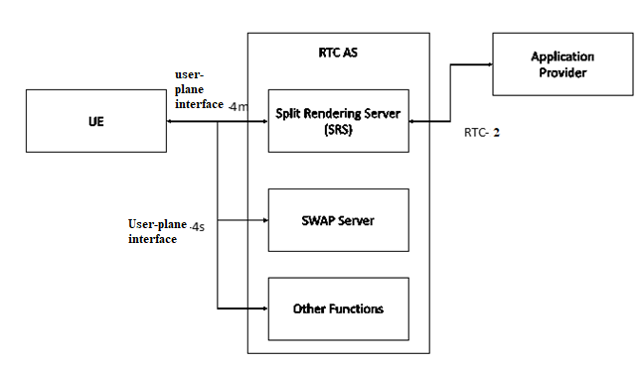

Figure 5.1-5 – User Plane Architecture for Split management architecture

|  |
| --- |
| End of change |

|  |
| --- |
| 3rd Change |

## 5.2 Procedures and Call Flows

### 5.2.1 Call flow for Split Rendering instance discovery

#### 5.2.1.1 Call flow for edge server and split rendering session setup

Figure 5.2.1.1-1 demonstrates a general call flow for split-rendering.



Figure 5.2.1-1: High-level call flow for split-rendering

Steps:

1. In this optional step, the Application Provider requests and sets up the edge server(s) used for the split-rendering as described in TS 26.506 clauses 6.1 or 6.2. The Application provider may use any other method to allocation edge servers, or leave it to the MNO to set up appropriate edge servers to run the split-rendering process.
2. The Application Provider provisions the split-rendering session using RTC-1 and RTC-3, as defined in call flow of clauses 5.1.3. If the edge servers were provisioned in step 1, the edge servers ids are provided in this session to employ them for split-rendering.

NOTE: In the case of the client-driven edge management (TS 26.501 8.1), only the client-driven split-rendering (5.2.1.2) is applicable.

1. The split-rendering session is set up according to clause 5.2.2.

|  |
| --- |
| End of change |