Source: HEAD acoustics GmbH
Title: Custom format for delay/error profile used for JBM performance testing
Document for: Agreement

Introduction
For the work item eUET [1], the delay & error profiles for testing performance of the jitter buffer management (JBM) in 3GPP TS 26.131/132 [2] [3] are planned to be replaced or extended by more realistic ones, which are preferably based on real network captures. In several contributions [4] [5] [6], new profiles were proposed and discussed, which also contain packet duplications.
When delay & error profiles were introduced in 3GPP TS 26.131/132 [2] [3], the format for describing delay and losses was adapted from clause 8.2.3.3 of 3GPP TS 26.114 [7]. Five profiles were actually completely taken over from this specification, see Annex F of TS 26.132 [3]. This rather simple format provides delay values (in ms) as raw text with one entry per line, packet losses are indicated as "-1". Packet duplications are not considered at all in this profile format, most likely due to the JBM specifications made clause in clause 8.2.2 of the same document [7], which states that …
A JBM implementation used in MTSI shall support the following requirements [...]. Speech JBM used in MTSI shall:
[…]
- be able to receive duplicate speech frames and only present unique speech frames for decoder consumption;
[…]
Even though UEs that show any other JBM behaviour than discarding duplicated packets would already violate the requirements of 3GPP TS 26.114, testing within the scope of 26.131/132 would require a new convention, how duplicated packets are specified in the text-based format currently used.

Proposal
As an extension for the existing text-based format for describing delay & error profiles, it is proposed to use "+" (plus sign) as a suffix to a delay value to indicate a duplicated packet. Note that it is not sufficient to just have a unique flag (like "-1" for packet loss) for duplication, as the first/regular packet still must have a valid delay value. An example of the proposed extension is shown in Figure 1.
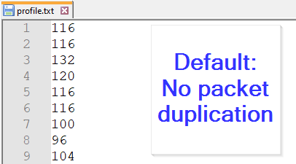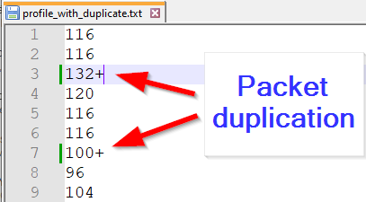
Figure 1: Example for indication of packet duplication

The delay between the two duplicated packets is assumed to be less than 0.5 ms, i.e., within an expected time range in which commonly used network impairment simulators are able to generate the duplication and submit it to the network interface.
In addition, the convention also allows the following extensions, if needed:
1) Multiple duplications can be indicated by repetitions of "+", e.g., the value "132+++" in a profile would thus refer to an initial delay of 132 ms of the actual packet, followed by three immediate duplicated packets.
2) To specify an additional larger delay between the duplications, the difference in delay to the previous packet (in ms) can be provided after each "+". Example: The value "132+3+2" in a profile would thus refer to an initial delay of 132 ms of the actual packet, followed by the first duplication after 3 ms (135 ms in total) and the second one after additional 2 ms (137 ms in total).
3) Each "+" without an additional delay value implies an immediate duplication without any artificial delay, as described above. Thus, a value like e.g., "132++" is equivalent to "132+0+0". Combinations of both are possible as well, example: The value "132++3" in a profile would thus refer to an initial delay of 132 ms of the actual packet, followed by a first immediate first duplication and a delayed duplication after 3 ms (135 ms in total)
NOTE 1: In general, packet duplications are extremely rare in live networks. In practice, they were actually only observed for a single and immediate duplication (see Figure 1). Thus, the convention proposed here might be heavily oversized for describing networks captures from e.g., drive testing.
NOTE 2: A suitable limit for number of duplications (5?) and a maximum value of summed delay values (< 20 ms?) should be considered.

Conclusion
For the description of new delay & error profiles that will also include packet duplication, a new convention is needed to extend the current format. To proceed with the actual work, the source proposes to agree on a certain extension, preferably the one suggested in the present document.
Since this (or any other) extension would become incompatible with the profiles defined in 3GPP TS 26.114 [7], the revised Annex F of TS 26.132, which will specify the new delay & error profiles, should clearly indicate this deviation.

References
[1] | 3GPP SP-220610, „New WID on Enhancements to UE Testing,“ Orange, HEAD acoustics GmbH, Fraunhofer IIS, ROHDE & SCHWARZ, Amazon, 2022.
[2] | 3GPP TS 26.131, „Terminal acoustic characteristics for telephony; Requirements,“ Release-17.1.
[3] | 3GPP TS 26.132, „Speech and video telephony terminal acoustic test specification,“ Release-17.1.
[4] | 3GPP TR 26.114, „IP Multimedia Subsystem (IMS); Multimedia telephony; Media handling and interaction,“ Release-18.3.
[5] | 3GPP S4-230236, „Proposed updates on JBM performance,“ Orange.
[6] | 3GPP S4-230617, „Follow-up on profiles for JBM behaviour evaluation,“ Orange.
[7] | 3GPP S4-230941, „Proposed changes for JBM performance testing,“ Orange.

