Source: InterDigital Communications, Philips

Title: [MeCAR] Use cases of V3C

Agenda item: 9.5

Document for: Discussion and Agreement

1 Introduction
This contribution introduces the possible levels of immersion of V3C codecs and highlights how content creation of point clouds and multi-view + depth is performed. The previous version of this contribution (S4-230935) further describes the respective and distinct use cases for V-PCC and MIV codecs. The use-cases build upon and are complementary to those in the FS_5GSTAR and FS_5GXR technical reports.

2 Proposed changes
The text below is new and is proposed to be inserted in existing clauses of the MeCAR PD.

------------------------------------------------------- Begin change ---------------------------------------------------------------

9.1 Volumetric video support in MPEG-I V3C

9.1.1. Content Creation

9.1.1.1 Point could content creation
Point clouds are generated from one or more cameras and depth sensors. These point clouds may contain from thousands up to billions of points with colours, materials, and other properties. They provide the ability to reproduce a scene with high realism and free interaction and navigation. The viewer is relatively close to the object or subject that can be looked at from all sides. Example of point cloud content are provided in the figure below.

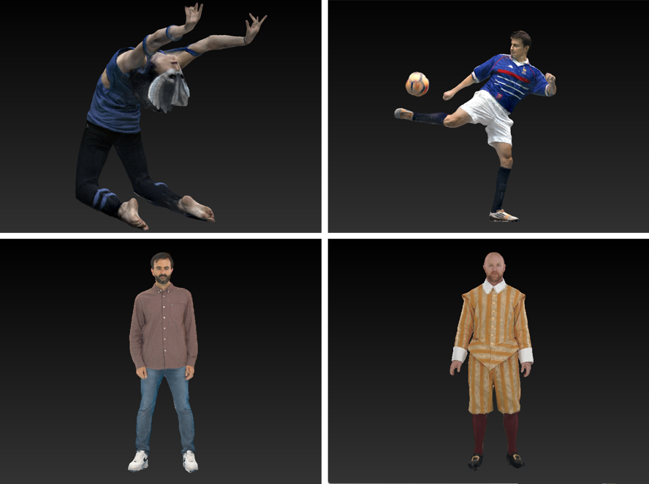
Figure 1 – XD Productions Acrobat 01 (on top left) and Soccer02 (on top right), Volograms Rafa (on bottom left) and Sir Frederick (on bottom right)

9.1.1.2 Multi-view + depth content creation
Multi-view videos are typically generated by one or more cameras that capture a scene from different viewpoints. Cameras can be 2D cameras, range sensing cameras, or both. Calibration of camera colour and intrinsics may be performed ahead of time using checkerboard patterns, and calibration of camera extrinsics (camera poses) may be performed after acquisition by matching the camera images. After that, multiview depth estimation or refinement creates full resolution depth maps in correspondence with the texture maps.
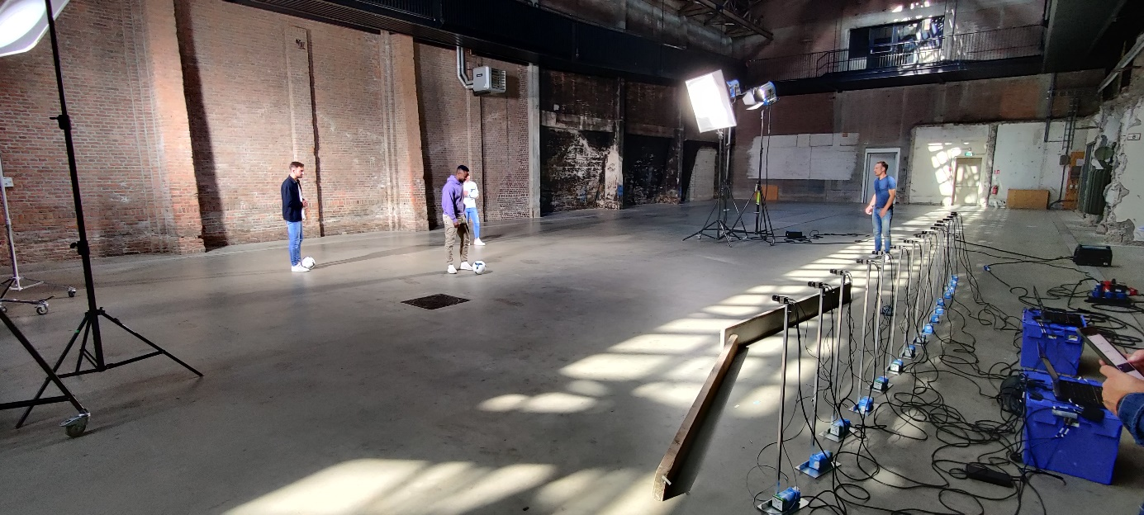
Figure 2: Shooting of MIV content in Veghel, Netherlands, September 2022

9.1.1.3 Multi-planar images content creation
Content in a multi-view + depth representation may be further processed using volume rendering to estimate volume densities and slice the scene into many layers. Depending on the projection type these layers are called planes (perspective projection), or spheres (equirectangular projection), resulting in multi-planar image (MPI) or multi-spherical image (MSI) representations.

While more effort may be needed to pre-process and encode, rendering is simplified because the layers can be rendered in order without z-buffering or view blending using the inverse painter's algorithm. However, MPI can be easily created by CGI sources.

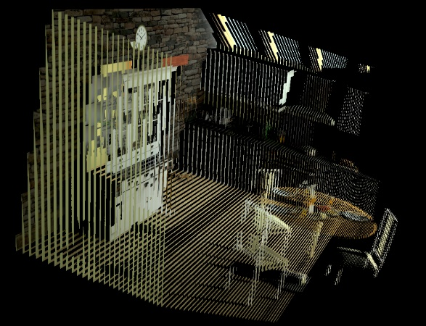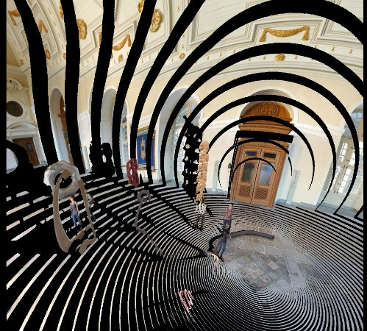
Figure 3: MPI processed images (front-parallel on the left, multiple sphere image on the right)

9.1.2 Levels of Immersion
V3C offers visual comfort and immersiveness over 2D video. Different levels of immersions can be distinguished (Figure 4):

- 3 degrees of freedom (3DoF) videos also called the 360° video is the ability to look around.
- 3DoF+ video adds the ability to move your head while standing or sitting on a chair meaning that there is a limited head movement.
- 6DoF video extends that by being able to walk a few steps or view the object from all sides.

In general, V3C is useful for a variety of applications such as sports events, media performances, immersive teleconferencing, remote assistance, tele-learning, post-event analysis, virtual tours, cultural heritage, and interactive advertisement and customer experiences.

Some key distinctions between MIV and V-PCC enabling the selection of the relevant technology for specific use cases include:

- AR and MR are enabled by V-PCC.
- Standalone VR is enabled by MIV.
- A scene description can integrate Immersive media (V3C) and notably V-PCC dynamic and static objects, while MIV can be seen as a “scene in itself” and as a standalone solution.
- In simple deployment, the capability of interacting and viewing a content from all angles is enabled by V-PCC, while the movement of a user for an MIV content is more limited, unless multiple complex rig sets are deployed.
- Generally, V-PCC is looking inward (focusing on an object to look at), while MIV is looking outward (from the viewpoint of the user, and include the background).

Figure 4 depicts the different levels of immersion provided by V-PCC and MIV.

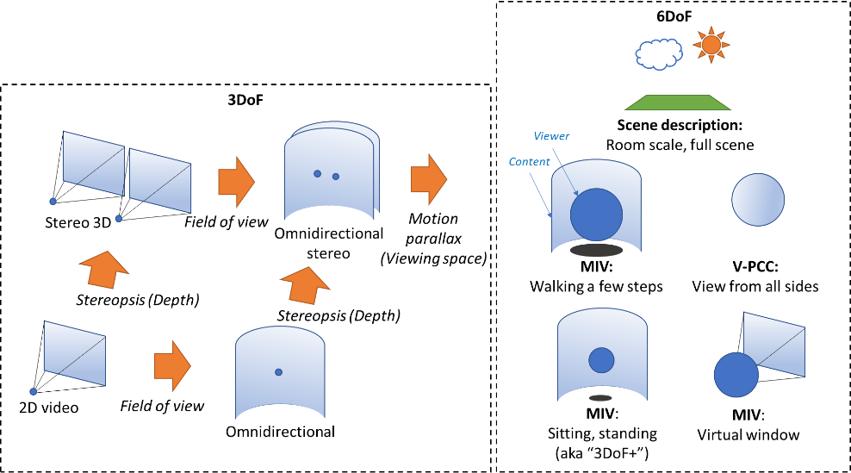
Figure 4- Levels of Immersion

9.1.3 Coding aspect of V3C
--------------------------------------------- End of change -------------------------------------------------------------------------

3 Proposal
We propose to include the text above in clause 9 of the MeCAR permanent document.

ISO/IEC 23090-5:—, Information technology — Coded representation of immersive media — Part 5: Visual volumetric video-based coding (V3C) and video-based point cloud compression (V-PCC)
ISO/IEC 23090-5:2021, Annex H Video-based Point Cloud Coding
ISO/IEC 23090-12:—, Information technology — Coded representation of immersive media — Part 12: MPEG immersive video
Arcobat01 and Soccer02 content courtesy from XD Productions, owner of copyright
Rafa and Sir Frederick content courtesy from Volograms, owner of copyright

