Source: Dolby Laboratories Inc., Fraunhofer IIS
Title: Text proposal on MeCAR audio capabilities
Document for: Agreement
Agenda Item: 9.5

Introduction
Audio function and capabilities were introduced within the MeCAR Permanent Document (S4-230738) clause 6.7 at 3GPP SA4#123-e. The proposed text is within brackets and a note was added that reads:
Note: This text in brackets is not yet agreed. Audio experts feedback requested. Brackets will be removed at SA4#124.

This document is a proposal for updates to that text.

- Background and discussion

As noted in the current text:
Note: “AAC-ELD” is not a defined profile in MPEG, and it should be considered to use v2.

ISO/IEC 14496-3 Information technology — Coding of audio-visual objects — Part 3: Audio, defines the following low-delay profiles:

- Low Delay AAC Profile (aka. “AAC-LD”; contains the audio object type 23 (ER AAC LD))
- Low Delay AAC v2 Profile (aka. “AAC-ELDv2”; contains the audio object types 23 (ER AAC LD), 39 (ER AAC ELD) and 44 (LD MPEG Surround))

“AAC-ELD” is not a defined profile in ISO/IEC 14496-3.

Referencing the Low Delay AAC v2 Profile offers the most flexible selection of tools (e.g., in order to be able to take tradeoffs between compression efficiency and algorithmic delay). The following figure illustrates the structure of the low-delay AAC-family and possible tradeoffs between bitrate and algorithmic delay:

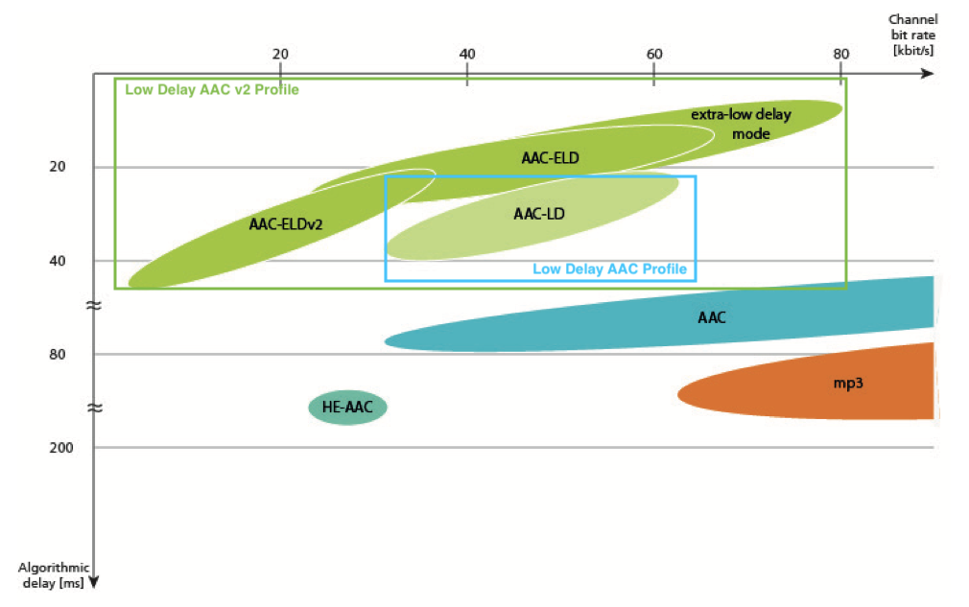

Named flexibility has been the main reason why the Low Delay AAC v2 Profile has been enabled to be used in Bluetooth transmissions (Advanced Audio Distribution Profile, Revision v1.4).

- Conclusion and proposal

Based on the background and discussion in clause 2, it is proposed to amend the MeCAR Permanent Document as follows:

[

6.7 Candidate Audio function and capabilities
NOTE: While considering audio codec capabilities, it is necessary to identify the targeted services and clarify the associated requirements (e.g., for 5GMS, split rendering, pixel streaming…), in terms of bit rate operation, algorithmic delay vs. motion to sound delay, quality, complexity…

6.7.1 Audio Decoding

AUDIO-DEC-1: a compliant entity shall be able to decode at least one MPEG-4 Low Delay AAC v2 Profile (AAC-ELDv2) with SBR disabled at 64kbps (ELD-64-S) compressed audio bitstream [AAC-ELDv2].

AUDIO-DEC-2: a compliant entity should be able to decode an EVS bitstream [EVS] with input sampling rate of up to 48kHz, operating on full band audio bandwidth at bitrates up to 128kbps.

6.7.2 Audio Encoding
AUDIO-ENC-1: a compliant entity shall support the encoding of an audio bitstream using MPEG-4 Low Delay AAC v2 Profile (AAC-ELDv2) with SBR disabled at 64kbps (ELD-64-S) with a total algorithmic latency no higher than 20 milliseconds [AAC-ELDv2].

AUDIO-ENC-2: a compliant entity shall support the encoding of an audio bitstream using EVS [EVS] with a total algorithmic latency no higher than 32 milliseconds.

]

