Source: Xiaomi
Title: On transparency information in MeCAR

Document for: Agreement

Agenda Item: 9.5

1 Introduction
In the MeCAR Permanent Document, the section 3.6 presents background on transparency information handling for visual content.

This contribution presents insights on the usage of such transparency information in the context of OpenXR. In addition, we propose to limit the usage of transparency information only for smartphone-based AR and not optical see-through as documented in the OpenXR specification.

2 Proposed change

3.6.1 Interest of Transparency information
It is desirable to support the transmission of transparency information (alpha_channel) in addition to the colour (e.g., RGB) information. Augmented reality services may overlay of virtual objects on the real world which are accessed directly through the “optical see-through” glasses. The overlay is not a full picture but only part of it, the other pixels of the picture being transparent or partially transparent, in case of a shadow effect for instance.
Figure 8 below depicts the overlay of a virtual dragon on the table of a real living room. If the whole video is overlayed, the dragon may appear in the middle of a rectangle corresponding to the video size. This is illustrated on the left picture. With additional transparency information, only the part of the video corresponding to the dragon is overlayed, as illustrated on the right picture.
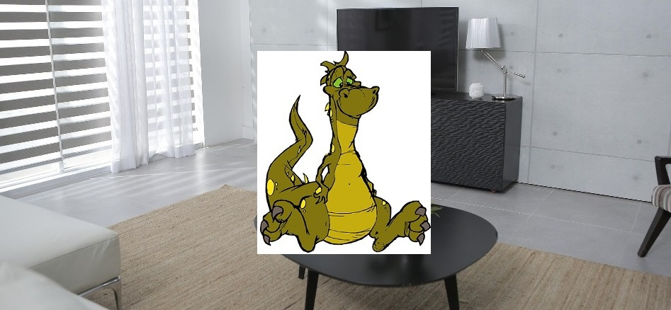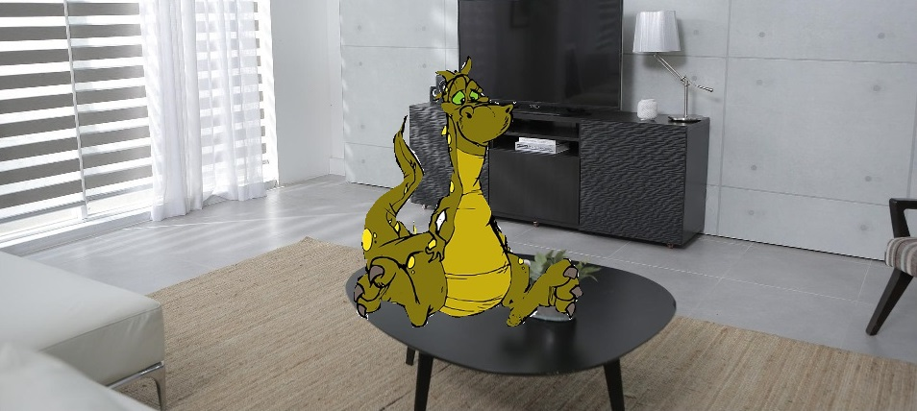
Figure 8 – Video overlay without (left) and with (right) transparency information

The following text is extracted from the OpenXR specification as illustrative purposes. It specifies how the XR Runtime has to render the views:
- blended with a capture view of the real-world,
- presented on top of the real world based on see-through display, or
- not related to real-world scene (e.g. VR).
Start of quote

After the compositor has blended and flattened all layers (including any layers added by the runtime itself), it will then present this image to the system’s display. The composited image will then blend with the user’s view of the physical world behind the displays in one of three modes, based on the application’s chosen environment blend mode.
VR applications will generally choose the XR_ENVIRONMENT_BLEND_MODE_OPAQUE blend mode, while AR applications will generally choose either the XR_ENVIRONMENT_BLEND_MODE_ADDITIVE or XR_ENVIRONMENT_BLEND_MODE_ALPHA_BLEND mode.
The possible blend modes are specified by the XrEnvironmentBlendMode enumeration:
typedef enum XrEnvironmentBlendMode {
XR_ENVIRONMENT_BLEND_MODE_OPAQUE = 1,
XR_ENVIRONMENT_BLEND_MODE_ADDITIVE = 2,
XR_ENVIRONMENT_BLEND_MODE_ALPHA_BLEND = 3,
XR_ENVIRONMENT_BLEND_MODE_MAX_ENUM = 0x7FFFFFFF
} XrEnvironmentBlendMode;
Enumerant Descriptions
- XR_ENVIRONMENT_BLEND_MODE_OPAQUE. The composition layers will be displayed with no view of the physical world behind them. The composited image will be interpreted as an RGB image, ignoring the composited alpha channel. This is the typical mode for VR experiences, although this mode can also be supported on devices that support video passthrough.
- XR_ENVIRONMENT_BLEND_MODE_ADDITIVE. The composition layers will be additively blended with the real world behind the display. The composited image will be interpreted as an RGB image, ignoring the composited alpha channel during the additive blending. This will cause black composited pixels to appear transparent. This is the typical mode for an AR experience on a see-through headset with an additive display, although this mode can also be supported on devices that support video passthrough.
- XR_ENVIRONMENT_BLEND_MODE_ALPHA_BLEND. The composition layers will be alpha-blended with the real world behind the display. The composited image will be interpreted as an RGBA image, with the composited alpha channel determining each pixel’s level of blending with the real world behind the display. This is the typical mode for an AR experience on a phone or headset that supports video passthrough.

End of quote

As can be seen on the specification, OpenXR indicates that the AR glasses as discussed in MeCAR are supposed to operate in the XR_ENVIRONMENT_BLEND_MODE_ADDITIVE mode. In this mode, the alpha channel if present is ignored. Instead, “black composited pixels to appear transparent”. Therefore, transparency information does not seem to be relevant for the current AR MeCAR devices when it comes to present virtual objects as overlay on the real scene as depicted in section 3.6.1 of the MeCAR PD.

Therefore, transparency information in the transmitted data seems to be relevant for AR devices which are able to occlude the real-world (e.g. smartphone, VR headset, video-see through device) but are not relevant for AR devices such as current optical-see through AR Glasses which are not capable of occluding the real-world.

4 Conclusion
We recommend integrating the updated section 3.6.1 as proposed in the MeCAR Permanent Document.

