3GPP TSG-WG SA4 Meeting #122 S4-230197
Athens, Greece, February 20 – 24, 2023

Source: Huawei, HiSilicon
Title: Discussion on the basic AR/MR use case for QoE study
Document for: Approval
Agenda Item: 9.8
Work Item / Release: FS_ARMRQoE / Rel-18
Abstract: In order to make the progress for the AR/MR QoE identification, it’s proposed to discuss and define the basic AR/MR use case as baseline for study of the QoE metrics.

1. Introduction
During last Toulouse SA4#121 meeting, it’s agreed to move forward to the QoE metrics identification after the collection of activities for AR/MR QoE related work in other SDOs. Before identifying the QoE metrics, it’s proposed to discuss and define the basic AR/MR use case as baseline.

2. Use case for AR/MR QoE
There are 22 core use cases identified for AR/MR devices in TR 26.998 [1] and they are further clarified into the several categories based on the similar requirements for media flow and device functional structure:
- Immersive media downlink streaming
- 5G interactive immersive service
- 5G cognitive immersive service
- AR conversational service
- Shared AR conversational service.

The AR/MR QoE metrics can be studied based on the following aspects:
1) Content part: study needs to be conducted on factors of content part which would help analyse user experience.
2) Delivery part: changing network conditions may lead to problems in user experience, especially the impact of transmission latency on user experience.
3) Device part: device capabilities also have impact on user experience 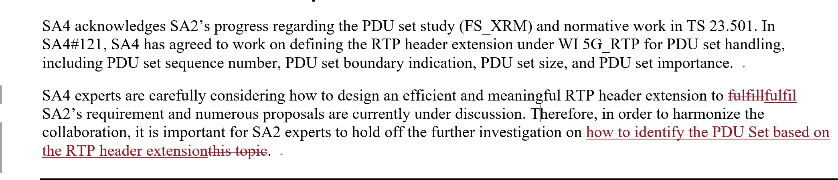.
QoE metrics relevant with the above aspects need to be studied under this study item, and based on the result of this study, user experience of AR/MR service could be evaluated.

3. Proposal
Based on the above-mentioned discussion, it is proposed to agree and capture section 2 into the TR 26.812.

References
- 3GPP TR 26.998, “Support of 5G Glass-type Augmented Reality / Mixed Reality (AR/MR) devices”

