|  |  |
| --- | --- |
| 3GPP TS 26.506 V1.1.0 (2023-02) | |
| Technical Specification | |
| 3rd Generation Partnership Project;  Technical Specification Group Services and System Aspects;  5G Real-time Media Communication Architecture (Stage 2)  (Release 18) | |
|  | |
| *5G-logo_175px* | 3GPP-logo_web |
|  | |
| The present document has been developed within the 3rd Generation Partnership Project (3GPP TM) and may be further elaborated for the purposes of 3GPP. The present document has not been subject to any approval process by the 3GPPOrganizational Partners and shall not be implemented. This Specification is provided for future development work within 3GPPonly. The Organizational Partners accept no liability for any use of this Specification. Specifications and Reports for implementation of the 3GPP TM system should be obtained via the 3GPP Organizational Partners' Publications Offices. | |

|  |
| --- |
|  |
| ***3GPP***  Postal address  3GPP support office address  650 Route des Lucioles - Sophia Antipolis  Valbonne - FRANCE  Tel.: +33 4 92 94 42 00 Fax: +33 4 93 65 47 16  Internet  http://www.3gpp.org |
| ***Copyright Notification***  No part may be reproduced except as authorized by written permission. The copyright and the foregoing restriction extend to reproduction in all media.  © 2022, 3GPP Organizational Partners (ARIB, ATIS, CCSA, ETSI, TSDSI, TTA, TTC).  All rights reserved.  UMTS™ is a Trade Mark of ETSI registered for the benefit of its members  3GPP™ is a Trade Mark of ETSI registered for the benefit of its Members and of the 3GPP Organizational Partners LTE™ is a Trade Mark of ETSI registered for the benefit of its Members and of the 3GPP Organizational Partners  GSM® and the GSM logo are registered and owned by the GSM Association |

Contents

Foreword 4

Introduction 5

1 Scope 6

2 References 6

3 Definitions of terms, symbols and abbreviations 6

3.1 Terms 6

3.2 Symbols 6

3.3 Abbreviations 7

4 Real-time Media Communication Architecture 7

4.1 Overall architecture for Real-Time Media Communication (RTC) 7

4.2 Functions and entities 8

4.2.1 General 8

4.2.2 Provisioning function 8

4.2.3 Configuration function 8

4.2.4 Media Session Handler (MSH) 8

4.2.5 Network support function 9

4.2.6 Trusted ICE functions 9

4.2.7 Trusted WebRTC signalling function 9

4.2.8 Trusted inter-working function 9

4.2.9 Trusted transport gateway function 9

4.2.10 Trusted media function 9

4.2.11 Trusted application supporting web function 10

4.3 Interfaces 10

4.3.1 RTC-1: Provisioning interface 10

4.3.2 RTC-3: AS to AF interface 10

4.3.3 RTC-4: Media-centric transport interface 10

4.3.4 RTC-5: Control transport interface 11

4.3.5 RTC-6: Client API 11

4.3.6 RTC-7: Client interface 12

4.3.7 RTC-8: Application interface 12

4.4 5G-RTC Architecture extension 12

4.4.1 Introduction 12

4.4.2 Extended 5G-RTC architecture for Edge Computing 12

4.4.2.1 Edge Application Server (EAS) 13

4.4.2.2 Edge Interfaces 13

5 Procedures for Real-time Media Communication 13

5.1 Procedures for Edge Processing 13

5.2 xxx 14

Annex A (informative): Architecture variants for collaboration scenarios 15

A.1 General 15

A.2 Collaboration scenario 1: 15

A.3 Collaboration scenario 2: 17

A.4 Collaboration scenario 3: 18

A.5 Collaboration scenario 4: 18

Annex B (informative): Change history 20

# Foreword

This Technical Specification has been produced by the 3rd Generation Partnership Project (3GPP).

The contents of the present document are subject to continuing work within the TSG and may change following formal TSG approval. Should the TSG modify the contents of the present document, it will be re-released by the TSG with an identifying change of release date and an increase in version number as follows:

Version x.y.z

where:

x the first digit:

1 presented to TSG for information;

2 presented to TSG for approval;

3 or greater indicates TSG approved document under change control.

y the second digit is incremented for all changes of substance, i.e. technical enhancements, corrections, updates, etc.

z the third digit is incremented when editorial only changes have been incorporated in the document.

In the present document, modal verbs have the following meanings:

**shall** indicates a mandatory requirement to do something

**shall not** indicates an interdiction (prohibition) to do something

The constructions "shall" and "shall not" are confined to the context of normative provisions, and do not appear in Technical Reports.

The constructions "must" and "must not" are not used as substitutes for "shall" and "shall not". Their use is avoided insofar as possible, and they are not used in a normative context except in a direct citation from an external, referenced, non-3GPP document, or so as to maintain continuity of style when extending or modifying the provisions of such a referenced document.

**should** indicates a recommendation to do something

**should not** indicates a recommendation not to do something

**may** indicates permission to do something

**need not** indicates permission not to do something

The construction "may not" is ambiguous and is not used in normative elements. The unambiguous constructions "might not" or "shall not" are used instead, depending upon the meaning intended.

**can** indicates that something is possible

**cannot** indicates that something is impossible

The constructions "can" and "cannot" are not substitutes for "may" and "need not".

**will** indicates that something is certain or expected to happen as a result of action taken by an agency the behaviour of which is outside the scope of the present document

**will not** indicates that something is certain or expected not to happen as a result of action taken by an agency the behaviour of which is outside the scope of the present document

**might** indicates a likelihood that something will happen as a result of action taken by some agency the behaviour of which is outside the scope of the present document

**might not** indicates a likelihood that something will not happen as a result of action taken by some agency the behaviour of which is outside the scope of the present document

In addition:

**is** (or any other verb in the indicative mood) indicates a statement of fact

**is not** (or any other negative verb in the indicative mood) indicates a statement of fact

The constructions "is" and "is not" do not indicate requirements.

# Introduction

This clause is optional. If it exists, it shall be the second unnumbered clause.

# 1 Scope

The present document specifies the architecture for real-time media communication. To support MNO and third-party services for real-time media, it is specified the essential functionalities and interfaces. The primary scope of this Technical Specification is the documentation of the following aspects:

- A real-time media communication architecture mapped to the 5GS architecture and any SA2 stage 2 architecture additions, with relevant core building blocks, reference point, and interfaces to support modern operator and third-party media services, based on the 5GMS architecture

- Provide all relevant reference points and interfaces to support different collaboration scenarios between 5G System operator and third-party media communication service provider, including but not limited to an AR media communication service provider.

- Call flows and procedures for different real-time communication service types,

- Specify support for AR relevant functionalities such as split-rendering or spatial computing on top of a 5G System based on this architecture

# 2 References

The following documents contain provisions which, through reference in this text, constitute provisions of the present document.

- References are either specific (identified by date of publication, edition number, version number, etc.) or non‑specific.

- For a specific reference, subsequent revisions do not apply.

- For a non-specific reference, the latest version applies. In the case of a reference to a 3GPP document (including a GSM document), a non-specific reference implicitly refers to the latest version of that document in the same Release as the present document.

[1] 3GPP TR 21.905: "Vocabulary for 3GPP Specifications".

[2] 3GPP TR 26.998: "Support of 5G glass-type Augmented Reality / Mixed Reality (AR/MR) devices".

[3] 3GPP TS 26.119: "Media Capabilities for Augmented Reality".

[4] 3GPP TS 26.113: "Enabler for Immersive Real-time Communication".

[5] 3GPP TR 26.930: "Study on the enhancement for Immersive Real-Time communication for WebRTC".

[6] 3GPP TS 26.501: "5G Media Streaming (5GMS); General description and architecture".

[7] 3GPP TS 23.558: "Architecture for enabling Edge Applications".

# 3 Definitions of terms, symbols and abbreviations

## 3.1 Terms

For the purposes of the present document, the terms given in 3GPP TR 21.905 [1] and the following apply. A term defined in the present document takes precedence over the definition of the same term, if any, in 3GPP TR 21.905 [1].

Definition format (Normal)

**<defined term>:** <definition>.

**example:** text used to clarify abstract rules by applying them literally.

## 3.2 Symbols

For the purposes of the present document, the following symbols apply:

Symbol format (EW)

<symbol> <Explanation>

## 3.3 Abbreviations

For the purposes of the present document, the abbreviations given in 3GPP TR 21.905 [1] and the following apply. An abbreviation defined in the present document takes precedence over the definition of the same abbreviation, if any, in 3GPP TR 21.905 [1].

AR Augmented Reality

EAS Edge Application Server

ECS Edge Configuration Server

EEC Edge Enabler Client

EES Edge Enabler Server

IETF Internet Engineering Task Force

ICE Interactive Connectivity Establishment

IMS IP Multimedia Subsystem

MCU Multi-point Control Unit

MR Mixed Reality

MSH Media Session Handler

MTSI Multimedia Telephony Service for IMS

NAT Network Address Translation

RTC Real-Time Media Communication

SDP Session Description Protocol

SFU Selective Forwarding Unit

STUN Session Traversal Utilities for NAT

TURN Traversal Using Relays around NAT

W3C World Wide Web Consortium

WebRTC Web Real-Time Communication

# 4 Real-time Media Communication Architecture

## 4.1 Overall architecture for Real-Time Media Communication (RTC)

Real-Time media Communication over 5G system (5G-RTC) in the context of this specification is defined as the delivery of delay-sensitive media from one peer to another with support of 5G network. AR conversational service described in TR 26.998 [2] is a typical use cases for 5G-RTC, which enables end-users to directly communicate real-time media including AR/MR media contents as specified in TS 26.119 [3].As identified in clause 8.4 of TR 26.998, there may be different options to enable such AR conversational service, for example re-use of parts of MTSI such as the IMS data channel or 5G Media Streaming for managed services. In this specification, 5G-RTC architecture provides the core functions and entities to support WebRTC framework over 5G system. The WebRTC framework is a subset of WebRTC and is limited to a protocol stack and its implementation, excluding media codecs and other media processing functions defined in W3C and IETF.

The overall 5G-RTC architecture is shown in Figure 4.1-1 as below.



Figure 4.1-1: 5G-RTC General Architecture

Note: Some of functions may not be required depending on the collaboration scenario. Description of collaboration scenario and its architecture variant are specified in Annex A.

## 4.2 Functions and entities

### 4.2.1 General

This clause defines minimal and essential functions and extra functions and entities may appear in some cases. The definitions of extra functions and entities are specified in TS 26.113 [4] and TR 26.930 [5].

### 4.2.2 Provisioning function

The provisioning function may enable an application provider to perform provisioning of the following functionalities:

- QoS support provisioning for WebRTC sessions

- Charging provisioning for WebRTC sessions

- Collection of consumption and QoE metrics data provisioning related to WebRTC sessions

- Offering ICE functionality provisioning such as STUN and TURN servers

- Offering WebRTC signalling servers provisioning, potentially with interoperability to other signalling servers.

The provisioning function may not be relevant to all collaboration scenarios and some of the 5G support functionality may be offered without application provider provisioning.

NOTE: The integration/collocation of this 5G-RTC AF and WebRTC signalling server is possible. Co-located WebRTC signalling server is able to act as a 5G-RTC AF which is accessible to 5GC, and replace some of this 5G-RTC AF’s interfaces and APIs with WebRTC signalling. For example, interfaces and APIs between this 5G-RTC AF and UE will be replaced to avoid concurrent/redundant requests from UE.

### 4.2.3 Configuration function

The configuration function stores WebRTC-related configuration information and makes them accessible to the UE. It stores information and recommendations to operate network-assisted WebRTC sessions over 5G system.

The configuration information may consist of static information such as the following:

- Recommendations for media configurations

- Configurations of STUN and TURN server locations

- Configuration about consumption and QoE reporting

- Discovery information for WebRTC signalling and data channel servers and their capabilities in static and/or dynamic way.

NOTE: The integration/collocation of this 5G-RTC AF and WebRTC signalling server is possible. Co-located WebRTC signalling server is able to act as a 5G-RTC AF which is accessible to 5GC, and replace some of this 5G-RTC AF’s interfaces and APIs with WebRTC signalling. For example, interfaces and APIs between this 5G-RTC AF and UE will be replaced to avoid concurrent/redundant requests from UE.

### 4.2.4 Media Session Handler (MSH)

The MSH is an entity running on the UE, which assists with the 5G integration of the WebRTC application. It exchanges, on behalf of the application, information about the WebRTC sessions with the network.

The MSH receives information about a new WebRTC session from the application. It relays the information to the Network Support Function. It also receives events and other network information about the WebRTC session from the Network Support Function, which it may relay to the application.

In addition, one of subfunction in MSH is the metric collection and reporting. It executes the collection of QoS and QoE metrics measurements from the WebRTC Framework and the WebRTC application and sends metrics reports to the 5G-RTC AF for the purpose of metrics analysis or to enable potential transport optimizations by the network.

### 4.2.5 Network support function

The support functionality includes the following:

- Network Support Function receives information from the UE and/or other ASs about a WebRTC session and its state

- Network Support Function requests the network that QoS should be allocated (or satisfied) for a starting or modified session

- Network Support Function receives notification from the network about changes to the QoS allocation for the ongoing WebRTC session

- Network Support Function exchanges information about the WebRTC session with the trusted STUN/TURN/Signalling Server, e.g. to identify a WebRTC session and associate it with a QoS template.

NOTE: The integration/collocation of this 5G-RTC AF and WebRTC signalling server is possible. Co-located WebRTC signalling server is able to act as a 5G-RTC AF which is accessible to 5GC, and replace some of this 5G-RTC AF’s interfaces and APIs with WebRTC signalling. For example, interfaces and APIs between this 5G-RTC AF and UE will be replaced to avoid concurrent/redundant requests from UE.

### 4.2.6 Trusted ICE functions

The MNO may offer trusted ICE functions to the WebRTC application to be used during the WebRTC ICE gathering phase. These functions may be STUN and TURN servers that facilitate NAT and firewall traversal.

The MNO-operated trusted ICE functions may assist with the 5G integration of the WebRTC application. This could be done by triggering network assistance to starting or ongoing WebRTC sessions.

### 4.2.7 Trusted WebRTC signalling function

The trusted WebRTC signalling function is used to setup and manage MNO-operated WebRTC applications. They offer a standardized signalling protocol for the session setup to both parties of the WebRTC session. The WebRTC signalling function will handle the offer/answer exchange and will have access to the SDP in both directions.

The WebRTC signalling function may use that knowledge to offer network assistance and other 5G features to the endpoints of the WebRTC session.

The WebRTC signalling function manages media flow sessions in both uplink and downlink directions.

### 4.2.8 Trusted inter-working function

This function provides inter-working functionality to enable MNO-facilitated WebRTC sessions that involve endpoints across different MNOs. They may for example provide cross-network signalling functionality to allow WebRTC signalling server that are hosted in different networks to communicate, in order to establish and manage the WebRTC sessions.

### 4.2.9 Trusted transport gateway function

A transport gateway function may be offered by the MNO to support cross-operator WebRTC sessions. It may offer the border control function for user plane (e.g., topology hiding, IPv4-IPv6 translation) as a gateway, which is located at the network boundary where different operators or third-party network connects. It works under the control of the trusted inter-working function.

Note: Detailed functionality is specified in TR 26.930 [5].

### 4.2.10 Trusted media function

A media server may be offered by the MNO to support WebRTC sessions. It may offer a wide range of functionality such as:

- a content server that serves content to the WebRTC application, e.g. through a data channel

- media processing functionality: may be used by the WebRTC application as a relay that performs some media processing function such as transcoding, recording, 3D reconstruction, etc.

- scene composition functionality: the server may compose a 3D scene and distribute it to several point-to-point WebRTC sessions

- Multi-point Control Unit (MCU) functionality: the server may offer multi-party conferencing functionality to merge a number of point-to-point WebRTC sessions

- Selective Forwarding Unit (SFU) functionality: the server may offer the selection, copy, and forwarding functionality of IP steams produced by multiple WebRTC endpoints (i.e., participants).

- Maintain uplink and downlink flow context (QoS, remote control and etc.) by interacting with the WebRTC signalling function.

### 4.2.11 Trusted application supporting web function

A web server may be offered by the MNO to support applications by providing web service entry point, authorization/authentication, sharing files, or scheduling conferencing sessions.

## 4.3 Interfaces

Editor’s NOTE: All context here needs to be updated based on the future inputs/discussions

### 4.3.1 RTC-1: Provisioning interface

The RTC-1 interface allows the Application Provider to provision support for RTC sessions that are offered by it. The provisioning may cover the following aspects:

- QoS support for WebRTC sessions

- Charging provisioning for WebRTC sessions

- Collection of consumption and QoE metrics data related to WebRTC sessions

- Offering ICE functionality such as STUN and TURN servers

- Offering WebRTC signalling servers, potentially with interoperability to other signalling servers

The provisioning interface is not relevant to all collaboration scenarios and some of the 5G support functionality may be offered without application provider provisioning.

### 4.3.2 RTC-3: AS to AF interface

The 5G-RTC AS may exchange information regarding the RTC session with the 5G-RTC AF. This information may cover QoS flow information and QoS allocation as well as QoE and consumption reports. The 5G-RTC AF may subscribe to information about the status of the QoS flow, which it may share with the 5G-RTC AS, e.g. in form of bitrate recommendations.

### 4.3.3 RTC-4: Media-centric transport interface

This interface is used to exchange the WebRTC traffic with the other endpoint as well as to exchange signalling information related to the WebRTC session with the trusted application servers.

The traffic includes:

- Media streams sent over RTP

- Application data sent over data channel

- WebRTC Signalling data along with STUN and TURN servers

- Other application data

RTC-4 may further be grouped into two sub-interfaces as follows.

**RTC-4s:**

The RTC-4s interface is an interface between the WebRTC framework and the 5G-RTC AS such as WebRTC Signalling server. This interface is used for the exchange of signalling information related to the WebRTC session between two or more WebRTC endpoints using trusted application servers. In some cases where the signalling is not handled by WebRTC framework, the RTC-4s interface is an interface between the native WebRTC applications and the WebRTC Signalling server.

**RTC-4m:**

This interface is used for transmission of media and other related data between two or more WebRTC endpoints.

The traffic includes

* Media data transmitted over RTP
* Application data transmitted using Data channel
* Media related meta-data transmitted using Data channel

NOTE 1: The Media Server should maintain the status for both uplink and downlink traffic and a separate interface for supporting downlink and uplink is expected to be defined in this specification.

NOTE 2: WebRTC-enabled UE should support streaming functions for uplink and downlink traffic. Therefore a new entity in UE may be defined.

### 4.3.4 RTC-5: Control transport interface

The RTC-5 interface is an interface between the Media Session Handler and the 5G-RTC AF. It is used to convey configuration information from the 5G-RTC AF to the MSH and to request support for a starting/ongoing WebRTC session. The configuration information may consist of static information such as the following:

- Recommendations for media configurations

- Configurations of STUN and TURN server locations

- Configuration about consumption and QoE reporting

- Discovery information for WebRTC signalling and data channel servers and their capabilities

The support functionality includes the following:

- MSH receives the configuration information

- MSH informs the 5G-RTC AF about a WebRTC session and its state

- MSH requests QoS allocation for a starting or modified session

- MSH receives notification about changes to the QoS allocation for the ongoing WebRTC session

- MSH receives the updated information about the WebRTC session with the 5G-RTC STUN/TURN/Signalling Server, e.g. to identify a WebRTC session and associate it with a QoS template

The 5G-RTC functionality that offer application functions to the WebRTC application may equally be provided by Application Servers (5G-RTC AS) instead of 5G-RTC AFs. These then use a dedicated interface RTC-3 to request configurations and network support for the ongoing WebRTC sessions from the 5G-RTC AF.

### 4.3.5 RTC-6: Client API

The MSH is a function in the UE that provides access to 5G-RTC support functions to the native WebRTC applications. These functions may be offered on request, i.e., through the RTC-6 interface, or transparently without direct involvement of the application. The MSH may assist indirectly in the ICE negotiation by providing a list of STUN and TURN server candidates that offer 5G-RTC functionality. The MSH also collects QoE metric reports and submits consumption reports. It may also offer media configuration recommendations to the application through RTC-6.

### 4.3.6 RTC-7: Client interface

This interface is similar in functionality to RTC-6. The difference lies in the face that this interface may not be exposed as an API to application developers but may be in form of a direct communication between the MSH and the WebRTC framework. The WebRTC framework hides away all details of the QoS allocation and network support from the application. It autonomously and transparently invokes the functions offered by the MSH to provide support for the RTC session.

### 4.3.7 RTC-8: Application interface

This is a proprietary interface between the application and the application provider, which may be used to exchange configuration information related to the RTC session or the application.

## 4.4 5G-RTC Architecture extension

### 4.4.1 Introduction

This clause defines an architecture that enables a 5G-RTC Application Provider to provision resources in the Edge Data Network (EDN) for an application through the RTC-1 interface.

Media processing in the edge may be achieved in one of two different ways at the application layer:

1. Client-driven management. 5G-RTC Applications that are aware of the edge processing can directly request an edge resource and discover the Edge Application Server (EAS) that is best suited to serve the application.

2. Application Function-driven management. The 5G-RTC AF automatically allocates edge resources for new streaming sessions on behalf of the application using information in the 5G-RTC provisioning session.

An Edge-enabled 5G=RTC Client leverages the Edge Computing capabilities as defined in TS 23.558.

### 4.4.2 Extended 5G-RTC architecture for Edge Computing

#### 4.4.2.1 General

The 5G-RTC architecture can be extended to add support for media processing in the edge. The extended architecture is an integration of the 5G-RTC architecture defined in TS 26.506 with the architecture for enabling Edge Applications defined in TS 23.558. The extended architecture is as shown in Figure 4.4.2-1.

The extended 5G-RTC architecture supports both client-driven as well as Application Function-driven management of the edge processing session.

The 5G-RTC Application Provider may request the deployment of edge resources as part of the Provisioning Session.

- In the client-driven approach, the WebRTC Application is aware of the support of edge processing in the network and takes steps, such as using the EDGE-5 APIs, to discover and locate a suitable 5G-RTC AS instance in the Edge DN.

- In the Application Function driven approach, the 5G-RTC Application Provider configures the 5G-RTC AF to automatically deploy edge processing for the media sessions of the corresponding Provisioning Session. The WebRTC Application may not be aware of the edge deployment and the EAS is discovered through other means, such as DNS resolution with support from the DNS server (e.g., EASDF/DNS resolver) as specified in 3GPP TS 23.548 [1].

When the WebRTC application is a web application, the implementation of the EDGE-5 interface to discover the 5G-RTC AS/EAS location by accessing the EEC is difficult as the Web browser providers may not implement interfaces necessary for supporting edge enabled 5G-RTC applications/services. Also, in the Application Function-driven approach the Application Client (AC) and EEC are not used to discover the 5G-RTC AS/EAS location.

To resolve the above EAS discovery issue in the Application Function-driven approach and when the WebRTC application is a web application, the EAS information can be shared with the Media Session Handler by the 5G-RTC AF using RTC-5 interface.

NOTE: Other methods that can be used for sharing EAS information (e.g., sharing EAS hostname to the WebRTC application by RTC-8 or by other means and then using DNS resolution) are FFS.



Figure 4.4.2-1: Edge-enabled 5G-RTC architecture

NOTE: This architecture diagram is an example for CS-2 scenario.

#### 4.4.2.2 Edge Application Server (EAS)

EAS is the application server resident in the EDN, performing edge-based processing for AR functionalities such as split rendering and spatial computing. The Application Client (AC) connects to the EAS in order to avail the services of the application with the benefits of Edge Computing.

It is possible that the server functions of an application are available only as an EAS.

However, it is also possible that certain server functions are available both at the edge and in the cloud as an EAS and an Application Server resident in the cloud.

The EAS can use the 3GPP Core Network capabilities in the following ways, all of which are optional to support:

a) invoking 3GPP Core Network capabilities via the edge enabler layer through the Edge Enabler Server (EES)

b) invoking 3GPP Core Network function (e.g., PCF) APIs directly, if it is an entity trusted by the 3GPP Core Network; and

c) invoking the 3GPP Core Network capabilities through the capability exposure functions, i.e., SCEF/NEF/SCEF+NEF.

The functions of Edge enabler Client (EEC), Edge Enabler Server (EES), Edge Configuration Server (ECS) are as defined in TS 23.558.

#### 4.4.2.3 Edge Interfaces

Based on the extended architecture, the following interfaces are defined for performing edge-based processing for AR functionalities such as split rendering and spatial computing:

1. A 5G-RTC AF that is edge-enabled shall support EES functionality including:

- EDGE-1 API for supporting registration and provisioning of EEC functions, and discovery by them of EAS instances.

- EDGE-3 API towards the EAS function of 5G-RTC AS instances.

- EDGE-6 API for registering with an ECS function.

- EDGE-9 API for media session relocation.

2. A 5G-RTC AS that is edge-enabled shall support EAS functionality including the EDGE-3 API for registration with the EES.

3. A Media Session Handler that is edge-enabled should support EEC functionality including:

- Invoking the EES function using the EDGE‑1 API.

- Invoking the ECS function using the EDGE‑4 API.

- EDGE-5 API exposed to the Application Client.

4. A WebRTC Application that is edge-enabled shall support Application Client functionality and should invoke the ECS function using the EDGE‑5 API.

# 5 Procedures for basic RTC architecture

## 5.1 General

The RTC procedures that are defined in this clause are classified based on the collaboration scenarios that are described in Annex A. Depending on the scenario, only a subset of the functions that are defined in 4.2 may be be involved.

In general, the 5G-RTC call flow may consist of the following procedures. Details per each collaboration scenario is specified in Annex B;

- Provisioning

- Configuration

- ICE candidates discovery

- Session establishment

- QoS request (either client-driven or WebRTC signalling function/server-driven)

- WebRTC traffic delivery

- QoS updates

- Session termination

## 5.2 Provisioning Procedure

An application provider may use the RTC-1 interface to provision network assistance and other resources for its RTC sessions.

This procedure is common to the different collaboration scenarios.

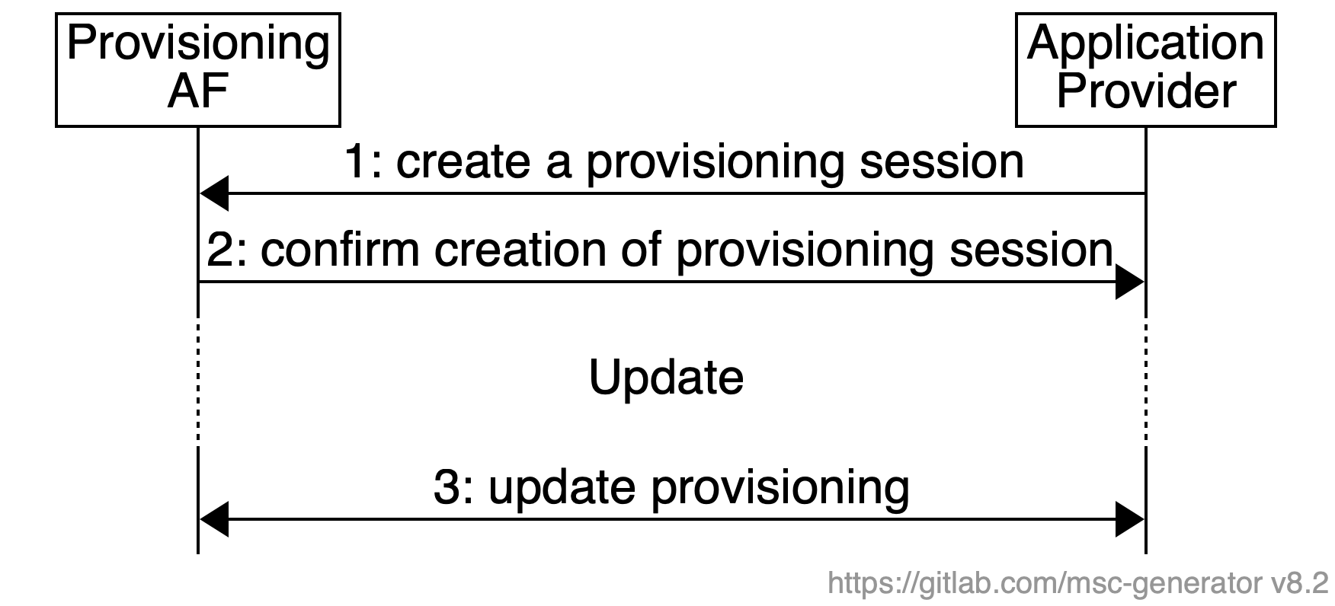

Figure 5.2-1: Provisioning procedure

## 5.3 Configuration procedure

Editor’s Note: This sub-clause may not be required depending on whether we identify the common procedure or not…

## 5.4 XXX procedure….

## 5.x Call flow for Over-the-top (OTT) RTC sessions (CS#1)

The RTC session is established between two endpoints using external signaling mechanisms. Each endpoint of the connection that is using the 5G system may benefit from 5G network support for the network path within that 5G network.

The following call flow applies.

 Figure 5.x-1: Call flow for Over-the-top (OTT) RTC sessions (collaboration scenario 1)

The working assumptions are:

- The application on UE1 and the remote endpoint use an external WebRTC signaling server to establish the WebRTC session.

- Step 0: A provisioning session may have been created by the AP with the MNO.

Network assistance for the RTC session is achieved through the following steps:

- The application on UE1 uses application-specific signaling functions to establish a WebRTC session with the remote endpoint.

- The application informs the MSH about the new RTC session and shares information about the media streams and their associated 5-Tuples.

- The MSH requests network assistance for the RTC session and provides the transport and bandwidth information to the Network Support AF.

- The Network Support AF uses the N5 or N33 interface to request QoS allocation. It may request differential charging based on pre-existing provisioning for these sessions. The Network Support AF will also subscribe to events related to the QoS flows of the RTC session with the PCF and SMF.

- The Network Support AF receives notifications about any changes to the QoS flows of the RTC session from the PCF or the SMF.

- The Network Support AF sends notifications to the MSH about changes to the session. This information may contain for example be bitrate recommendations.

- The MSH forwards the bitrate recommendation to the RTC application.

- The application may act on the bitrate recommendation, e.g. by reducing the uplink media bitrate.

- The application may request the remote endpoint to adjust the bitrate of the downlink media.

Editor’s note: Descriptive text above need to be updated based on the diagram

## 5.y Call flow for Network-supported RTC sessions (CS#2)

The MNO offers access to trusted ICE functionality to UEs that wish to participate in RTC sessions. The session establishment takes into account the configured trusted ICE functions.

The call flow is as follows.



Figure 5.y-1: Call flow for Network-supported RTC sessions (collaboration scenario 2)

The working assumptions are:

- The application on UE1 and the remote endpoint use an external WebRTC signaling server to establish the WebRTC session.

- Step 0: A provisioning session may have been created by the AP with the MNO.

1. The AF uses the RTC-5 interface to provide the MSH with a list of trusted STUN/TURN servers that the UE may use for establishing RTC sessions.
2. The application queries the MSH for the list of trusted ICE servers.
3. The UE discovers and tests the ICE candidates to validate that they are suitable for the connection.
4. The application on UE1 and the remote UE2 use an external RTC signaling server to exchange information about ICE candidates and to exchange the SDP offer/answer.
5. The WebRTC session is then established using the most suitable ICE candidate.
6. The STUN or TURN server in ICE function, upon reception of the allocation request by the application (or WebRTC framework) may extract the 5-Tuple information for each of the media sessions and convey the information to the Network Support AF in 5G-RTC AF.
7. The Network Support AF uses the N5 interface to request QoS allocation. It may request differential charging based on pre-existing provisioning for these sessions. The Network Support AF will also subscribe to events related to the QoS flows of the WebRTC session with the PCF and SMF.
8. The Network Support AF receives notifications about any changes to the QoS flows of the WebRTC session from the PCF or the SMF.
9. The Network Support AF sends notifications to the ICE function (STUN/TURN server).
10. The STUN/TURN server may forward the bitrate recommendation to the application, if the allocation session is still active.
11. The application may act on the bitrate recommendation, e.g. by reducing the uplink media bitrate.
12. Media traffic is delivered to the remote endpoint. If TURN server is present in the configuration, RTC-4m interface is involved.
13. The application may request the remote endpoint to adjust the bitrate of the downlink media.

Editor’s note: Descriptive text above need to be updated based on the diagram

# 6 Procedures for Edge Processing

## 6.1 Client-driven Management of 5G RTC Edge Processing

The detailed call flow for client-driven management of edge processing session is shown in Figure 6.1-1.

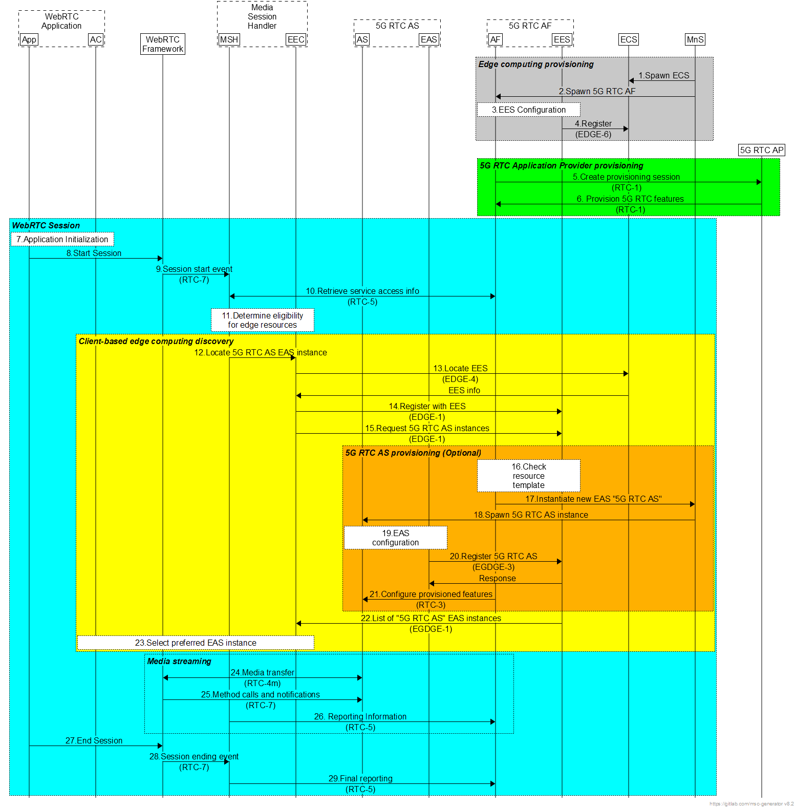

Figure 6.1-1. Client-driven management of 5G-RTC edge processing

The ***Edge Computing Provisioning*** phase is a provisioning phase, that may be repeated several times (e.g., to extend edge processing coverage to new geographical areas or to increase the capacity of an already provisioned area). All steps in this phase are optional and performed on need basis. The steps are:

1. Spawn ECS: In this step, a new ECS instance is instantiated to manage new or increased demand for edge processing.

2. Spawn 5G-RTC AF: In this step, a new 5G-RTC AF that is edge-enabled is instantiated to handle new or increased demand for WebRTC sessions with edge processing.

3. EES Configuration: The EES is configured for a specific Edge Data Network (EDN).

4. EES Registration with ECS: The EES registers with the ECS that is in authority over the target EDN.

The ***5G-RTC Application Provider Provisioning*** phase is performed prior to the establishment of any related WebRTC sessions by the 5G-RTC Application Provider. Subsequent updates to the provisioning session are possible.

5. Create Provisioning Session: In this step, the 5G-RTC Application Provider creates a new provisioning session.

6. Provision 5G-RTC features: In this step, the 5G-RTC Application Provider may create different configurations such as QoS support, charging, collection of consumption, offering STUN/TURN servers, WebRTC signalling servers, Edge Processing, etc.

The WebRTC Application initiates a new RTC session:

7. Application Initialization: The user launches the WebRTC Application. The WebRTC application performs any required initialization steps.

8. Start session: The WebRTC Application invokes the WebRTC framework with appropriate real-time streaming access parameters.

9. Session starting event: The application informs the Media Session Handler about the start of a new WebRTC session over 5G.

10. Retrieve service access information: The Media Session Handler retrieves Service Access Information from the 5G-RTC AF appropriate to the WebRTC session.

11. Determine eligibility for requesting edge resources: Using information from the Service Access Information, the Media Session Handler determines whether the WebRTC session is eligible for requesting edge resources.

If the eligibility criteria are met in the previous step, the UE discovers an EAS instance offering 5G-RTC AS functionality in the ***Client-based Edge Computing Discovery*** phase:

12. Locate EAS instances: The MSH asks the EEC to discover the location of one or more suitable EAS instances offering the “5G-RTC AS” capability that can serve the application.

13. Locate local EES: The EEC queries the ECS for a suitable EES (EDGE-4 API).

14. Register with EES: The EEC registers with the selected EES (EDGE-1 API).

15. Request list of “5G-RTC AS” EAS instances: The EEC queries the EES or one or more EAS instances offering the “5G-RTC AS” capability that can serve the session, using EAS discovery filters (see Table 8.5.3.2-2 in [2]) provided by the Application Client, e.g. “5G-RTC AS” for EAS type, appropriate values for service feature(s), and other EAS characteristics.

The optional sub-flow ***5G-RTC AS Provisioning*** is for provisioning an additional 5G-RTC AS instance if a suitable EAS instance offering the **"**5G-RTC AS**"** capability cannot be located. The steps are:

16. Check resource template: The 5G-RTC AF checks the provisioned edge processing resource template for the related application to determine the requirements of the application.

17. Instantiate new EAS/5G-RTC AS: The 5G-RTC AF requests the MnS to instantiate a new “5G-RTC AS” EAS instance with the specified requirements and considering parameters provided in the query by the EEC.

18. Spawn 5G-RTC AS instance: The MnS creates a new instance of the EAS offering “5G-RTC AS” capability with the requested placement and resources.

19. EAS configuration: The newly instantiated “5G-RTC AS” EAS instance is configured.

20. Register EAS with EES: The newly instantiated EAS instance registers itself with the triggering EES.

21. Configure provisioned features: This may include configuring and launching the server-side application in the 5G-RTC AS.

Completion of UE Edge Computing Discovery phase:

22. List of suitable “5G-RTC AS” EAS instances: The EES/5G-RTC AF responds to the EEC with a list of “5G-RTC AS” EAS instances and their characteristics in an EAS discovery response (see Table 8.5.3.3-1 in [16]).

23. Select preferred “5G-RTC AS” EAS instance: The AC and/or EEC select(s) a “5G-RTC AS” EAS instance from the provided list, based on the AC’s desired criteria.

After successful discovery of a “5G-RTC AS” EAS instance, the actual ***WebRTC session*** over 5G may start:

24. Media transfer: The WebRTC Application connects to the selected EAS “5G-RTC AS” and the real-time streaming starts.

25. Method calls and notifications: Supporting information about the WebRTC session is passed from the WebRTC framework to the Media Session Handler.

26. Reporting, network assistance, and dynamic policy: The Media Session Handler exchanges supporting information about the WebRTC session with the 5G-RTC AF.

27. End session: The WebRTC Application informs the WebRTC framework that the RTC session has ended.

28. Session ending event: The WebRTC framework informs the Media Session Handler about the end of the RTC session.

29. Final reporting: The Media Session Handler performs any final reporting to the 5G-RTC AF.

Annex A (informative):  
Architecture variants for collaboration scenarios

## A.1 General

This clause addresses the derivative architecture for each of the collaboration scenarios. The four collaboration scenarios are summarized below and further details is specified in Annex A.

It specifies the four collaboration scenarios as summarized below based on the location of required functional entities in trusted domain as defined as follows.

- 5G support for OTT WebRTC: in this scenario the WebRTC session runs completely over the top. However, the MNO may offer support in form of QoS allocation, bitrate recommendations, and QoE report collection based on request by the UE.

- MNO-provided trusted WebRTC functions: in this scenario the MNO offers trusted support functions such as ICE servers to the WebRTC application on the UE.

- MNO-facilitated WebRTC services: the MNO may host and facilitate WebRTC sessions by providing a trusted WebRTC signalling server, which may also offer 5G network assistance.

- Inter-operable WebRTC services: collaboration scenario 3 is extended with functions to support MNO to MNO inter-operability.

NOTE: Collaboration scenario 4 is in the scope of this specification. Some of its details, which are not specified in the current version of the document, will be specified, after the relevant works are finished.

The list of key functional entities in trusted domain differs from collaboration scenarios as described in Table A.1-1.

Table A.1‑1: Mapping of key functions to each collaboration scenarios

|  |  |  |  |  |
| --- | --- | --- | --- | --- |
| Functions | **Collaboration scenario 1** | **Collaboration scenario 2** | **Collaboration scenario 3** | **Collaboration scenario 4** |
| **Provisioning function** | Optional | Optional | Optional | Optional |
| **Configuration function** | Optional | Required | Optional (maybe fulfilled by WebRTC signalling server) | Optional (maybe fulfilled by WebRTC signalling server) |
| **MSH** | Required | Optional | Optional | Optional |
| **Network support function** | Required | Required | Optional (maybe fulfilled by WebRTC signalling server) | Optional (maybe fulfilled by WebRTC signalling server) |
| **Trusted ICE function** | N/A | Required | Optional | Optional |
| **Trusted WebRTC signalling server** | N/A | N/A | Required | Required |
| **Trusted media server** | N/A | Optional | Optional | Optional |

NOTE: The collaboration scenario 3 may further split depending on the role of MNO, as addressed in TR 26.930.

## A.2 Collaboration scenario 1:

Figure A.2-1 shows the architecture variant for the collaboration scenario 1 when the WebRTC session is completely running over the top. For this case, many of WebRTC-related entities are not the scope of this specification. However, Network Support Function is present in the trusted domain to support QoS allocation, bitrate recommendations, and QoE report collection.



Figure A.2-1: Derivative 5G-RTC architecture for collaboration scenario 1

## A.3 Collaboration scenario 2:

Figure A.3-1 shows the architecture variant for the collaboration scenario 2 when MNO provides the trusted WebRTC functions such as ICE function. It also contains the configuration function to support the network-assisted WebRTC sessions over 5G system.



Figure A.3-1: Derivative 5G-RTC architecture for collaboration scenario 2

NOTE: RTC-4m interface is present only when the ICE function contains the TURN server in this scenario.

## A.4 Collaboration scenario 3:

Figure A.4-1 shows the architecture variant for the collaboration scenario 3 when MNO hosts the WebRTC sessions by providing the trusted WebRTC signalling server in 5G-RTC AS. In addition, trusted media server is present in 5G-RTC AS to support SFU and MCU functionality.



Figure A.4-1: Derivative 5G-RTC architecture for collaboration scenario 3x

## A.5 Collaboration scenario 4:

NOTE: This scenario is extended from collaboration scenario 3 by supporting interoperability between multiple MNOs. The details are FFS.

Annex B (informative):  
Change history

|  |  |  |  |  |  |  |  |
| --- | --- | --- | --- | --- | --- | --- | --- |
| **Change history** | | | | | | | |
| **Date** | **Meeting** | **TDoc** | **CR** | **Rev** | **Cat** | **Subject/Comment** | **New version** |
| 2022-08 | SA4#120 |  |  |  |  | Initial draft | 0.1.0 |
| 2022-11 | SA4#121 | S4-221543 |  |  |  | SA4#121 Agreements: S4-221344, S4-221542, S4-221544, S4-221545, S4-221510, S4-221509, S4-221371, S4-221508 | 0.2.0 |
| 2022-11 | SA4#121 | S4-221610 |  |  |  | Minor update in Scope: word “generic” removed | 0.2.1 |
| 2022-12 |  |  |  |  |  | Created by MCC to be presented to TSG for information | 1.0.0 |
| 2023-02 | SA4#122 | S4-230343 |  |  |  | SA4#122 Agreements: S4-230214, S4-230299, S4-230343, S4-230371 | 1.1.0 |