**3GPP TSG-SA WG4 Meeting #122 S4-230141**

**Athens, Greece, 20 – 24 February 2023**

|  |  |  |  |  |  |  |  |  |
| --- | --- | --- | --- | --- | --- | --- | --- | --- |
| *CR-Form-v12.2* | | | | | | | | |
| **CHANGE REQUEST** | | | | | | | | |
|  | | | | | | | | |
|  | **26.506** | **CR** |  | **rev** |  | **Current version:** | **1.0.0** |  |
|  | | | | | | | | |
| *For* [***HE******LP***](http://www.3gpp.org/3G_Specs/CRs.htm#_blank)*on using this form: comprehensive instructions can be found at* [*http://www.3gpp.org/Change-Requests*](http://www.3gpp.org/Change-Requests)*.* | | | | | | | | |
|  | | | | | | | | |

|  |  |  |  |  |  |  |  |  |
| --- | --- | --- | --- | --- | --- | --- | --- | --- |
| ***Proposed change affects:*** | UICC apps |  | ME |  | Radio Access Network |  | Core Network |  |

|  |  |  |  |  |  |  |  |  |  |  |
| --- | --- | --- | --- | --- | --- | --- | --- | --- | --- | --- |
|  | | | | | | | | | | |
| ***Title:*** | CR on Procedures for GA4RTAR | | | | | | | | | |
|  |  | | | | | | | | | |
| ***Source to WG:*** | [Qualcomm Incorporated, Samsung, Intel] | | | | | | | | | |
| ***Source to TSG:*** | S4 | | | | | | | | | |
|  |  | | | | | | | | | |
| ***Work item code:*** | GA4RTAR | | | | |  | ***Date:*** | | | 14-02-2023 |
|  |  | | | |  | |  | | |  |
| ***Category:*** | B |  | | | | | ***Release:*** | | | Rel-18 |
|  | *Use one of the following categories:* ***F*** *(correction)* ***A*** *(mirror corresponding to a change in an earlier release)* ***B*** *(addition of feature),* ***C*** *(functional modification of feature)* ***D*** *(editorial modification)*  Detailed explanations of the above categories can be found in 3GPP [TR 21.900](http://www.3gpp.org/ftp/Specs/html-info/21900.htm). | | | | | | | | *Use one of the following releases: Rel-8 (Release 8) Rel-9 (Release 9) Rel-10 (Release 10) Rel-11 (Release 11) … Rel-16 (Release 16) Rel-17 (Release 17) Rel-18 (Release 18) Rel-19 (Release 19)* | |
|  |  | | | | | | | | | |
| ***Reason for change:*** | |  | | | | | | | | |
|  | |  | | | | | | | | |
| ***Summary of change:*** | |  | | | | | | | | |
|  | |  | | | | | | | | |
| ***Consequences if not approved:*** | |  | | | | | | | | |
|  | |  | | | | | | | | |
| ***Clauses affected:*** | |  | | | | | | | | |
|  | |  | | | | | | | | |
|  | | **Y** | **N** |  | | | |  | | |
| ***Other specs*** | |  |  | Other core specifications | | | | TS/TR ... CR ... | | |
| ***affected:*** | |  |  | Test specifications | | | | TS/TR ... CR ... | | |
| ***(show related CRs)*** | |  |  | O&M Specifications | | | | TS/TR ... CR ... | | |
|  | |  | | | | | | | | |
| ***Other comments:*** | |  | | | | | | | | |
|  | |  | | | | | | | | |
| ***This CR's revision history:*** | |  | | | | | | | | |

|  |
| --- |
| 1st Change |

## 5.1 General

The RTC procedures that are defined in this clause are classified based on the collaboration scenarios that are described in Annex A. Depending on the scenario, only a subset of the functions that are defined in 4.2 may be be involved.

In general, the 5G-RTC call flow may consist of the following procedures. Details per each collaboration scenario is specified in Annex B;

- Provisioning

- Configuration

- ICE candidates discovery

- Session establishment

- QoS request (either client-driven or WebRTC signalling function/server-driven)

- WebRTC traffic delivery

- QoS updates

- Session termination

## 5.2 Provisioning Procedure

An application provider may use the RTC-1 interface to provision network assistance and other resources for its RTC sessions.

This procedure is common to the different collaboration scenarios.

The following call flow describes the provisioning procedure:

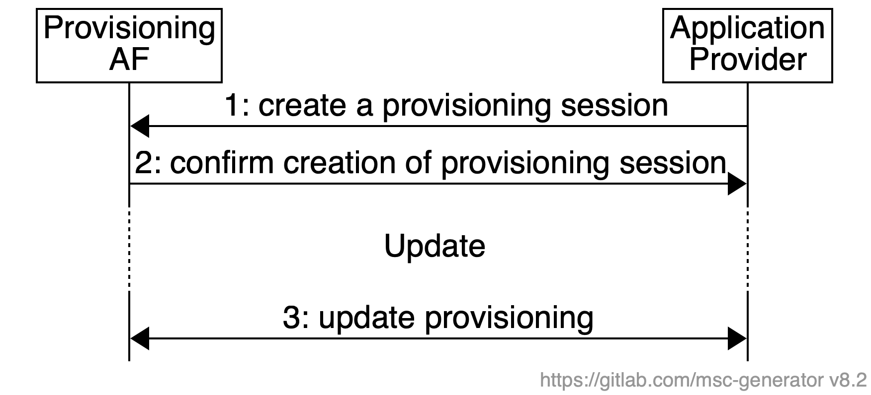

## 5.3 Configuration procedure

Editor’s Note: This sub-clause may not be required depending on whether we identify the common procedure or not…

## 5.4 XXX procedure….

|  |
| --- |
| 2nd Change |

Annex B (normative|informative):  
Call flows for collaboration scenarios

## B.1 Call flow for Over-the-top (OTT) RTC sessions (CS#1)

The RTC session is established between two endpoints using external signaling mechanisms. Each endpoint of the connection that is using the 5G system may benefit from 5G network support for the network path within that 5G network.

The following call flow applies.

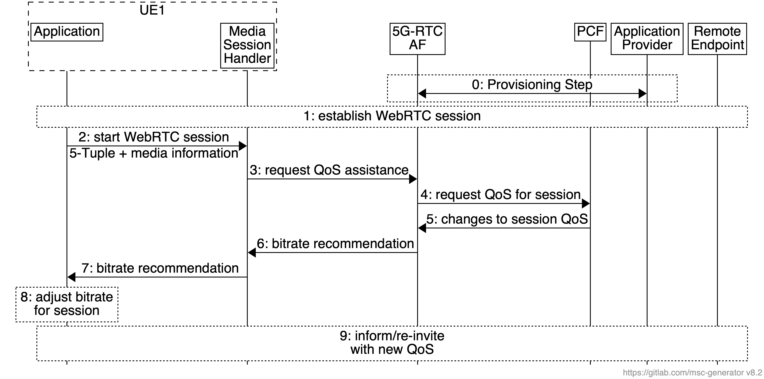

The working assumptions are:

* The application on UE1 and the remote endpoint use an external WebRTC signaling server to establish the WebRTC session.
* Step 0: A provisioning session may have been created by the AP with the MNO.

Network assistance for the RTC session is achieved through the following steps:

1. The application on UE1 uses application-specific signaling functions to establish a WebRTC session with the remote endpoint.
2. The application informs the MSH about the new RTC session and shares information about the media streams and their associated 5-Tuples.
3. The MSH requests network assistance for the RTC session and provides the transport and bandwidth information to the Network Support AF.
4. The Network Support AF uses the N5 or N33 interface to request QoS allocation. It may request differential charging based on pre-existing provisioning for these sessions. The Network Support AF will also subscribe to events related to the QoS flows of the RTC session with the PCF and SMF.
5. The Network Support AF receives notifications about any changes to the QoS flows of the RTC session from the PCF or the SMF.
6. The Network Support AF sends notifications to the MSH about changes to the session. This information may for example be bitrate recommendations.
7. The MSH forwards the bitrate recommendation to the RTC application.
8. The application may act on the bitrate recommendation, e.g. by reducing the uplink media bitrate.
9. The application may request the remote endpoint to adjust the bitrate of the downlink media.

## B.2 Call flow for Network-supported RTC sessions (CS#2)

The MNO offers access to trusted ICE functionality to UEs that wish to participate in RTC sessions. The session establishment takes into account the configured trusted ICE functions.

The call flow is as follows.



The working assumptions are:

* The application on UE1 and the remote endpoint use an external WebRTC signaling server to establish the WebRTC session.
* Step 0: A provisioning session may have been created by the AP with the MNO.

1. The AF uses the RTC-5 interface to provide the MSH with a list of trusted STUN/TURN servers that the UE may use for establishing RTC sessions.
2. The application queries the MSH for the list of trusted ICE servers.
3. The UE discovers and tests the ICE candidates to validate that they are suitable for the connection.
4. The application on UE1 and the remote UE2 use an external RTC signaling server to exchange information about ICE candidates and to exchange the SDP offer/answer.
5. The WebRTC session is then established using the most suitable ICE candidate.
6. The STUN or TURN server in ICE function, upon reception of the allocation request by the application (or WebRTC framework) may extract the 5-Tuple information for each of the media sessions and convey the information to the Network Support AF in 5G-RTC AF.
7. The Network Support AF uses the N5 interface to request QoS allocation. It may request differential charging based on pre-existing provisioning for these sessions. The Network Support AF will also subscribe to events related to the QoS flows of the WebRTC session with the PCF and SMF.
8. The Network Support AF receives notifications about any changes to the QoS flows of the WebRTC session from the PCF or the SMF.
9. The Network Support AF sends notifications to the ICE function (STUN/TURN server).
10. The STUN/TURN server may forward the bitrate recommendation to the application, if the allocation session is still active.
11. The application may act on the bitrate recommendation, e.g. by reducing the uplink media bitrate.
12. Media traffic is delivered to the remote endpoint. If TURN server is present in the configuration, RTC-4m interface is involved.
13. The application may request the remote endpoint to adjust the bitrate of the downlink media.

## B.3 Call flow for MNO-Facilitated RTC sessions (CS#3)

In the collaboration scenario 3, the session is established through a trusted WebRTC signalling function. The MNO also provides trusted ICE functionality to assist the session. The call flow is as follows.



|  |
| --- |
| Second Change |

A.2 Collaboration scenario 1:

Editor’s NOTE: Detailed text to be added

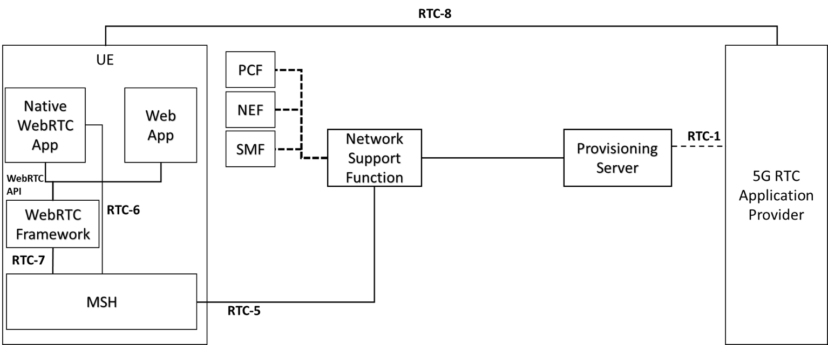

Figure A.2-1: Derivative 5G-RTC architecture for collaboration scenario 1

Call flow for collaboration scenario 1 is as follows. Session setup part and QoS request part are separately performed.



Figure A.2-2: Session setup flow in Collaboration Scenario #1



Figure A.2-3: QoS request flow in Collaboration Scenario #1

Requests and responses in the sequence are as follows:

* 1 and 2. The session information is exchanged between the client application and WebRTC signalling server. It can be proprietary when the interoperability between operators is not necessary.
* 3 and 10. The application requests MSH the network assistance with iRTC session information. The response includes the result of the request and may include the bitrate recommendation.
* 4 and 5. MSH requests Network Support AF the service access information for following procedures. The response is the result of the request and may include the service access information.
* 6 and 9. MSH requests Network Support AF the network assistance. The response may include the bitrate recommendation.
* 7 and 8 Network Support AF requests PCF the QoS control through N5. The response is the result of the request success or failure. The QoS flow event subscription may be conducted.

## 