3GPP TSG-SA WG4 Meeting #122 S4-230070

Athens, Greece, 20 – 24 February 2023

Source: China Mobile Com. Corporation
Title: A Use Case for XR Streaming over WebRTC
Agenda item: 10.5
Document for: Discussion and Agreement

Introduction

In this contribution, we proposed a cloud-based interactive XR Streaming solution using SFU architecture. The Application Server runs remotely, and streams rendered video frames and audio to multiple users. Users can view that broadcast XR media stream in any standard web browser that supports the WebRTC connection model on their own computer or mobile device. Users can also interact with the application from their browser by sending user’s inputs (e.g., keyboard, mouse, touch events, and other custom events) emitted from the player Web page back to the Application Server. There's no need for users to install or download anything.

A Use Case for XR Streaming over WebRTC

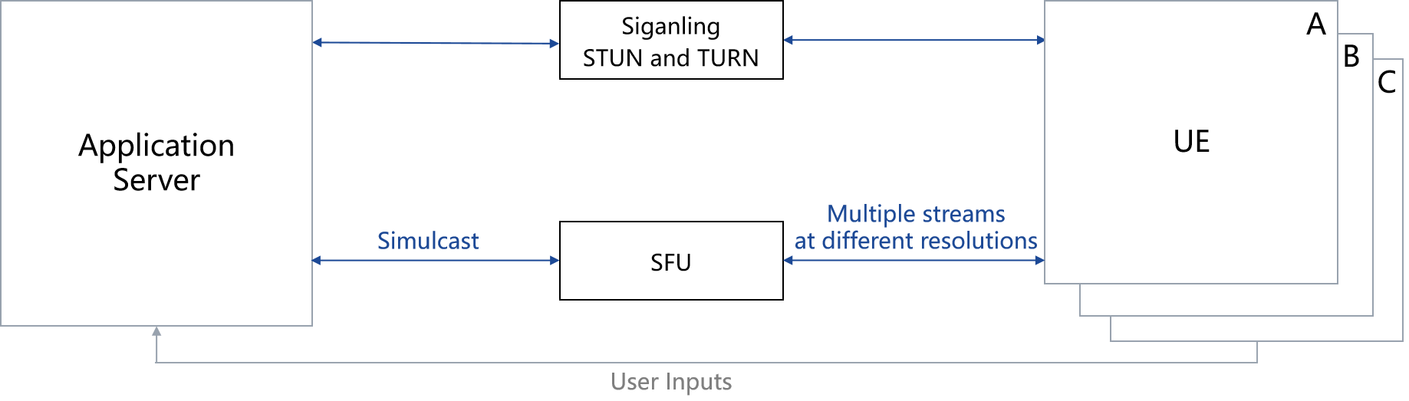

The workflow is described in the following steps:
- The Application Server shall be GPU-capable, such as a virtual machine provided by a custom cloud-hosted
platform. It runs the game logic, renders every frame in real-time, and continuously encodes (e.g., H.264,VP 8, VP 9 video compression) the rendered video frames along with the audio into a media stream.
- The SFU (selective forwarding unit) receives the stream from the Application Server and deliver it to the
recipients peers (typically connected web browsers), optionally subsetting the data (e.g. lower bitrates, resolutions, or framerates) to adapt to the prevailing network conditions of each recipient peer.
- The receiving devices display the received media stream, and send the user’s inputs back to the Application
Server using WebRTC data channel. The user’s inputs can be generic (e.g., keyboard, mouse, touch events) or App specific.

Proposal
We propose to include section 2 of this document into clause 5.2.3 of the permanent document as a use case for discussion.

References
- Unity Unity Render Streaming https://docs.unity3d.com/Packages/com.unity.renderstreaming@3.1/manual/index.html
- Unreal Pixel Streaming
https://docs.unrealengine.com/4.27/en-US/SharingAndReleasing/PixelStreaming/PixelStreamingOverview/
- Unreal Pixel Streaming in Azure
https://learn.microsoft.com/en-us/gaming/azure/reference-architectures/unreal-pixel-streaming-in-azure
- 3GPP TR 26.928: " Extended Reality (XR) in 5G".
- 3GPP TSG SA WG4 S4-230022, “iRTCW Permanent Document v0.3.0”, February 2023

