3GPP TSG-SA4#122 Meeting Tdoc <S4-230189>
Athens, GR, 20th – 24th February 2023
Title: Add the spatial perception test for stereo UE in ATIAS
Source: Xiaomi
Document for: Discussion & Agreement

Agenda Item: 7.6

Introduction
Spatial perception is an essential part of immersive audio. To get the immersive experience, the UE must have a correct auditory location. Otherwise, users will be confused about the discrepant spatial information.
So, this proposal aims to add a test method to determine the central and left\right direction for a hand-held hands-free stereo audio system in the sending direction. Then, discuss the threshold of mismatch between different spatial information.
Clause 3 is a test method proposed for the permanent doc S4-221517. Clause 4 is discussing the associated requirements.

Rationale
The stereo format is becoming common on the market because of the demand for immersive experience, though an official standardized test method hasn't appeared.
Some devices may have an excellent sound image location and quality, but it may be discrepant when it integrates with other information, like visual.
This proposal measures the interchannel level difference\interchannel time difference of UE, which has been investigated for decades to evaluate the sound image location. And discuss the central and left\right direction, the primary function of stereo audio.
Since the work on stereo audio is just initial, it's better first to focus on the audio. Integrating other spatial information (like visual) is for further study.

Test setup

Introduction
This test is applicable to UEs capturing stereo audio.

test conditions
- The test conditions should follow the Free-field propagation conditions and test environment noise floor described in TS 26.260[1].

Setup for terminals
The setup is referred to TS 26.260 and TS 26.132[2], including the POI, reference point, etc.

Where the manufacturer gives conditions of use, these will apply for testing. If the manufacturer gives no other requirement, the DUT will be positioned according the reference usage of hand-held hands-free UE in TS 26.132 describing in the following block:
##########################################################################################
If HATS measurement equipment is used, it shall be configured to the hand-held hands-free UE according to figure 4. The HATS should be positioned so that the HATS Reference Point is at a distance d_{HF} from the centre point of the visual display of the Mobile Station. The distance d_{HF} is specified by the manufacturer. A vertical angle θ_{HF} may be specified by the manufacturer. Where it is not specified, the nominal distance d_{HF} shall be 42 cm and θ_{HF} shall be 0º.
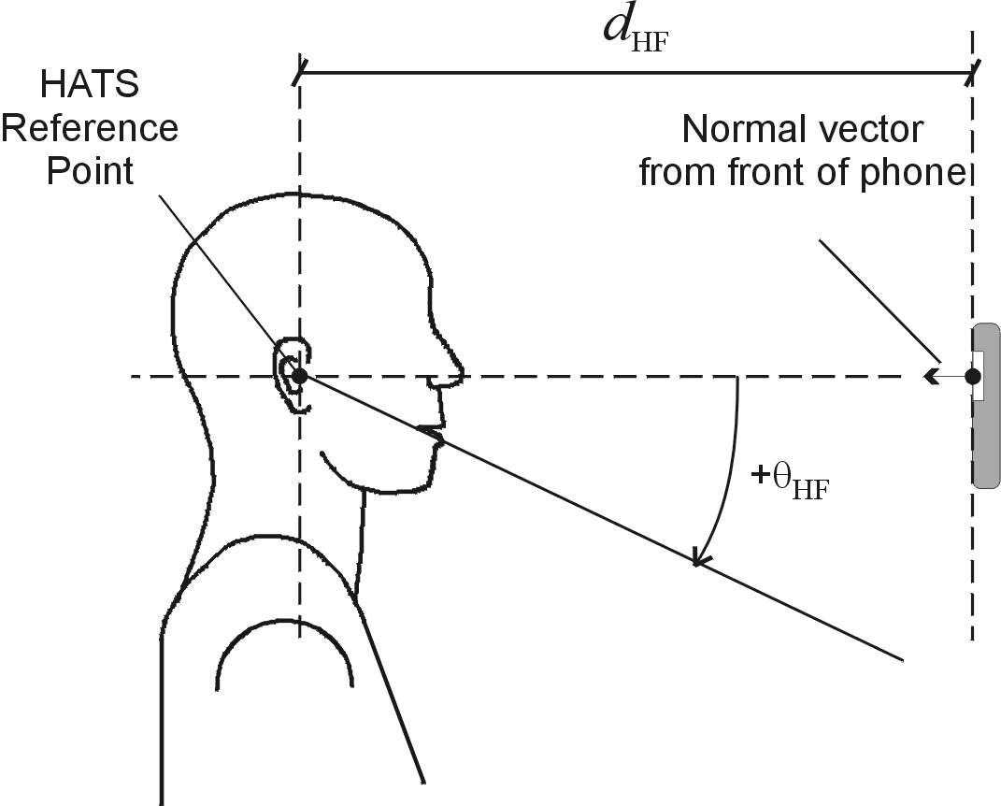
Figure 4: Configuration of hand-held hands-free UE relative to the HATS
################################################################################################
Measurement points:
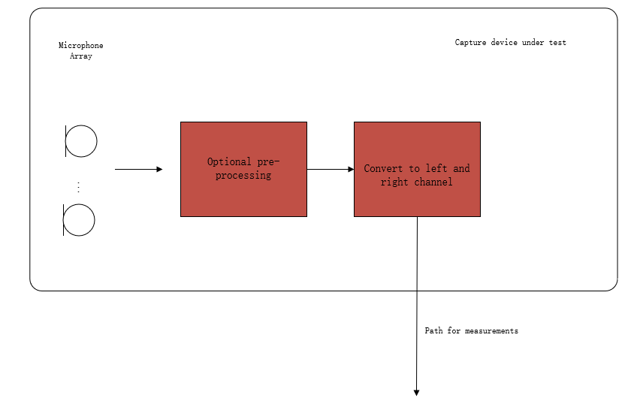
Figure 1: Audio capture block diagram for sending direction measurements
Note: The test should represent what sound the user will get. Hence, the test operator doesn't need to calibrate the DUT. The result should include all the deviations between components in one device (like the sensitivity difference between a microphone array used in DUE) and deviations between different manufactured batches.

Definition
interchannel level difference
The interchannel level difference is the sound level of the left channel minus the right channel.

interchannel time difference
The interchannel time difference is the times-of-arrival of the sounds of the left channel minus the right channel.

NOTE: If other parameters like subband signal, SNR, etc., need to be considered is TBD. Since the actual performance of stereo UE hasn't been confirmed.

Central direction:
To create a central direction, the left and right channels usually have the same or similar signals.
The central direction range is TBD
The requirement of a central direction is TBD

Left\Right direction:
The left and right channels should have sufficient differences to make sound images located on the left or right. If the sound source comes from the left direction, the interchannel time difference<0 and\or interchannel level difference >0 in general and vice versa.
The left and right range is TBD
The requirement of left and right direction is TBD

NOTE: The model to calculate the stereo sound image is TBD.

Measurement method
- The UE device under test is mounted in the free-field volume such that its reference point is on the axis of the sound source.
Repeat steps b-c) with an azimuth angular resolution of N degrees for every possible usage range defined by the manufacturer):
- The sound source pointed directly toward the reference point of the DUT, and the output of DUT on the α degree from the reference line (minus for left) is stored for analysis.
- Change the angle between the sound source and DUT.

Sound source:
HAT or coaxial loudspeaker.
NOTE: Since the UE is most used for speech service, and avoid phase different cause by x-way loudspeaker.
Test signal:
Refer to TS 26.132 clause 7.10.
NOTE: The influence of processing like echo cancel on stereo audio is still unclear. It should be careful about the differences caused by processing.

Delay Measurement Methodologies
Refer to TS 26.132 clause 7.10.

Calculate interchannel time difference and interchannel level difference:

Interchannel Time Difference=Delayleft-Delayright
Interchannel Level DifferenceILD=Levelleft-Levelright

αa
αv
αd=αa-αv

Discuss on requirement
To create an immersive experience correctly, the UE should have a basic requirement that the audio spatial perception has the right direction (left, central or right), at least for Audio-visual spatial perception.
NOTE: The prior research is mainly based on a standard HDTV sound system. But the performance on UE is different greatly, the requirement should consider the limit of UE devices.

Conclusion
According to the descriptions above, it might be reasonable to consider the audio spatial perception accuracy in ATIAS. It proposes a test method to measure interchannel time difference\interchannel level difference, which can be used to evaluate audio spatial perception.
The test method in Clause 3 is proposed to be include in ATIAS Pdoc.

References
- 3GPP TS 26.260: " Objective test methodologies for the evaluation of immersive audio systems."
- 3GPP TS 26.132: " Speech and video telephony terminal acoustic test specification."

- S4-221517 ATIAS-1: Permanent Document on ATIAS

