Source: Nokia Corporation
Title: Real-time scene composition for AR use cases
Document for Agreement
Agenda item: 10.6

Introduction
The document discusses the role of a compositor in conversational AR use cases.

Scene Composition for conversational AR use cases
Virtual objects in an AR call need to be composited with real-world objects. Scene composition can place multiple virtual objects at varying levels of depth in the scene. Scene composition may be done by a network entity for AR two-party and multiparty calls.
- Scene composition for two-party AR calls is simple and can possibly be handled with SDP. Use cases with multiple AR objects and multiparty calls may need to rely on glTF, MPEG scene description or other formats for defining scene composition.
- Real-time composition of a scene can be handled by a network entity. This can be the MRF (media path) or a conference server (session signalling path).
- A network entity may process multiple AR objects into a single media bitstream.
Real-time composition of a scene may include:
- Receiving from the participants of an AR call, their media capabilities, AR objects that are to be shared, and if the use case involved mixed reality then a description of the space where the virtual scene is to be created.
- Real-time scene composition only implies it is done when the call session is established. Updates may be possible but may not be always required.
An example of real-time scene composition is shown in Figure xx, where UE-A is an AR device capable of rendering AR objects composited with real-world. The scene server is a network entity and can be part of the MRF or an application server. The other UEs are users sending AR objects for the AR call. In a real-scenario, the call can be bidirectional and the UE would perform both functions.

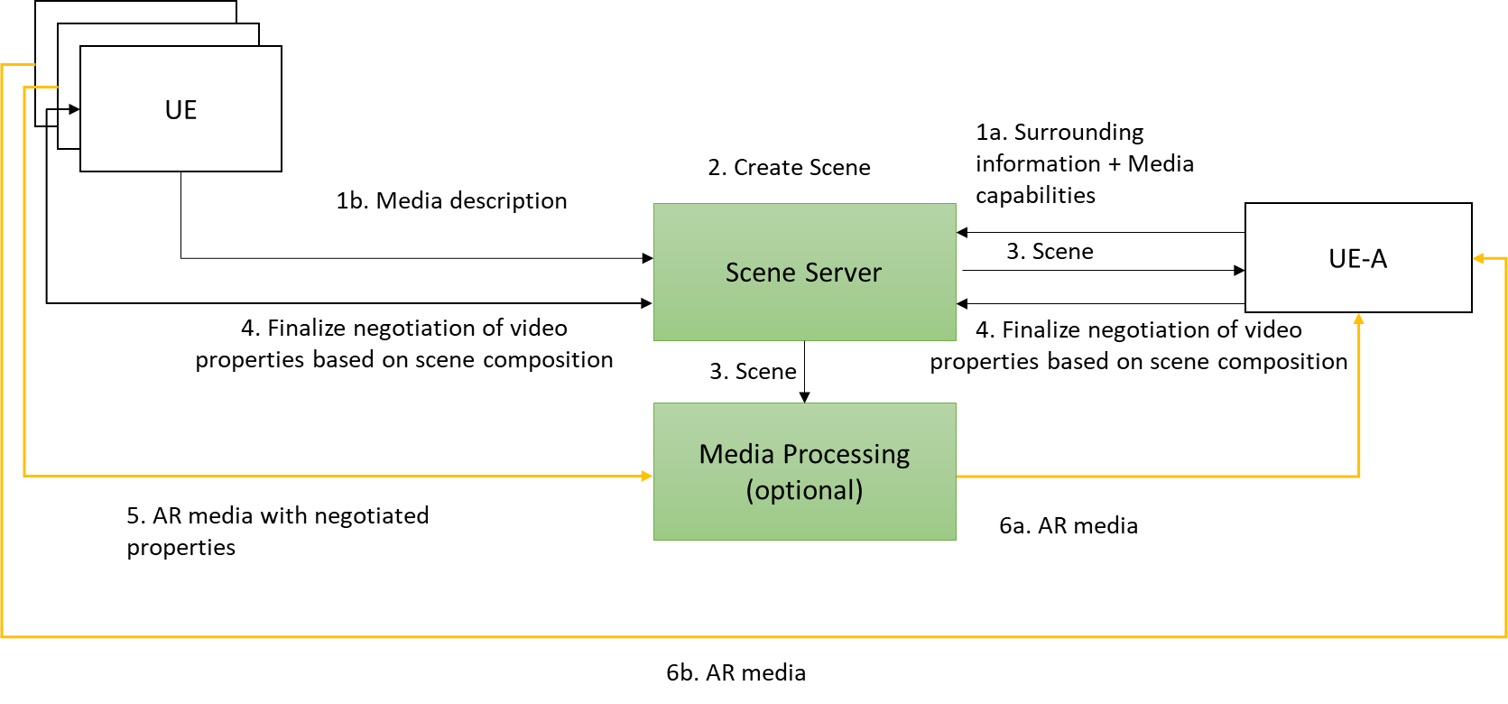
Figure xx: Real-time scene composition for AR calls
The following steps are shown in Figure xx.
1a. UE-A that will receive AR content shares its media capabilities and a description of the user surroundings in which the scene is to be rendered. The latter may not always be required.
1b. UEs that want to send media share media description of the AR media.
2. The scene server creates an AR scene using the information.
3. The scene server shares the scene description with the UEs and media processing function.
4. The media stream negotiation is completed for all UEs.
5. Media is delivered from the sender UE to the MRF which may process the media before delivery based on the scene composition e.g., mixing and/or transcoding.
6a/b. Media is delivered to the receiver UE-A (either via MRF or directly from the other UEs).
The description of the user surroundings here defines the layout of the physical space in which the streams should be rendered, e.g., a simple mesh or a geometric primitive (cylinder or cube) that represents occlusion free space around the user. Scene composition may take into account other aspects, e.g., lower resolution streams may be rendered with greater depth from the user for a realistic experience, considering spatial description of multiple participants to create a symmetric experience etc.

Proposal
The proposal is to move the content of section 2 to the Permanent document of IMS4AR as a basis for further work.

Contact: Igor Curcio, Saba Ahsan, Nokia Technologies, Finland. Emails: ⎨igor.curcio, saba.ahsan⎬@nokia.com.

