**3GPP TSG-SA WG4 Meeting #120-e *S4-221005***

***E-meeting, 17th-26th Aug 2022***

**Title:** [draft] **Reply LS on questions on RAN visible QoE**

**Response to:** **LS S4-220909(****R2-2206833)**

**Release: Release 17**

**Work Item: NR_QoE-Core**

**Source: SA4**

**To: RAN2, RAN3**

**Cc:**

**Contact person: Qi Pan**

**panqi8@huawei.com**

**Send any reply LS to: 3GPP Liaisons Coordinator,** [**mailto:3GPPLiaison@etsi.org**](mailto:3GPPLiaison@etsi.org)

**Attachments:** **None**

1 Overall description

SA4 thanks to RAN2 for the LS which raises the questions on RAN visible QoE. SA4 has discussed the question, and would like to provide the answers as shown below:

Question 1: *Is a periodicity specific for buffer level measurement necessary for RVQoE? If yes, what is the motivation and what should be the configurable values? If not, what are the assumptions on how often the application layer performs the measurements of buffer level and how the buffer level list is filled?*

Answer to Question 1: In the legacy QoE configuration, there is a reporting interval which indicates how often to report the QoE metrics. Each report shall contain only the newly measured information since the previous report. Similarly, for RVQoE, there may be a specific reporting interval for RVQoE (which may be different from the reporting interval for legacy QoE configuration).

Both legacy QoE reports and RVQoE reports may contain a list of buffer level measurements (up to max eight entries for RVQoE). For legacy QoE measurements the interval between adding a new buffer level measurement to the list is specified by the key "n", see the red-marked part of the description below (copied from ISO/IEC 23009-1, which TS 26.247 refers to for buffer level reporting). For instance, legacy QoE reporting might be configured to be sent every 10 minutes, with buffer level measurements done every n=10000 ms, resulting in a buffer level list with 60 buffer level entries being reported.  
  
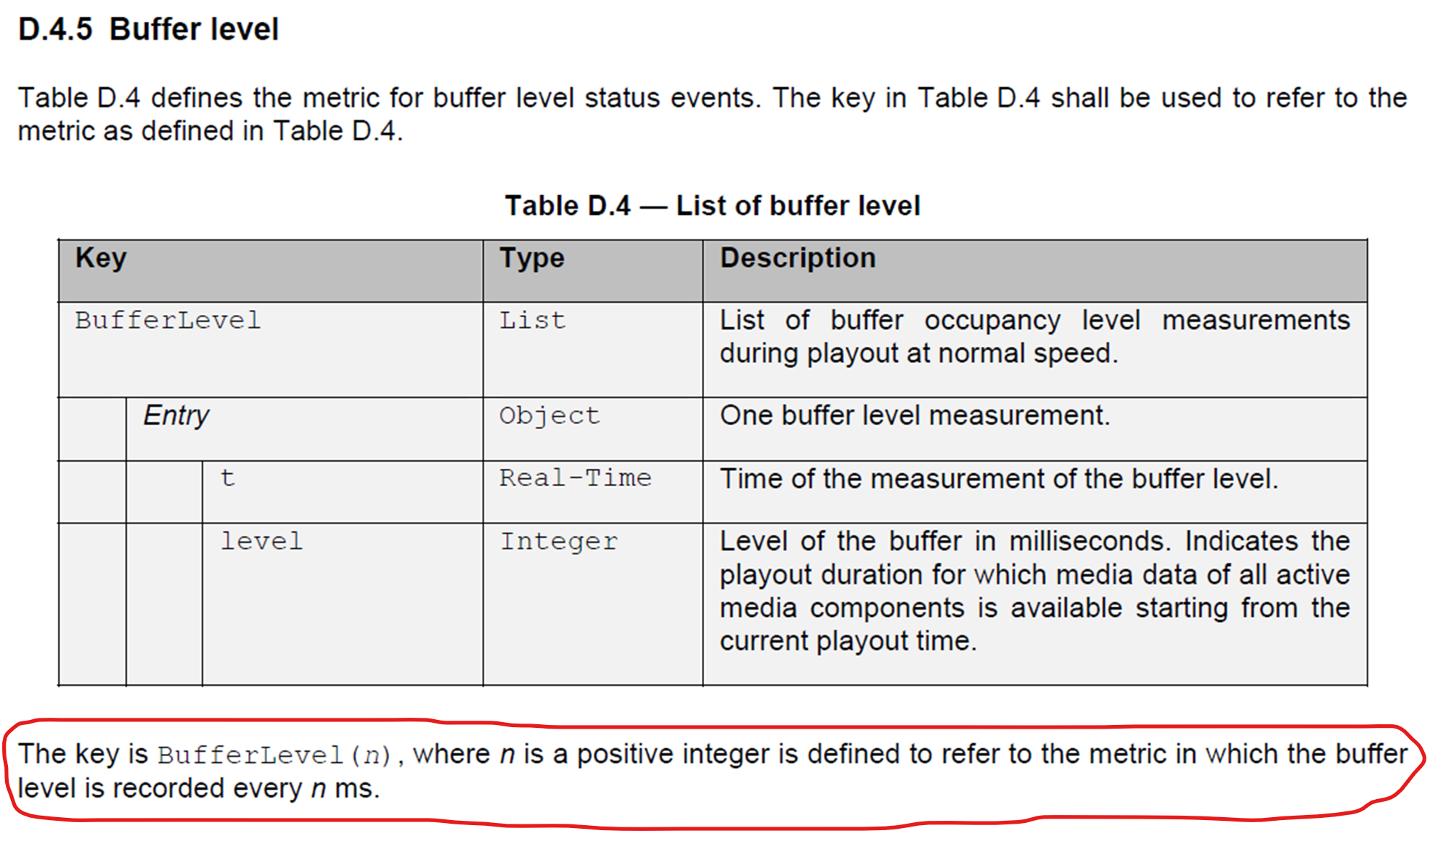  
  
However, for RVQoE there is currently no specification on how often the application layer needs to measure the buffer level. Note that even if buffer level measurements is already configured by the legacy QoE reporting, it is likely not relevant to re-use the same measurement interval (the "n" value) for the RVQoE buffer level measurements, as the legacy QoE reporting and measurements are typically done on a much longer time-scale.

There are several possible options for how to handle this, and the application layer needs to know what to do. For instance, the buffer level measurement interval could relate to the reporting interval. In such a case the application layer could do eight equally divided buffer level measurements to fill the eight entries in one RVQoE report. So if the RVQoE reporting interval is configured as 640 ms, there will be 80 ms between each buffer level measurement.

Alternatively, RAN2/3 could also add a new configuration parameter (similar to "n") which specifies a fixed measurement interval. In such a case the application layer will fill the buffer level list accordingly (and disregard the oldest values in case more than eight measurements are done during one reporting interval).

Anyway, from SA4’s perspective, how the application layer shall handle the periodicity for buffer level measurement for RVQoE must be clearly specified.

Note that with the relatively short reporting intervals for RVQoE (from 120 ms up to 1024 ms), the relevance of making many buffer level measurements during one reporting interval is not obvious. However, that depends on the RVQoE requirements and intended usage of these RVQoE reports, and SA4 defers to RAN3 to making such detemination/decision and inform us of the associated reasons.

2 Actions

**To RAN2 and RAN3:**

**ACTION: SA4 kindly asks RAN2 and RAN3 to take the feedback above into account, and to inform SA4 about any decisions regarding the buffer level measurement interval.**

3 Dates of next SA4 meetings

SA4#121 14th – 18th November 2022 EU

SA4#122 20th – 24th February 2023 EU