Source: Xiaomi, Qualcomm Incorporated, Tencent Cloud, Samsung Electronics Co., Ltd.
Title: Terminal architecture for “EDGAR” MeCAR

Document for: Agreement

Agenda Item: 9.5

1 Introduction
At the 3GPP meeting #118-e, the Permanent Document for MeCAR v1.0 [1] and the draft TS of MeCAR [2] were approved. In the PD, clause 2.3 depicts the device architecture of the EDGAR-type defined in TR 26.998 5G_STAR study.

This contribution is the result of a collective work combining the input received at 3GPP SA4 #119-e comprising:
- S4-220643 Proposed terminal architecture for “EDGAR” MeCAR
- S4-220651 [MeCAR] The EDGAR device architecture
- S4-220674 [MeCAR] On MeCAR architecture
- S4-220613 [MeCAR] Device Architecture for External Display Glass for AR (EDGAR) device

Although the discussion on the device category name is still ongoing at this point, the term EDGAR-1 is used in this document as a tentative name. This document provides thus a figure for the EDGAR-1 device architecture as well as a descriptive text.

2 Proposal
Figure 1 provides a technical architecture of EDGAR-1 UE.
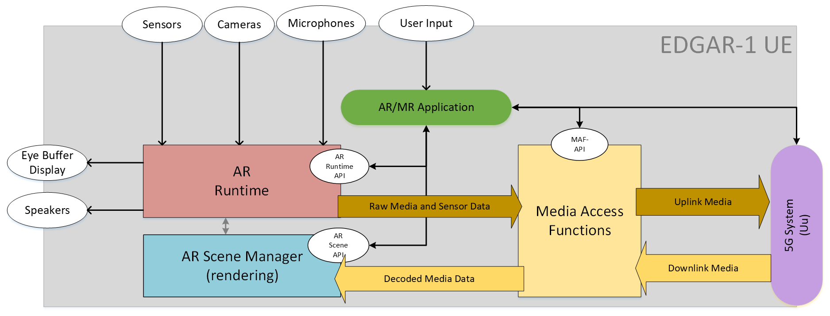
Figure 1 - Device architecture of EDGAR-1 device
The EDGAR-1 is regular 5G UE with 5G connectivity provided through an embedded 5G modem and 5G system components. The EDGAR-1 UE also features several sensors and user controllers relevant for AR experiences that are cameras, microphones, speakers, display and generic user input. The AR/MR Application is responsible for orchestrating the various device resources to offer the AR experience to the user. In particular, the AR/MR Application can leverage three main internal components on the device which are:
- The Media Access Functions (MAF)
- The AR Runtime
- The AR Scene Manager

The AR/MR Application can communicate with those three components via dedicated APIs called the MAF-API, the AR Scene Manager API and the AR Runtime API. Among other functionalities, those APIs enables the AR/MR Application to discover and query the media capabilities in terms of support as well as available resources at runtime.
Once the AR/MR application is running, the downlink media flows from the 5G System to the MAF in compressed form and then from The MAF to the AR Scene Manger in a decoded form. In parallel, the EDGAR-1 UE is capable of establishing an uplink data flow from the AR Runtime to the MAF wherein the data may be in an uncompressed form and then from the MAF to the 5G System wherein the MAF may have compressed the data in order to facilitate the expected transmission over the network.

3 Conclusion
We recommend adopting Clause 2 on terminal architecture of EDGAR-1 device in the upcoming MeCAR Permanent Document revision.

Reference
- S4-220501, MeCAR Permanent Document v1.0, 3GPP TSG SA WG4 118-e Meeting, 6th – 14th April 2022
- S4-220504, Draft TS: Proposed specification skeleton for MeCAR, 3GPP TSG SA WG4 118-e Meeting, 6th – 14th April 2022

