Agenda item: 9.6
Source: Qualcomm Incorporated (Rapporteur), Tencent
Title: [FS_5GVideo] Time Plan Considerations
Document for Discussion and Agreement

Introduction
During SA4#119e, its expected that the FS_5GVideo study item is declared completed. The current time plan according to S4-220495 is provided below:

SA4#119-e (E-meeting:11-20 May) | - Complete the characterization of new codecs  - Complete documentation of gaps and opportunities  - Complete the documentation of the conclusions  - Agree on TR26.955v2.0.0  - Endorse work item summary.
SA#96 (Jun 8 - 10 2022, Budapest , HU) | - Present TR26.955v2.0.0 for approval  - Present work item summary.

This document addresses:
- A time plan prior to SA#96 to complete the study item and what happens afterwards for the study.
- A review of the fulfillment of the work item objectives
- A consideration for a work and time plan moving forward on 5G Video

Time Plan updates
It is expected that the completion of the study item and the TR will take some time in order to check all detailed implementations. Hence, it is proposed to have a telco post SA4#119e in order to agree on the Technical Report. The expectation of this telco is exclusively to address editorial fixes and any issues that needs implementation, that are identified during SA4#119e. Based on this, the following is considered:

SA4#119-e (E-meeting:11-20 May) | - Complete the characterization of new codecs  - Complete documentation of gaps and opportunities  - Complete the documentation of the conclusions  - Agree on next version of TR26.955  - Update schedule and provide power to AHG telco to agree on TR 26.955v2.0.0 and to endorse work item summary
3GPP SA4 Video SWG Telco (May 25, 2022, 15:30 – 17:30 CEST, Host Qualcomm) | - Complete all editorial fixes and non-contentious, non-technical open issues identified during SA4#119e  - Agree on TR26.955v2.0.0  - Endorse work item summary.  - Submission deadline May 24, 16:30 CET.
SA#96 (Jun 8 - 10 2022, Budapest , HU) | - Present TR26.955v2.0.0 for approval  - Present work item summary.

It is expected that after completion at SA#96, some remaining bugs and open issues may still be identified in TR26.955. These bugs are encouraged to be fixed by formal CRs to be submitted to SA4#120e and follow up meetings as part of FS_5GVideo. This is business as usual.

Fulfillment of Work Item Objectives
During SA4#107 the New Study Item on “Feasibility Study on 5G Video Codec Characteristics” in S4-200309 was agreed and afterwards approved in by SA plenary #87 in SP-200052. The work item was later revised in SA4#114-e and the revision was approved in SA plenary #92 in SP-210378.
The objectives of the study item are primarily to identify relevant interoperability requirements, performance characteristics and implementation constraints of video codecs in 5G services, and to characterize existing 3GPP video codecs, in particular H.264/AVC and H.265/HEVC in order to have a benchmark for the addition of potential future video codecs.
The concrete objectives are as follows:
- Collect a subset of relevant scenarios for video codecs in 5G-based services and applications, including video formats (resolution, frame rates, color space, etc.), encoding and decoding requirements, adaptive streaming requirements, predominantly based on scenarios defined for 5G media streaming as well as for TR 26.925 and TR 26.928.
  - This is completed. 5 Scenarios were identified, a sixth one (8K TV) was considered
- Collect relevant and exemplary test conditions and material for such scenarios, including test sequences.
  - This is completed. Many exemplary test conditions for all scenarios are collected
- Define performance metrics for such scenarios with focus on objective performance metrics.
  - This is completed. Metrics were defined that allow characterization.
- Collect relevant interoperability functionalities and enabling elements for video codecs in different 5G services such as MTSI and Telepresence (i.e. RTP based conversational communications), or 5G media streaming (e.g. based on DASH/CMAF) supporting the identified scenarios.
  - This is completed. Interoperability requirements for relevant scenarios are documented.
- Collect relevant criteria and key performance indicators for the integration of video codecs in 5G processing platforms, taking into account factors such as encoding and decoding complexity in the context of the defined scenarios.
  - This is largely completed. The scenarios address most of the topics and encoding constraints and decoding constraints were carefully selected to meet these requirements
- Characterize the existing codecs H.264/AVC and H.265/HEVC in the context of the above scenarios and document the findings in a consistent manner.
  - This is fully completed, all relevant characterization is done.
- Identify gaps and deficiencies of existing codecs in such use cases and derive requirements for potential new codecs.
  - This is partially completed, some input is provided during this meeting on existing codecs. More work is encouraged on the rest of the objectives.
- Collect initial information on how new coding technologies under development in ISO/IEC SC29 WG 4 / WG 5 (MPEG Video / JVET) (in particular including VVC and EVC) may meet the above criteria based on the characterization results provided for example by ISO/IEC JVET.
  - This is fully completed. An initial set of information is collected in clause 8.2 and 8.4, including test configurations and initial characterization results.
- Collect initial information on how the new AV1 coding technology developed by the Alliance for Open Media may meet the above criteria.
  - This is largely completed. An initial set of information is collected in clause 8.3 pending some final confirmation.
- For any coding technology being characterized in the study and reported in the TR
  - the evaluation is expected to be conducted consistent with the already-agreed framework and test designs defined for the anchors in 3GPP TR 26.955v1.1.3 clauses 5 and 6.
    - This is fully completed. See all information in clause 8.
  - technical documentation to conduct the study is expected to be available and provided. Such information includes normative specification text, reference software and description of configuration files, and codec description.
    - This is fully completed. See all information in clause 8.
  - additional data such as subjective test results (with description of test methodology and conditions) not conducted as part of this study item, encoding tool and configuration file description is also important information that could be provided
    - This is fully completed. Some information in clause 8.

Moving Forward on 5G Video
According to clause 2 and 3, the study item can be declared complete during SA4#119-e and the TR can be sent to approval to SA#96 with good justification. 80% completeness can easily be claimed. SA4#120e, as already indicated, can be used to update the TR addressing bug fixes or any outstanding topics. Feature-wise the study is complete.

For the first time, 3GPP has taken on the challenge and work to create a systematic, flexible and extensible framework on benchmarking and characterizing video codecs, in particular existing ones H.264/AVC and H.265/HEVC. This exercise was novel and lots of new aspects were collected, together with gain in expertise and experience. This effort turned out to be a valuable exercise and the information collected in TR 26.955 can be used as the basis for future work for the characterization of video codecs, as well as to support the technical evaluation of video codecs in context of 3GPP services.

One important outcome of the study and exercise was the characterization and evaluation of H.265/HEVC against relevant scenarios and its characterization against H.264/AVC. Also, a first understanding was collected to what extent H.265/HEVC is competitive with potential new codecs. From the scenarios and results in TR26.955 it is observed that
- H.265/HEVC does not show any functional deficiencies or gaps nor does it lack any relevant features.
- In terms of compression efficiency, H.265/HEVC evaluated based on the HM performs sufficiently well for all the scenarios in this technical report.
Providing consistent HEVC-based interoperability in 3GPP services, for traditional and new scenarios is definitely a benefit. It is considered beneficial to upgrade 3GPP specifications to support profiles, levels and possibly features available in HEVC. Features may include better support for screen content and computer-generated content, XR/AR type of services as well as low and very low latency services.

On the initial evaluation of new codecs, the results from TR26.955 are extremely helpful to understand the functionalities of existing codecs and to understand potential benefits of new codecs in 5G services. New codecs in 3GPP need preparation to identify the needs, requirements and a characterization. A new study that uses the information in TR 26.955 as well as the baseline technologies in Rel-18 to come to conclusions may be prepared and conducted, but no urgent needs has been identified.

Based on these discussions, a consideration of a time plan is as follows:
- Complete the study at this meeting as discussed in clause 2 and 3
- Plan for a work item to address improved HEVC functionality to be submitted to SA#96 (Sep 2022)
- Prepare a study item to be submitted for SA#97 or later that looks for requirements, characterization and possibly conclusions for new video codecs in 3GPP, in particular based on gaps and opportunities that are identified based on Rel-18 HEVC specifications.
- Based on these conclusions, initiate normative work on new video codecs – possibly for Rel-19.
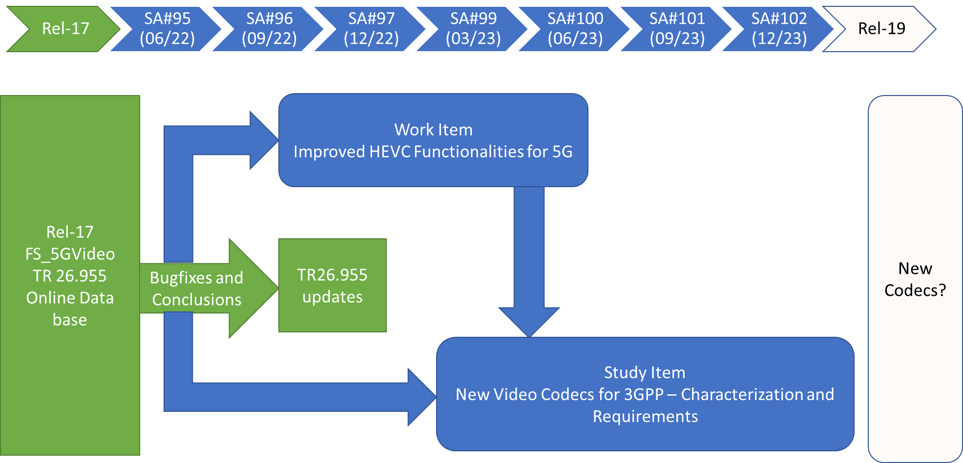

Proposal
Based on the discussion on this document, the following is proposed:
- Update the time plan based on clause 2, if needed.
- Declare completion of FS_5GVideo during SA4#119e and submit TR26.955 v2.0.0 for approval to SA#95
- Expect bug fixes and updates to conclusions for SA4#120 for TR26.955
- Plan a normative work item for improved HEVC capabilities for 5G to be submitted to SA#96 (Sep 2022)
- Document the basic agreements as part of the conclusions of TR26.955.

